**SDG3-GOOD HEALTH AND WELL BEING.**

TEAM SAPS

**INTRODUCTION**

“Health is Wealth” good health plays a vital role in our everyday life and well being. Whatever we may be a doctor, an artist or a leader good health is really important. Good health nowadays has become a real luxury. Due to high population in Telangana the many health issues that occurs because of food habits and hypertensions. Family planning is suggested across the state to reduce population and decrease unwanted uterus cancer. Ending this condition in Telangana has become real difficult because of this the state stands one of the highest in poor health.

**METHODOLOGY**

The methodology used here is charts option from spreadsheet(Microsoft Excel)in this data the file is now separated in to dependent, independent and indicators to make the required visualization.

Data used here is given in the resources and hence used accordingly to predict and visualize the data set into understandable graphs.

**Hypertension among women(Age 15 years and above)**

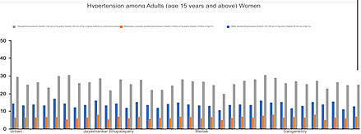

**Hypertension among men(Age 15 years and above)**

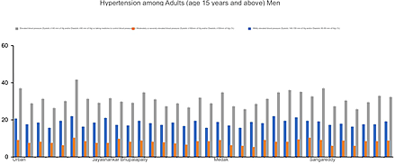

Hypertension, often known as high or increased blood pressure, is a disorder in which the blood vessels have an abnormally high pressure for an extended period of time. The vessels transport blood from the heart to all areas of the body.

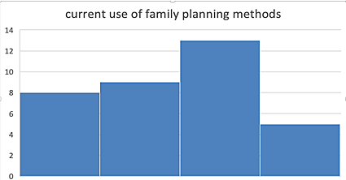

Family planning stimulates the maternal health, it reduces number of unwanted abortions, prevents sexually transmitted infections, it helps to avoid uterus cancer and many other maternal problems.

Mentally it provides social security and enhances physical activities and many more.

**CONCLUSION**

Overall the health related issues Telangana has increased over the years and in the time of covid pandemic it elevated in an alarming rate and its really important to a human to maintain mental and physical peace together to avoid any kind od hypertension. Conducting oneself in physical and psychological activities helps to reduce hypertension and running free family plan camps and education women about family planning will escalate the awareness.