CLIMATE ACTION

---------------------------------------------2019 was the [second warmest year on record](https://news.un.org/en/story/2020/03/1059061) and the end of the warmest decade (2010- 2019) ever recorded. Carbon dioxide (CO2) levels and other [greenhouse gases in the atmosphere](https://news.un.org/en/story/2020/04/1062332) rose to new records in 2019. Climate change is affecting every country on every continent. It is disrupting national economies and affecting lives. Weather patterns are changing, sea levels are rising, and weather events are becoming more extreme. Although greenhouse gas emissions are projected to drop about 6 per cent in 2020 due to travel bans and economic slowdowns resulting from the COVID-19 pandemic, this improvement is only temporary. [Climate change is not on pause](https://news.un.org/en/story/2020/04/1062332). Once the global economy begins to recover from the pandemic, emissions are expected to return to higher levels. Saving lives and livelihoods requires urgent action to address both the pandemic and the climate emergency. The [Paris Agreement](https://unfccc.int/process-and-meetings/the-paris-agreement/the-paris-agreement), adopted in 2015, aims to strengthen the global response to the threat of climate change by keeping a global temperature rise this century well below 2 degrees Celsius above pre-industrial levels. The agreement also aims to strengthen the ability of countries to deal with the impacts of climate change, through appropriate financial flows, a new technology framework and an enhanced capacity building framework.

**COVID-19 RESPONSE**

[](https://i2.wp.com/www.un.org/sustainabledevelopment/wp-content/uploads/2020/05/covid19_response_logo_horizontal_april_2020-01.png?ssl=1)As countries move toward rebuilding their economies after COVID-19, recovery plans can shape the 21st century economy in ways that are clean, green, healthy, safe and more resilient. The current crisis is an opportunity for a profound, [systemic shift to a more sustainable economy](https://news.un.org/en/story/2020/04/1061082) that works for both people and the planet.

The UN Secretary-General has proposed  [six climate-positive actions](https://www.un.org/en/un-coronavirus-communications-team/un-urges-countries-%E2%80%98build-back-better%E2%80%99) for governments to take once they go about building back their economies and societies:

1. Green transition: Investments must accelerate the decarbonization of all aspects of our economy.
2. Green jobs and sustainable and inclusive growth
3. Green economy: making societies and people more resilient through a transition that is fair to all and leaves no one behind.
4. Invest in sustainable solutions: fossil fuel subsidies must end and polluters must pay for their pollution.
5. Confront all climate risks
6. Cooperation – no country can succeed alone.

To address the climate emergency, post-pandemic recovery plans need to trigger [long-term systemic shifts](https://news.un.org/en/story/2020/04/1061082) that will change the trajectory of CO2 levels in the atmosphere.

Governments around the world have spent considerable time and effort in recent years to develop plans to chart a safer and more sustainable future for their citizens. Taking these on board now as part of recovery planning can help the world [build back better](https://blogs.worldbank.org/climatechange/how-countries-climate-ambitions-can-support-sustainable-recovery-covid-19-coronavirus) from the current crisis.

**Climate Action Summit 2019**

With global emissions are reaching record levels and showing no sign of peaking, UN Secretary-General António Guterres called on all leaders to come to New York on 23 September 2019 for the [Climate Action Summit](https://www.un.org/en/climatechange/un-climate-summit-2019.shtml) with concrete, realistic plans to enhance their nationally determined contributions by 2020, in line with reducing greenhouse gas emissions by 45 per cent over the next decade, and to net zero emissions by 2050.

Read the [Report of the Secretary-General](https://www.un.org/en/climatechange/assets/pdf/cas_report_11_dec.pdf) on the outcomes of the Summit.

[**IPCC Climate Report 2018**](http://www.ipcc.ch/report/sr15/)

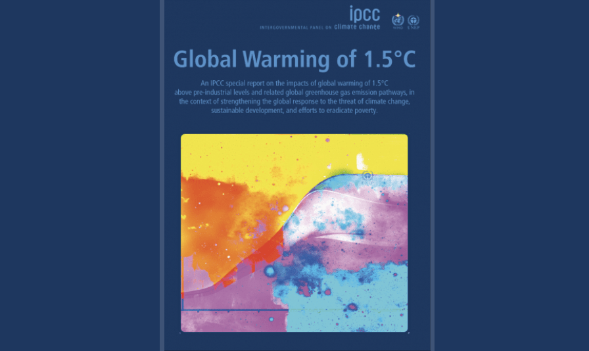

Limiting global warming to 1.5ºC would require rapid, far-reaching and unprecedented changes in all aspects of society, the [Intergovernmental Panel on Climate Change](http://ipcc.ch/index.htm) (IPCC) said in their [Climate Report 2018](https://www.ipcc.ch/sr15/). With clear benefits to people and natural ecosystems, limiting global warming to 1.5ºC compared to 2ºC could go hand in hand with ensuring a more sustainable and equitable society.

[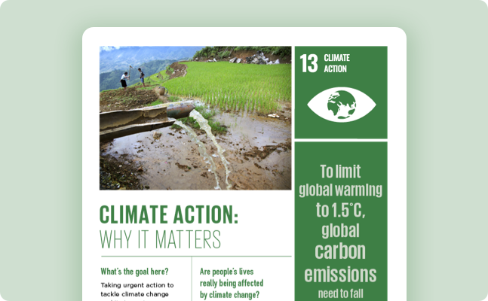](https://www.un.org/sustainabledevelopment/wp-content/uploads/2019/07/13_Why-It-Matters-2020.pdf)

[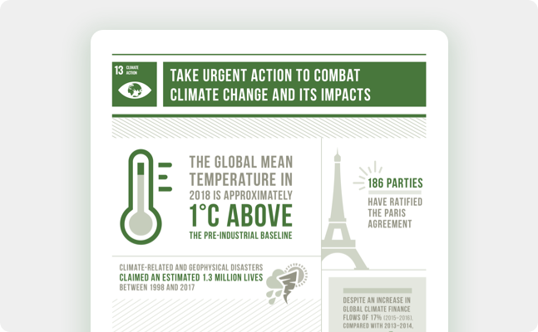](https://www.un.org/sustainabledevelopment/wp-content/uploads/2020/07/E_infographics_13.pdf)

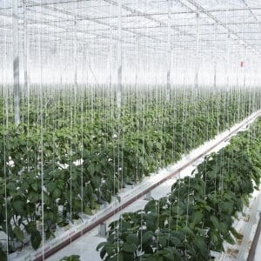

* As of April 2018, 175 parties had ratified the Paris Agreement and 168 parties had communicated their first nationally determined contributions to the UN framework convention on Climate Change Secretariat.
* As of April 2018, 10 developing countries had successfully completed and submitted their first iteration of their national adaptation plans for responding to climate change.
* Developed country parties continue to make progress towards the goal of jointly mobilizing $100 billion annually by 2020 for mitigation actions.

Thanks to the Intergovernmental Panel on Climate Change we know:

* **From 1880 to 2012, average global temperature increased by 0.85°C**. To put this into perspective, for each 1 degree of temperature increase, grain yields decline by about 5 per cent. Maize, wheat and other major crops have experienced significant yield reductions at the global level of 40 megatons per year between 1981 and 2002 due to a warmer climate.
* **Oceans have warmed, the amounts of snow and ice have diminished and sea level has risen.** From 1901 to 2010, the global average sea level rose by 19 cm as oceans expanded due to warming and ice melted. The Arctic’s Sea ice extent has shrunk in every successive decade since 1979, with 1.07 million km² of ice loss every decade
* **Given current concentrations and on-going emissions of greenhouse gases, it is likely that by the end of this century, the increase in global temperature will exceed 1.5°C compared to 1850 to 1900 for all but one scenario**. The world’s oceans will warm and ice melt will continue. Average sea level rise is predicted as 24 – 30cm by 2065 and 40-63cm by 2100. Most aspects of climate change will persist for many centuries even if emissions are stopped
* Global emissions of carbon dioxide (CO2) have increased by almost 50 per cent since 1990
* Emissions grew more quickly between 2000 and 2010 than in each of the three previous decades
* It is still possible, using a wide array of technological measures and changes in behaviour, to limit the increase in global mean temperature to two degrees Celsius above pre-industrial levels
* Major institutional and technological change will give a better than even chance that global warming will not exceed this threshold

**The Paris Agreement on climate change**

The historic [Paris Agreement](http://unfccc.int/paris_agreement/items/9485.php) provides an opportunity for countries to strengthen the global response to the threat of climate change by keeping a global temperature rise this century well below 2 degrees Celsius and to pursue efforts to limit the temperature increase even further to 1.5 degrees Celsius. It entered into force on 4 November 2016.

**The UN continues to encourage all stakeholders to take action toward reducing the impacts of climate change.**