Movie Ticketing Bot Powered by IBM Watson Assistant

##### CHAT BOT:

A chatbot is a software or computer program that simulates human conversation or "chatter" through text or voice interactions. Adding chatbot assistants reduces overhead costs, uses support staff time better and enables organizations to provide customer service during hours when live agents aren't available.

##### Why are chatbots important?

Organizations looking to increase sales or service productivity may adopt chatbots for time savings and efficiency, as artificial intelligence (AI) chatbots can converse with users and answer recurring questions.

##### Project Description:

In this project, we will be building a chatbot using Watson assistant. This chat should have the following capabilities

* Give the list of movies available
* The Bot should be able to show different show timings
* When a movie is selected the bot should show the availability of tickets and their respective prices.
* The bot should be in a position to book tickets.
* **Services Used:**

1. IBM Cloud
2. IBM Watson Assistant

**Technical Architecture:**

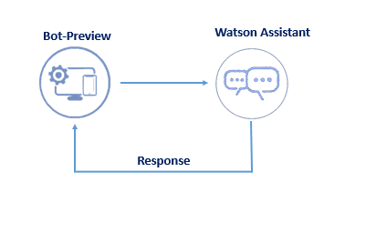

**Work Flow:**

**Intents:**

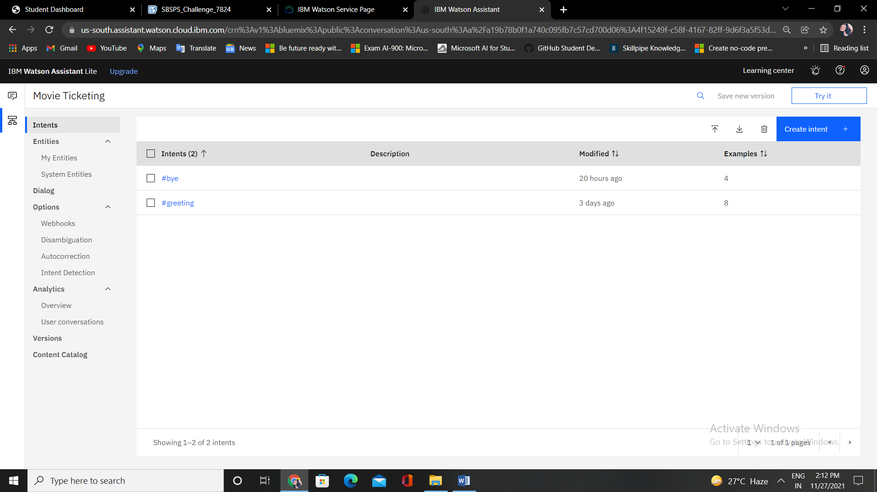

**Entities:**

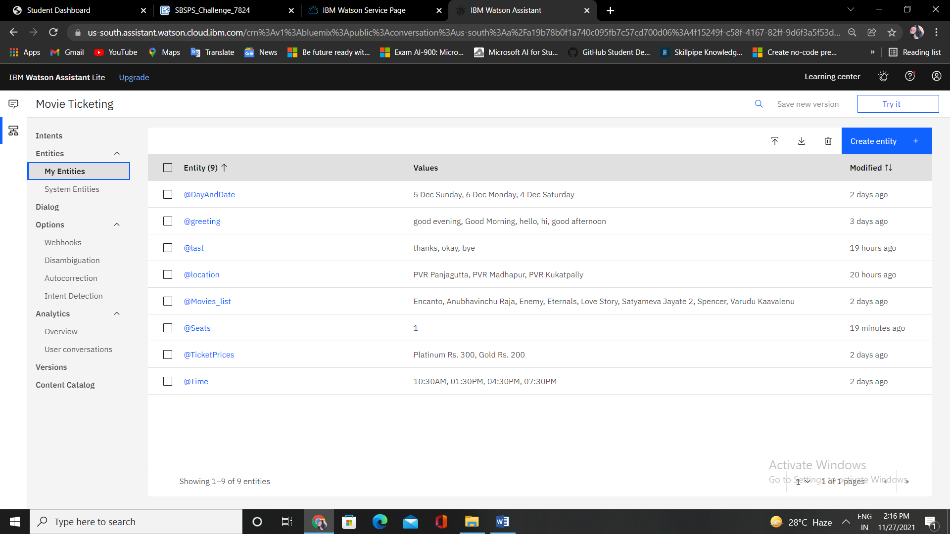

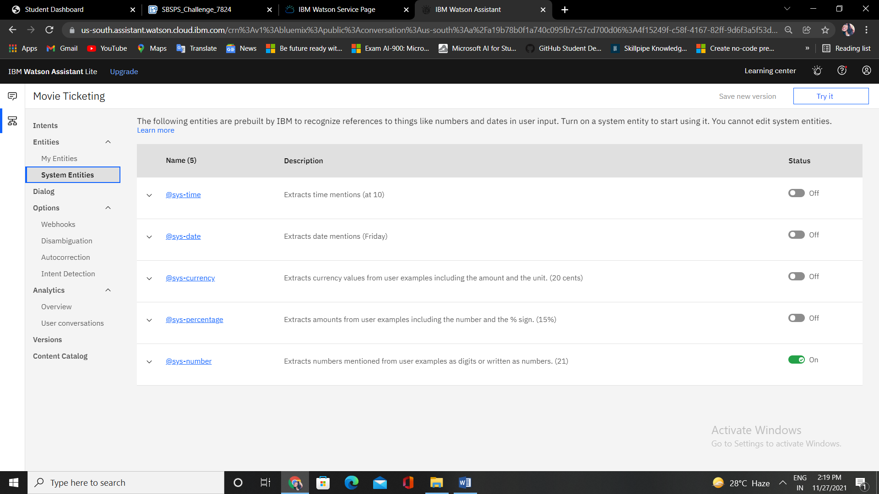

**Dialogs:**

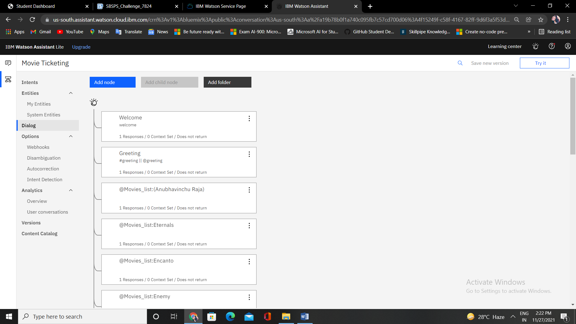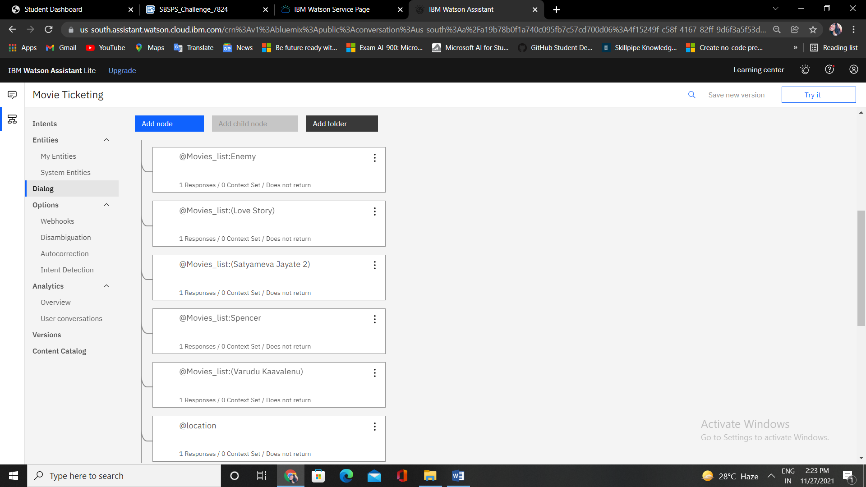

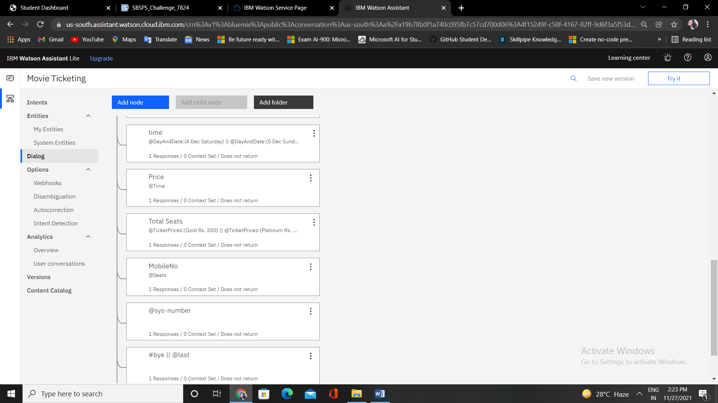

**Result:**

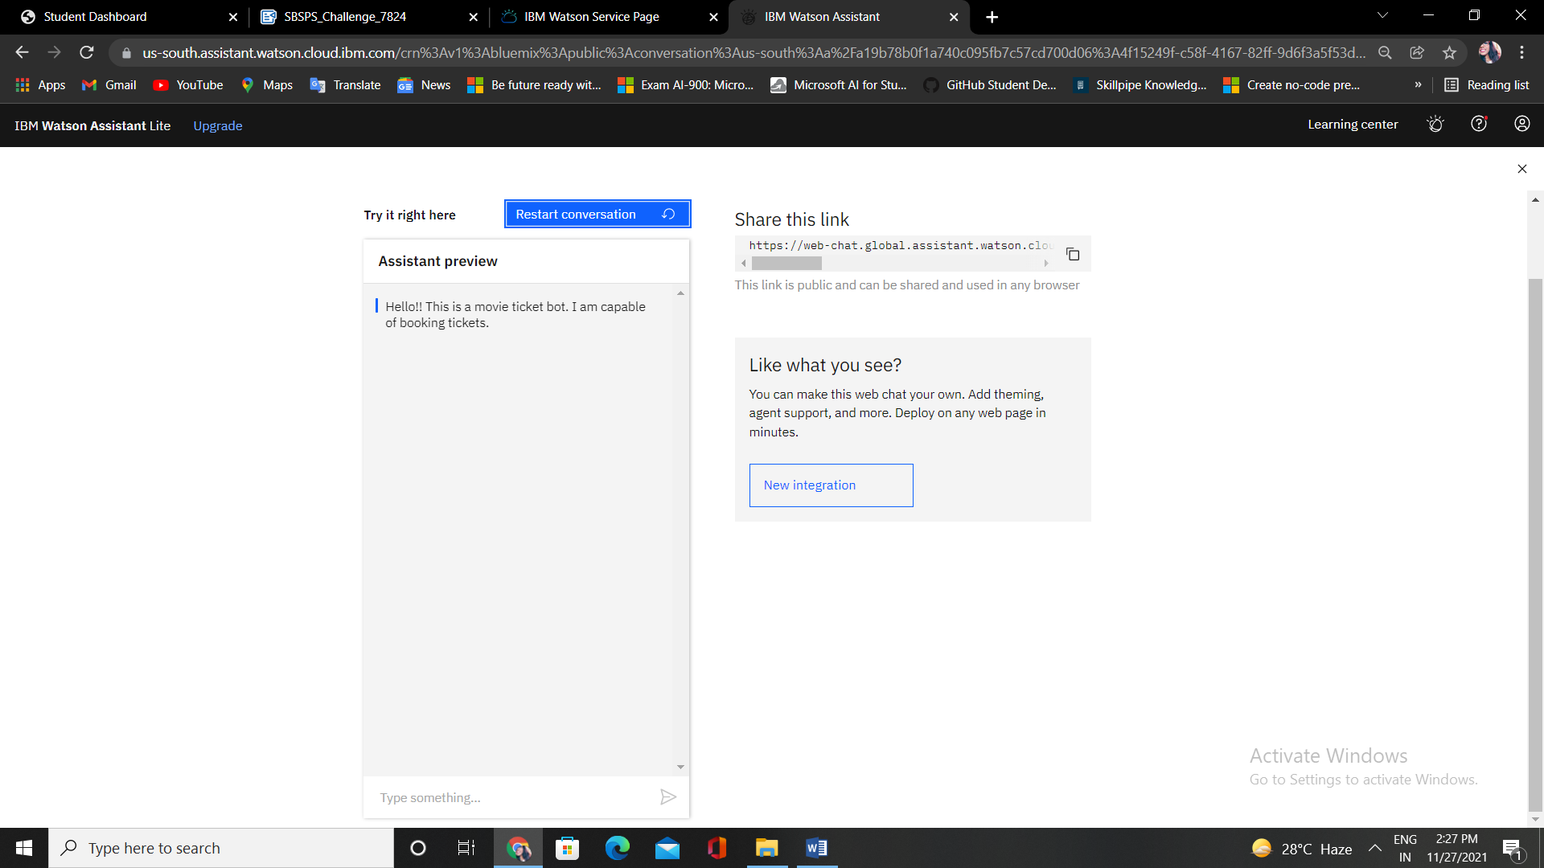

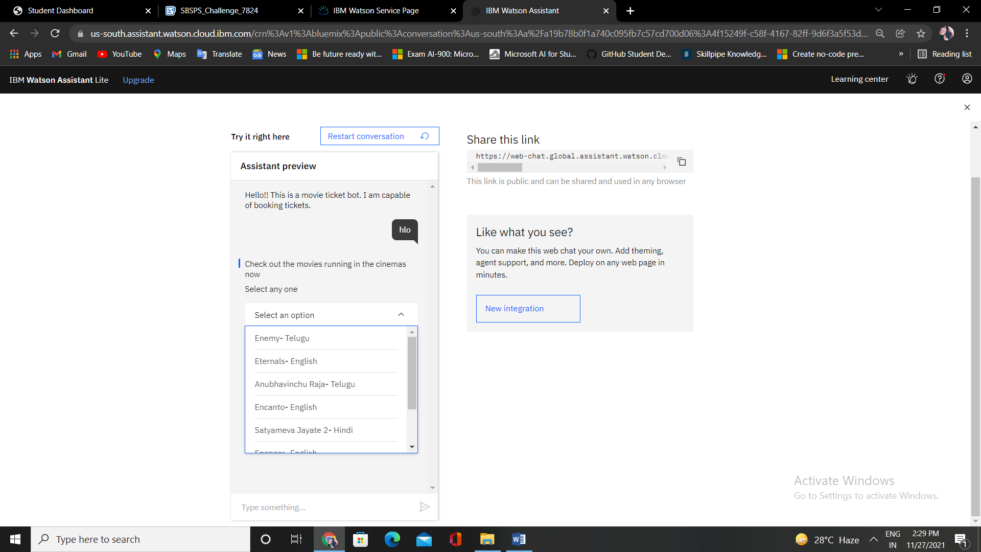

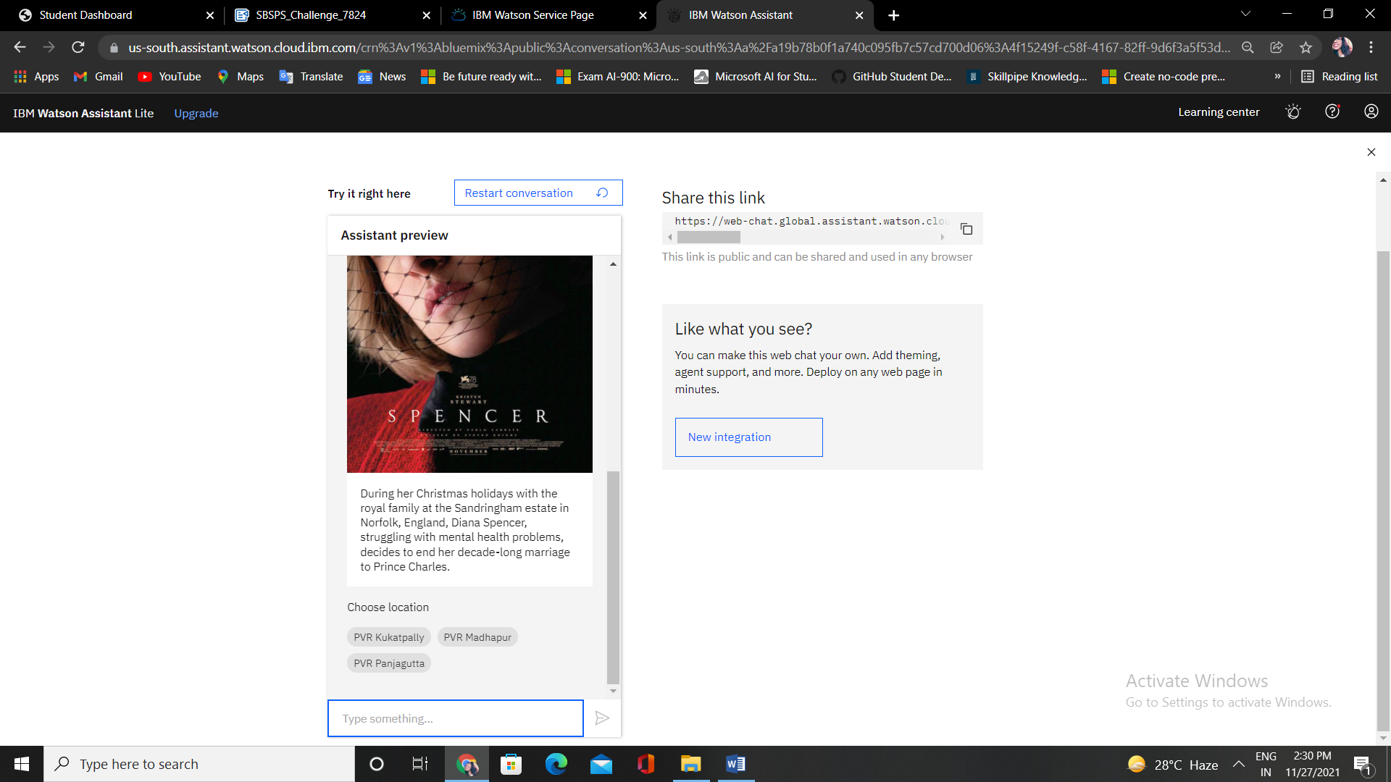

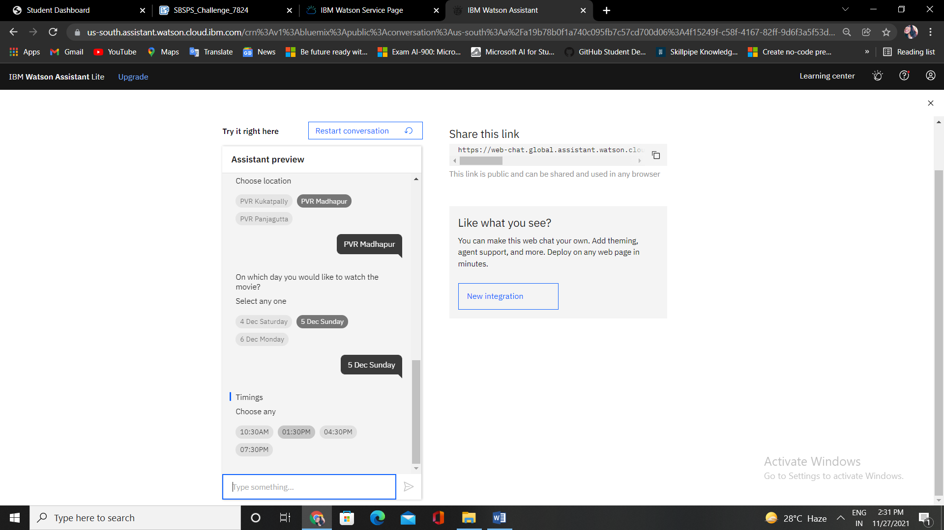

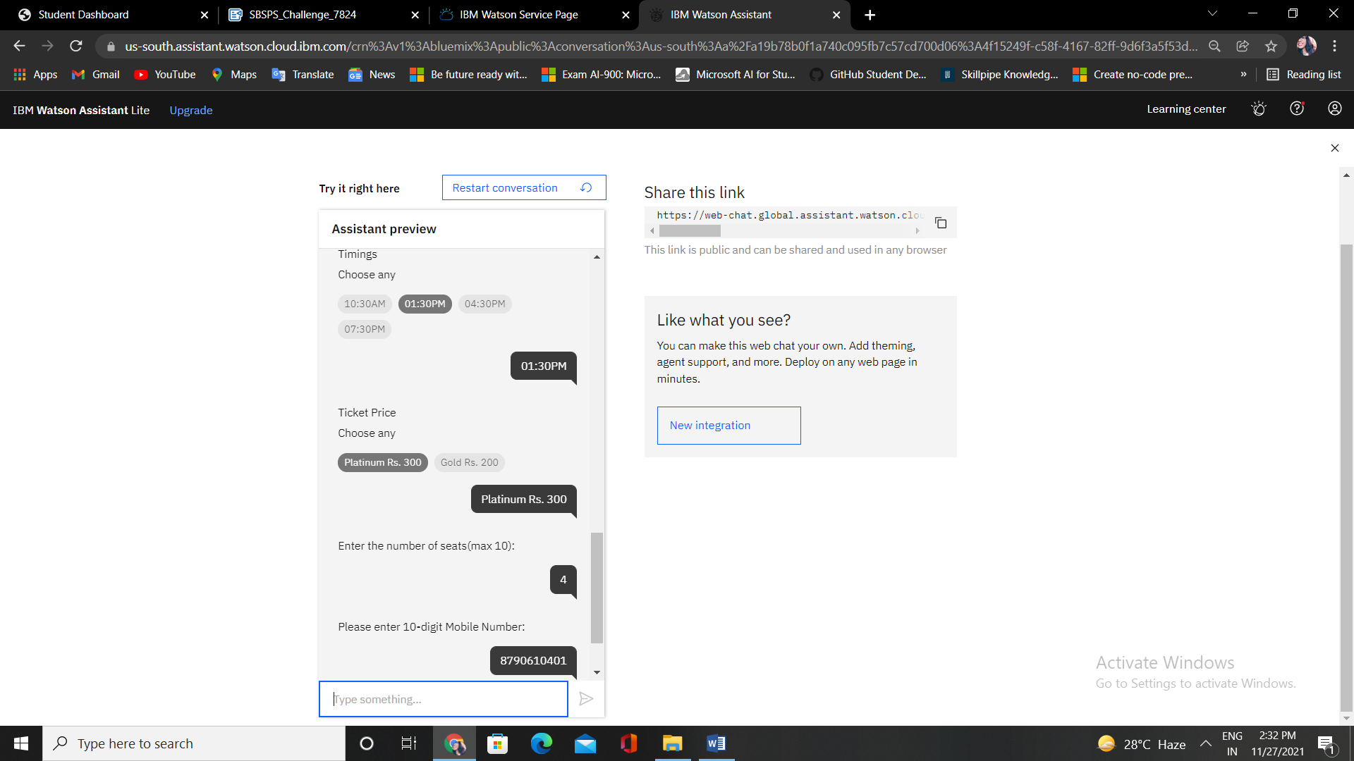

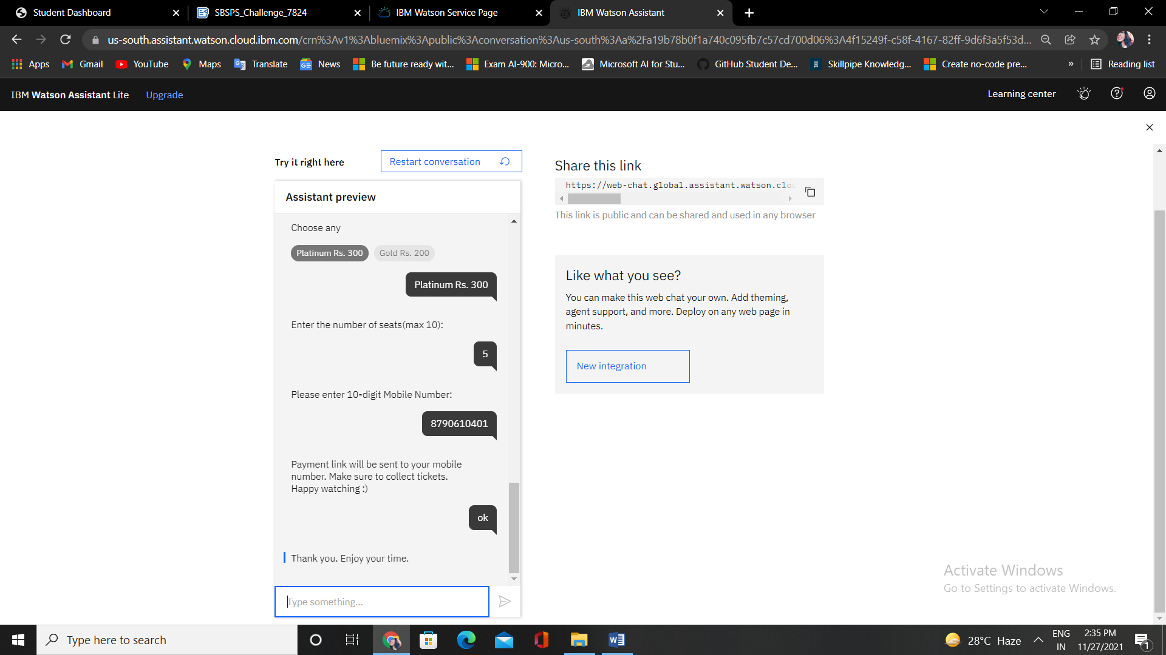

**Pros of Using Chatbots****:**

1. Faster Customer Service
2. Constantly Available
3. Promotes Conversational Marketing
4. Helps Manage Customer Requests

**Cons of Using Chatbots:**

1. Don’t Understand Natural Language
2. Not Personalized or Emotive
3. Higher Capacity for Misunderstanding
4. Need to be Maintained

**Applications:**

Content delivery, Order food, Book flights, Market research, Transportation, Health care, Book movie tickets...

**Conclusion:**

Developed Movie Ticket Booking Chatbot using IBM Watson Assistant.

**Demonstration Video:**

<https://youtu.be/gnV25vJN2xs>

**Preview Link:**

**<https://web-chat.global.assistant.watson.cloud.ibm.com/preview.html?region=us-south&integrationID=bc76d58f-b614-43e1-baee-70be740b4e41&serviceInstanceID=4f15249f-c58f-4167-82ff-9d6f3a5f53dc>**

**Source Code:**

**<https://github.com/smartinternz02/SBSPS-Challenge-7824-Movie-Ticketing-Bot-Powered-by-IBM-Watson-Assistant/blob/main/skill_MovieTicketing>**