PROBLEM STATEMENT:

***Real-Time Air Quality Monitoring & Weather Forecasting System***

**TEAM DEATAILS**

**Ayman Faris**

**Joy Rithik**

**Harish Kumar**

**Faheem**

**General Description**

Air pollution represents a serious environmental problem. Each year, millions premature deaths are attributed to air pollution, with huge economic consequences. Furthermore, air pollution is detrimental for ecosystems, damages property, impacts visibility and haze, and threatens food and water security. Air Quality Forecasts, if they are reliable and sufficiently accurate, can play an important role as part of an air quality management system The air quality (AQ) Forecast lets the public know expected air quality conditions for next 72 hours so that Government authorities can take action to manage the air quality and issue health advisories. Local air quality affects how you live and breathe. With the help of Weather API we can get immediate access to local weather conditions and upcoming forecast, It will provide real-time notifications about prevailing and expected weather conditions which helps governments and local administrations prepare for natural disasters and save lives.

The higher the [AQI value](https://www.business-standard.com/article/current-affairs/delhi-pollution-aqi-at-708-odd-even-scheme-starts-today-schools-shut-119110400076_1.html), the greater the level of air pollution and the greater the health concerns. The concept of AQI has been widely used in many developed countries for over the last three decades. AQI quickly disseminates air quality information in real-time.

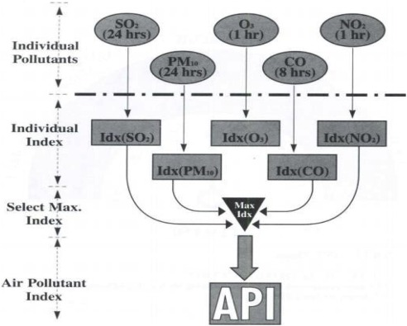

**Novelty / Uniqueness:**

A Supervised Machine Learning Algorithm is used for classifications or regression.

We have trained the data and test the data to analyse and estimate best performing Machine learning (ML) Algorithms for better predictions.

The ML model we have developed is reliable and is sufficiently accurate.

**Business / Social Impact:**

This model will help many common people from getting stuck in natural calamitis and save themselves from many life-killing diseases.

* Comparing air quality conditions at different locations/cities.
* It also helps in identifying faulty standards and inadequate monitoring programmes.
* AQI helps in analysing the change in air quality (improvement or degradation).
* AQI informs the public about environmental conditions. It is especially useful for people suffering from illnesses aggravated or caused by air pollution.

**Technology Architecture:**

We will be developing the model using ML, Python, Weather API and SVM

**Scope of the Work:**

Air Quality Index is a scale designed to communicate the current air quality status to the people in readily comprehensible terms. It converts the complex air quality data of different pollutants/contaminants into a numerical value (index value), terminology and colour.

The main objective of this Network is to record the concentration levels of atmospheric pollutants in order to define air quality and establish action plans if high levels of contaminations are detected.