NFT Sale Dashboard Report

# Introduction:

## Overview:

My project is to analyse NFT data and to create Dashboard to easily visualize the NFT market.

## Purpose:

A non-fungible token (NFT) is a unique digital identifier that cannot be copied, substituted, or subdivided, that is recorded in a blockchain, and that is used to certify authenticity and ownership.

Since the market is on boom and huge, to make any decision is very difficult. The purpose is to create something which give insight to anyone how want to make any investment can make decision easily and those how are already in the market can handle their account easily and get insight of the market.

# LITERATURE SURVEY

## Existing Problem:

The NFT market grew dramatically from 2020–2021: the trading of NFT’s in 2021 increased to more than $17 billion, up by 21,000% over 2020's total of $82 million. NFT’s have been used as speculative investments, and they have drawn increasing criticism for the energy cost and carbon footprint associated with validating blockchain transactions as well as their frequent use in art scam. The NFT market has also been compared to an Economic Bubble or a Ponzi Scheme.

In this situation, it is not possible to make any correct decision and any wrong decision can cause loss of wealth.

## Proposed Solution:

I proposed the NFT Analytics Dashboard which have interactive graphs that represent stats of market. The graph are easy to analyse the market and get useful information from them.

# THEORITICAL ANALYSIS

## Block Diagram:

Step 1: Take Data Set.

Step 2; Perform Data Cleaning and Data Pre-processing using Python.

Step 3: Perform EDA.

Step 4: Use Machine Learning to get the insight from the Data.

Step 5: Create Dashboards

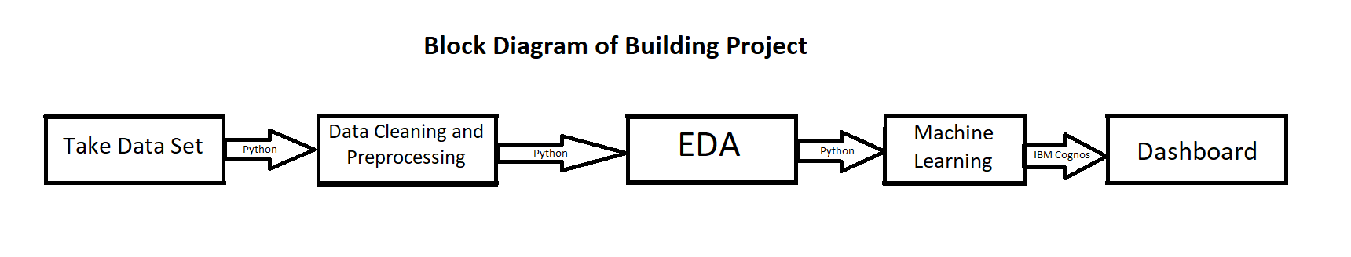

# Hardware and Software:

There is no need of any specific hardware. One can use his normal computer.

The software used in the project are Anaconda IDE (for EDA and Machine Learning) and IBM Cognos Analytics with Watson.

# FLOWCHART:

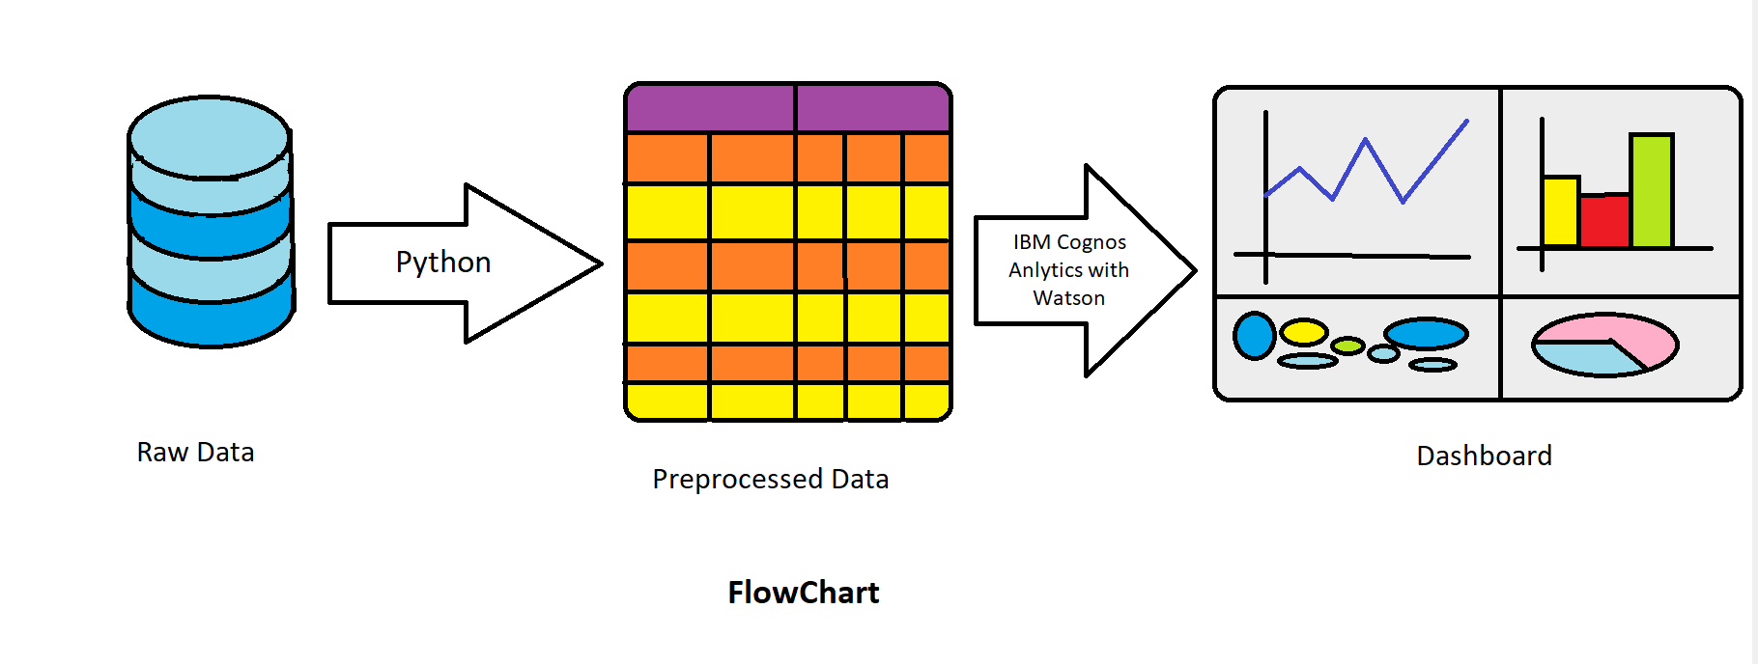

# RESULT:

At the end we get Dashboard of NFT sales which help us to get insight of NFT market. Some screenshot of project are follows.

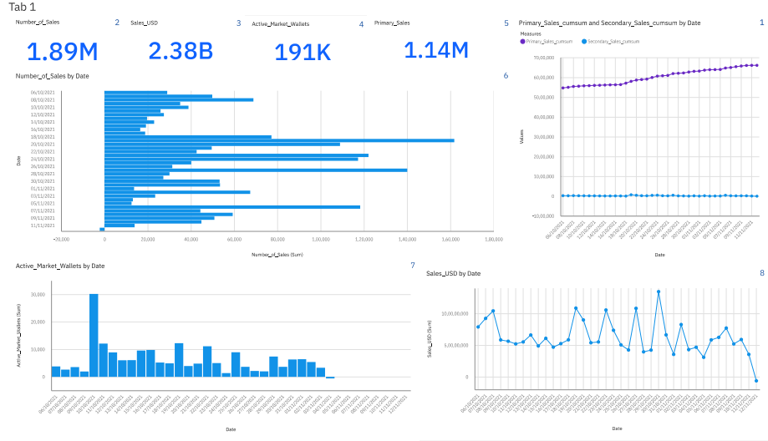

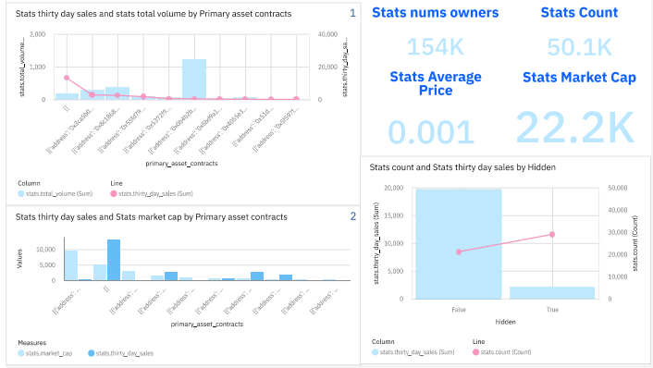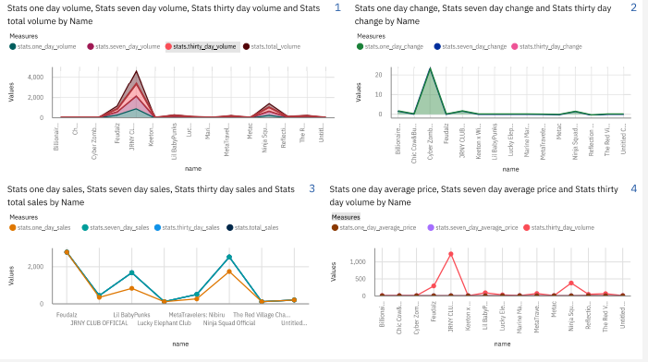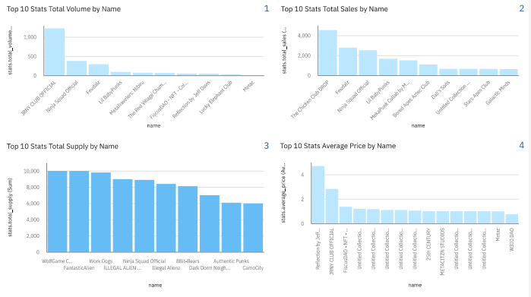

# ADVANTAGE:

* Help us to get insight of market without wasting time in seeing the whole data set.
* Easy to understand
* Filter by different categories.

# APPLICATION:

* Used in website, apps and software where NFT market is involved.
* Used for personal collection of NFT.
* Used to predict the market.

# CONCLUSION:

This project is helpful as the market is growing exponentially and the data is also generated in huge amount. To understand the data, we need some visualization tool. As it saves time in this busy life.

# FUTURE SCOPE:

Since, the NFT market is booming now. According to NFTGO statistics, at least one NFT project has launched on chain every day since May 2021. At the same time, similar to DeFi, the quality of NFT projects is varied, and investors may easily fall into the “liquidity trap”.In fact, in the world of blockchain, whether as an investor or a beginner, you can rely on data to stay away from “hearsay” and decide which NFT to buy by yourself. Analytics dashboards and reports can be created to know more about NFT. By using analytics tools to identify patterns and discrepancies, traders, builders, and collectors can gain a competitive edge in a brand new market.

The dashboard that can visualize NFT Data and grab insights from it that can help buyers as well as Sellers. The dashboard can be linked with the website and mobile apps and software which are market are of NFT’s.

# BIBLIOGRAPHY:

## Dataset References

1. https://www.kaggle.com/datasets/mathurinache/opensea-collections  
2. https://www.kaggle.com/datasets/mathurinache/nft-history-sales

## Dashboard Link

1. <https://us3.ca.analytics.ibm.com/bi/?perspective=dashboard&pathRef=.public_folders%2FNFT%2Fnftsale1&action=view&mode=dashboard>

## Embedded Code

1. <iframe src="https://us3.ca.analytics.ibm.com/bi/?perspective=dashboard&amp;pathRef=.public_folders%2FNFT%2Fnftsale1&amp;closeWindowOnLastView=true&amp;ui_appbar=false&amp;ui_navbar=false&amp;shareMode=embedded&amp;action=view&amp;mode=dashboard" width="1000" height="1000" frameborder="0" gesture="media" allow="encrypted-media" allowfullscreen=""></iframe>allowfullscreen=""></iframe>