**IBM HACK CHALLENGE 2023**

### Project Documentation on Global Economic Data: Comprehensive Analysis And Insights

### Contents

INTRODUCTION

LITERATURE SURVEY

THEORITICAL ANALYSIS

EXPERIMENTAL INVESTIGATIONS

FLOWCHART

RESULT

ADVANTAGES & DISADVANTAGES

APPLICATIONS

CONCLUSION

FUTURE SCOPE

BIBILOGRAPHY

APPENDIX

### INTRODUCTION

**\*\*Overview A brief description about your project:**

We aim to develop a model that can accurately forecast the economic, social, and technological progress of a country over a specific time period. By analyzing various indicators such as GDP, population growth, education levels, and infrastructure development, we can provide valuable insights to policymakers, investors, and businesses. Ultimately, our goal is to support evidence-based decision-making and contribute to sustainable development.

**\*\*Purpose of this project:**

With the ability to accurately predict country growth, we can achieve several significant outcomes:

**Informed Policy Decisions**: Policymakers can utilize these predictions to make informed decisions on economic, social, and technological policies.

**Economic Planning**: Businesses and investors can leverage these predictions to plan their investments and expansion strategies.

**Risk Mitigation**: The ability to predict country growth can help identify potential risks.

**Global Collaboration**: Accurate predictions can foster international collaboration.

**LITERATURE SURVEY**

**\*\*Existing Problem and Existing approaches to solve this problem:**

There are some potential reasons for a weakened economy, from domestic political factors to worldwide market conditions. Regardless of the proximate causes, high levels of unemployment, debt, or inflation can cause economic weakness by reducing consumers' discretionary spending. We have a Solution like Rooting out corruption, upholding human rights, and adherence to the rule of law are essential conditions for successful development. The health and education of their people. Investment in schools, health care, and immunization provide for healthy and educated citizens who become agents of development.

**\*\*Proposed solution:**

If a country can maintain good gdp along with the good cost index and better purchasing power index we can have good country growth and can avoid inflation and all other droughts. We have used linear regression and some factors for predicting the country growth based on gdp, cost index, purchasing power index and more. With this we can predict and can know what will happen when any minor elements is changed and how they affect the growth.

I have another solution which will use the tourists data, gdp per capita (or) percentage of gdp and annual income for predicting the country's growth and if any changes occur in the 3 attributes we can see a change in the country's growth.

**THEORITICAL ANALYSIS**

**\*\*Block diagram Diagrammatic overview of the project:**

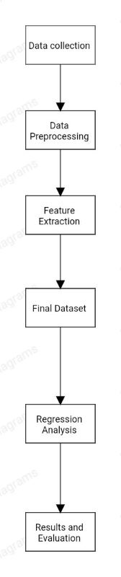

**\*\*Hardware and software requirements of the project:**

**Computer**: A reliable computer or laptop with sufficient processing power and memory.

**Display**: A good monitor to comfortably view and work with data visualizations.

**Internet Connection**: A stable internet connection to fetch online economic databases.

**Statistical Analysis Software**: Tools such as R, Python with data analysis libraries, specialized statistical software for data cleaning, manipulation, and statistical analysis.

**Data Visualization Software**: Software like IBM Data Analytics, Tableau, Power BI for creating interactive and visually appealing charts, graphs, and maps.

**Spreadsheet Software**: Applications like Microsoft Excel or Google Sheets for organizing and preprocessing data.

**Document Collaboration Tools**: Tools like Microsoft Office or Google Docs for collaborative report writing and documentation.

**EXPERIMENTAL INVESTIGATIONS**

**\*\*Analysis or the investigation made while working on the solution:**

During the solution of a global economy analysis project, several analyses and investigations are typically undertaken. Here are some common ones:

**Economic Indicators Analysis:** Examining key economic indicators such as GDP growth, inflation rates, unemployment rates, trade balances, and interest rates to understand the overall health and performance of different economies.

**Comparative Analysis:** Comparing the economic performance of different countries or regions to identify relative strengths, weaknesses, and trends. This analysis helps in understanding the competitive advantages, trade patterns, and potential investment opportunities.

**Regression Analysis:** Conducting regression analysis to determine relationships and correlations between different economic factors like gdp growth, cost index, purchasing power index. This helps in understanding the impact of variables like government spending, interest rates, or exchange rates on economic outcomes.

**Sectoral Analysis:** Examining specific sectors of the economy, such as manufacturing, services, or agriculture, to assess their contributions, growth potential, and vulnerabilities. This analysis helps in identifying opportunities for sector-specific interventions or policies.

**Impact Assessment:** Evaluating the potential economic impact of specific policies, events, main Business Decisions and more with these result's we can infer about the country growth and some product analysis.

**FLOWCHART**

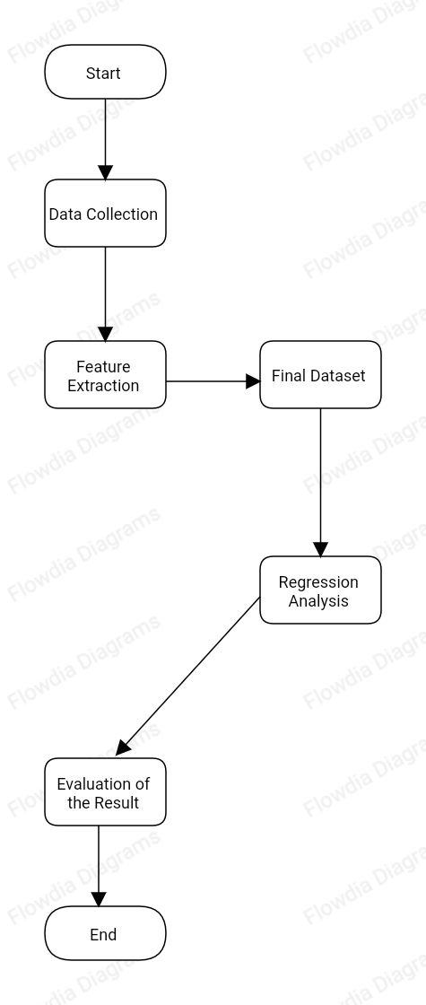

**RESULT**

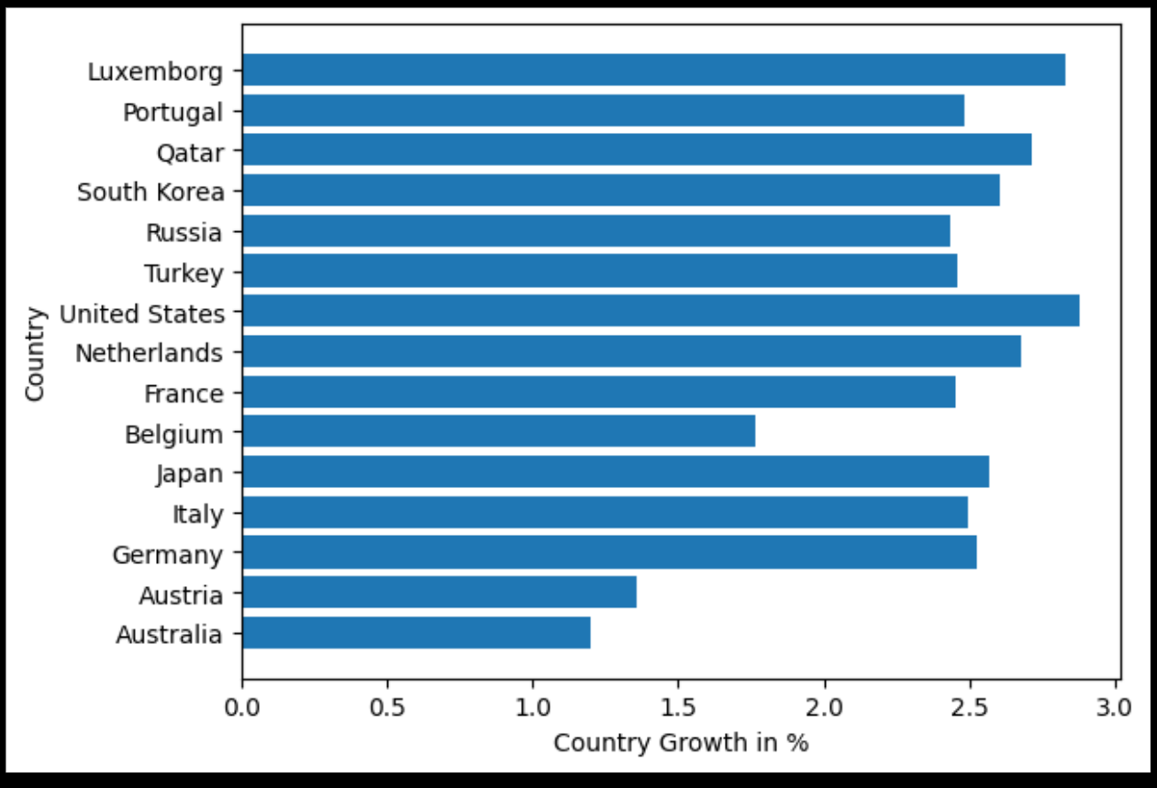

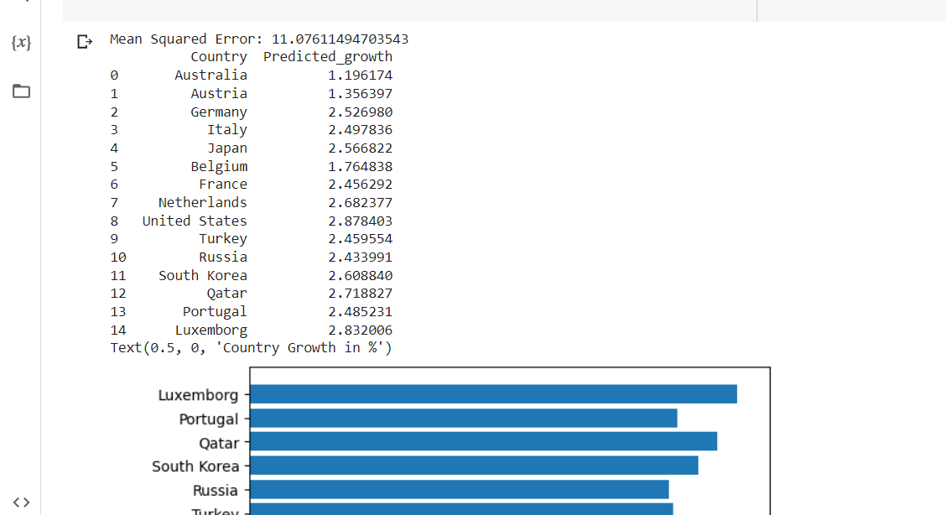

**ADVANTAGES & DISADVANTAGES**

**\*\*Advantages:**

**1. Economic Indicator**: GDP is a widely recognized economic indicator that measures the total value of goods and services produced within a country. By analyzing GDP along with other factors, it provides insights into a country's economic growth.

**2. Cost Analysis:** The cost index helps in understanding the relative cost of living and doing business in different countries. It considers factors like housing, transportation, utilities, and goods and services prices.

**3. Purchasing Power:** The purchasing power index reflects the relative purchasing power of a currency in different countries. It compares the prices of a standardized basket of goods and services across countries.

**4. Comprehensive Analysis:** By combining GDP, cost index, and purchasing power index, the prediction model can provide a more comprehensive analysis of a country's growth potential. It considers both the economic output (GDP) and the factors to offer a holistic view of the country's economic landscape.

**\*\*Disadvantages:**

**1. Data Limitations:** The accuracy of predictions heavily relies on the quality and availability of data. GDP, cost index, and purchasing power index data may not always be up-to-date or accurate which can affect the predictions.

**2. Complex Factors:** Economic growth is influenced by a multitude of factors beyond GDP, cost index, and purchasing power index. Other factors such as political stability, government policies, infrastructure, education, and technological advancements also play significant roles. Neglecting these factors in the prediction model may result in oversimplification and inaccurate predictions.

**3. Dynamic Nature:** Economic conditions and factors affecting growth are constantly evolving. GDP, cost index, and purchasing power index can change over time due to various reasons, including economic crises, policy changes, natural disasters.

**4. Regional Variations:** Country-level predictions may not account for regional variations within a countr and Economic growth can vary. Ignoring regional disparities can lead to inaccurate predictions and may not reflect the true growth potential of specific areas.

**APPLICATIONS**

The solution of predicting country growth using GDP, cost index, and purchasing power index can be utilized or applied in various domains and scenarios:

**1. Investment and Business Decisions:** Investors and businesses can leverage these predictions to make informed decisions regarding market entry, expansion, or investment opportunities. By analyzing the predicted growth of different countries, they can identify potential markets with favorable economic conditions, low costs, and high purchasing power.

**2. Economic Policy Formulation:** Governments and policymakers can use these predictions to formulate economic policies and strategies. By understanding the projected growth of different countries, they can prioritize areas for development, attract investments, and design policies to improve competitiveness and affordability.

**3. International Trade and Commerce:** Predictions of country growth can guide decisions related to international trade and commerce. Businesses can align their export/import strategies based on projected growth in target markets, enabling them to take advantage of emerging opportunities and adapt to changing economic conditions.

**4. Market Research and Analysis:** Market research firms can incorporate these predictions into their analyses to provide insights and forecasts to their clients. By considering GDP, cost index, and purchasing power index, they can offer a comprehensive understanding of market dynamics, consumer behavior, and market potential in different countries.

**5. Development Aid and Assistance:** Organizations involved in development aid and assistance can utilize these predictions to prioritize their efforts and allocate resources effectively. By identifying countries with high projected growth, they can focus on supporting initiatives that contribute to sustainable development and poverty reduction.

**CONCLUSION**

In conclusion, this work presented an approach for predicting country growth using GDP, cost index, and purchasing power index. The study utilized these indicators to analyze economic conditions, affordability, and consumer purchasing power. The advantages of this approach include providing a comprehensive analysis, assisting in policy and investment decisions, and offering insights for various sectors.

However, it is important to acknowledge the limitations of this approach, such as data limitations, the complexity of economic factors, the dynamic nature of economic conditions, regional variations, external influences, and the need for considering causal relationships. As we can't say that everything will be stable.

Despite these limitations, the solution of predicting country growth using GDP, cost index, and purchasing power index finds applications in investment decisions, economic policy formulation, international trade, market research, development aid, and academic research. And if any factors are included this solution can be helpful for more areas.

Further research and refinement of the prediction models should consider incorporating additional data sources and accounting for a broader range of influential factors. By addressing these limitations, the predictive accuracy and applicability of this approach can be enhanced, enabling more informed decision-making and contributing to sustainable economic growth.

**FUTURE SCOPE**

There are several enhancements that can be made in the future to improve the accuracy and effectiveness of this Solution:

**1. Incorporating Additional Economic Indicators**: While GDP, cost index, and purchasing power index provide valuable insights, adding other economic indicators can enhance the predictive models. Factors such as unemployment rates, inflation, trade balances, and investment flows can provide a more comprehensive understanding of a country's economic growth potential.

**2. Utilizing Big Data and Machine Learning:** Leveraging big data and machine learning techniques can help improve the predictive models. By analyzing large volumes of data from various sources, including social media, online consumer behavior, more accurate predictions can be made. Machine learning algorithms can identify patterns, trends, and correlations that may not be apparent through traditional analysis.

**3. Considering Social and Environmental Factors:** Future enhancements should also consider incorporating social and environmental factors into the predictive models. Factors such as income inequality, social stability and climate change can significantly impact a country's long-term growth prospects. Incorporating these factors can provide a more holistic understanding of a country's growth potential.

**4. Regional and Subnational Analysis:** To capture regional disparities and variations within a country, future enhancements should focus on incorporating regional and subnational data. This will provide a more granular understanding of economic growth patterns and enable targeted policy interventions at the regional level.

**5. Dynamic and Real-time Data Integration:** To account for the dynamic nature of economic conditions, future enhancements should focus on integrating real-time and dynamic data into the predictive models. This can include real-time GDP estimates, cost indices, and relevant economic data, to ensure predictions are based on real time data.

**6. Validation and Calibration:** Enhancements should also focus on validating and calibrating the predictive models against historical data. This will help refine the models and improve their accuracy over time.

**BIBILOGRAPHY**

[1] https://www.kaggle.com/code/saisandeepjallepalli/world-economic-data-complete-data-analysis/input

[2] https://en.wikipedia.org/wiki/Data_analysis

[3] https://bookdown.org/mike/data_analysis/references.html

[4] https://www.globaldata.com/

**APPENDIX**

**Code for Solution**

**Code 1**

import pandas as pd

from sklearn.model_selection import train_test_split

from sklearn.linear_model import LinearRegression

from sklearn.metrics import mean_squared_error

from matplotlib import pyplot as plt

pc = pd.read_csv("Book1.csv")

data = {

'Country': pc["country"],

'Tourists': pc["tourists_in_millions"],

'Percentage_of_gdp': pc["percentage of gdp"],

'Annual_income': pc["annual income"],

}

df = pd.DataFrame(data)

X = df[['Tourists', 'Annual_income']]

y = df['Percentage_of_gdp']

X_train, X_test, y_train, y_test = train_test_split(X, y, test_size=0.2, random_state=42)

model = LinearRegression()

model.fit(X_train, y_train)

y_pred = model.predict(X_test)

mse = mean_squared_error(y_test, y_pred)

print("Mean Squared Error:", mse)

predictions = model.predict(X)

df['Predicted_growth'] = predictions

print(df[['Country', 'Predicted_growth']])

plt.barh(df["Country"],predictions)

plt.ylabel("Country")

plt.xlabel("Country Growth in %")

**Code 2**

import pandas as pd

from sklearn.model_selection import train_test_split

from sklearn.linear_model import LinearRegression

from sklearn.metrics import mean_squared_error

pc = pd.read_csv("Book1.csv")

pc.head()

data = {

'Country': pc["country"],

'Percentage_of_gdp': pc["percentage of gdp"],

'Cost_index': pc["cost_index"],

'Purchasing_power_index': pc["purchasing power index"],

}

df = pd.DataFrame(data)

X = df[['Cost_index', 'Purchasing_power_index']]

y = df['Percentage_of_gdp']

X_train, X_test, y_train, y_test = train_test_split(X, y, test_size=0.2, random_state=42)

model = LinearRegression()

model.fit(X_train, y_train)

y_pred = model.predict(X_test)

mse = mean_squared_error(y_test, y_pred)

print("Mean Squared Error:",mse)

predictions = model.predict(X*10)

df['Predicted_growth'] = predictions

print(df[['Country', 'Predicted_growth']])

plt.barh(df["Country"],predictions)

plt.ylabel("Country")

plt.xlabel("Country's growth in %")

Dashboard on Tourism data (link) - https://us3.ca.analytics.ibm.com/bi/?perspective=dashboard&pathRef=.my_folders%2Ffinal%2Bdashboard&action=view&mode=dashboard&subView=model0000018a3557054f_00000000

Story on Cost of living data (link) -

https://us3.ca.analytics.ibm.com/bi/?perspective=story&pathRef=.my_folders%2FFinal%2Bstory&action=view&sceneId=model0000018a357ddb11_0000000b&sceneTime=0