**SMARTINTERZ - SMARTBRIDGE**

**DATA ANALYTICS**

**-UJJAWAL SRIVASTAVA**

**-19BIT0072**

**LINKS FOR CONGNOS WORKS:-**

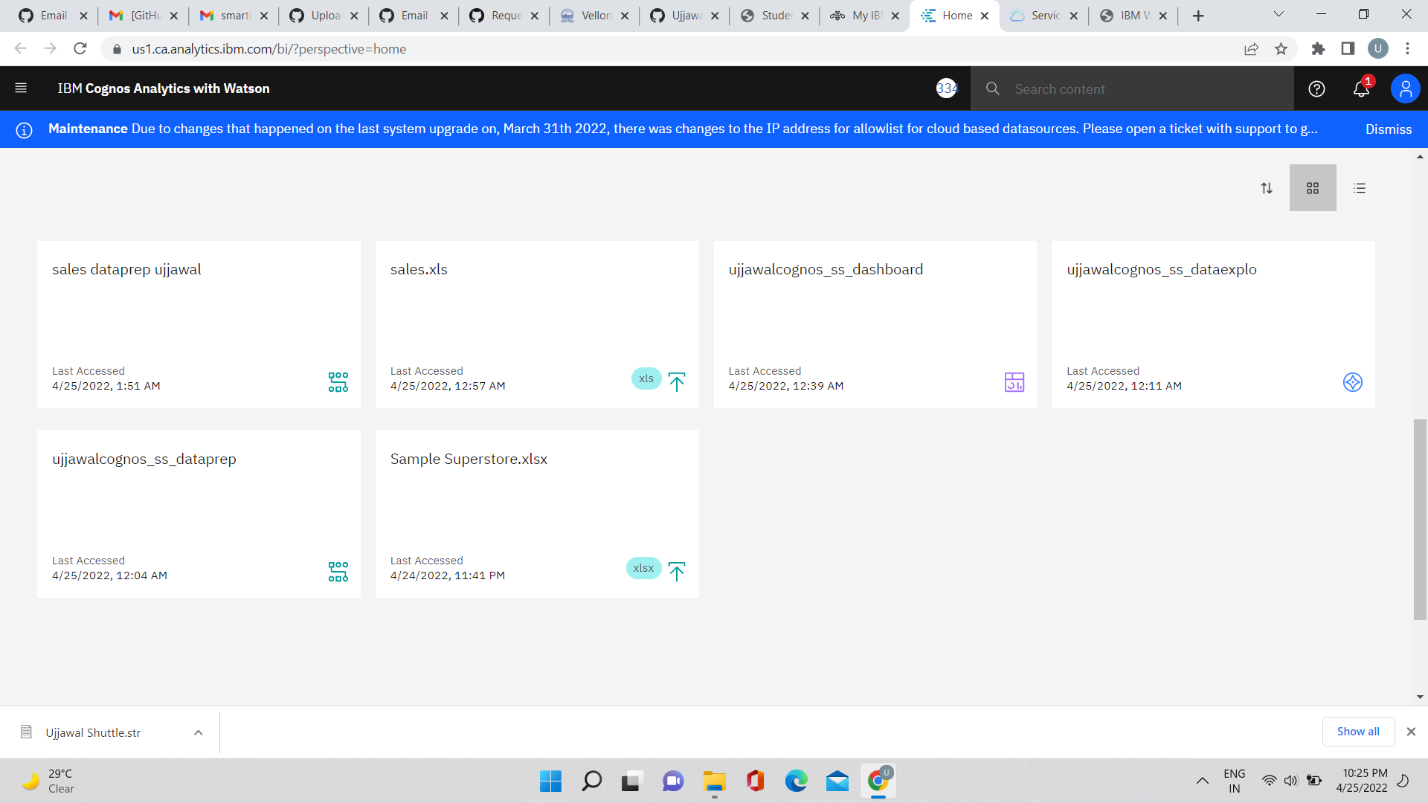

Sample superstore dataprep:-

<https://us1.ca.analytics.ibm.com/bi/?perspective=ca-modeller&pathRef=.my_folders%2Fujjawalcognos_ss_dataprep>

Sample superstore dataexplo:-

<https://us1.ca.analytics.ibm.com/bi/?perspective=explore&pathRef=.my_folders%2Fujjawalcognos_ss_dataexplo>

Sample superstore dashboard:-

<https://us1.ca.analytics.ibm.com/bi/?perspective=dashboard&pathRef=.my_folders%2Fujjawalcognos_ss_dashboard&action=view&mode=dashboard>

Union of 3 sales table :

