Watson studio screen shot showing the created classifier

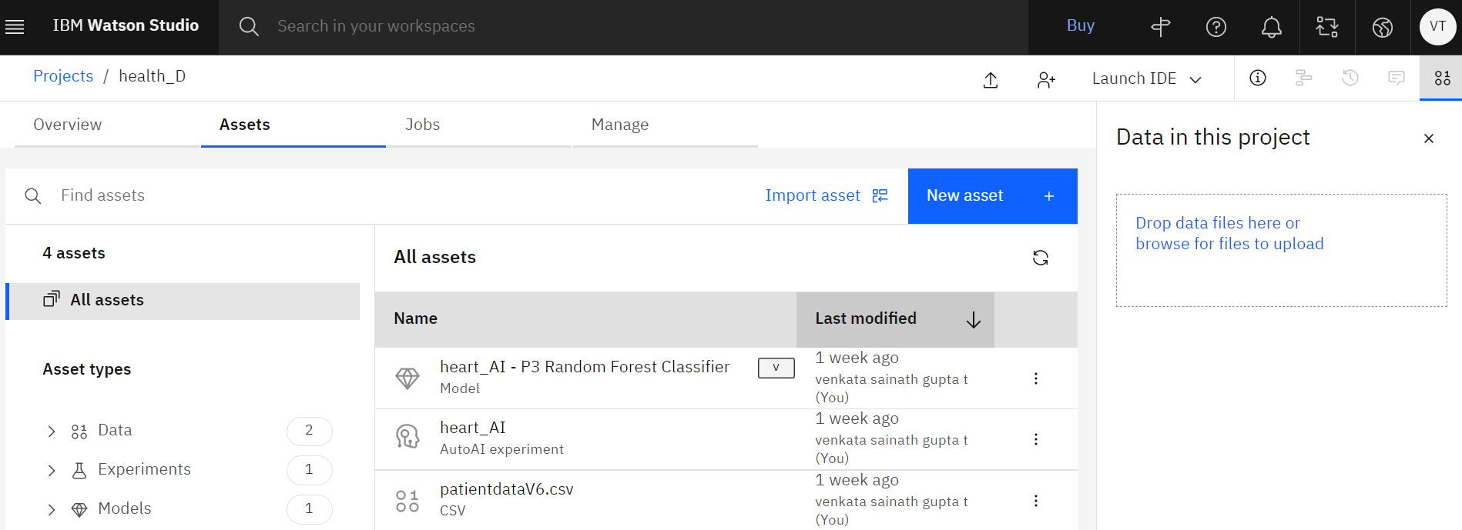

It was observed that random forest classifier is showing good performance and deployed the same in cloud

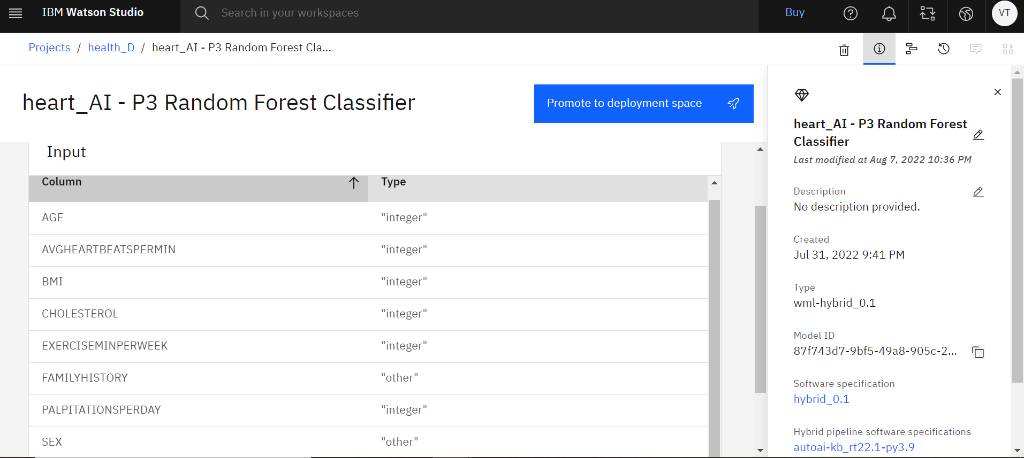

The below screen shot presents the deployments in ibm cloud

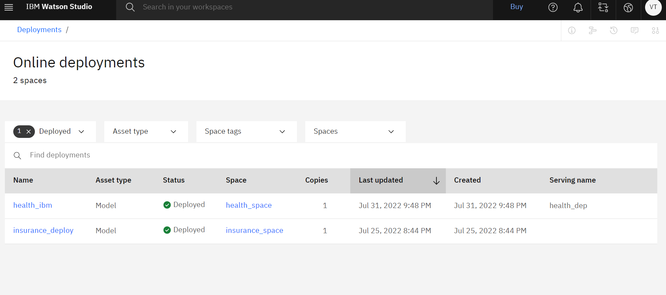

Among the two deployments, health_ibm is the required one and the below screen shot is showing the API details of the health_ibm

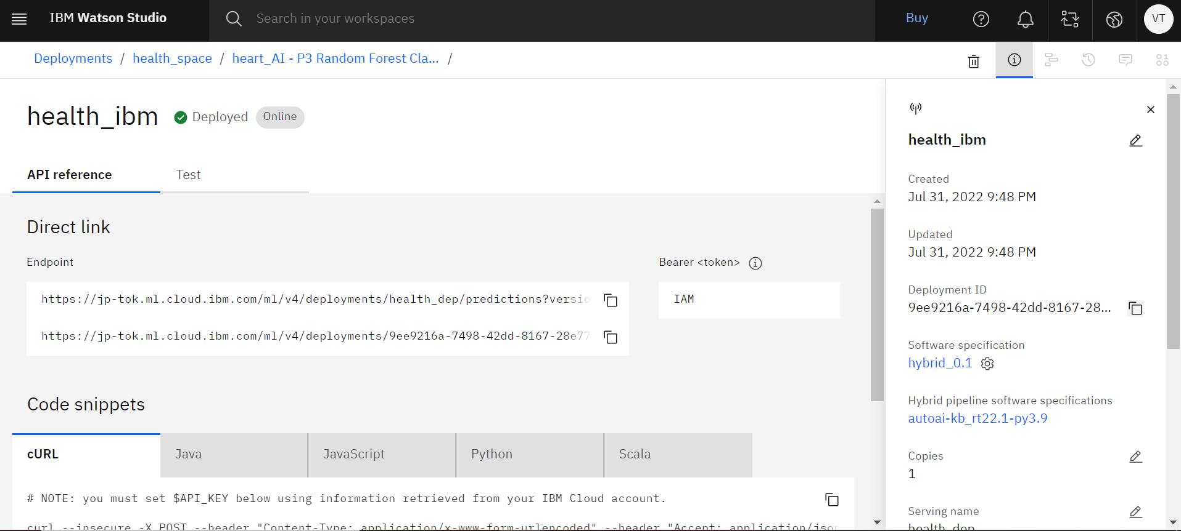

The deployed model is tested using the test button

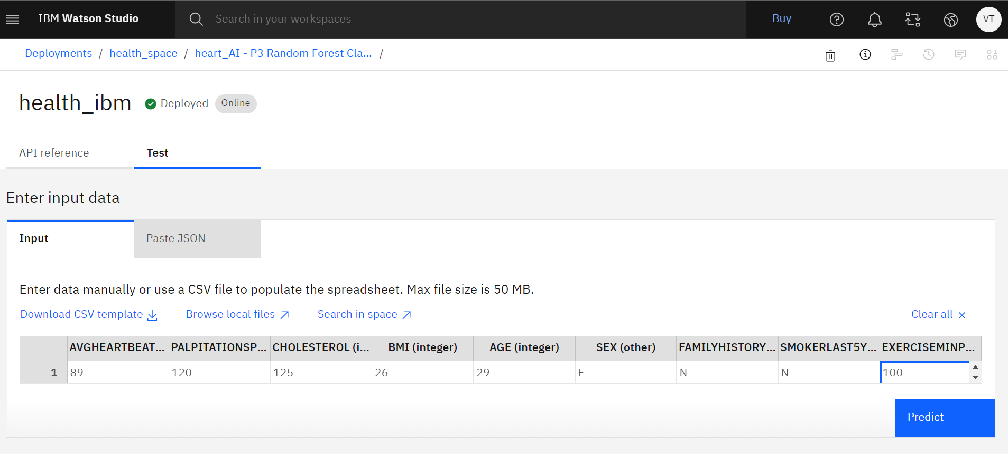

The below screen shot shows the prediction accuracy for the same

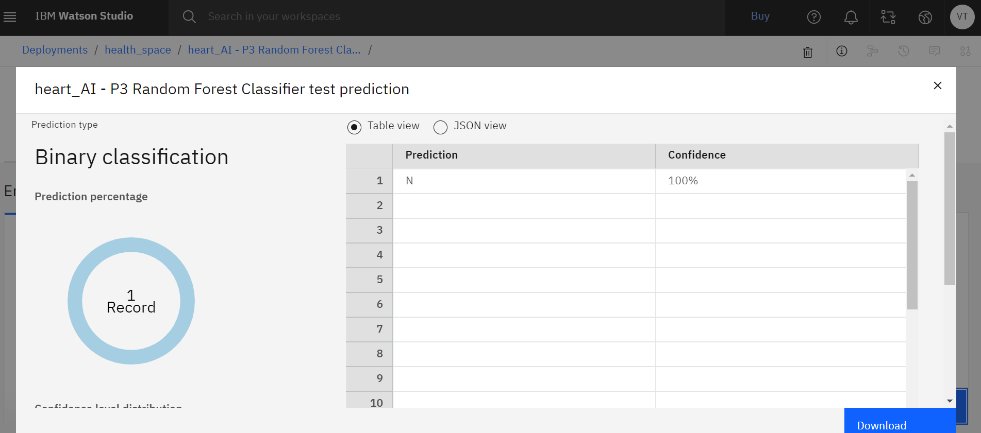

The below screen shot shows the deployed model using node red app.

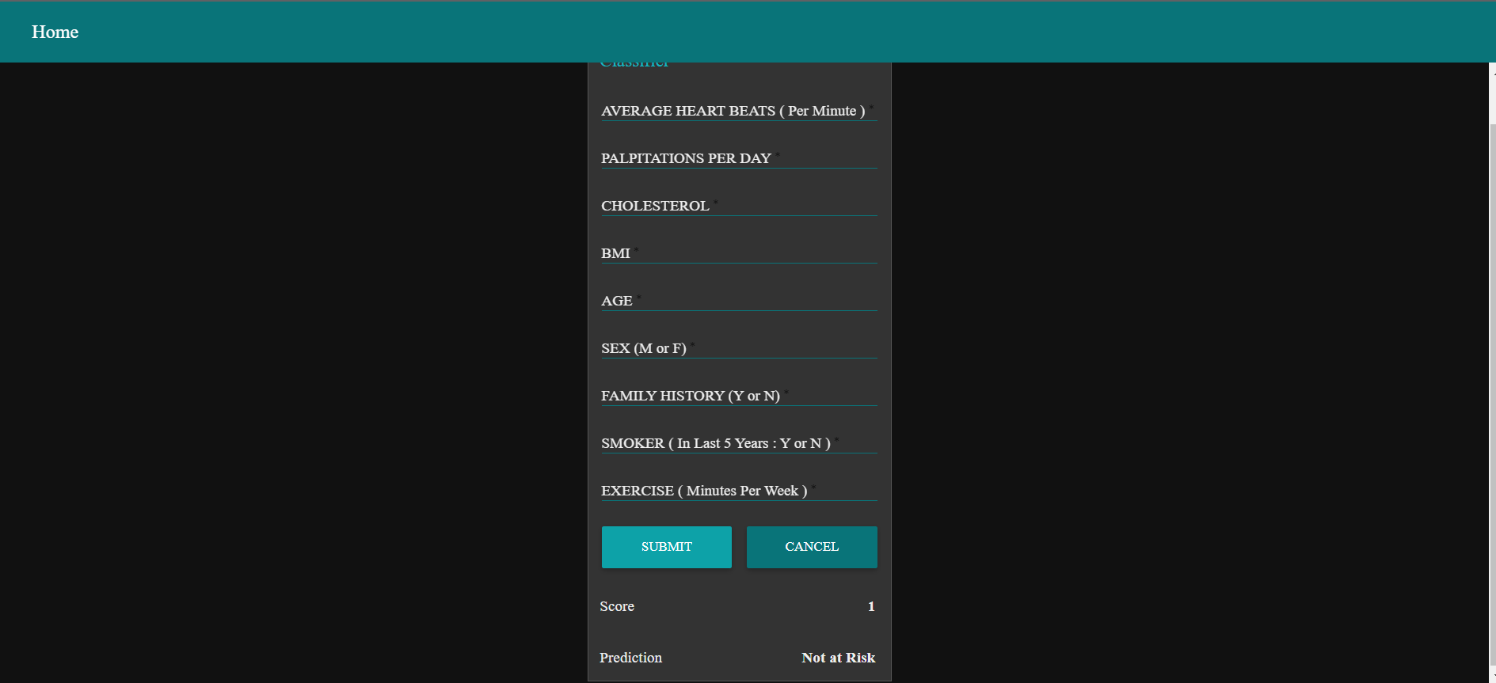

The below screen shot shows the flow diagram build in node red app

