**Develop a Smart Home Automation project using ESP32.**

**The tasks involved in completing this project are:**

1. **Get the Temperature, Humidity from the DHT11 sensor**
2. **Get the light intensity from LDR**
3. **Display the light intensity, Temperature, Humidity values on the OLED display.**
4. **control the lights based on Light intensity ( Control led's as an indication of light)**
5. **Control the fans based on the temperature and humidity parameters ( Control led's as an indication of fan)**

**PROGRAM**

#include "DHT.h"

#define DHTPIN 4

#define DHTTYPE DHT11

#include <Wire.h>

#include <Adafruit_GFX.h>

#include <Adafruit_SSD1306.h>

#define SCREEN_WIDTH 128

#define SCREEN_HEIGHT 64

Adafruit_SSD1306 display(SCREEN_WIDTH, SCREEN_HEIGHT, &Wire, -1);

DHT dht(DHTPIN, DHTTYPE);

void setup()

{

Serial.begin(9600);

dht.begin();

if (!display.begin(SSD1306_SWITCHCAPVCC, 0x3C))

{

Serial.println("SSD1306 allocation failed");

for (;;);

}

delay(2000);

display.clearDisplay();

display.setTextColor(WHITE);

pinMode(2, OUTPUT);

dht.begin();

}

void loop() {

int i = 1;

delay(2000);

float h = dht.readHumidity();

float t = dht.readTemperature();

float f = dht.readTemperature(true);

if (isnan(h) || isnan(t) || isnan(f))

{

Serial.println(F("Failed to read from DHT sensor!"));

return;

}

float hif = dht.computeHeatIndex(f, h);

float hic = dht.computeHeatIndex(t, h, false);

Serial.println("1-Getting the Temperature, Humidity from the DHT11 sensor");

for (i = 1; i < 7; i++)

{

Serial.println("");

Serial.print(F("Humidity: "));

Serial.print(h);

Serial.print(F("% Temperature: "));

Serial.print(t);

Serial.print(F("°C "));

Serial.print(f);

delay(1000);

}

Serial.println("");

Serial.println("-----------------------------------------------------------------------");

Serial.println("2-Getting the light intensity from LDR");

for (i = 1; i < 7; i++)

{

int a = analogRead(15);

Serial.println("the ldr value is");

Serial.println(a);

delay(2000);

}

Serial.println("-----------------------------------------------------------------------");

Serial.println("3- light intensity, Temperature, Humidity values on the OLED display.");

for (i = 1; i < 7; i++)

{

display.clearDisplay();

display.setTextSize(1);

display.setCursor(0, 0);

display.print(F("Humidity: "));

display.setTextSize(1);

display.setCursor(0, 10);

display.print(h);

display.setTextSize(1);

display.setCursor(0, 20);

display.println("% Temperature:");

display.setTextSize(1);

display.setCursor(0, 30);

display.print(t);

display.print(" °C- ");

display.print(f);

display.setTextSize(1);

display.setCursor(0, 40);

display.println(F("°F Heat index: "));

display.print(hic);

display.print("°C ");

display.print(hif);

display.print("°F");

display.display();

}

Serial.println("-----------------------------------------------------------------------");

Serial.println("4-control the lights based on Light intensity");

int b = analogRead(15);

for (i = 1; i < 7; i++)

{

Serial.print("the ldr value is: ");

Serial.print(b);

if (b > 3500)

{

digitalWrite(2, HIGH);

Serial.println("lights are on");

delay(1000);

}

else

{

digitalWrite(2, LOW);

Serial.println("lights are off");

delay(1000);

}

}

Serial.println("-----------------------------------------------------------------------");

Serial.println("5-Control the fans based on the temperature and humidity parameters");

for (i = 1; i < 7; i++)

{

Serial.print(F("Humidity: "));

Serial.print(h);

Serial.print(F("% Temperature: "));

Serial.print(t);

Serial.print(F("°C "));

Serial.print(f);

Serial.print(F("°F "));

if ( (h > 95.00) && (t > 31.00))

{

digitalWrite(2, HIGH);

Serial.println("fans are on");

delay(1000);

}

else

{

digitalWrite(2, LOW);

Serial.println("fans are off");

delay(1000);

}

}

Serial.println("-----------------------------------------------------------------------");

}

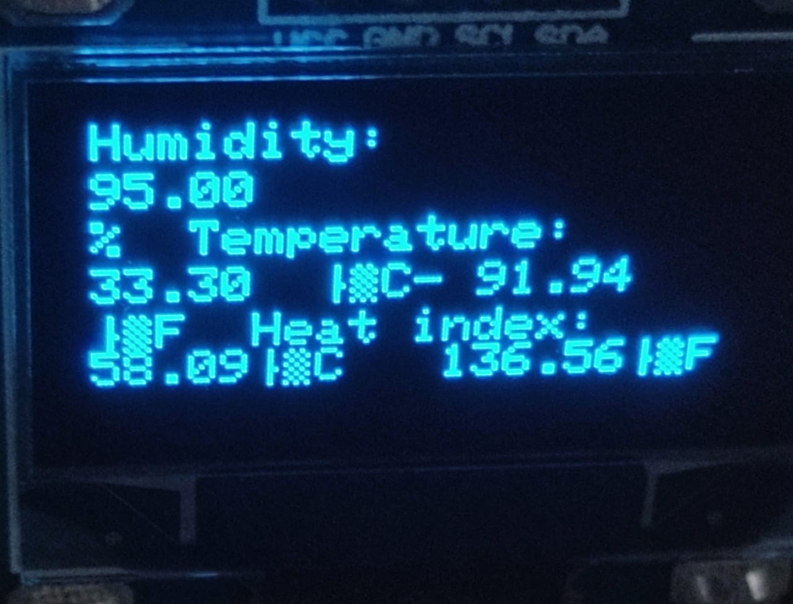

**OUTPUT-1**

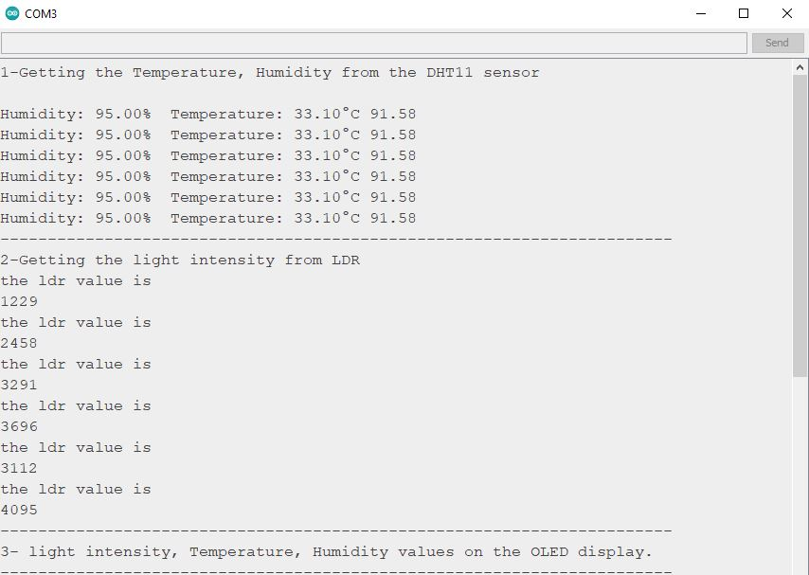

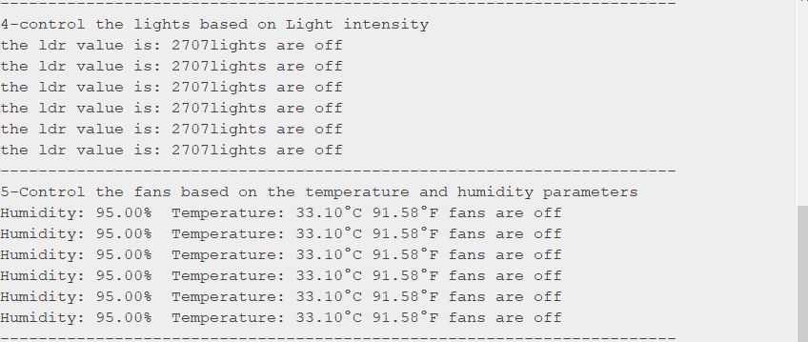

**OUTPUT-2**

