**Assignment-4**

**Develop a Smart water pump controller using ESP32.**

**The tasks to be covered are:**

1. **use an ultrasonic sensor for monitoring tank water level and send the values to the mobile app using Bluetooth communication**
2. **Integrate buttons in the mobile app for controlling the water pump**
3. **when the buttons are clicked send the data to ESP32 using Bluetooth communication**
4. **receive the data from the mobile app using ESP32 and control the pump accordingly.**

**Program**

#include "BluetoothSerial.h"

BluetoothSerial SerialBT;

int echopin = 4;

int trigpin = 5;

byte a;

void setup() {

Serial.begin(115200);

Serial.println("water pump connected");

SerialBT.begin("ESP32test"); //Bluetooth device name

Serial.println("cheaking water level now you can pair it with bluetooth!");

pinMode(echopin, INPUT);

pinMode(trigpin, OUTPUT);

pinMode(2, OUTPUT);

}

void loop() {

delay(20);

digitalWrite(trigpin, HIGH);

delay(1000);

digitalWrite(trigpin, LOW);

int duration = pulseIn(echopin, HIGH);

int distance = duration * 0.034 / 2;

delay (2000);

if (Serial.available()) {

SerialBT.write(Serial.read());

}

if (SerialBT.available()) {

a=SerialBT.read();

SerialBT.println(distance);

Serial.write(SerialBT.read());

if(a=='1')

{

Serial.println("the water level is");

Serial.println(distance);

digitalWrite(2, HIGH);

Serial.println("pump is on");

}

if(a=='2')

{

Serial.println("the water level is");

Serial.println(distance);

digitalWrite(2, LOW);

Serial.println("pump is off ");

}

}

delay(20);

}

**Block for App**

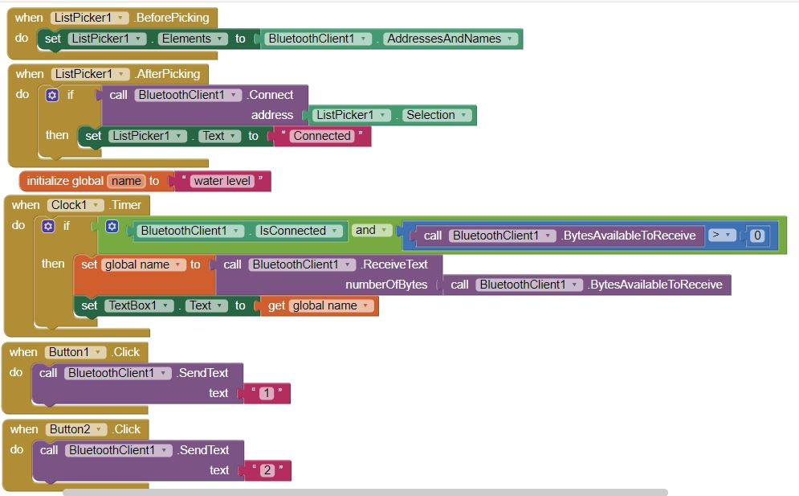

**APP** :-

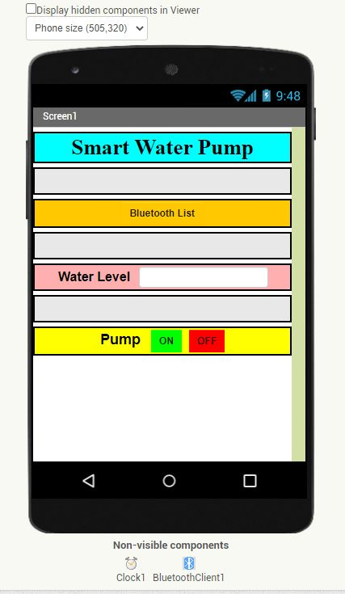

**OUTPUT:-**

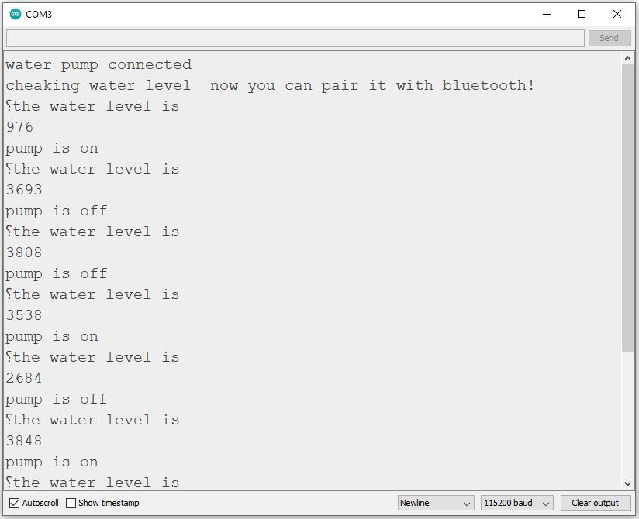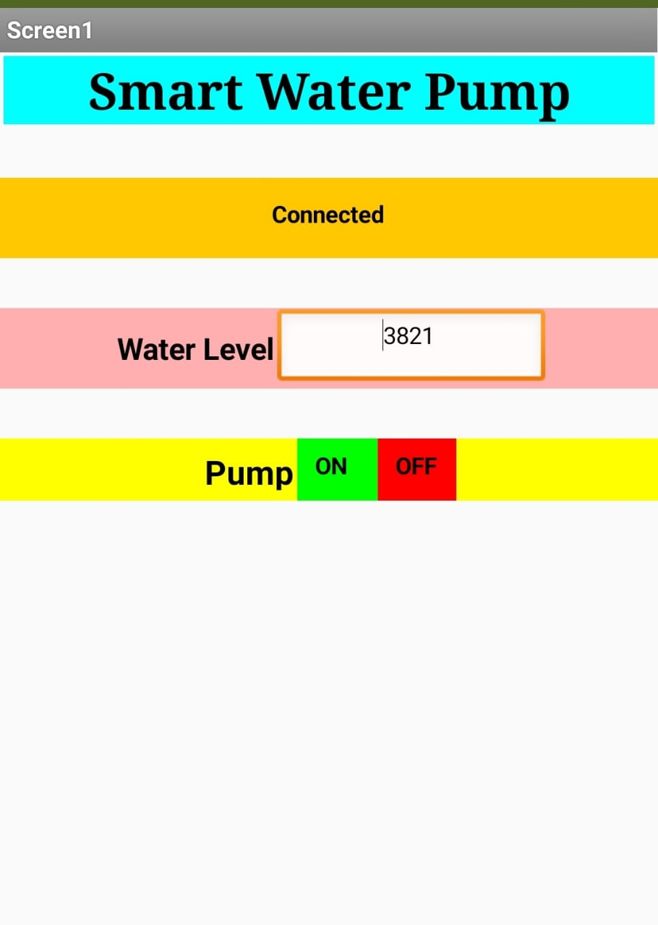

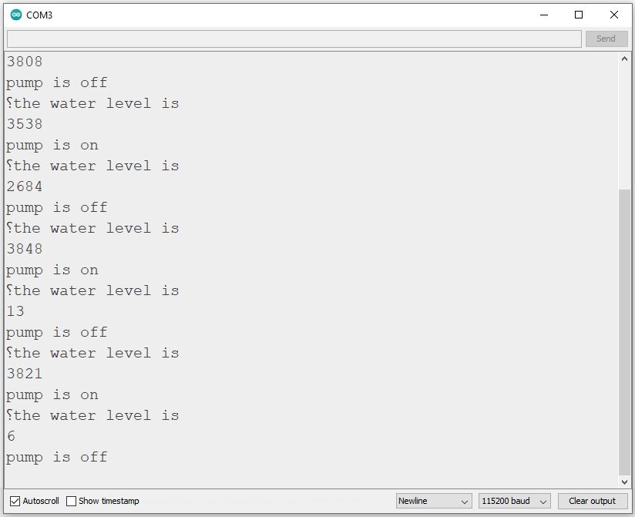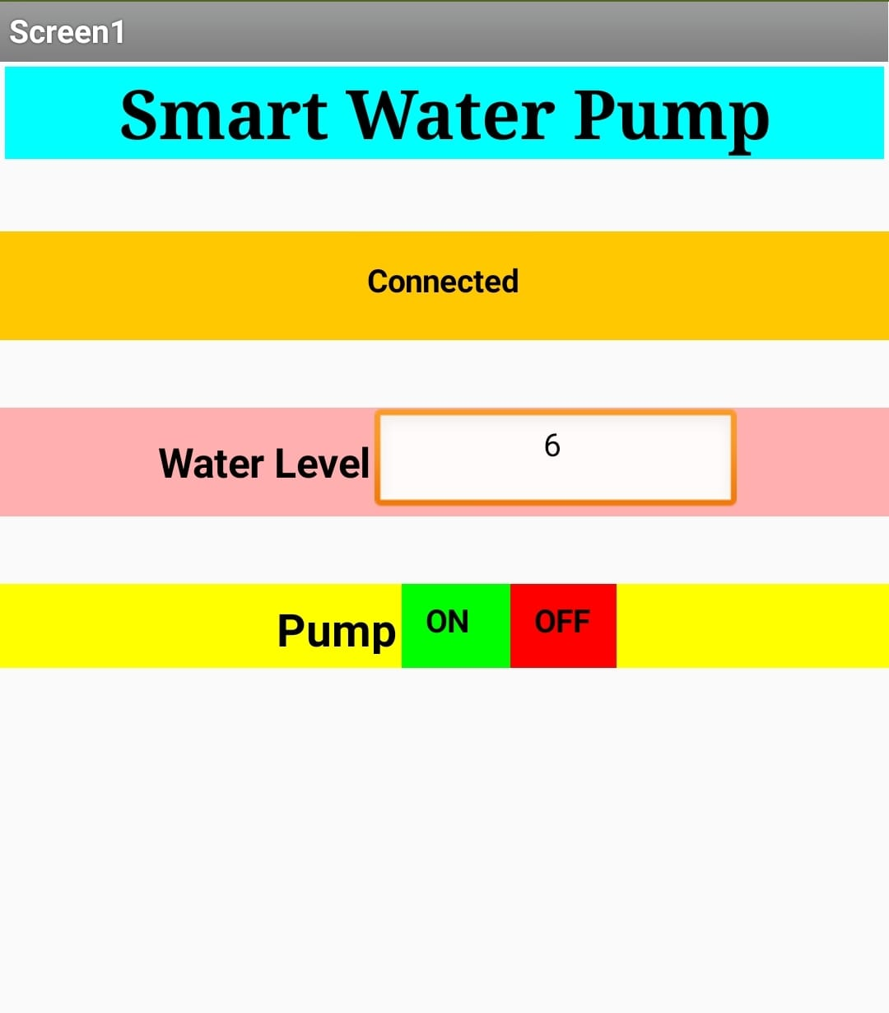

**19R11A0522-Assignment-4**