**19485A0414 Assignment2**

**Develop an "Automatic garage door opening system". Use an Ultrasonic sensor to detect if there is a vehicle in front of the garage. if any vehicle is detected open the garage door (rotate the servo motor) for some time and close it.**

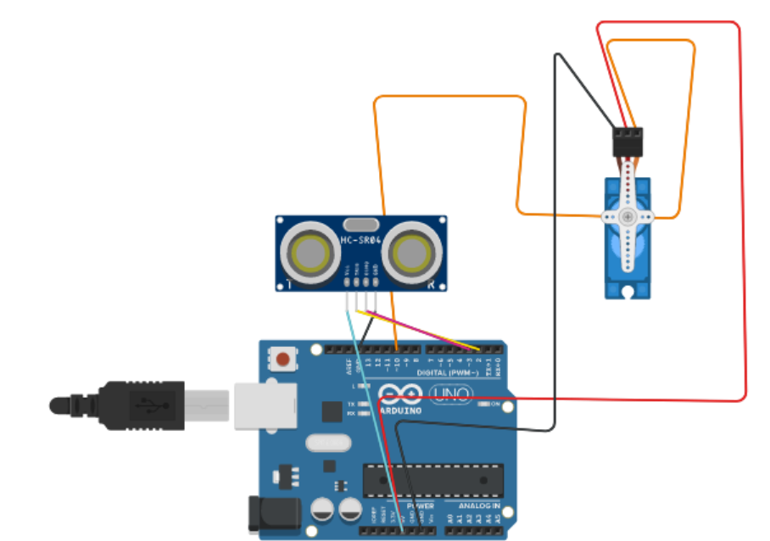

// C++ code

//

int trigpin=2;

int echopin=3;

#include<Servo.h>

Servo myservo;

void setup()

{

pinMode(trigpin,OUTPUT);

pinMode(echopin,INPUT);

Serial.begin(9600);

myservo.attach(10);

myservo.write(0);

}

void loop()

{

digitalWrite(trigpin,HIGH);

delay(1000);

digitalWrite(trigpin,LOW);

float duration=pulseIn(echopin,HIGH);

float distance=duration*0.0343/2;

Serial.print("the distance is");

Serial.println(distance);

if(distance>=80)

{

Serial.print("the door of the garage is opened");

myservo.write(90);

delay(1000);

Serial.print("the door of the garage is closed");

myservo.write(0);

}

else

{

myservo.write(0);

}

}