**ASSIGNMENT-2**

**2. Develop an "Automatic garage door opening system". Use an Ultrasonic sensor to detect if there is a vehicle in front of the garage.**

**Automatic Garage Door Opening System**

**Platform Reqiured:- Tinker Cad Tool**

**Procedure: We will drag all the components that we required for connection on to work space.**

**Connections are given as per the schematic diagram which is shown after the code.**

**When we execute the code we will get the output which is shown after the schematic diagram.**

**Code**

int trigpin=11;

int echopin=10;

#include<Servo.h>

Servo myservo;

void setup()

{

Serial.begin(9600);

myservo.attach(7);

pinMode(trigpin,OUTPUT);

pinMode(echopin,INPUT);

myservo.write(0);

}

void loop()

{

digitalWrite(trigpin,HIGH);

delay(1000);

digitalWrite(trigpin,LOW);

float duration=pulseIn(echopin,HIGH);

float distance=duration*0.0345/2;

Serial.print(“The distance is “);

Serial.println(distance);

if(distance>80) {

myservo.write(90);

Serial.println(“The Garage Door is Opened”);

delay(5000);

myservo.write(0);

Serial.println(“The Garage Door is Closed”);

}

else {

myservo.write(0);

}

}

**Schematic Diagram**

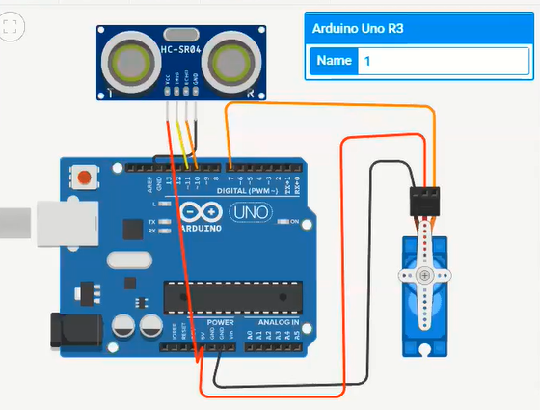

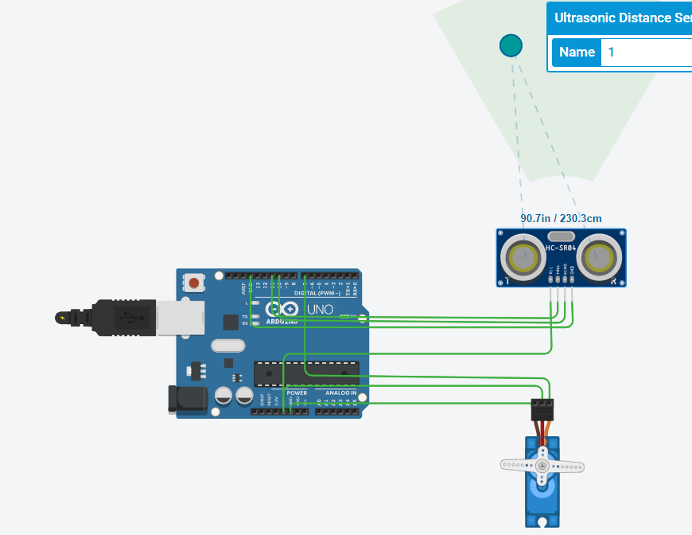

**Output**

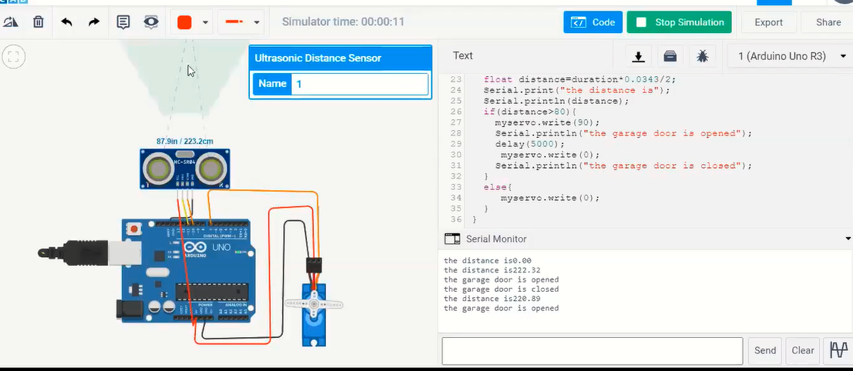

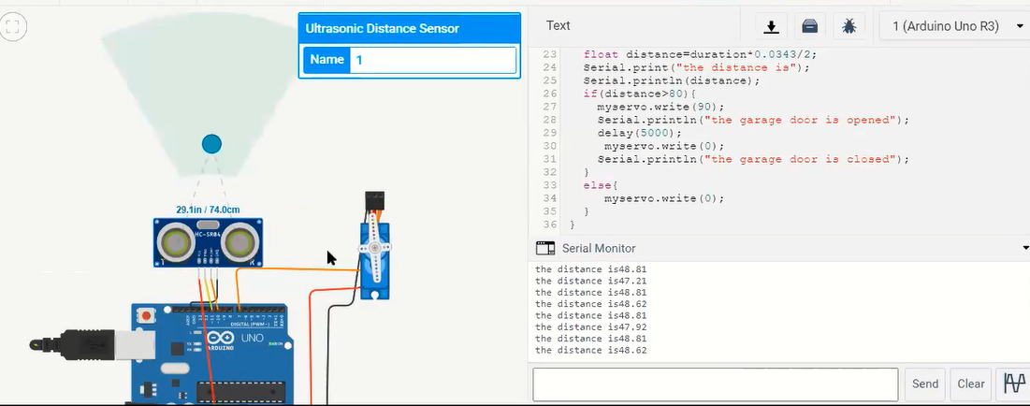

**Output Obtained In Serial Mointor**

the distance is229.50

the garage door is opened

the garage door is closed

the distance is229.52

the garage door is opened

the garage door is closed

the distance is228.10

the garage door is opened

the garage door is closed

the distance is228.06

the garage door is opened

the garage door is closed

the distance is333.55

the garage door is opened

the garage door is closed

the distance is298.50

the garage door is opened

the garage door is closed

the distance is92.13

the garage door is opened

the garage door is closed