**ASSIGNMENT-5**

**Create a web dashboard to take user input for scheduling the pump controller (date & time). store the data in the Cloudant DB.**

**You can use Form Nodes in dashboard nodes to take user input.**

***Nodes Required:***

***1.Inject Node***

***2.Debug Node***

***3.Form Node***

***4.Cloudant Input Node***

***1.Connect all the nodes as shown below figure.***

***2. We need to see user input by using node red URL of given user and append UI. We will be able to see the required output.***

***NODE RED CONNECTIONS***

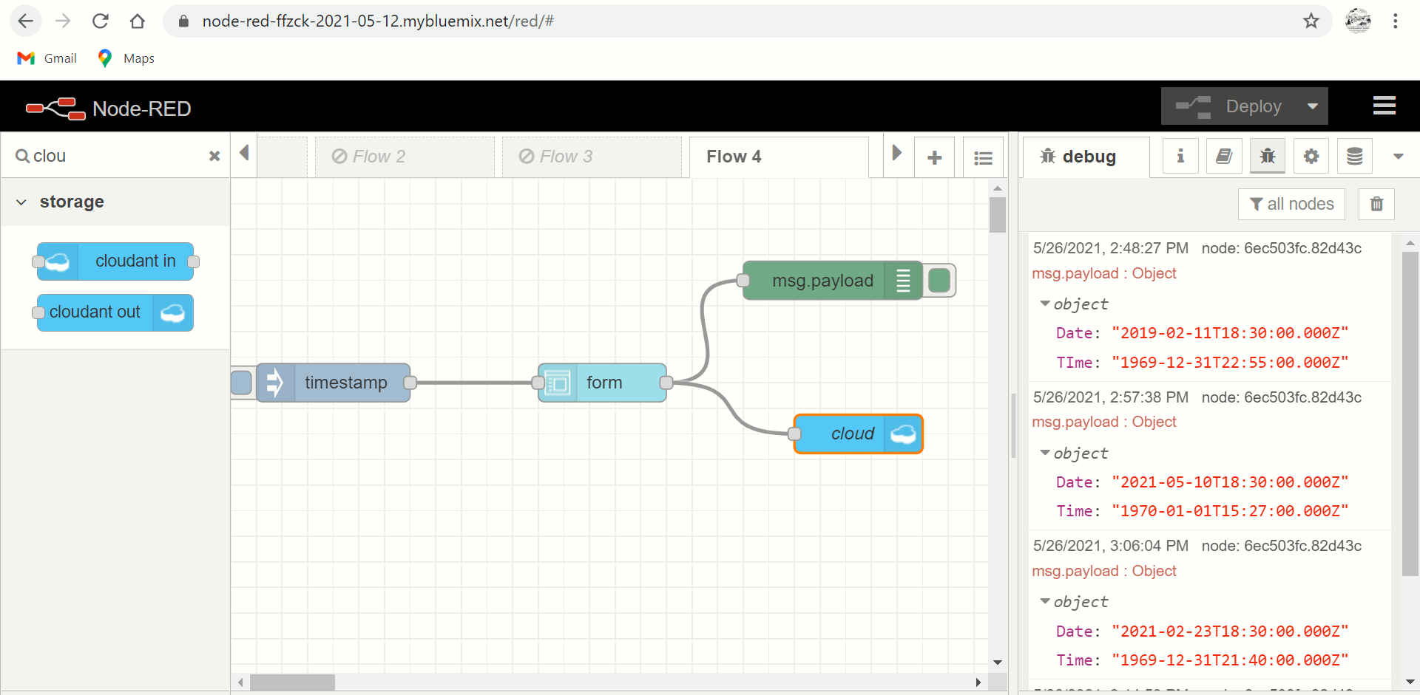

***NODE RED UI(User Interface)***

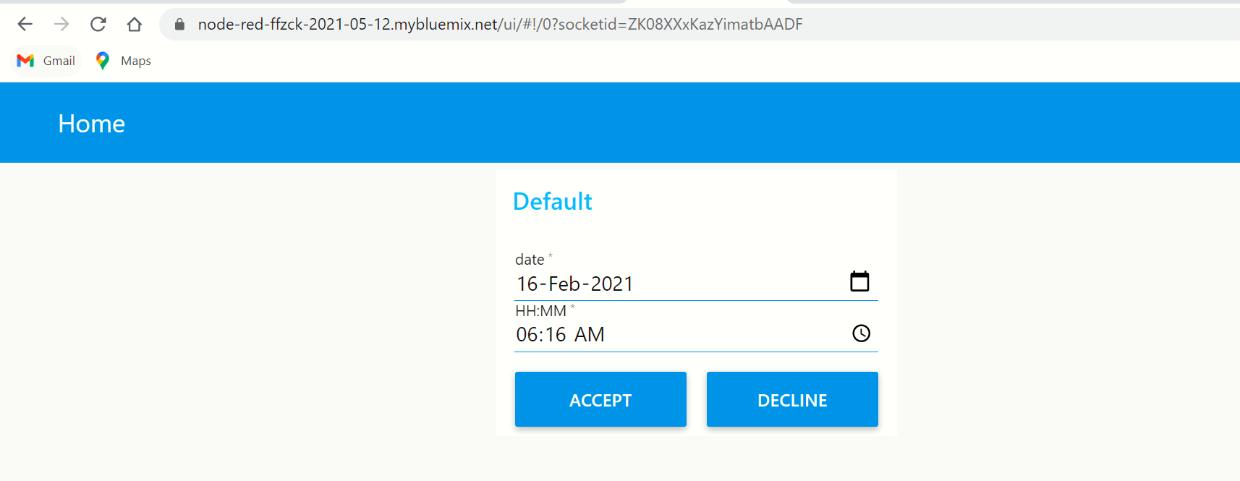

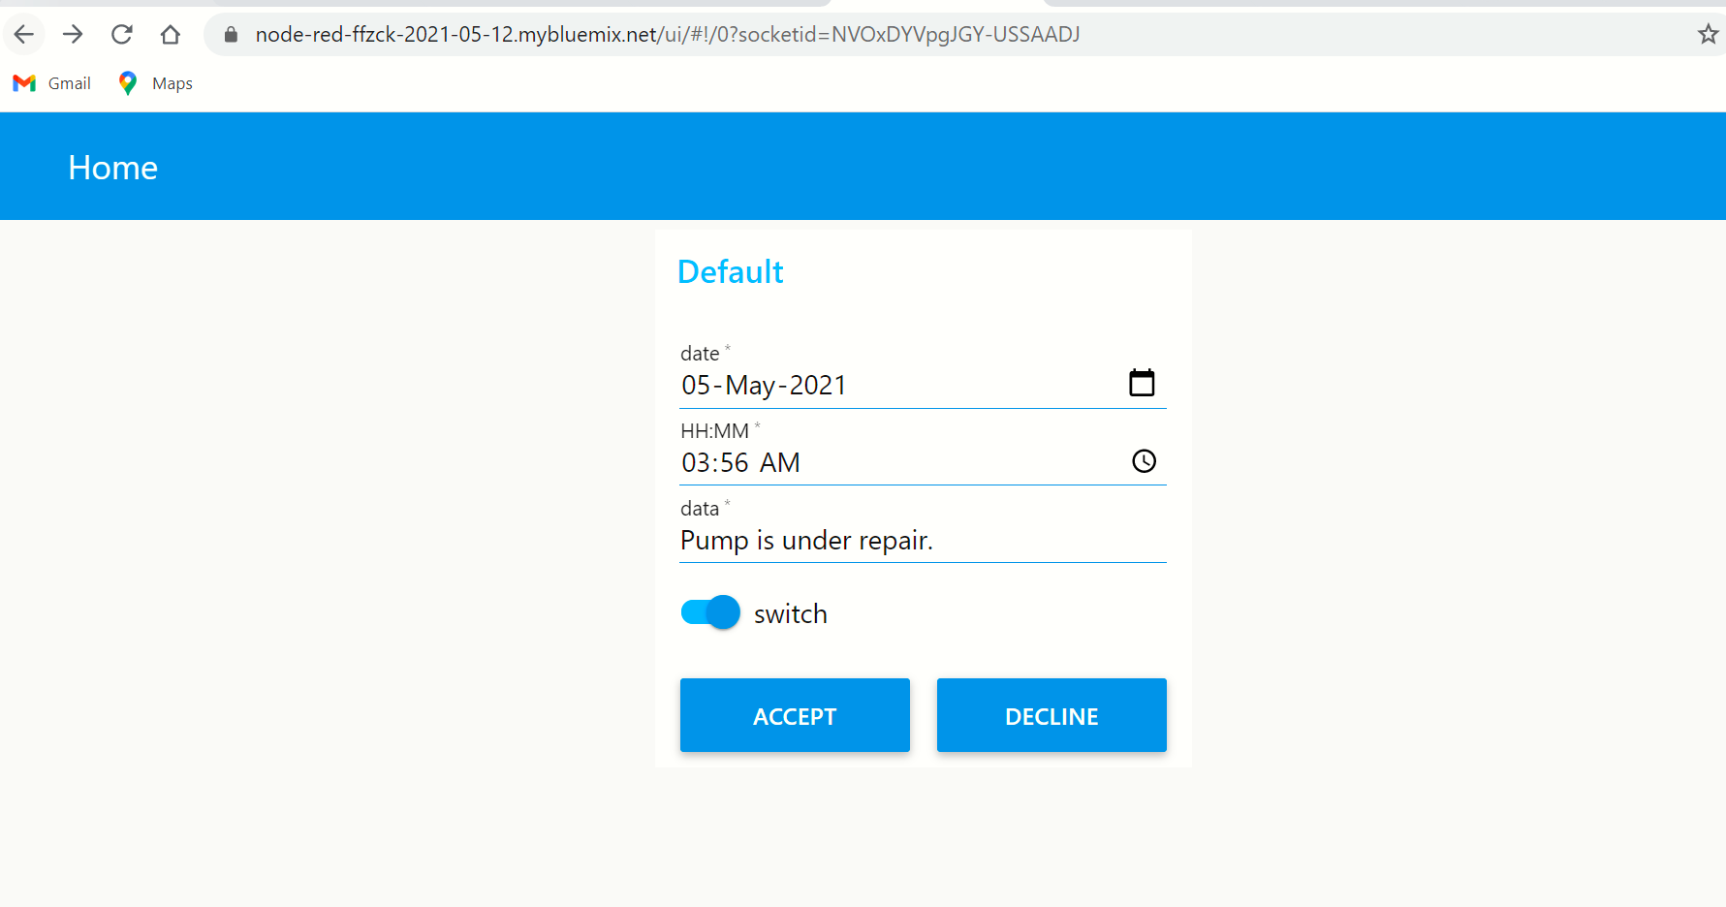

***DATABASE OUTPUT***

