Python code for Water-Level and Light-Intensity

import time 18481A04H3

import sys

import ibmiotf.application

import ibmiotf.device

import random

import json

#Provide your IBM Watson Device Credentials

organization ="kbfeya"

deviceType = "IOTDEVICE"

deviceId = "1010"

authMethod = "token"

authToken = "07_13*11&83"

# Initialize the device client.

WL=0

LI=0

def myCommandCallback(cmd):

print("Command received: %s" % cmd.data['command'])

if cmd.data['command']=='switchon':

print("SWITCH ON IS RECEIVED")

elifcmd.data['command']=='switchoff':

print("SWITCH OFF IS RECEIVED")

if cmd.command == "setInterval":

if 'interval' not in cmd.data:

print("Error - command is missing required information: 'interval'")

else:

interval = cmd.data['interval']

elifcmd.command == "print":

if 'message' not in cmd.data:

print("Error - command is missing required information: 'message'")

else:

print(cmd.data['message'])

try:

deviceOptions = {"org": organization, "type": deviceType, "id": deviceId, "auth-method": authMethod, "auth-token": authToken}

deviceCli = ibmiotf.device.Client(deviceOptions)

#..............................................

except Exception as e:

print("Caught exception connecting device: %s" % str(e))

sys.exit()

# Connect and send a datapoint "hello" with value "world" into the cloud as an event of type "greeting" 10 times

deviceCli.connect()

while True:

WL=29.58

LI=35.46

#Send Water-Level & Light Intensity to IBM Watson

data =jsondata={"d":{ 'waterlevel': WL, 'lightintensity': LI}}

print (data)

def myOnPublishCallback():

print ("Published Water Level = %s %%" % WL, "Light Instensity = %s %%" % LI, "to IBM Watson")

success = deviceCli.publishEvent("Data", "json", data, qos=0, on_publish=myOnPublishCallback)

if not success:

print("Not connected to IoTF")

time.sleep(1)

deviceCli.commandCallback = myCommandCallback

# Disconnect the device and application from the cloud

deviceCli.disconnect()

Python Program Output:

Published Water Level = 25.56 % Light Instensity = 34.78 % to IBM Watson

{'d': {'waterlevel': 25.56, 'lightintensity': 34.78}}

Published Water Level = 25.56 % Light Instensity = 34.78 % to IBM Watson

{'d': {'waterlevel': 25.56, 'lightintensity': 34.78}}

Published Water Level = 25.56 % Light Instensity = 34.78 % to IBM Watson

{'d': {'waterlevel': 25.56, 'lightintensity': 34.78}}

Published Water Level = 25.56 % Light Instensity = 34.78 % to IBM Watson

Command received: switchon

SWITCH ON IS RECEIVED

{'d': {'waterlevel': 25.56, 'lightintensity': 34.78}}

Published Water Level = 25.56 % Light Instensity = 34.78 % to IBM Watson

{'d': {'waterlevel': 25.56, 'lightintensity': 34.78}}

Published Water Level = 25.56 % Light Instensity = 34.78 % to IBM Watson

Command received: switchon

SWITCH ON IS RECEIVED

User Interface Image :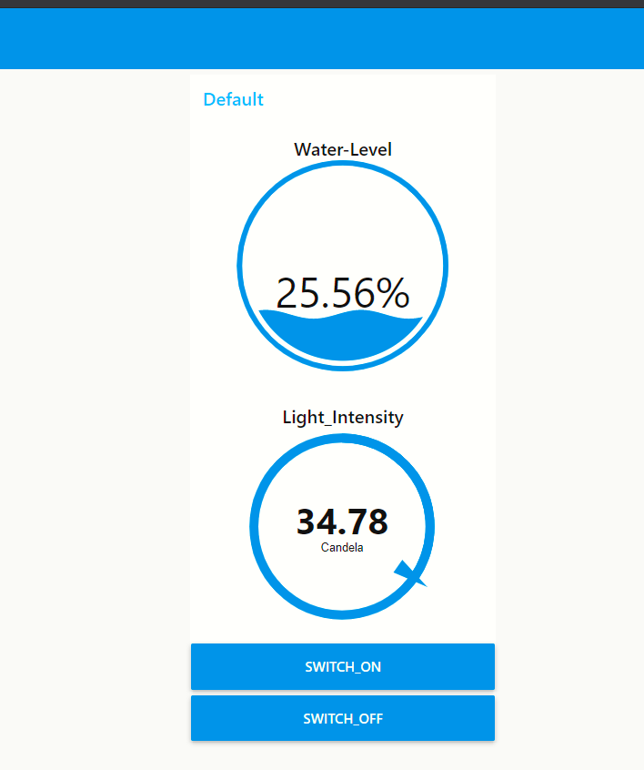

Node-Red Connections:

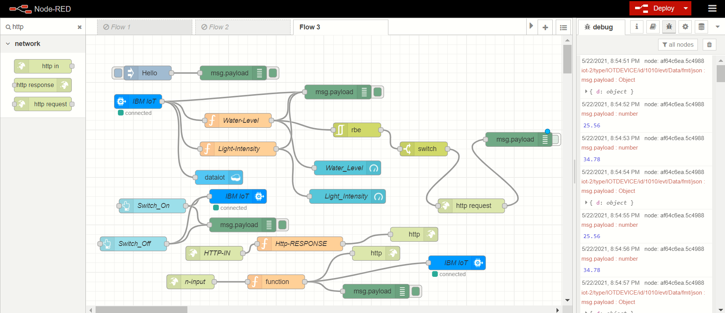

MIT DESIGN:

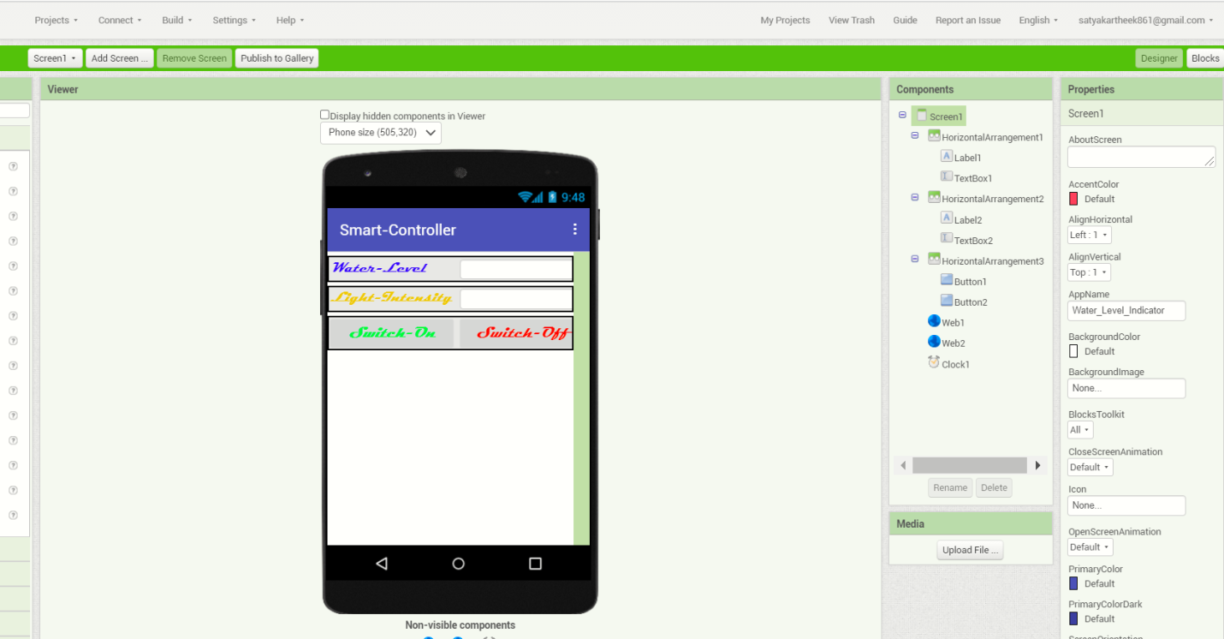

MIT BLOCKS

