ASSIGNMENT-3

Develop a code to upload the water tank level and light intensity values to the IBM IoT platform and visualize them in the web application.

PYTHON CODE:

import time

import sys

import ibmiotf.application

import ibmiotf.device

import random

import json

#Provide your IBM Watson Device Credentials

organization = "2w96tp"

deviceType = "iotdevice"

deviceId = "1001"

authMethod = "token"

authToken = "0123456789n"

# Initialize the device client.

w=0

I=0

def myCommandCallback(cmd):

print("Command received: %s" % cmd.data['command'])

if cmd.data['command']=='lighton':

print("LIGHT ON IS RECEIVED")

elif cmd.data['command']=='lightoff':

print("LIGHT OFF IS RECEIVED")

try:

deviceOptions = {"org": organization, "type": deviceType, "id": deviceId, "auth-method": authMethod, "auth-token": authToken}

deviceCli = ibmiotf.device.Client(deviceOptions)

#..............................................

except Exception as e:

print("Caught exception connecting device: %s" % str(e))

sys.exit()

# Connect and send a datapoint "hello" with value "world" into the cloud as an event of type "greeting" 10 times

deviceCli.connect()

while True:

w=70

I=30

#Send Temperature & Humidity to IBM Watson

data = {"d":{ 'waterlevel' : w, 'lightintensity': I }}

print (data)

def myOnPublishCallback():

print ("Published Waterlevel = %s%% " %w, "Lightintensity = %s %%" % I, "to IBM Watson")

success = deviceCli.publishEvent("Data", "json", data, qos=0, on_publish=myOnPublishCallback)

if not success:

print("Not connected to IoTF")

time.sleep(1)

deviceCli.commandCallback = myCommandCallback

# Disconnect the device and application from the cloud

deviceCli.disconnect()

NODERED –BLOCK:

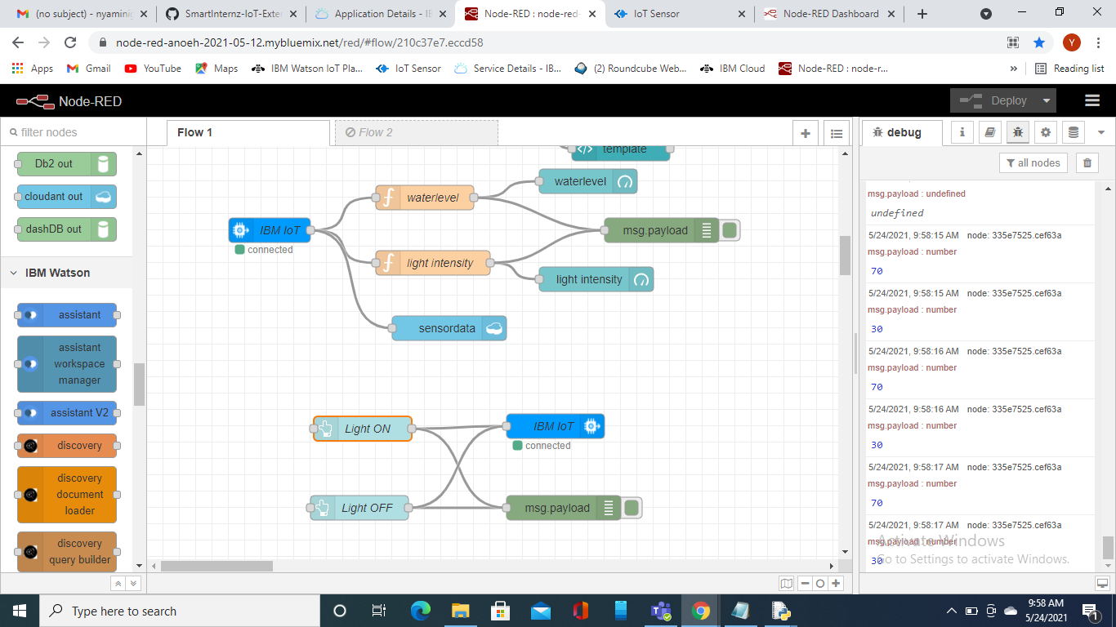

UI:

