ASSIGNMENT-5
18481A04E0
Create a web dashboard to take user input for scheduling the pump controller (date & time). store the data in the Cloudant DB.
you can use Form Nodes in dashboard nodes to take user input.

Node RED:
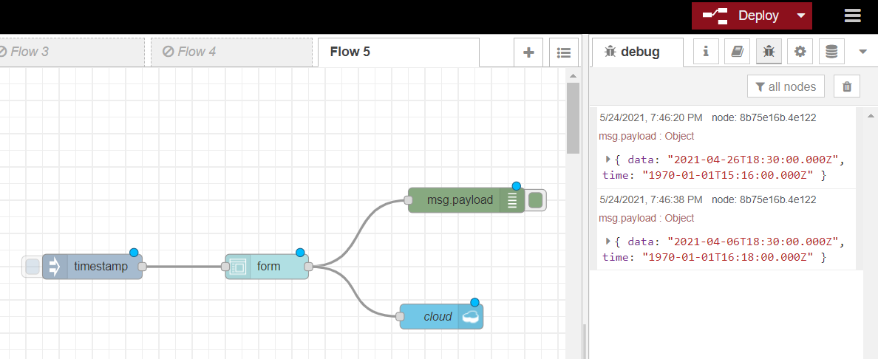
Node RED UI:
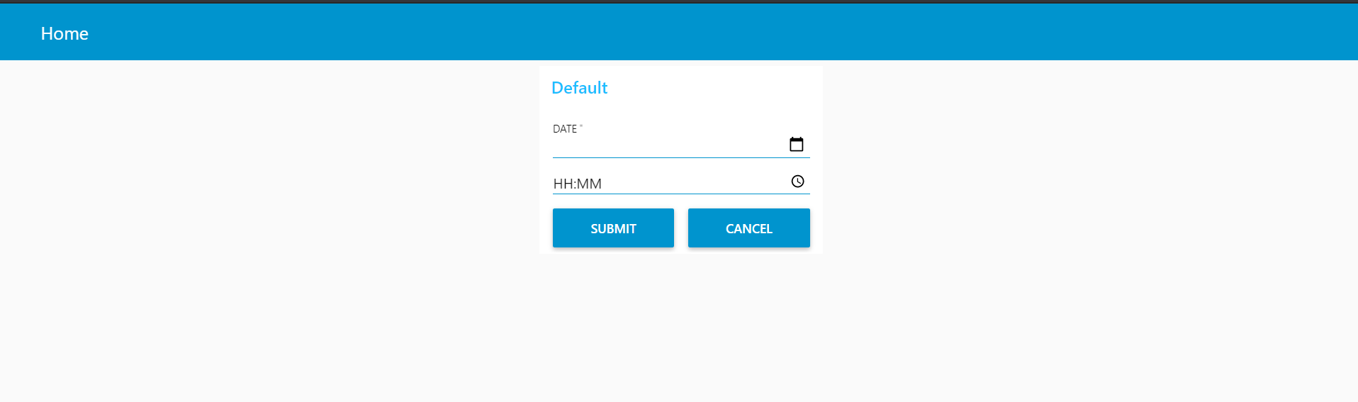

DATABASE OUTPUT:
