ASSIGNMENT-3
- Develop a code to upload the water tank level and light intensity values to the IBM IoT platform and visualize them in the web application.
Python code
import time
import sys
import ibmiotf.application
import ibmiotf.device
import random
import json
organization = "ajidb5"
deviceType = "iotdevice"
deviceId = "1001"
authMethod = "token"
authToken = "1234567890"
w=0
l=0
def myCommandCallback(cmd):
print("Command received: %s" % cmd.data['command'])
if cmd.data['command']=='lighton':
print("LIGHT ON IS RECEIVED")
elif cmd.data['command']=='lightoff':
print("LIGHT OFF IS RECEIVED")

if cmd.command == "setInterval":
if 'interval' not in cmd.data:
print("Error - command is missing required information: 'interval'")
else:
interval = cmd.data['interval']
elif cmd.command == "print":
if 'message' not in cmd.data:
print("Error - command is missing required information: 'message'")
else:
print(cmd.data['message'])
try:
deviceOptions = {"org": organization, "type": deviceType, "id": deviceId, "auth-method": authMethod, "auth-token": authToken}
deviceCli = ibmiotf.device.Client(deviceOptions)
except Exception as e:
print("Caught exception connecting device: %s" % str(e))
sys.exit()
deviceCli.connect()
while True:
w=70
l=30
data = {"d":{ 'waterlevel': w,'lightintensity': l}}
#print data
def myOnPublishCallback():
print ("Published Waterlevel = %s %%" %w, "Lightintensity = %s %%" %l, "to IBM Watson")
success = deviceCli.publishEvent("Data", "json", data, qos=0, on_publish=myOnPublishCallback)
if not success:
print("Not connected to IoTF")
time.sleep(1)
deviceCli.commandCallback = myCommandCallback
deviceCli.disconnect()
Node-RED blocks:
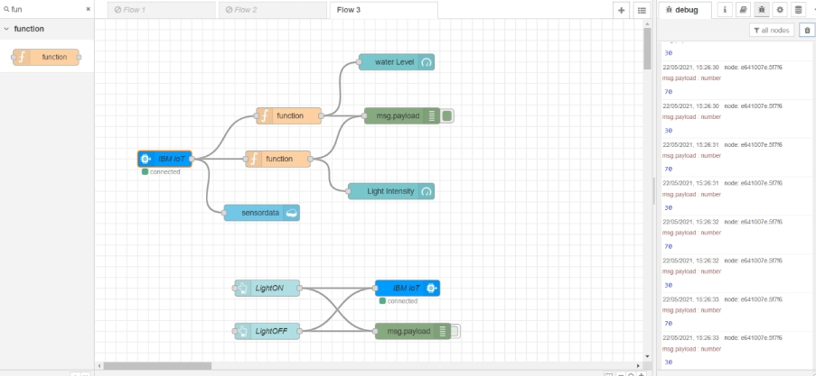
UI:
