**ASSIGNMENT-2**

GARAGE DOOR OPENER – USING ULTRASONIC AND SERVO MOTOR

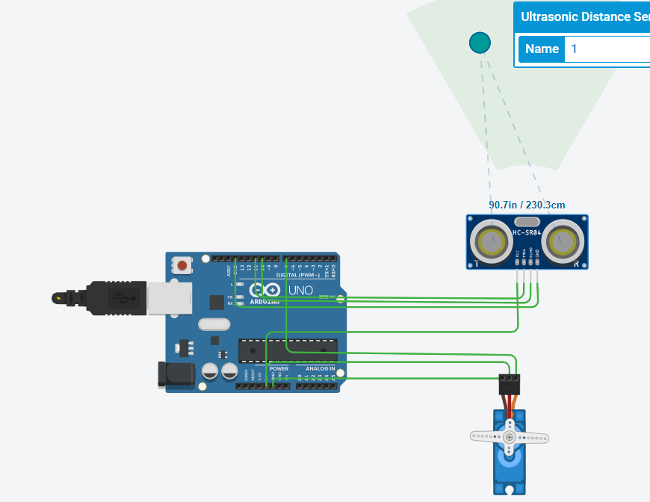

**CODE**

#include<Servo.h>

Servo myservo;

int trigpin = 11;

int echopin =10;

void setup()

{

Serial.begin(9600);

myservo.attach(7);

pinMode(trigpin,OUTPUT);

pinMode(echopin,INPUT);

myservo.write(0);

}

void loop()

{

digitalWrite(trigpin,HIGH);

delay(1000);

digitalWrite(trigpin,LOW);

float duration=pulseIn(echopin,HIGH);

float distance=duration*0.0343/2;

Serial.print("the distance is");

Serial.println(distance);

if(distance>80){

myservo.write(90);

Serial.println("the garage door is opened");

delay(5000);

myservo.write(0);

Serial.println("the garage door is closed");

}

else{

myservo.write(0);

}

}

**OUTPUT**

the distance is229.50

the garage door is opened

the garage door is closed

the distance is229.52

the garage door is opened

the garage door is closed

the distance is228.10

the garage door is opened

the garage door is closed

the distance is228.06

the garage door is opened

the garage door is closed

the distance is333.55

the garage door is opened

the garage door is closed

the distance is298.50

the garage door is opened

the garage door is closed

the distance is92.13

the garage door is opened

the garage door is closed

the distance is66.71

the distance is61.28