Assignment-4 18481A04A5
Develop a mobile application that takes the user input and sends it to IoT device (python code). print the received data in python shell.
Keep a text box to accept the user input.integrate a submit button.
whenever user enters the text input in text box and clicks the button the data should be sent to IBM cloud using URL(HTTP API).

Code:

import ibmiotf.application
import ibmiotf.device
import random
import json
import time

#Provide your IBM Watson Device Credentials
organization = "frtx4v"
deviceType = "iotdevice"
deviceId = "1001"
authMethod = "token"
authToken = "1234567890"

# Initialize the device client.
T=0
H=0

def myCommandCallback(cmd):
print("Command received: %s" % cmd.data['command'])

if cmd.data['command']=='lighton':
print("LIGHT ON IS RECEIVED")

elif cmd.data['command']=='lightoff':
print("LIGHT OFF IS RECEIVED")

if cmd.command == "setInterval":
if 'interval' not in cmd.data:
print("Error - command is missing required information: 'interval'")
else:
interval = cmd.data['interval']
elif cmd.command == "print":
if 'message' not in cmd.data:
print("Error - command is missing required information: 'message'")
else:
print(cmd.data['message'])

try:
deviceOptions = {"org": organization, "type": deviceType, "id": deviceId, "auth-method": authMethod, "auth-token": authToken}
deviceCli = ibmiotf.device.Client(deviceOptions)
#..............................................

except Exception as e:
print("Caught exception connecting device: %s" % str(e))
sys.exit()

# Connect and send a datapoint "hello" with value "world" into the cloud as an event of type "greeting" 10 times
deviceCli.connect()

while True:
T=23
H=45
#Send Temperature & Humidity to IBM Watson
data = {"d":{ 'temperature' : T, 'humidity': H }}
#print (data)
def myOnPublishCallback():
print ("Published Temperature = %s C" % T, "Humidity = %s %%" % H, "to IBM Watson")

success = deviceCli.publishEvent("Data", "json", data, qos=0, on_publish=myOnPublishCallback)
if not success:
print("Not connected to IoTF")
time.sleep(1)

deviceCli.commandCallback = myCommandCallback

# Disconnect the device and application from the cloud
deviceCli.disconnect()

Node Red:

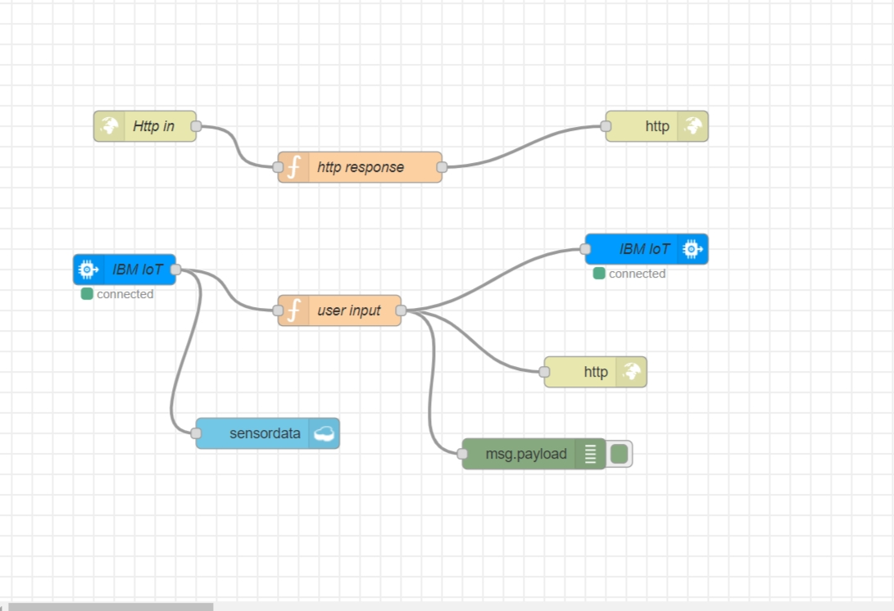
MIT APP INVENTOR:
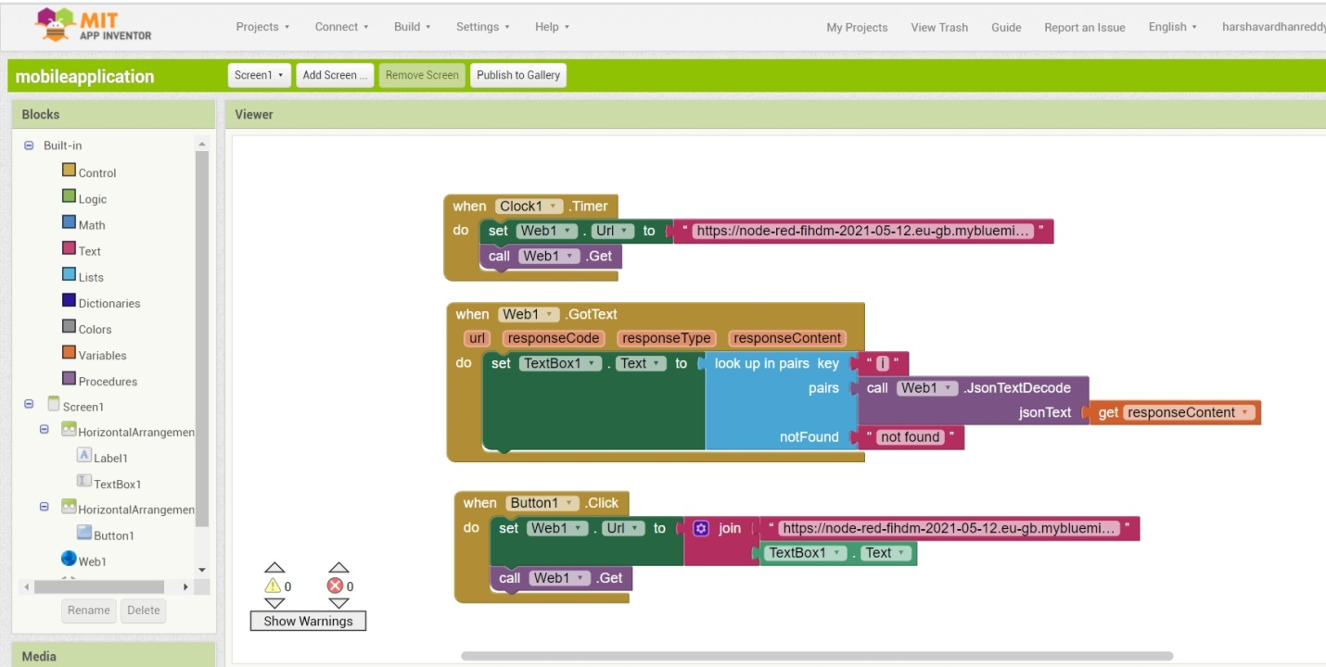

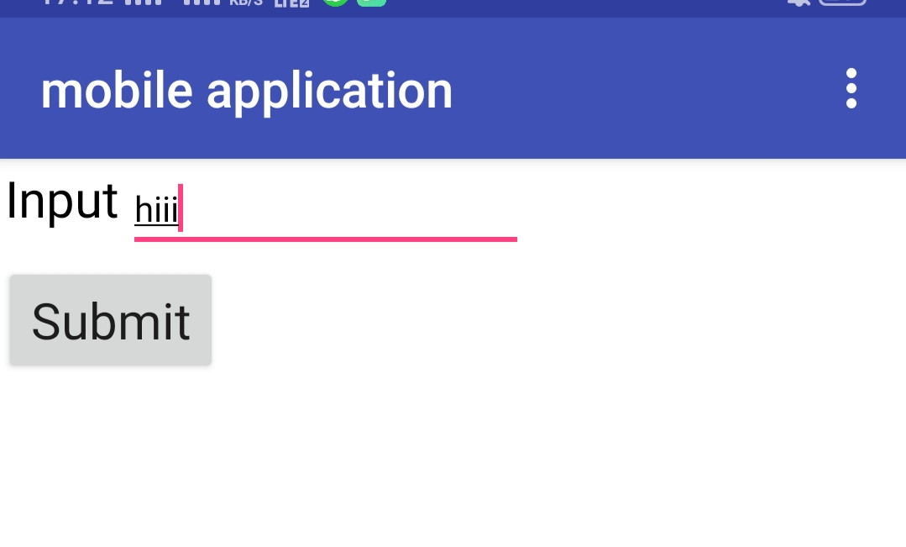

Python Output:
