**ASSIGNMENT-6**

**Object Detection-Haarcascade Classifier**

**Pythoncode:**

import cv2

import numpy as np

# multiple cascades: https://github.com/Itseez/opencv/tree/master/data/haarcascades

#https://github.com/Itseez/opencv/blob/master/data/haarcascades/haarcascade_frontalface_default.xml

face_classifier = cv2.CascadeClassifier('C:/Users/anant/OneDrive/Documents/haarcascade_frontalface_default.xml')

#https://github.com/Itseez/opencv/blob/master/data/haarcascades/haarcascade_eye.xml

eye_classifier = cv2.CascadeClassifier('C:/Users/anant/OneDrive/Documents/haarcascade_eye.xml')

cap=cv2.VideoCapture(0)

while True:

check,img=cap.read()

gray=cv2.cvtColor(img, cv2.COLOR_BGR2GRAY)

faces=face_classifier.detectMultiScale(gray, 1.3, 5)

for (x,y,w,h) in faces:

cv2.rectangle(img, (x,y), (x+w,y+h), (255,0,0), 2)

roi_gray=gray[y:y+h, x:x+w]

roi_color=img[y:y+h, x:x+w]

eyes = eye_classifier.detectMultiScale(roi_gray)

for (ex,ey,ew,eh) in eyes:

cv2.rectangle(roi_color, (ex,ey), (ex+ew,ey+eh), (0,255,0), 2) cv2.imshow('image',img)

cv2.imwrite('detect.jpg',img)

print('image is saved')

k=cv2.waitKey(1)

if k==ord('q'):

cap.release()

cv2.destroyAllWindows()

break

Python Shell O/P:

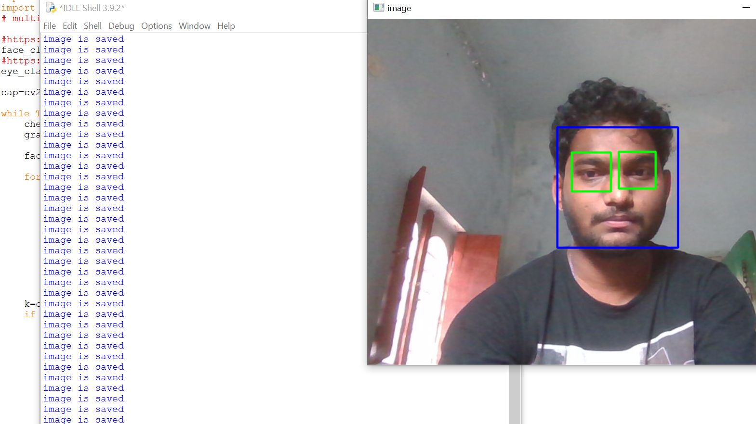

**Detected image:**

