**Assignment-5 18481A0486**

Create a web dashboard to take user input for scheduling the pump controller (date & time). store the data in the Cloudant DB.

you can use Form Nodes in dashboard nodes to take user input.

**Node Red:**

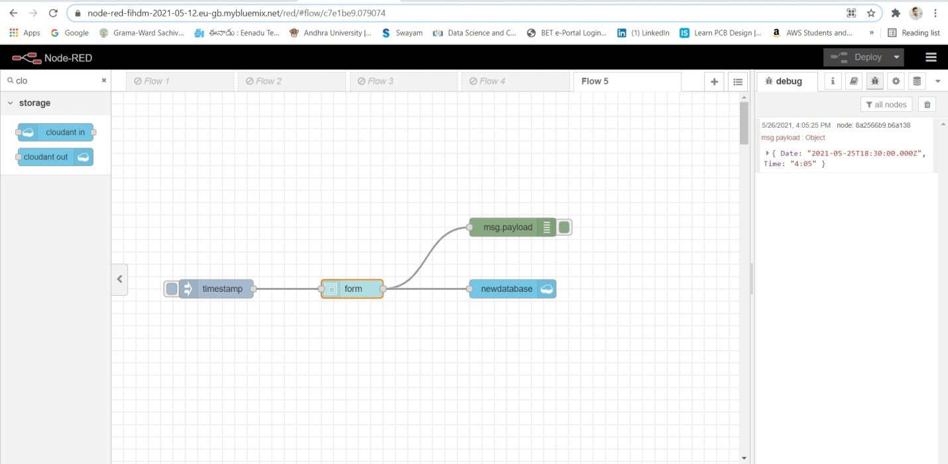

**Node Red UI:**

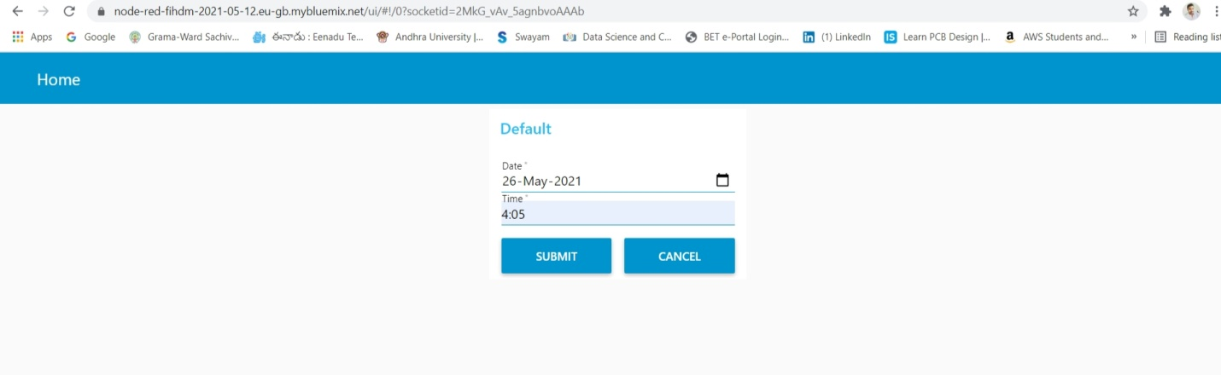

**Database Output:**

