**ASSIGNMENT-5**

**18481A0482**

Create a web dashboard to take user input for scheduling the pump controller (date & time). store the data in the Cloudant DB.

you can use Form Nodes in dashboard nodes to take user input.

**Node RED:**

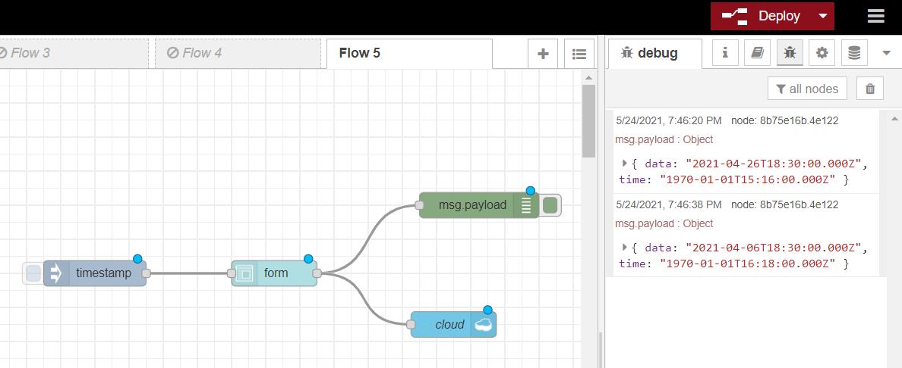

**Node RED UI:**

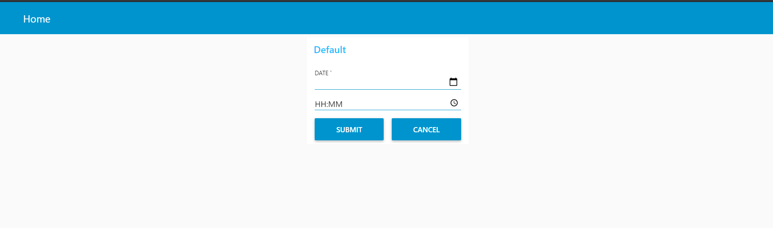

**DATABASE OUTPUT:**

