**Assignment -5 18481A0478**

Create a web dashboard to take user input for scheduling the pump controller (date & time). Store the data in the Cloudant DB, you can use Form Nodes in dashboard nodes to take user input.

**Node red:**

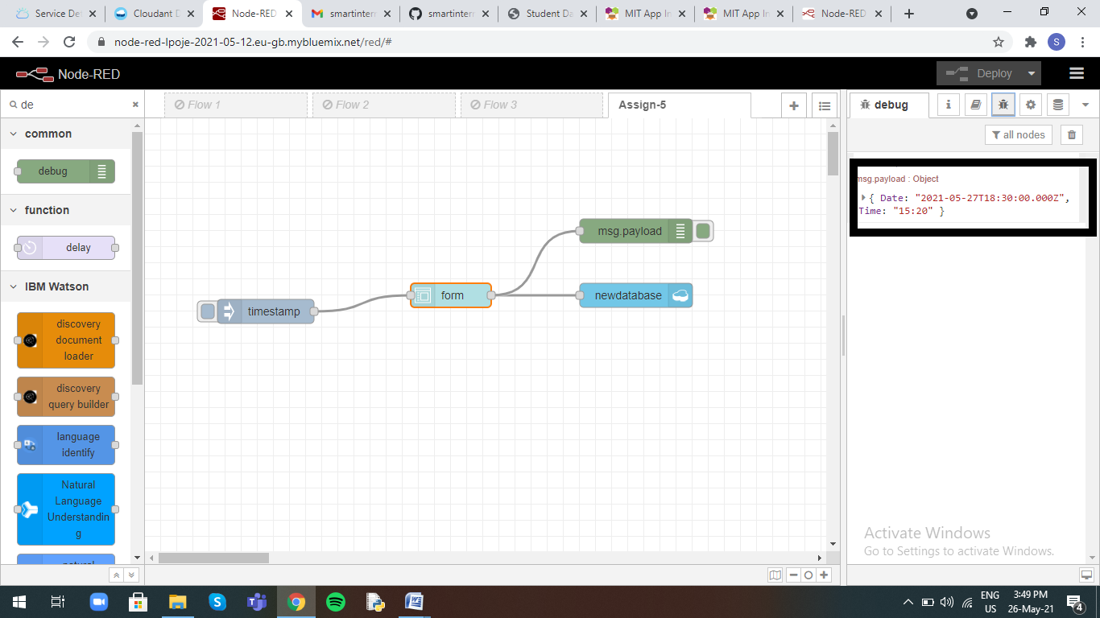

**Cloudant DB:**

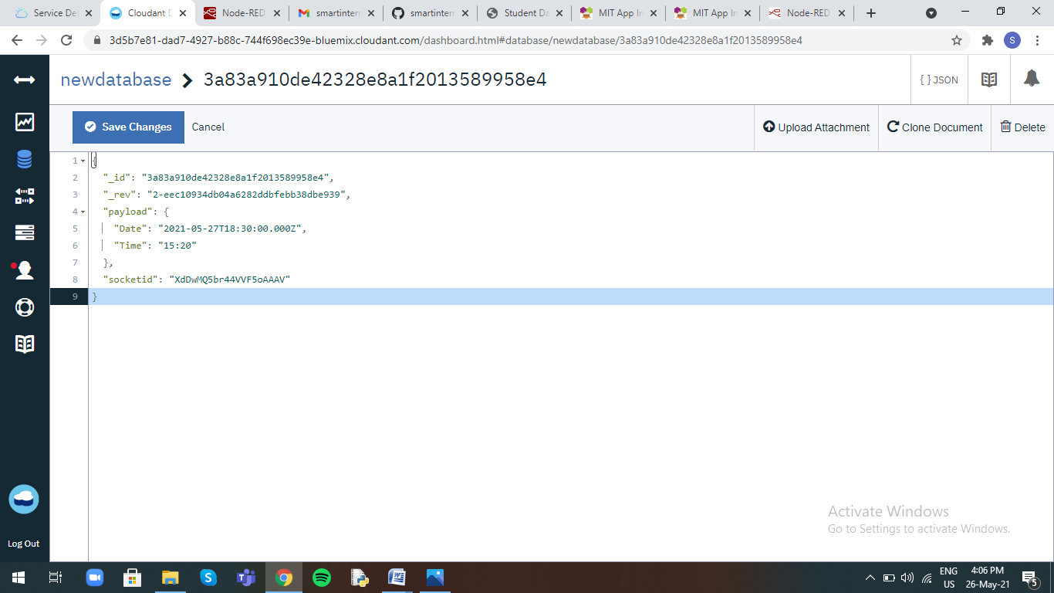

**UI:**

