**ASSIGNMENT-5**

**Date and Time**

**NodeRed:**

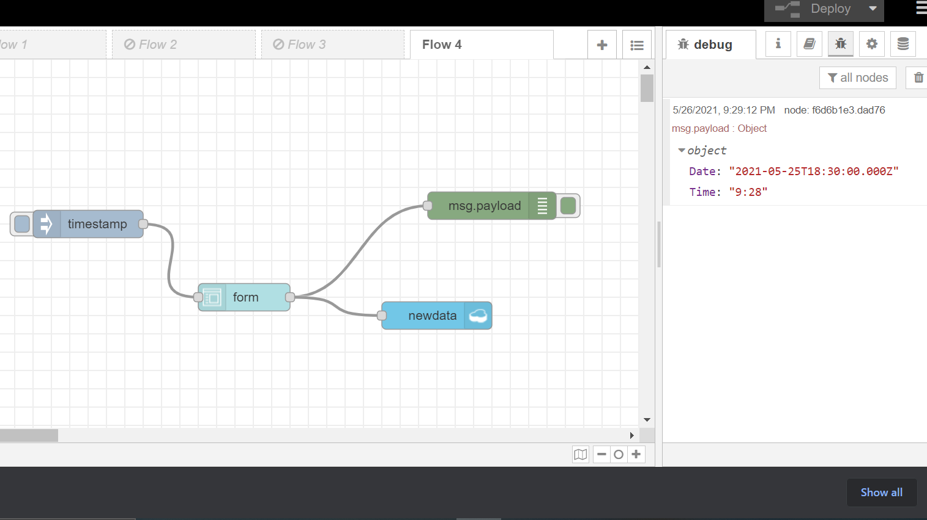

Database and Json Data:

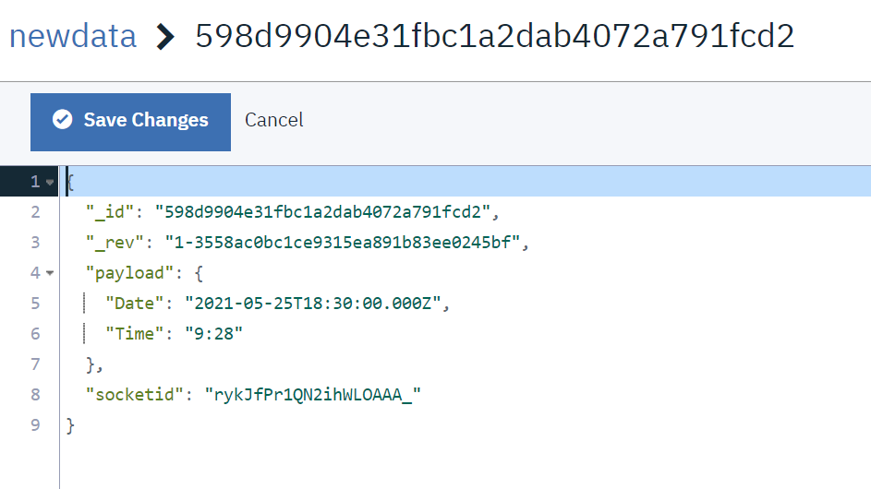

Web Application or UI O/P:

