**Ultrasonic Ranging Module HC – SR04**

Product features:

Ultrasonic ranging module HC - SR04 provides 2cm - 400cm non-contact measurement function, the ranging accuracy can reach to 3mm. The modules includes ultrasonic transmitters, receiver and control circuit. The basic principle of work: (1) Using IO trigger for at least 10us high level signal, (2) The Module automatically sends eight 40 kHz and detect whether there is a pulse signal back. (3) IF the signal back, through high level , time of high output IO duration is the time from sending ultrasonic to returning. Test distance = (high level time×velocity of sound (340M/S) / 2,

**Wire connecting direct as following:**

5V Supply

Trigger Pulse Input

Echo Pulse Output

0V Ground

**Electric Parameter**

Working Voltage DC 5 V

Working Current 15mA

Working Frequency 40Hz

Max Range 4m

Min Range 2cm

MeasuringAngle 15 degree

Trigger Input Signal 10uS TTL pulse

Echo Output Signal Input TTL lever signal and the range in proportion

Dimension 45*20*15mm

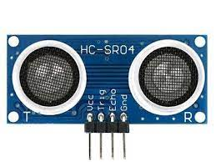

**Timing diagram**

The Timing diagram is shown below. You only need to supply a short 10uS pulse to the trigger input to start the ranging, and then the module will send out an 8 cycle burst of ultrasound at 40 kHz and raise its echo. The Echo is a distance object that is pulse width and the range in proportion .You can calculate the range through the time interval between sending trigger signal and receiving echo signal. Formula: uS / 58 = centimeters or uS / 148 =inch; or: the range = high level time * velocity (340M/S) / 2; we suggest to use over 60ms measurement cycle, in order to prevent trigger signal to the echo signal.

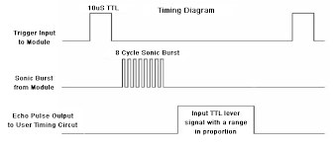

Attention:

The module is not suggested to connect directly to electric, if connected electric, the GND terminal should be connected the module first, otherwise, it will affect the normal work of the module.

When tested objects, the range of area is not less than 0.5 square meters and the plane requests as smooth as possible, otherwise ,it will affect the results of measuring.

**GARAGE DOOR OPENER---ULTRASONIC SENSOR WITH SERVO MOTOR**

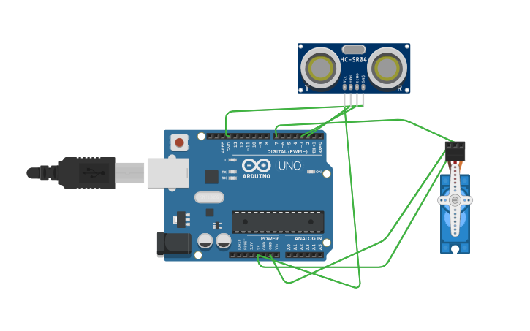

**CODE:**

int trigpin=2;

int echopin=3;

#include<Servo.h>

Servo myservo;

void setup()

{

Serial.begin(9600);

myservo.attach(7);

pinMode(trigpin,OUTPUT);

pinMode(echopin,INPUT);

myservo.write(0);

}

void loop()

{

digitalWrite(trigpin,HIGH);

delay(1000);

digitalWrite(trigpin,LOW);

float duration=pulseIn(echopin,HIGH);

float distance=duration*0.0343/2;

Serial.print("the distance is");

Serial.println(distance);

if(distance>80){

myservo.write(90);

Serial.println("the garage door is opened");

delay(5000);

myservo.write(0);

Serial.println("the garage door is closed");

}

else{

myservo.write(0);

}

}