**Assignment 3**

Develop a code to upload the water tank level and light intensity values to the IBM IoT platform and visualize them in the web application.

**Code:**

import time

import sys

import ibmiotf.application

import ibmiotf.device

import random

import json

organization = "g3y4kb"

deviceType = "iotdevice"

deviceId = "1001"

authMethod = "token"

authToken = "1234567890"

w=0

l=0

def myCommandCallback(cmd):

print("Command received: %s" % cmd.data['command'])

if cmd.data['command']=='lighton':

print("LIGHT ON IS RECEIVED")

elif cmd.data['command']=='lightoff':

print("LIGHT OFF IS RECEIVED")

if cmd.command == "setInterval":

if 'interval' not in cmd.data:

print("Error - command is missing required information: 'interval'")

else:

interval = cmd.data['interval']

elif cmd.command == "print":

if 'message' not in cmd.data:

print("Error - command is missing required information: 'message'")

else:

print(cmd.data['message'])

try:

deviceOptions = {"org": organization, "type": deviceType, "id": deviceId, "auth-method": authMethod, "auth-token": authToken}

deviceCli = ibmiotf.device.Client(deviceOptions)

except Exception as e:

print("Caught exception connecting device: %s" % str(e))

sys.exit()

deviceCli.connect()

while True:

w=80

l=40

data = {"d":{ 'waterlevel': w,'lightintensity': l}}

#print data

def myOnPublishCallback():

print ("Published Waterlevel = %s %%" %w, "Lightintensity = %s %%" %l, "to IBM Watson")

success = deviceCli.publishEvent("Data", "json", data, qos=0, on_publish=myOnPublishCallback)

if not success:

print("Not connected to IoTF")

time.sleep(1)

deviceCli.commandCallback = myCommandCallback

deviceCli.disconnect()

**Node-red:**

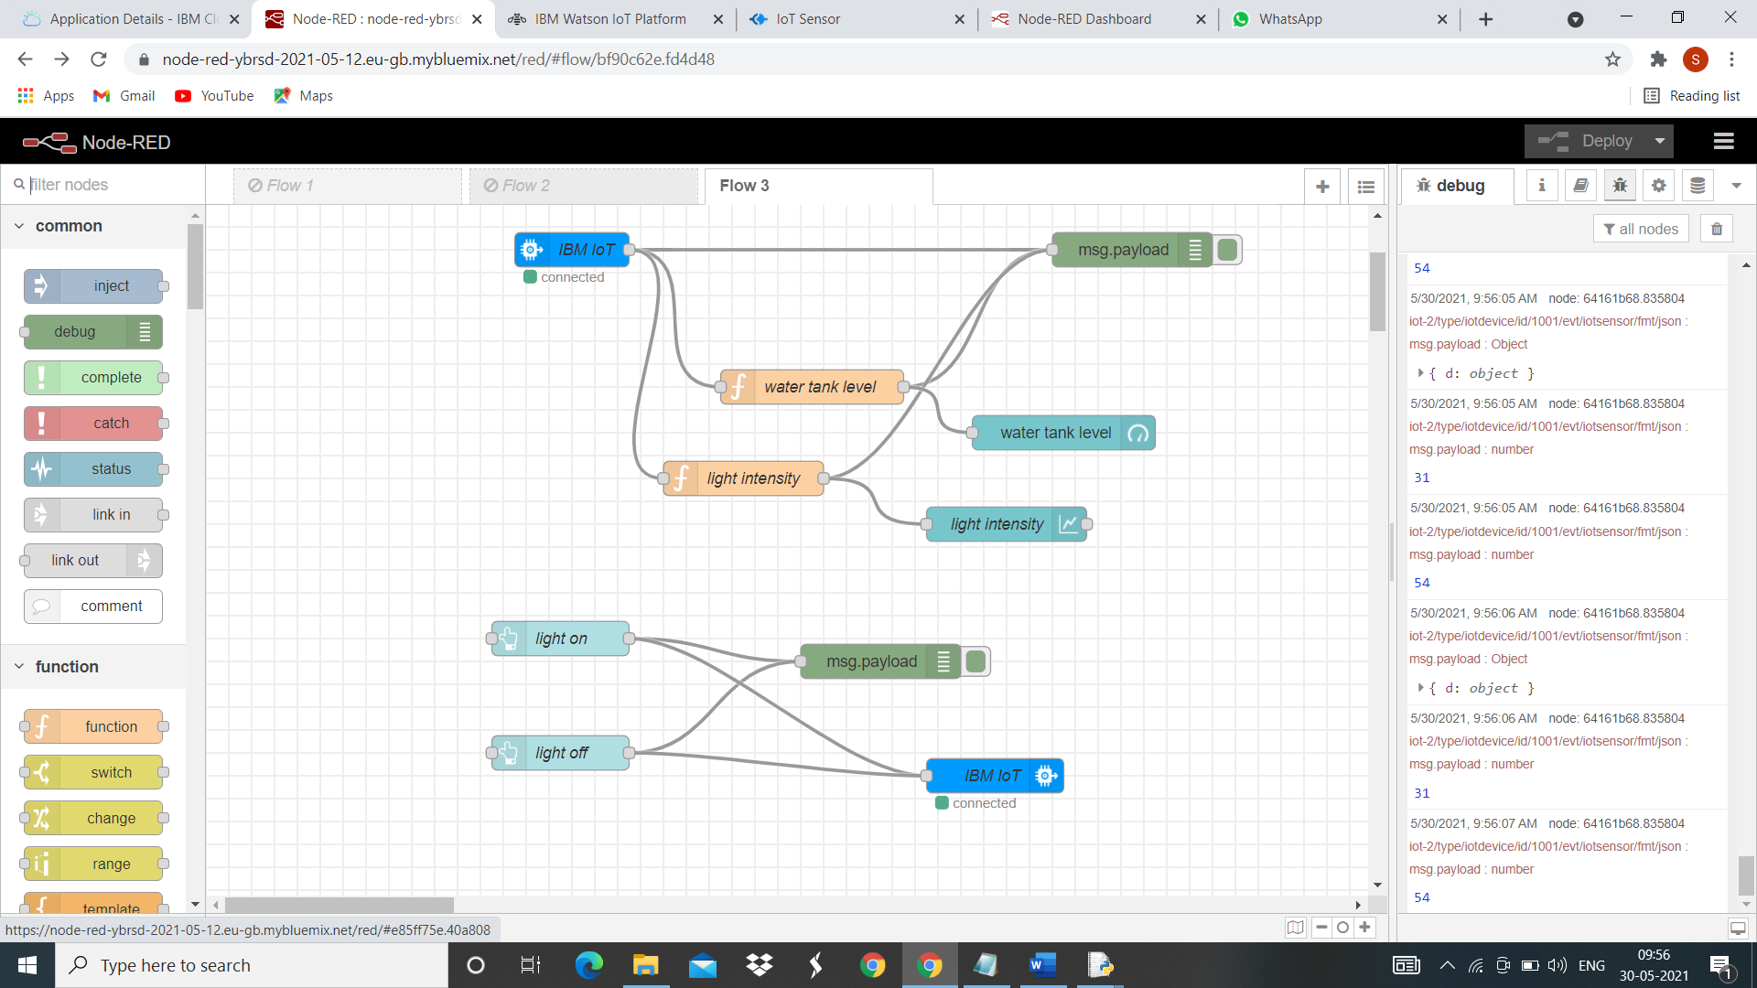

**UI:**

