**Assignment 2 :-**

Develop an "Automatic garage door opening system". Use an Ultrasonic sensor to detect if there is a vehicle in front of the garage. if any vehicle is detected open the garage door (rotate the servo motor) for some time and close it.

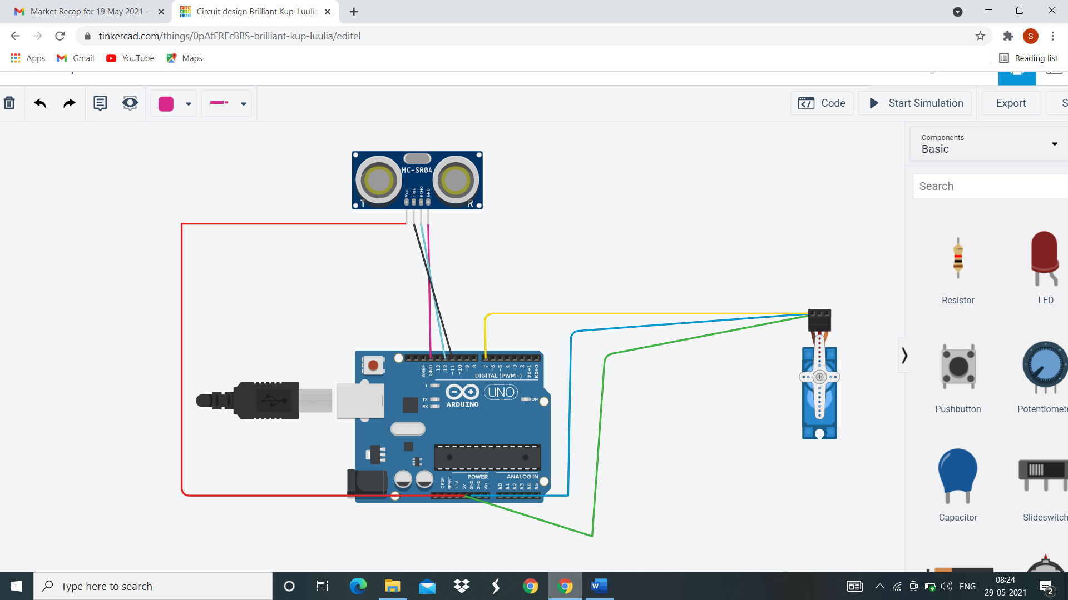

**Code:-**

// C++ code

//

int trigpin=11;

int echopin=12;

#include<Servo.h>

Servo s;

void setup()

{

Serial.begin(9600);

s.attach(7);

pinMode(trigpin,OUTPUT);

pinMode(echopin,INPUT);

s.write(0);

}

void loop()

{

digitalWrite(trigpin,HIGH);

delay(1000);

digitalWrite(trigpin,LOW);

float dur=pulseIn(echopin,HIGH);

float dis=dur*0.0343/2;

Serial.print("The distance is : ");

Serial.println(dis);

if(dis>80)

{

s.write(90);

Serial.println("The door is opened");

delay(7000);

s.write(0);

Serial.println("The door is closed");

}

else

{

s.write(0);

}

}

**OUTPUT:**

The distance is : 105.50

The door is opened

The door is closed

The distance is : 60.05

The distance is : 91.60

The door is opened

The door is closed

The distance is : 110.05

The door is opened

The door is closed