**WILD PLANTS EDIBILITY PREDICTION USING IBM WATSON STUDIO**

**CONTENTS**

|  |  |  |
| --- | --- | --- |
| **S No** | **TOPIC** | **PAGE** **No** |
| **1** | **ABSTRACT** | **2** |
| **2** | **INTRODUCTION** | **2-3** |
| **3** | **LITERATURE SURVEY** | **3-4** |
| **4** | **THEORITICAL ANALYSIS** | **5** |
| **5** | **EXPERIMENTAL INVESTIGATIONS** | **5** |
| **6** | **FLOWCHART** | **6-8** |
| **7** | **RESULT** | **8** |
| **8** | **ADVANTAGES AND DISADVANTAGES** | **9** |
| **9** | **APPLICATIONS** | **10** |
| **10** | **CONCLUSION** | **10** |
| **11** | **FUTURE SCOPE** | **10-11** |
| **12** | **BIBILOGRAPHY** | **11-12** |

1. **ABSTRACT**

In the present investigation indigenous knowledge on wild edible plants (WEPs) consumed by rural people in different parts of Bidar district of Karnataka state was recorded. Fifteen field trips were undertaken to different villages of the district and a total of 70 people were interviewed and their observations were recorded.

Surveys were also undertaken to vegetable markets of towns in the district during the years January 2014 to July 2015 (18 months). During the present survey it was found that 82 species of wild plants were consumed by the local people. The edible parts (whole plant, corm or tuber, leaves, stem, young shoots, flowers, fruits, fruit pulp and seeds) were also marketed in nearby towns by rural community and economically weaker section of the people who got their income by selling these wild edible plants.

**2.INTRODUCTION**

The consumption of wild edible plants is an ancient phenomenon which predates agriculture. These plants offer various benefits and opportunities to communities; for example, they enable communities to cope with food scarcity. This is also known as ecosystem-based adaptation. They hold great cultural significance to dependent communities. In addition, wild edible plants increase the nutritional quality of rural diets for instance, micronutrients (vitamins and minerals) which are sometimes superior to those of domesticated varieties. Some of them also contain genes that can be sought to improve the productivity of cultivars. They also contribute to household incomes, thereby contributing to the attainment of sustainable development goal 1 on eradicating poverty.

The selection of plants for ethnobotanical use is anchored in a theory. The theories include among others the optimal foraging theory and theory of non-random plant selection. The former predicts that foraging organisms will balance the effort it took to search for and eat that food. In so doing, individuals will place high value on plants that yield more benefit per unit of foraging/processing time; as abundance of plants with higher value increases, plants with lower value will no longer be used and individuals should have a quantitative threshold to decide when a specific plant should be included or excluded.

**PURPOSE:**

The grouping of WEP based on edible parts has offered a deeper understanding of the underlying trend of use, i.e., how edible parts drive plant use, which parts are being eaten the most, etc. From total used species, it was revealed that most have been used as leafy greens (52.7%) and fruits (47.6%), followed by underground parts (15.7%), seeds (12.8%), and flowers (11.2%).

[Turner et al. (2011)](https://www.frontiersin.org/articles/10.3389/fsufs.2020.00056/full#B186) underscored the preference toward the specific type of wild edible consumption and attributed it to prevailing climatic condition in an ecosystem that perhaps determines peoples' choice. They also highlighted the role of culture in shaping the type of wild edible use, such as the frequent use of leafy greens in east and south Asia being in vogue.

In a study conducted by [Cruz-Garcia and Price (2011)](https://www.frontiersin.org/articles/10.3389/fsufs.2020.00056/full#B35), the highest edible species clustered in the “shoot” and “fruit” category; however, their grouping does not entirely match with the part-wise classification we implemented. Similar leaning on wild leafy green use has also been reported by [Sujarwo et al. (2014)](https://www.frontiersin.org/articles/10.3389/fsufs.2020.00056/full#B177) in Bali.

**3.LITERATURE SURVEY**

1. Murray S. S. and Schoeninger M. J. (1999): Nutritional composition of some wild plant food and Honey used by Hadza foragers of Tanzania. Author reported compositional data for several foods that comprises the annual diet among Hadza Foragers. They found macronutrient composition of six fruits which is comparable to those of agricultural fruits, although they were somewhat higher in crude protein, carbohydrates and energy and somewhat lower in fat. They found Baobab seeds is high protein as reported in other studies after all. They observed in combination with our analytical data. They suggest that baobab seeds are an important source of energy and protein for these foragers.

2. Nazarudeen A. (2007): Nutritional composition of some lesser known fruits used by the ethnic communities and local folks of kerala. Author studied the wild edible fruits play a significant role in the dietary requirement of the tribal and local communities of Kerala. They studied 218 plant species of fruit, out of that 10 species they selected for chemical analysis. They studied moister protein, fats, non-reducing and total sugar, fiber, total vitamin. Vitamin C, iron, sodium, potassium and energy value were carried out and they compared the result with ten common cultivator fruits.

however they are often undervalued and underutilization as more exotic fruits. These production and consumption provide a dietary supplement as well as commercial opportunity.

**4.THEORITICAL ANALYSIS**

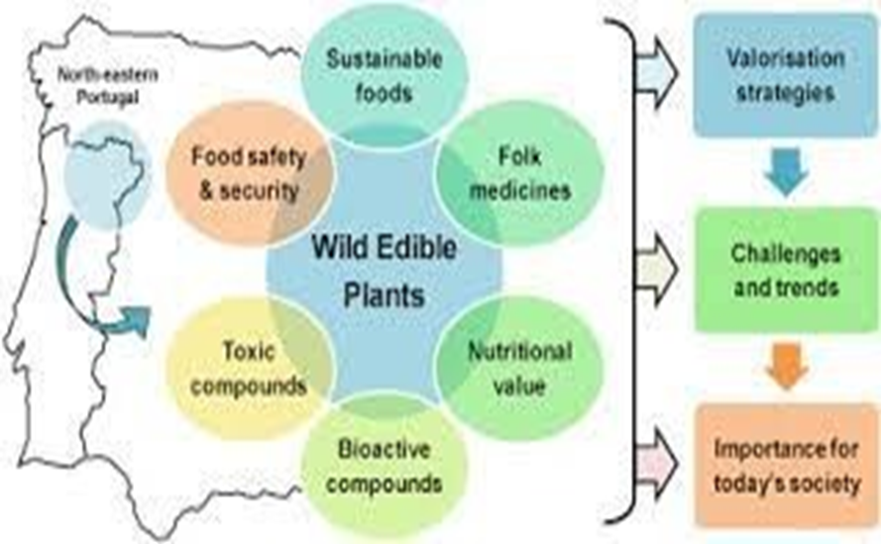

**5.EXPERIMENTAL INVESTIGATION**

The edible wild plant resources in Bhutan and to re-evaluate traditional knowledge of their effect on human health, investigations in three bazaars, three forests and four farming villages were carried out by both researchers of Shinshu University and Ministry of Agriculture, Bhutan. A total of 47 edible wild plant species that are belonging to total of 25 families of Magnoliophyta were determined. A total of 12 edible wild plant species of Pteridophyta were also determined, but they were not identified. Thirteen wild edible plant species including important vegetables in Bhutan such as Adhatota vasica, Plectocomia himalayana. Pogostemon amaranthoides, Asparagus racemosa, Phytolocca acinosa. Houttuynia cordata and Elatostema lineolatum, were common in investigations of 2005 and 2006. Some of the wild edible plants are believed to affect human health functionally. For example, leaves of Elatostema lineolatum, Mentha sp., Oenanthe javanica and Paris polyphylla are believed to improve blood condition. Leaves of Thlaspi arvense are believed to cure tuberculosis. Fagopyrum cymosum and Mentha sp. are believed to cure skin diseases.

Mentha sp. is also believed to cure asthma and gum problem. On the other hand, Amaranthus lividus, Amaranthus spinosus and Commelina benghalensis are believed to have a bad effect for the person who have an urine problem. Adhatoda vasica is believed to induce a bad effect for the person who have giddiness.

**6.FLOW CHART**

DATA COLLECTION



IMAGE PRE-PROCESSING



MODEL BUILDING



IMPORT LIBRARIES AND INTIALIZE THE MODEL



ADD CNN LAYERS



ADDING DENSE LAYERS



CONFIGURING THE LEARNING PROCESS



TRAIN AND SAVE THE MODEL



TEST THE MODEL



APPLICATION BUILDING



BUILD HTML PAGES



BUILD PYTHON CODE



RUN THE APP



TRAIN THE MODEL ON IBM

**7.RESULT**

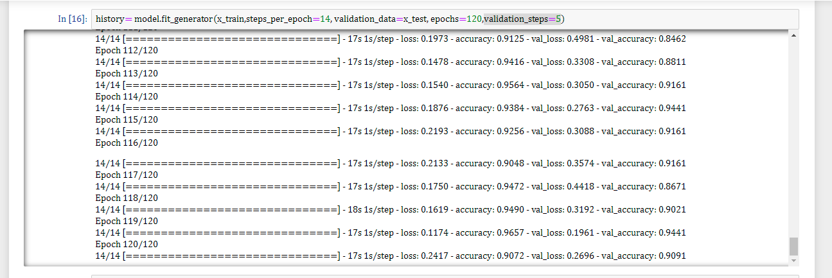

**8.ADVANTAGES AND DISADVANTAGES**

ADVANTAGES:

1.Suitable for species with recalcitrant and intermediate seeds.

2.Convenient for characterization and evaluation.

3.Easily accessible for use.

4.Allow for conservation of particular genotypes.

5.Possible to combine conservation and research/observation.

DISADVANTAGES:

1.Vulnerable to changes in management practices Susceptible to pests, diseases, and other natural and/or human-driven calamities such as drought, neglect, and

War.

2.Limited amount of genetic diversity conserved.

3.High maintenance costs.

4.Not suitable for long-term conservation.

**9.APPLICATION**

1.The main application of this model is to predict the provided image of wild plant is edible or not. It is well trained so that it will predict the correct data

2.we will be building a web application that is integrated to the model we built.

3.DA UI is provided for the uses where he has uploads an image. The uploaded image is given to the saved model and

4.prediction is showcased on the UI.

**10.CONCLUSION**

While using the machine learning algorithms in connection with images captured by satellites and drones, Al-enabled technologies predict weather conditions, analyze crop sustainability and evaluate farms for the presence of diseases or pests and poor plant nutrition on farms with data like temperature, precipitation.

**11.FUTURE SCOPE**

 They play a significant part in a wide range of agricultural systems as a source of wild foods and fuelwood, and they have an important socio-economic role through their use in medicines, dyes, poisons, shelter, fibres and religious and cultural ceremonies. Yet little systematic knowledge has been gathered on the uses of wild plants and they tend to be ignored in considerations of farming systems by extension workers, policy-makers and economists. Wild resources in general are often ignored and receive little recognition from the development community (Scoones, Melnyk and Pretty, 1992).

**12.BIBILOGRAPHY**

1.Angier, Bradford Feasting Free on Wild Edibles. New York: Pyramid Books. c1966 (also published by Stackpole Books in 1972) 288pp. Paperback.

🡪A one-volume edition of two earlier books: Free for the Eating and More free for the

🡪Eating Wild Foods good recipes for some plants

🡪quite comprehensive coverage of Eastern plants; includes common Western U.S. edibles as well.

2. Angier, Bradford Free For the Eating. Harrisburg, PA: Stackpole Books. c1966 191pp.

3.Angier, Bradford Field Guide to Medicinal Wild Plants. Harrisburg, PA: Stackpole Books.

c1978 320pp. Softcover.

4.Angier, Bradford More Free-For-The-Eating Wild Foods. Harrisburg, PA: Stackpole Books.

c1969 192pp.

5. Arora, David All that the Rain Promises, and More... A Hip Pocket Guide to Western Mushrooms. Berkeley, CA: Ten Speed Press. c1991 264pp.

6. Arora, David Mushrooms Demystified: A Comprehensive Guide to the Fleshy Fungi (second edition). Berkeley, CA: Ten Speed Press. c1979,1986 959pp.