**BRAIN TUMOR DETECTION FROM MRI IMAGES WITH IBM WATSON STUDIO**

**CONTENTS**

|  |  |  |
| --- | --- | --- |
| **S No** | **TOPIC** | **PAGE** **No** |
| **1** | **ABSTRACT** | **2** |
| **2** | **INTRODUCTION** | **3** |
| **3** | **LITERATURE SURVEY** | **4** |
| **4** | **THEORITICAL ANALYSIS** | **5-6** |
| **5** | **EXPERIMENTAL INVESTIGATIONS** | **7-8** |
| **6** | **FLOWCHART** | **9** |
| **7** | **RESULT** | **10** |
| **8** | **ADVANTAGES AND DISADVANTAGES** | **11** |
| **9** | **APPLICATIONS** | **11** |
| **10** | **CONCLUSION** | **12** |
| **11** | **FUTURE SCOPE** | **13** |
| **12** | **BIBILOGRAPHY** | **14-15** |

**1.ABSTRACT**

Automated defect detection in medical imaging has become the emergent field in several medical diagnostic applications. Automated detection of tumor in MRI is very crucial as it provides information about abnormal tissues which is necessary for planning treatment. The conventional method for defect detection in magnetic resonance brain images is human inspection. This method is impractical due to large amount of data. Hence, trusted and automatic classification schemes are essential to prevent the death rate of human. So, automated tumor detection methods are developed as it would save radiologist time and obtain a tested accuracy. The MRI brain tumor detection is complicated task due to complexity and variance of tumors. In this project, we propose the machine learning algorithms to overcome the drawbacks of traditional classifiers where tumor is detected in brain MRI using machine learning algorithms. Machine learning and image classifier can be used to efficiently detect cancer cells in brain through MRI.

**2. INTRODUCTION**

**2.1 Overview:** Brain tumor is one of the most rigorous diseases in the medical science. An effective and efficient analysis is always a key concern for the radiologist in the premature phase of tumor growth. Histological grading, based on a stereotactic biopsy test, is the gold standard and the convention for detecting the grade of a brain tumor. The biopsy procedure requires the neurosurgeon to drill a small hole into the skull from which the tissue is collected. There are many risk factors involving the biopsy test, including bleeding from the tumor and brain causing infection, seizures, severe migraine, stroke, coma and even death. But the main concern with the stereotactic biopsy is that it is not 100% accurate which may result in a serious diagnostic error followed by a wrong clinical management of the disease.

Tumor biopsy being challenging for brain tumor patients, non-invasive imaging techniques like Magnetic Resonance Imaging (MRI) have been extensively employed in diagnosing brain tumors. Therefore, development of systems for the detection and prediction of the grade of tumors based on MRI data has become necessary. But at first sight of the imaging modality like in Magnetic Resonance Imaging (MRI), the proper visualisation of the tumor cells and its differentiation with its nearby soft tissues is somewhat difficult task which may be due to the presence of low illumination in imaging modalities or its large presence of data or several complexity and variance of tumors-like unstructured shape, viable size and unpredictable locations of the tumor.

**2.2 Purpose:** Automated defect detection in medical imaging using machine learning has become the emergent field in several medical diagnostic applications. Its application in the detection of brain tumor in MRI is very crucial as it provides information about abnormal tissues which is necessary for planning treatment. Studies in the recent literature have also reported that automatic computerized detection and diagnosis of the disease, based on medical image analysis, could be a good alternative as it would save radiologist time and also obtain a tested accuracy.

**3. LITERATURE SURVEY**

**3.1 Existing problem:** Automated defect detection in medical imaging using machine learning has become the emergent field in several medical diagnostic applications.In general, diagnosing a brain tumor usually begins with magnetic resonance imaging (MRI). Once MRI shows that there is a tumor in the brain, the most common way to determine the type of brain tumor is to look at the results from a sample of tissue after a biopsy or surgery. This is a normal way to detect the brain tumor

**3.2 Proposed solution:** Here we are going to detect the tumor using a human trained model we trained our model using nearly 500 images and we got an accuracy of nearly 99%. And the person can collect there MRI and then he upload the copy of an image in our webpage then from there he can get know he is having an tumor in his brain or not. And then from there he can proceed for the further surgery steps.

**4. THEORITICAL ANALYSIS**

**4.1 Block diagram:**

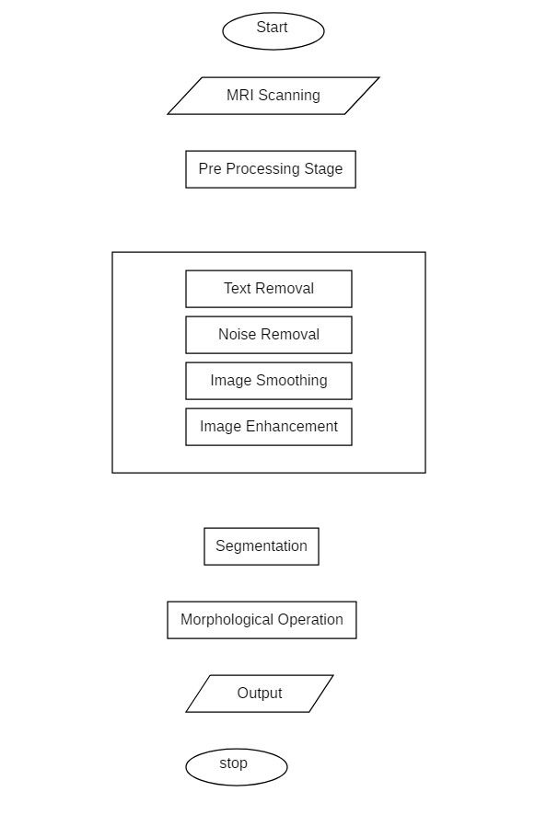

**4.2 Hardware / Software designing:**

**Software Requirements:**

Python 3 - We have used Python which is a statistical mathematical programming language like R instead of MATLAB due to the following reasons:

1. Python code is more compact and readable than MATLAB

2. The python data structure is superior to MATLAB

3. It is an open source and also provides more graphic packages and data sets Keras (with TensorFlow backend 2.3.0 version) - Keras is a neural network API consisting of TensorFlow, CNTk, Theano etc. Python packages like Numpy, Matplotlib, Pandas for mathematical computation and plotting graphs, SimpleITK for reading the images which were in .mha format and Mahotas for feature extraction of GLCM Kaggle was used to obtain the online dataset. GitHub and Stackoverflow was used for reference in case of programming syntax errors. OpenCV (Open Source Computer Vision) is a library of programming functions aimed at real time computer vision i.e. used for image processing and any operations relating to image like reading and writing images, modifying image quality, removing noise by using Gaussian Blur, performing binary thresholding on images, converting the original image consisting of pixel values into an array, changing the image from RGB to grayscale etc. It is free to use, simple to learn and supports C++, Java, C, Python. Its popular application lies in CamScanner or Instagram, GitHub or a web-based control repository. Google Colaboratory (open-source Jupyter Notebook interface with high GPU facility) - Google Colab /Colaboratory is a free Jupyter notebook environment that requires no setup and runs entirely on cloud. With Colab, one can write and execute code, save and share analyses, access powerful computing resources, all for free from browser.[Jupyter Notebook is a powerful way to iterate and write on your Python code for data analysis. Rather than writing and rewriting an entire code, one can write lines of code and run them at a time. It is built off of iPython which ©RCCIIT, DEPT. OF EE Page 20 is an interactive way of running Python code. It allows Jupyter notebook to support multiple languages as well as storing the code and writing own markdown.]

**Hardware Requirements:**

Processor: Intel® Core™ i3-2350M CPU @ 2.30GHz

Installed memory (RAM):4.00GB

System Type: 64-bit Operating System

**5. EXPERIMENTAL INVESTIGATIONS**

while working on the solution we investigated on the what is AL and what is ML and how to build models using them and how to do image processing. And mainly we had studied about the CNN because our solution mainly need this so we worked on these aspects.

**Artificial Intelligence**: Artificial intelligence (AI) is the simulation of human intelligence processes by machines, especially computer systems enabling it to even mimic human behaviour. Its applications lie in fields of Computer Vision, Natural Language Processing, Robotics, Speech Recognition, etc.

**Basic Operation of Neural Networks:** Neural Networks (NN) form the base of deep learning, a subfield of machine learning where the algorithms are inspired by the structure of the human brain. NN take in data, train themselves to recognize the patterns in this data and then predict the outputs for a new set of similar data. NN are made up of layers of neurons. These neurons are the core processing units of the network.

**Transfer Learning:** A major assumption in many machine learning and data mining algorithms is that the training and future data must be in the same feature space and have the same distribution. However, in many real-world applications, this assumption may not hold. For example, we sometimes have a classification task in one domain of interest, but we only have sufficient training data in another domain of interest, where the latter data may be in a different feature space or follow a different data distribution. In such cases, knowledge transfer, if done successfully, would greatly improve the performance of learning by avoiding much expensive data labelling efforts. In recent years, transfer learning has emerged as a new learning framework to address this problem.

**Convolutional Neural Network:** Classifier models can be basically divided into two categories respectively which are generative models based on hand- crafted features and discriminative models based on traditional learning such as support vector machine (SVM), Random Forest (RF) and Convolutional Neural Network (CNN). One difficulty with methods based on hand-crafted features is that they often require the computation of a large number of features in order to be accurate when used with many traditional machine learning techniques. This can make them slow to compute and expensive memory-wise. More efficient techniques employ lower numbers of features, using dimensionality reduction like PCA (Principle Component Analysis) or feature selection methods, but the reduction in the number of features is often at the cost of reduced accuracy. Brain tumor segmentation employ discriminative models because unlike generative modelling approaches, these approaches exploit little prior knowledge on the brain‘s anatomy and instead rely mostly on the extraction of [a large number of] low level image features, directly modelling the relationship between these features and the label of a given voxel.

**Activation Function:** Sigmoid function ranges from 0 to 1 and is used to predict probability as an output in case of binary classification while Softmax function is used for multi-class classification. tanh function ranges from -1 to 1 and is considered better than sigmoid in binary classification using feed forward algorithm. ReLU (Rectified Linear Unit) ranges from 0 to infinity and Leaky ReLU (better version of ReLU) ranges- from -infinity to +infinity. ReLU stands for Rectified Linear Unit for a non-linear operation.

The output is ƒ(x) = max(0,x).ReLU‘s purpose is to introduce non-linearity in our ConvNet. Since, the real world data would want our ConvNet to learn would be non-negative linear values. There are other nonlinear functions such as tanh or sigmoid that can also be used instead of ReLU. Most of the data scientists use ReLU since performance wise ReLU is better than the other two. Stride is the number of pixels that would move over the input matrix one at a time.

Sometimes filter does not fit perfectly fit the input image. We have two options: either pad the picture with zeros (zero-padding) so that it fits or drop the part of the image where the filter did not fit. This is called valid padding which keeps only valid part of the image.

**6. FLOW CHART**

**7. RESULT**

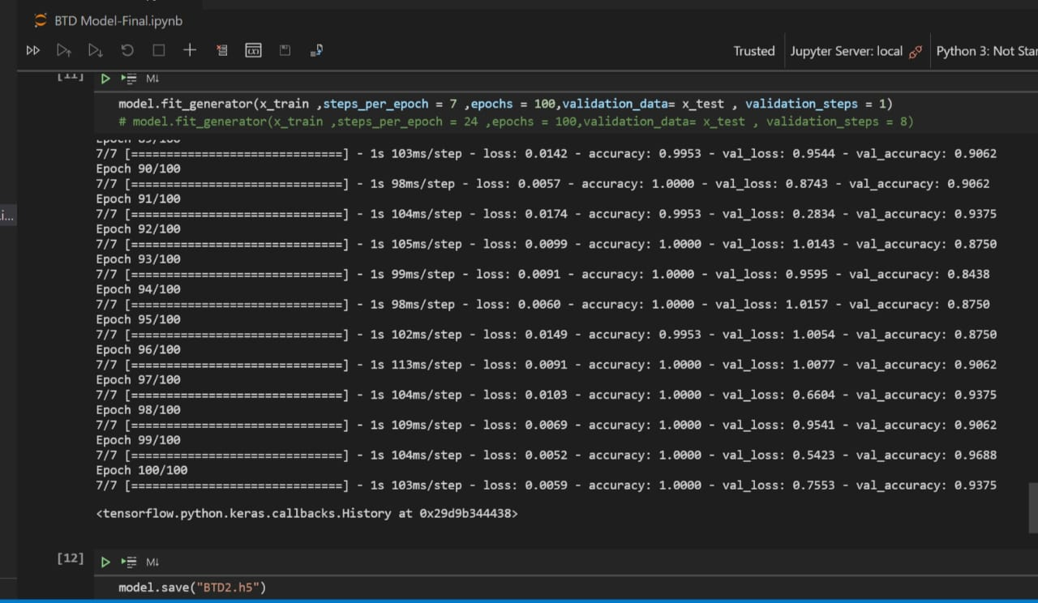

**8. ADVANTAGES & DISADVANTAGES**

**Advantages:**

1. It is considered as the best ml technique for image classification due to high accuracy.

2. Image pre-processing required is much less compared to other algorithms.

3. It is used over feed forward neural networks as it can be trained better in case of complex images to have higher accuracies.

4. It reduces images to a form which is easier to process without losing features which are critical for a good prediction by applying relevant filters and reusability of weights

5. It can automatically learn to perform any task just by going through the training data i.e. there no need for prior knowledge

6. There is no need for specialised hand-crafted image features like that in case of SVM, Random Forest etc.

**Disadvantages**:

1. It requires a large training data.

2. It requires appropriate model.

3. It is time consuming.

4. It is a tedious and exhaustive procedure.

5. While convolutional networks have already existed for a long time, their success was limited due to the size of the considered network.

**9. APPLICATIONS**

1. The main application of this model is to predict the provided image is having brain tumor or not. It is well trained so that it will predict the correct data.

**10. CONCLUSION**

Without pre-trained Keras model, the train accuracy is 100 % and validation accuracy is 93.75.0%. The validation result had a best figure of 91.09% as accuracy. It is observed that without using pre-trained Keras model, although the training accuracy is >90%, the overall accuracy is low unlike where pre-trained model is used.

Also, when we trained our dataset without Transfer learning, the computation time was 40 min whereas when we used Transfer Learning, the computation time was 20min. Hence, training and computation time with pre-trained Keras model was 50% lesser than without. Chances over over-fitting the dataset is higher when training the model from scratch rather than using pre-trained Keras.Keras also provides an easy interface for data augmentation. Amongst the Keras models, it is seen that ResNet 50 has the best overall accuracy as well as F1 score.ResNet is a powerful backbone model that is used very frequently in many computer vision tasks. Precision and Recall both cannot be improved as one comes at the cost of the other .So, we use F1 score too.

Transfer learning can only be applied if low-level features from Task 1(image recognition) can be helpful for Task 2(radiology diagnosis). For a large dataset, Dice loss is preferred over Accuracy. For small size of data, we should use simple models, pool data, clean up data, limit experimentation, use regularisation/model averaging ,confidence intervals and single number evaluation metric. To avoid overfitting, we need to ensure we have plenty of testing and validation of data i.e. dataset is not generalised. This is solved by Data Augmentation. If the training accuracy too high, we can conclude that it the model might be over fitting the dataset. To avoid this, we can monitor testing accuracy, use outliers and noise, train longer, compare variance (=train performance-test performance).

**11.FUTURE SCOPE**

Build an app-based user interface in hospitals which allows doctors to easily determine the impact of tumor and suggest treatment accordingly Since performance and complexity of ConvNets depend on the input data representation we can try to predict the location as well as stage of the tumor from Volume based 3D images. By creating three dimensional (3D) anatomical models from individual patients, training, planning and computer guidance during surgery is improved. Using VolumeNet with LOPO (Leave-One-Patient-Out) scheme has proved to give a high training as well as validation accuracy(>95%).In LOPO test scheme, in each iteration, one patient is used for testing and remaining patients are used for training the ConvNets, this iterates for each patient. Although LOPO test scheme is computationally expensive, using this we can have more training data which is required for ConvNets training. LOPO testing is robust and most applicable to our application, where we get test result for each individual patient. So, if classifier misclassifies a patient then we can further investigate it separately.

Improve testing accuracy and computation time by using classifier boosting techniques like using more number images with more data augmentation, fine-tuning hyper parameters, training for a longer time i.e. using more epochs, adding more appropriate layers etc.. Classifier boosting is done by building a model from the training data then creating a second model that attempts to correct the errors from the first model for faster prognosis. Such techniques can be used to raise the accuracy even higher and reach a level that will allow this tool to be a significant asset to any medical facility dealing with brain tumors. For more complex datasets, we can use U-Net architecture rather than CNN where the max pooling layers are just replaced by upsampling ones. Ultimately we would like to use very large and deep convolutional nets on video sequences where the temporal structure provides very helpful information that is missing or far less obvious in static images.

Unsupervised transfer learning may attract more and more attention in the future.

**12.BIBILOGRAPHY**

[1]. S. Bauer et al., ―A survey of MRI-based medical image analysis for brain tumor studies,‖ Phys. Med. Biol., vol. 58, no. 13, pp.97–129, 2013.

[2]. B. Menze et al., ―The multimodal brain tumor image segmentation benchmark (BRATS),‖ IEEE Trans. Med. Imag., vol. 34, no.10, pp. 1993–2024, Oct. 2015

[3]. B. H. Menze et al., ―A generative model for brain tumor segmentation in multi-modal images,‖ in Medical Image Computing and Comput.- Assisted Intervention-MICCAI 2010. New York: Springer, 2010, pp. 151–159

[4]. S. Bauer, L.-P. Nolte, and M. Reyes, ―Fully automatic segmentation of brain tumor images using support vector machine classification in combination with hierarchical conditional random field regularization,‖ in Medical Image Computing and Comput.-Assisted Intervention-MICCAI 2011. New York: Springer, 2011, pp. 354–361.

[5]. C.-H. Lee et al., ―Segmenting brain tumors using pseudo-conditional random fields,‖ in Medical Image Computing and Comput.-Assisted

[6]. Intervention-MICCAI 2008. New York: Springer, 2008, pp. 359–366

[7]. R. Meier et al., ―A hybrid model for multimodal brain tumor segmentation,‖ in Proc. NCIMICCAI BRATS, 2013, pp. 31–37.

[8]. Vinod Kumar, JainySachdeva, Indra Gupta ―Classification of brain tumors using PCAANN‖ 2011 World Congress on Information and Communication Technologies.

[9]. Sergio Pereira, Adriano Pinto, Victor Alves, and Carlos A. Silva ―Brain Tumor Segmentation Using Convolutional Neural Networks in MRI Images‖IEEE TRANSACTIONS ON MEDICAL IMAGING, VOL. 35, NO. 5, MAY 2016

[10]. RaselAhmmed, Md. Foisal Hossain ―Tumor Detection in Brain MRI Image Using Template based K-means and Fuzzy C-means Clustering Algorithm‖ 2016 International Conference on Computer Communication and Informatics (ICCCI -2016), Jan. 07 –09, 2016, Coimbatore, INDIA

[11]. S.C. Turaga, J.F. Murray, V. Jain, F. Roth, M. Helmstaedter, K. Briggman,W. Denk, and H.S. Seung. Convolutional networks can learn to generate affinity graphs for image segmentation. Neural Computation, 22(2):511–538, 2010

[12] A Reliable Method for Brain Tumor Detection Using Cnn Technique NeethuOuseph C1, Asst. Prof. Mrs.Shruti K2 1(Digital electronics ECE, Malabar Institute of Technology, India) 2(Electronics and Communication Engineering, Malabar Institute of Technology, India)

**Appendix**

**CNN code:**

from tensorflow.keras.models import Sequential

from tensorflow.keras.layers import Dense

from tensorflow.keras.layers import Convolution2D

from tensorflow.keras.layers import MaxPooling2D

from tensorflow.keras.layers import Flatten

from keras.preprocessing.image import ImageDataGenerator

train_datagen = ImageDataGenerator(rescale = 1./255,shear_range = 0.2,zoom_range = 0.2,horizontal_flip = True)

test_datagen = ImageDataGenerator(rescale = 1./255)

x_train = train_datagen.flow_from_directory(r"C:\Users\Sathwika\OneDrive\Desktop\siddhu\BTD\train",target_size = (64,64),batch_size = 32, class_mode ="categorical")

x_test = test_datagen.flow_from_directory(r"C:\Users\Sathwika\OneDrive\Desktop\siddhu\BTD\test",target_size = (64,64),batch_size = 32, class_mode ="categorical")

model = Sequential()

model.add(Convolution2D(32,(3,3), input_shape=(64,64,3)))

model.add(MaxPooling2D(2,2))

model.add(Flatten())

model.add(Dense(units = 256,activation = "relu",kernel_initializer = "random_uniform"))

model.add(Dense(units = 256,activation = "relu",kernel_initializer = "random_uniform"))

model.add(Dense(units = 2,activation = "softmax",kernel_initializer = "random_uniform"))

model.compile("sgd",loss = "categorical_crossentropy",metrics = ["accuracy"])

model.fit_generator(x_train ,steps_per_epoch = 7 ,epochs = 100,validation_data= x_test , validation_steps = 1)

model.save("BTD5.h5")

**prediction code**

from tensorflow.keras.models import load_model

from tensorflow.keras.preprocessing import image

import cv2

import numpy as np

index = ["no","yes"]

model = load_model(r"C:\Users\Sathwika\AppData\Roaming\Microsoft\Windows\Start Menu\Programs\Anaconda3 (64-bit)\smartbridge\BTD5.h5")

img = image.load_img(r"C:\Users\Sathwika\OneDrive\Desktop\siddhu\1 no.JPEG",target_size = (64,64))

type(img)

x = image.img_to_array(img)

x = np.expand_dims(x,axis=0)

pred = model.predict_classes(x)

pred

print(index[pred[0]])