A Project Report on

### Snapchat Ads Dashboard Visualizations Using IBM Cognos Analytics

Submitted to Smart Bridge

By:

T. Shailendra Sainath 19R11A0539

T. Saketh Sai 19R11A0540

V. Jeeshitha 19R11A0542

V. Pooja 19R11A0543

V. Vinitha 19R11A0544



**GEETHANJALI OF ENGINEERING AND TECHNOLOGY**

1.Introduction:

**Overview:**

In recent years there has been a growing public concern to the amount of personal data that social media sites collect. This data can benefit us as a consumer through targeted advertisement of products. However, it is important that the public are aware of biased ads that may target them.

**Purpose:**

To create a dashboard which shows the following :

1.Money spent on a particular Ad.

2.Number of time’s a particular Ad is displayed on the user screen while using snapchat.

3.Targeting the audience which is based on age, interests, segments, language, country or gender.

2.Literature Survey:

**Existing problem:**

We don't know a person's likes and dislikes to show the ad's according to it so that he can buy the stuff he likes.

Proposed Solution:

We can use dashboard by IBM congo analytics to visualize the data and give advertizements according to it and also increases the company sales.

3.Theoritical Analysis:

Block diagram:

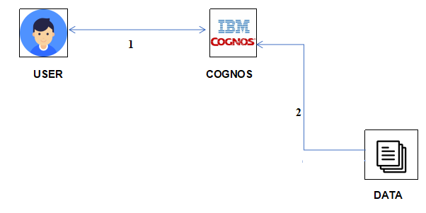

Hardware and software requirements :

Hardware : A Laptop, good network connection.

Software : IBM Congo Analytics

4.Experimental Ivestigations :

**SNAPCHAT**

**Snapchat is a mobile messaging application used to share photos, videos, text, and drawings.** It’s free to download the app and free to send messages using it. It has become hugely popular in a very short space of time, especially with young people. The feture because of which snapchat stands out with respect to other apps is that the messages in snapchat is self destructive.

**Snapchat Ads**

**There are huge number of advertisements which are published on snapchat by bih companies in order to increase their name is the market.**

**Why Snapchat for advertising?**

Snapchat Ads are full-screen, immersive and engaging ads that inspire action and drive results. Snapchat Ads make the brand or business a part of Snapchatters' everyday conversations.

**Snapchat has shown a good rate of growth in the past years and very popular amongst the teens.**

**So, to target a large audience snapchat snapchat would serve good.**

**IBM COGNOS ANALYTICS**

IBM Cognos Analytics is a set of **[business intelligence](https://www.deeperthanblue.co.uk/solutions/analytics/business-intelligence/)** tools available on cloud or on-premise. The primary focus is in the area of **Descriptive Analytics**, to help users see the information in your data through dashboards, professional reporting and self-service data exploration.

**Why IBM COGNOS ANALYTICS**

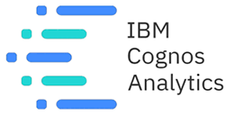

1. Self Service Analytics 

### 2. Intuitive Web-Based Interface

3. Dashboarding

4. Mobile

5. Easy to Implement

4.Procedure :

1. Download the Dataset first.

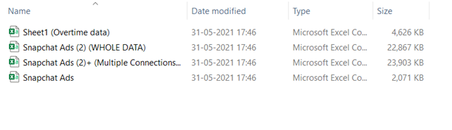

2.Select the data files after uploading them for the further process.  
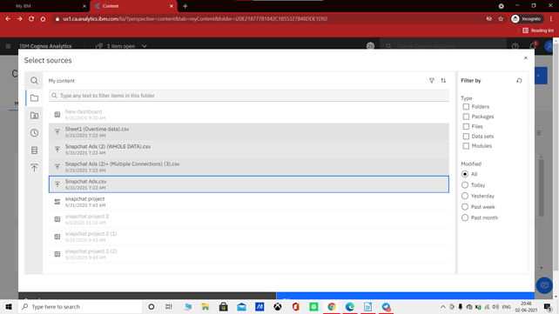

3.To create a relationship, right click on the Snapchat Ads.csv file to bring up the context menu. Select Relationship.

Complete the relationship with the files.

The end result should result in the following:

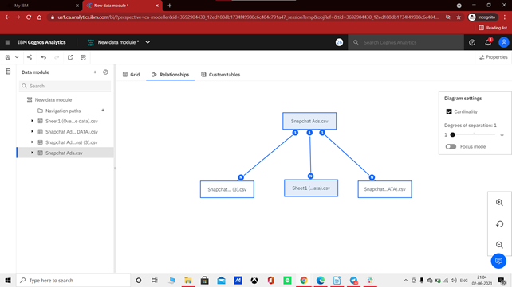

5.Flowchart :

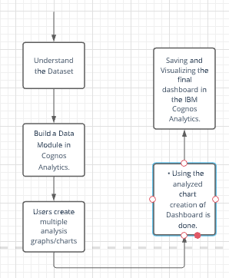

6.Problem statements and Result :

1.Number ads in case of snapchat ads data set .

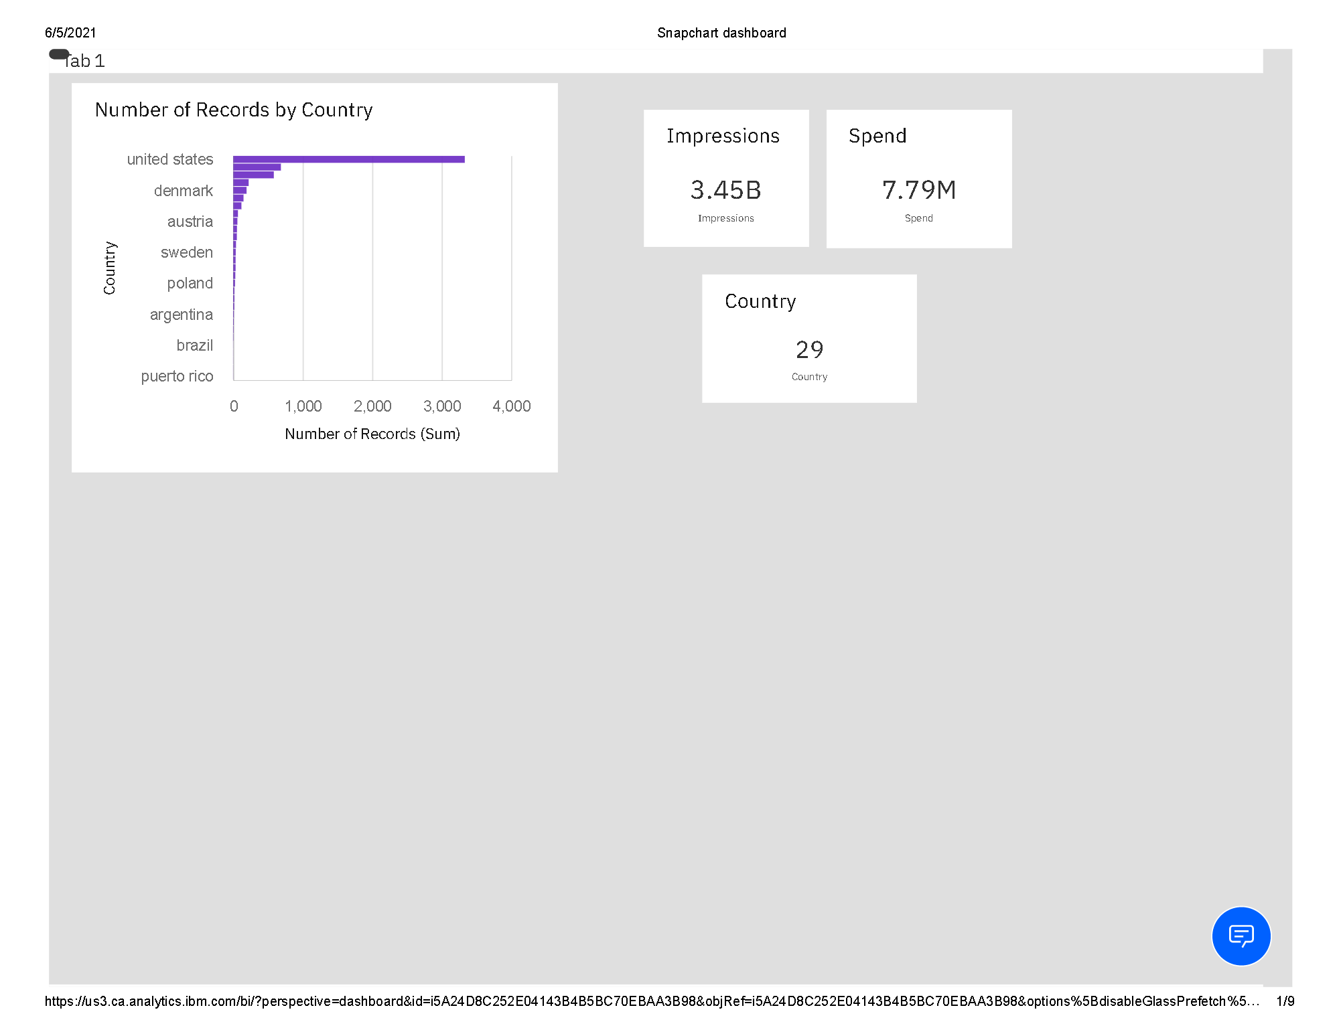  
2.Visualizing the textual data of countries send and impression.

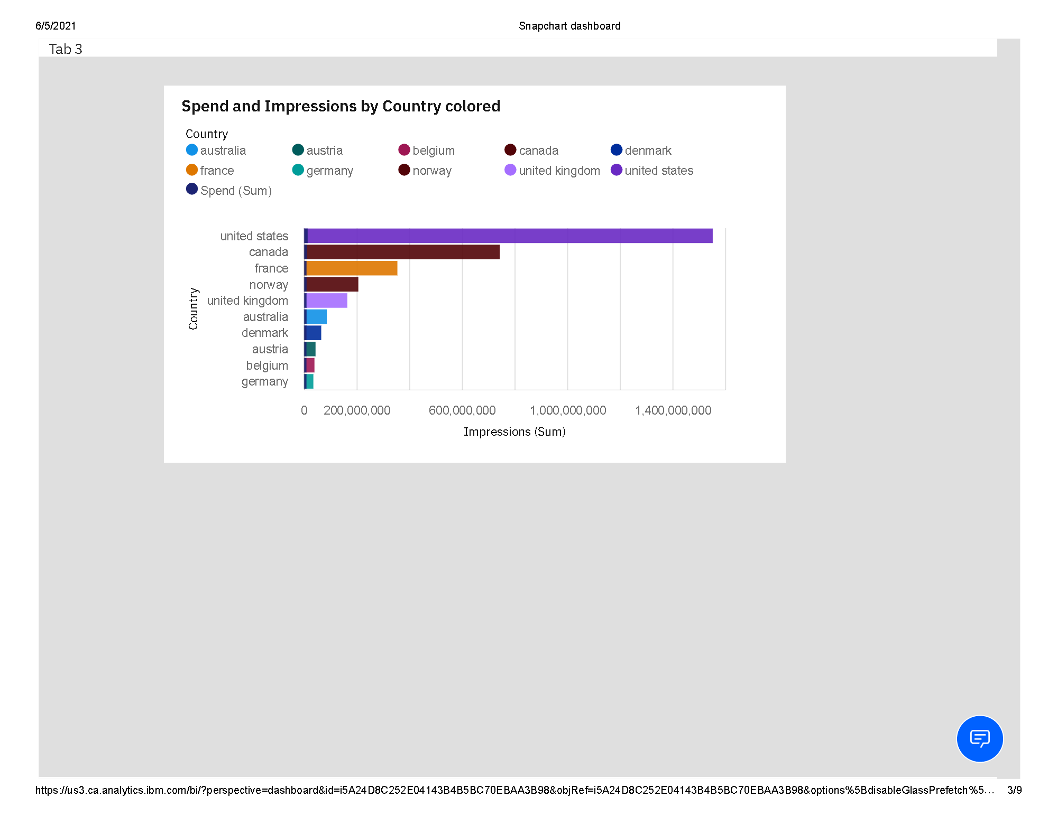  
3.How ads are targeting using age and number of records and amount spend on them.

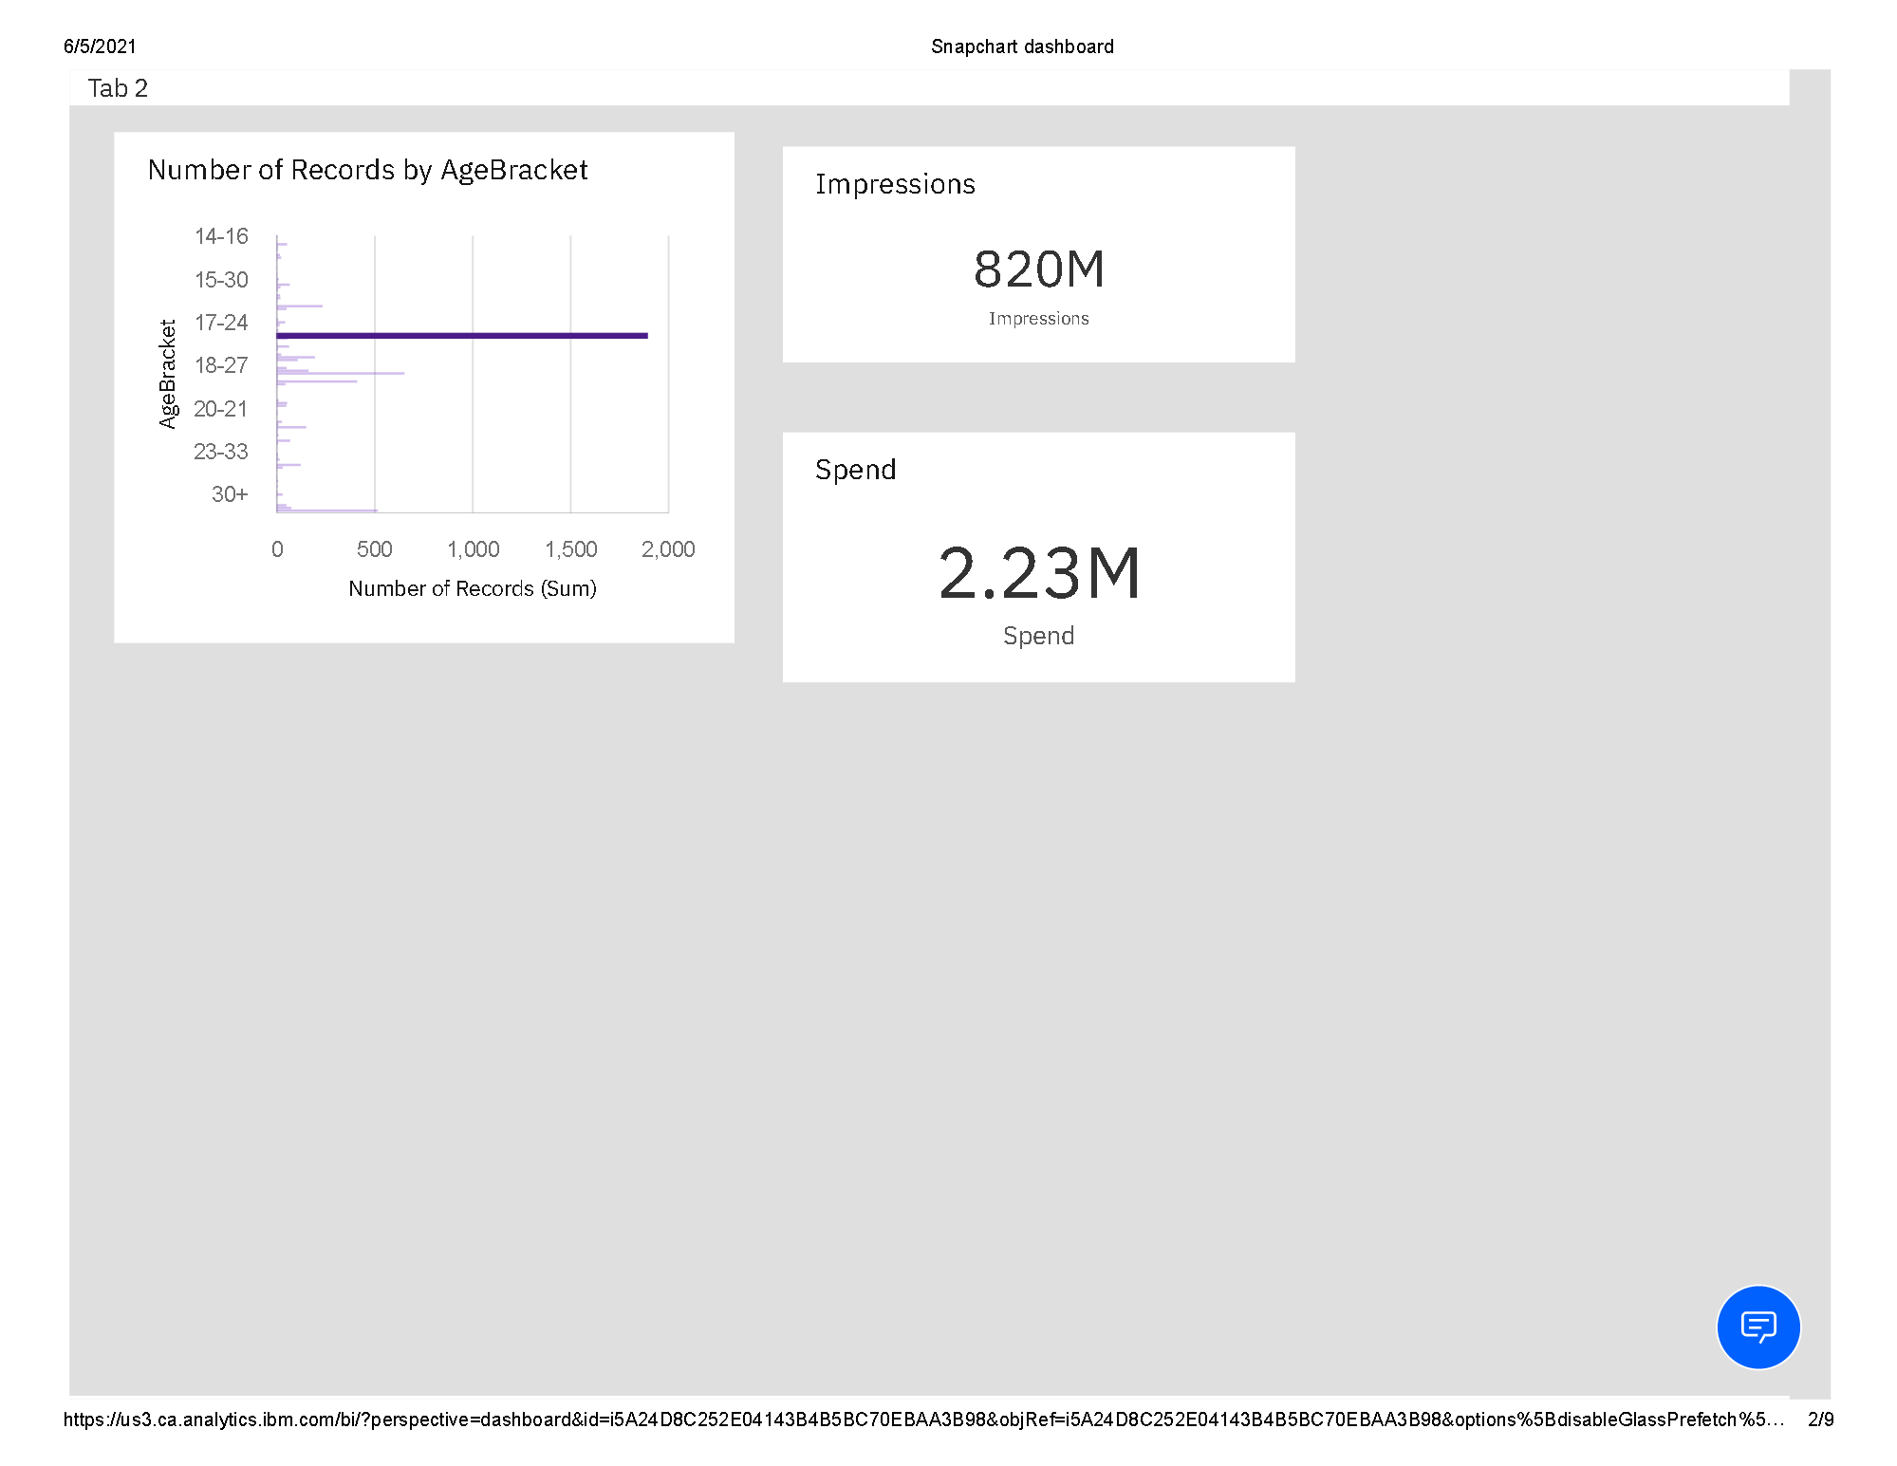  
4.Amount spent ,impressions made country wise.

  
5.Age group and their interests.

  
6.Ads language used in a country.

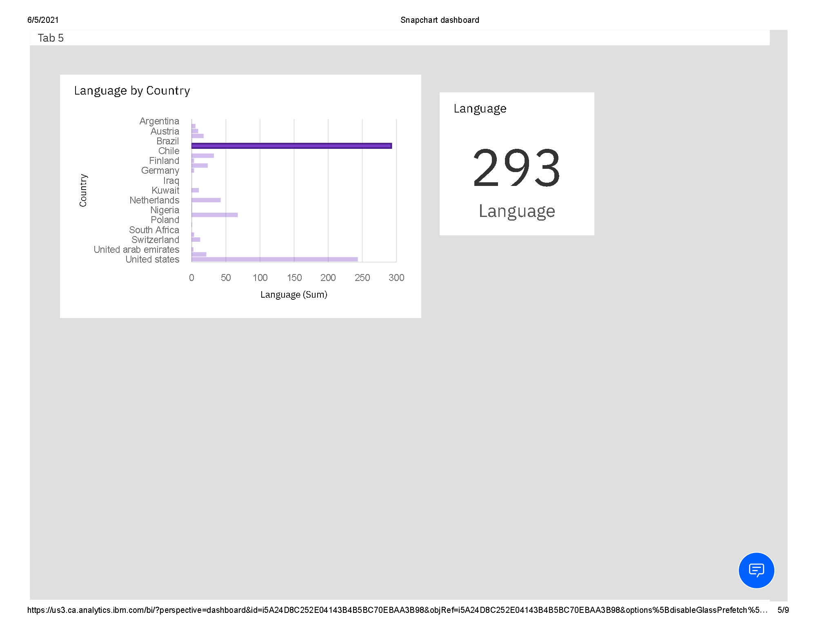  
7.Appearance (Impressions) of an ad by start date.

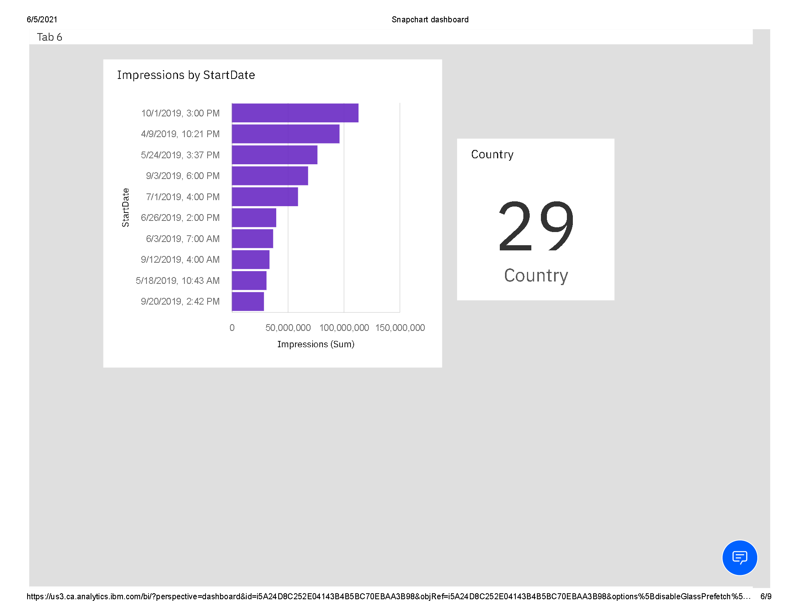  
8.Countries and organisations that produce ads In a particular country .

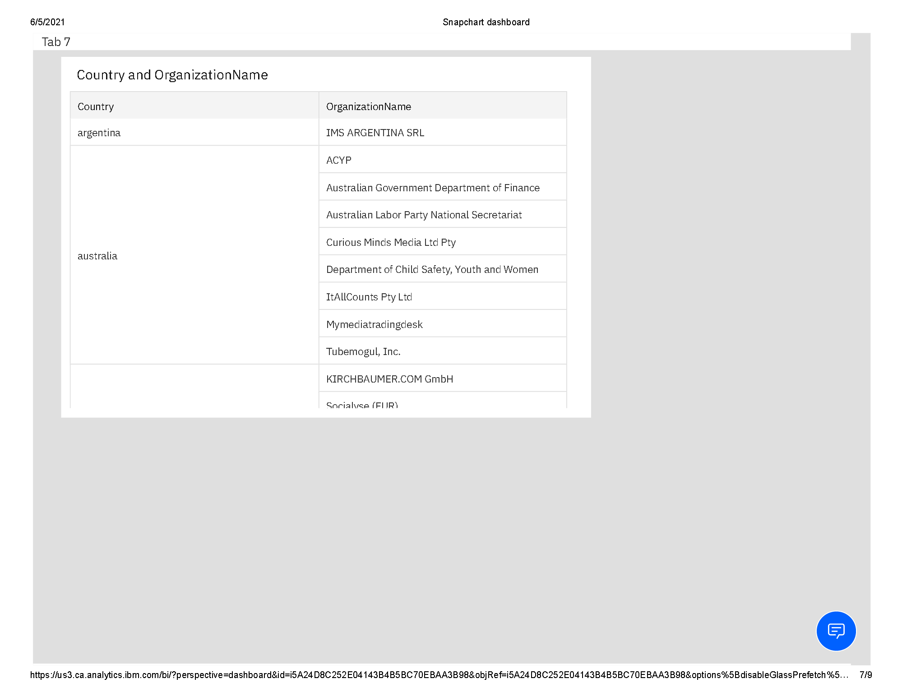  
Organisations and there ads.

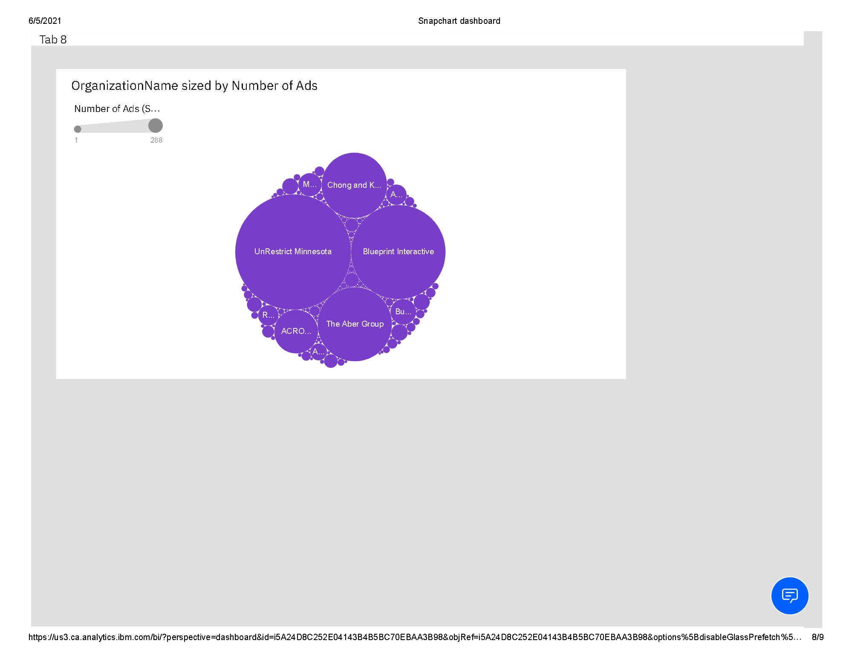  
9.Organisations and the amount spent on ads.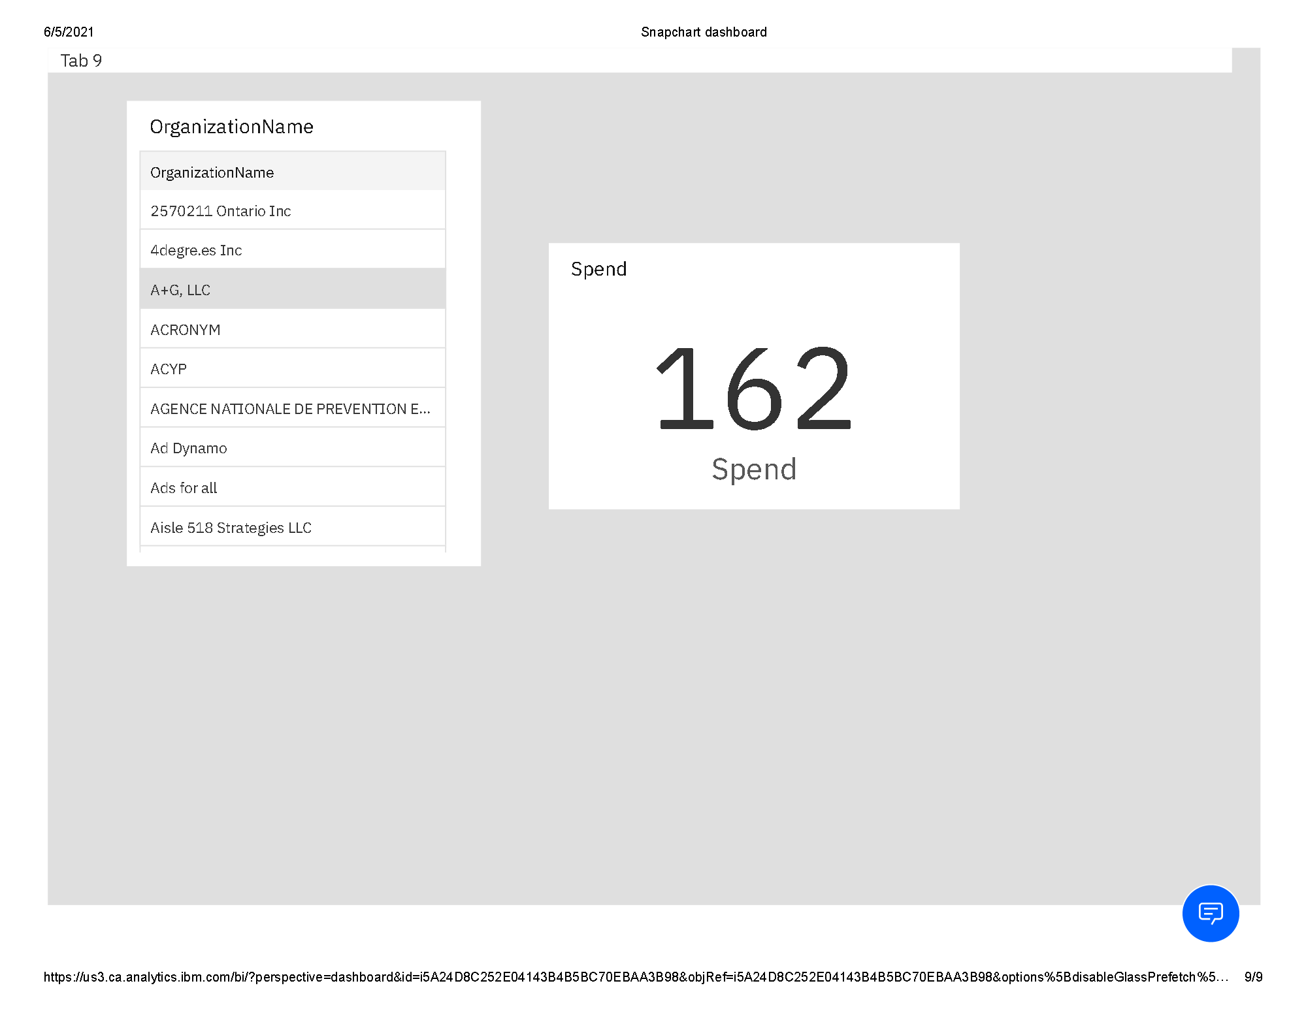

In the following dashboard we plot a bar chart for showing number of ads and texual data of country, impression and spend.

When a specific country is choosen we get to see all the insights about the advertisements published and the texual data.

The visualisations of the above problem statements is depicted below in the following dashboard.

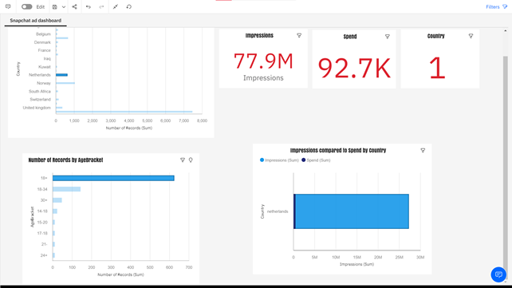

7.Advantages :

### Dashboards are fueled by Business Questions

### Dashboards can focus on presenting operational and analytical data

### Dashboards present interactive data visualizations

### Easy to Read

### Cloud Accessibility

Dashboards make reporting more efficient

Disadvantages:

1. If work is not saved constantly we cannot recover it if system is shutdown for some reasons.

2. Sharing the dashboard is a bit problem cause only photos of dashboard can be shared not the dashboard

8.Applications Of IBM COGNOS ANALYTICS:

1. view or create business reports
2. analyze data
3. monitor events and metrics
4. integrates the following business intelligence activities in one Web-based solution.

9.Conclusion :

Hence all the visualizations of the respective problem statements are been achived according to the problem statement.

We can create many number of visualizations using this IBM Congo Analytics.

10.Future scope:

Data Visualization influences the methodology of analysts working with data. Having more insights and responding to problems more easily are two of the main benefits of Data Visualization.

Data Visualization in the pack of infographics and some other visual tools helps companies to operate efficiently and also accelerates the analytical process. That's because when visually presenting the data, it is simpler to display the data than to view it on spreadsheets.

The future of Big Data visualization dramatically increases efficiency and improves efficiency by delivering infographics that can be turned into valuable insights.

Nothing is best than becoming able to communicate insights in real-time using immersive visuals. Increased reality or virtual reality systems are both practical and powerful.

According to analysts, augmented virtual reality's market value is projected to be approximately $209 billion globally by 2022. The virtual reality applications industry's scale is projected to be worth $6.4 billion globally by 2021.

11.Bibliography:

Source :

"Storytelling With Data: A Data Visualization Guide for Business Professionals” by Cole Nussbaumer Knaflic

wikipedia, google.

Snapchat app.

Project details in Snapchat Ads Dashboard Visualizations Using IBM Cognos Analytics in smartinternz.com

https://smartinternz.com/Student/guided_project_workspace/2487