Project Report on



(Department of CSE)

Under the guidance of

Mrs. Pradeepthi

LEAD – Artificial Intelligence at SmartBridge Educational Services Pvt Ltd.

By:

M Mahesh (19R11A0526)

M Ravinder (19R11A0523)

“Intelligent handwritten digit identification system for computer applications using IBM watson studio”

**Intelligent handwritten digit identification system for computer applications using IBM watson studio**

INTRODUCTION

Handwriting recognition is one of the compelling research works going on because every individual in this world has their own style of writing. It is the capability of the computer to identify and understand handwritten digits or characters automatically. Because of the progress in the field of science and technology, everything is being digitalized to reduce human effort. Hence, there comes a need for handwritten digit recognition in many real-time applications. MNIST data set is widely used for this recognition process and it has 70000 handwritten digits. We use Artificial neural networks to train these images and build a deep learning model. Web application is created where the user can upload an image of a handwritten digit. this image is analyzed by the model and the detected result is returned on to UI.

LITERATURE SURVEY

An experiment is conducted to find the best suitable machine learning method from the existing methods. An experiment is conducted using SVM, ANN, and CNN. By considering the results obtained from the experiment, a comparison is made on the metrics considered which results in CNN as the best method suitable for Documents Images.

Results: Compare the results for SVM, ANN with HOG Feature extraction and the CNN method by using segmented results. Based on the Experiment results it is found that SVM and ANN have some drawbacks like low accuracy and low performance in the recognition of documented images. So, the other method i.e., CNN has greater performance with high accuracy.

The following are the results of the recognition rates of each method.

● SVM performance - 39%

● ANN performance - 37%

● CNN performance - 71%.

Conclusion: This research concentrates on providing an efficient method for recognition of Handwritten digits recognition. Here a sample training data is treated with existing machine learning and deep learning methods like SVM, ANN, and CNN. By the results obtained from the experimentation, it clearly is shown that the CNN method is much efficient with 71% performance when compared to ANN and SVM methods.

THEORITICAL ANALYSIS

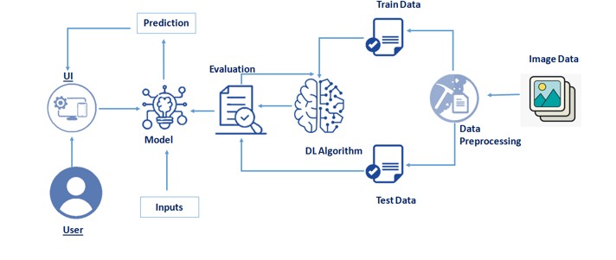

Hardware requirements of the project:

* 4 GB of RAM and above
* 100 GB of Harddisk space

Software requirements of the project:

* Anaconnda Navigator
* Pyhton 3
* Spyder
* Any Code Editor

EXPERIMENTAL INVESTIGATIONS

Convolutional Neural Network is a family of multi-layer neural networks it is particularly designed for use on two-dimensional data, such as images and video. Basically, it is influenced by earlier work in time-delay neural networks, which reduce learning computation requirements by sharing weights in a temporal dimension and are intended for speech and time-series processing. It has many hierarchy layers to train in a robust manner. This architecture that leverages spatial and temporal relationships to reduce the number of parameters which must be learned and thus improves upon general feed-forward backpropagation training. It is proposed as a deep learning framework that is motivated by minimal data preprocessing requirements. In CNN, small portions of the image are treated as inputs to the lowest layer of the hierarchical structure. The fully connected layers form a network in this first layer is named as “input layer” and the last layer are named as “output layer” and between these two layers and remaining all are known as “hidden layers”. In the hidden layer, the inputs were passed and the output layer calculates the class probabilities for the classification. A regular neural network performs high computation if the size of data is increased or if the number of layers are increased. in these many parameters were calculated without overfitting results for accuracy. On the other hand, CNN not fully connected in all levels of layers. The neurons in these layer connected to a small region. This encourages the local spatial relationship in the data and the hierarchy features to increase the abstraction from low-level to high-level when multiple were layers are stacked. In these first layers can see only a small portion of the input data and the last layers can see the whole of the input data and draw conclusions from it. In CNN there are three types of layers were used in a convolutional network:

1) Convolutional layer

2) Pooling layer

3) Fully-connected layer

Convolutional layer: In this layer few parameters like a number of filters, size of filters, stride, etc. Small window filter slid along with the dimensions of input data and performs dot products between the values stored in the filter and the input data points.

Pooling layer: This layer reduces the dimensionality of the input data which reduces the computations, number of parameters and therefore reduces overfitting. Typically, the pooling layer is inserted between convolutional layers. It discards the activations of previous layers and hence forcing the next convolutional layers to learn from a limited variety of data.

Fully-connected layer: In this layer neurons that are connected to all neurons of the previous layer as explained it.

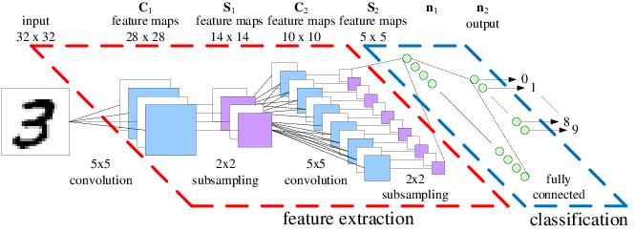

FLOWCHART

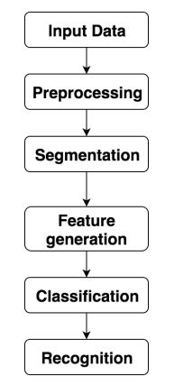

RESULT

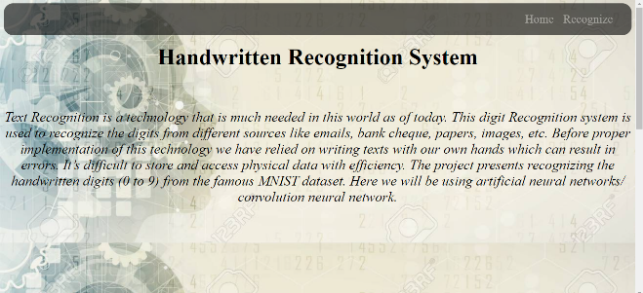

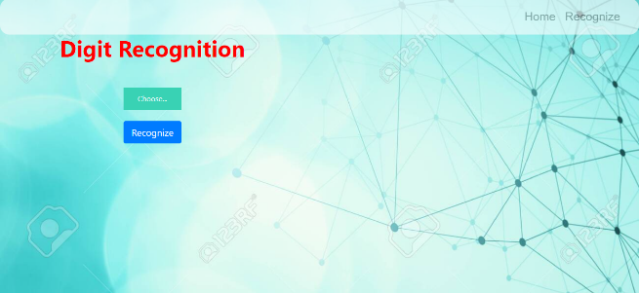

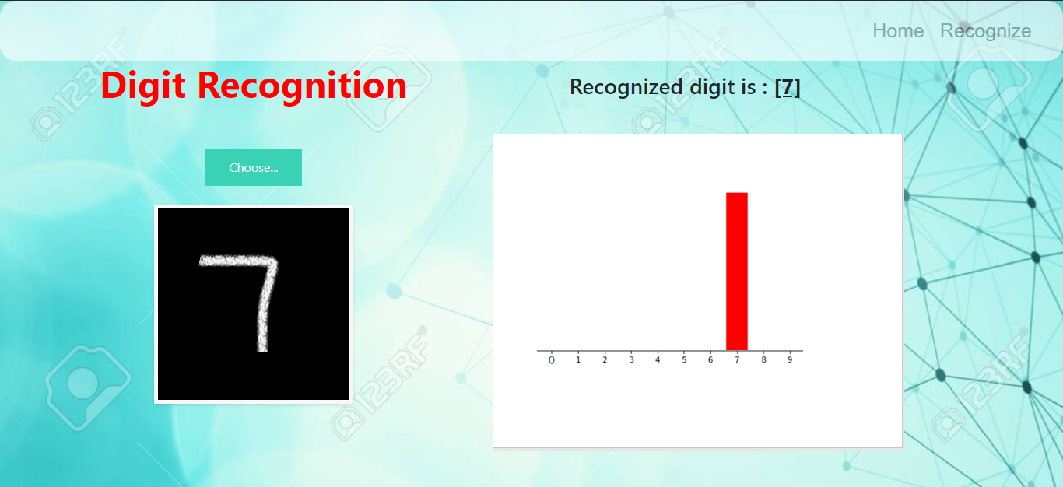

ADVANTAGES

Handwriting Recognition has many advantages that made it grow rapidly in the technology word now. There is much different kind of technologies that abide to enable others to take advantage of the handwriting recognition. The way this work was when people write letters a different way and they let the computer know what the intended letter was and change in to a text document. But the problem with this was the different way that the letters are written and this could make unnatural feel to the person who is writing it. Another way of appreciating this technology is that just write and the computer changes it to a text document but at the same time, the computer doesn’t always get the right word and sometimes it insert the wrong letters.

Certain cell phones have the handwriting recognition system in it. The advantage of this is that it allows people to write on the cell phones using stylus and then the phone software translates the written words to the phone in text. But at the same time, the problem or called as disadvantage of this again is the same problem that the original software face, which is the unnatural letters strokes and sometimes the software predict the letters wrongly. This is one of the reasons that not all phones have this software in it.

Disadvantages

Deep learning has been widely used to recognise handwriting. Digit is analysed after being written. The only information that can be analysed is the binary output of a character against a background. Although shifts towards digital stylus for writing gives more information, such as pen stroke, pressure and speed of writing, there is still a necessity for offline methods, when online is inaccessible. It is particularly necessary for historical documents, archives, or mass digitisation of hand-filled forms.

The main disadvantage was image preprocessing. This can consume a lot of time if input data is not accurate. Sometimes it doesn’t predict right due to blurred or depixelated image input.

APPLICATIONS

This system is widely used in many industries. Any task where identification of certain parameters id required, we can use this technology. Human brain can perform a task until certain limit unlike computers. This technology is used in Automation industry, where cars can recognise the obstacle. Traffic police use this technology to track a vehicle. Banks use this to validate the cheques. This technology is a part of Image-Processing. There are many applications of this technology in various industries.

CONCLUSION

We can predict the hand-written digit through this application. Our project is limited to predict only one digit at a time. We can create more applications which can predict a set of digits, set of characters, set of digits and numbers combined, and so on. This technology is widely used in Automation Industry and Cyber Security cell. We can get a wide range of knowledge about Neural Networks and data processing. This project can help one-self how to deal with various aspects of Machine Learning and Deep learning.

FUTURE SCOPE

A new method can be proposed to cut or segmenting the digit strings still there are some limitation for this method, where improvements has to be made. Thus, there is a place for some future work such as:

● Different classifications models can be used at a time to improve the performance of the segmentation.

● To reduce the complexity of the algorithm, it’s better to reduce the number of hypothesis to function the algorithm faster.

● To reduce the computation time, better filters are to be used to eliminate the unnecessary segmentation hypothesis.

BIBILOGRAPHY

References from various websites and articles.

<https://ieeexplore.ieee.org/document/41400>

<https://mxnet.apache.org/versions/1.1.0/tutorials/python/mnist.html>

<http://sersc.org/journals/index.php/IJAST/article/view/25505>