**Assignment 6**

Develop a python code to detect any object using Haar cascade classifier.

Python code:

# Importing all required packages

import cv2

import numpy as np

import matplotlib.pyplot as plt % matplotlib inline

# Read in the cascade classifiers for face and eyes

face_cascade = cv2.CascadeClassifier('../DATA / haarcascades / haarcascade_frontalface_default.xml')

eye_cascade = cv2.CascadeClassifier('../DATA / haarcascades / haarcascade_eye.xml')

# create a function to detect face

def adjusted_detect_face(img):

face_img = img.copy()

face_rect = face_cascade.detectMultiScale(face_img,

scaleFactor = 1.2,

minNeighbors = 5)

for (x, y, w, h) in face_rect:

cv2.rectangle(face_img, (x, y),

(x + w, y + h), (255, 255, 255), 10)\

return face_img

# create a function to detect eyes

def detect_eyes(img):

eye_img = img.copy()

eye_rect = eye_cascade.detectMultiScale(eye_img,

scaleFactor = 1.2,

minNeighbors = 5)

for (x, y, w, h) in eye_rect:

cv2.rectangle(eye_img, (x, y),

(x + w, y + h), (255, 255, 255), 10)

return eye_img

# Reading in the image and creating copies

img = cv2.imread('../sachin.jpg')

img_copy1 = img.copy()

img_copy2 = img.copy()

img_copy3 = img.copy()

# Detecting the face

face = adjusted_detect_face(img_copy)

plt.imshow(face)

# Saving the image

cv2.imwrite('face.jpg', face)

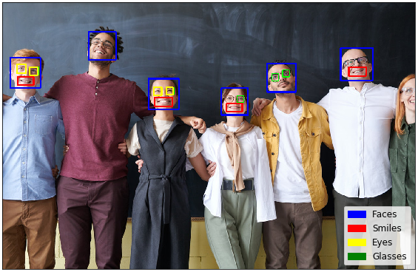s

Detected pic