Smart Kitchen using IOT

Introduction :

Over view:

This Smart Kitchen using IOT is constructed of diffrent sensors used to get the accurate out put. Gas lekage sensors are used when the lekage of gas is happned this will indicated by the text message come to our mobile phone which is registred.Light ON and Light OFF indications are also used for this platform.Temperature sensors are used to detect the current room temperature.Humidity sensors are used to detcet the current humidity of the room.

purpose:

**Smart kitchen** provides you all the automation features that include safety features over gas leakage detection system. ... Gas sensors are used to detect the leakage of a gas in the system. Temperature sensors are used to detect the current room temperature.

Literature

Literature Survey:

Excisting Problem:

Intelligent System for Domestic Gas Appliances using IOT. In our day-to-day life there is serious threat about leakage which leads to suffocation when inhaled, when ignited leads to explosion and causes a number of deaths.

Proposed Solution:

This project is about designing a LPG leakage monitoring system which is proposed for home safety. This system detects the leakage of the LPG and alerts the consumer about the leak by SMS and as an emergency measure the system will turnoff the power supply, while activating the alarm.

By this we can fix the problem in fraction of mintues after detecting the problem with out charge of single life.

Theoretical Analysis:

Block Diagram:

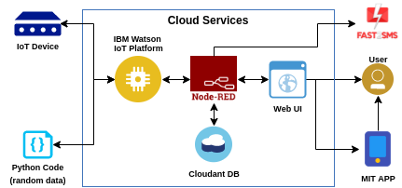

Analysis

About block diagram, As we know that the message will recive to the mobile by Fast2sms web by using the web UI that I have given tpo the NOde Red flow chart by indicating the Temperature and Humidity and about clekage of gas.

Software Designing:

Create the IBM IOT Account to negotiate with the App,then create the IBM watson platform to know the temperature and humidity.Now to know the temperature and humidity open the watson sensor simulator and after creating the divice in the IOT platform service credentials will bbe given copy that credentials in the notepad, then copy your credentials in the Watson sensor simulator to connect the IOT platform to the sensor.

Then create the Node red that is creating the App URL to connecting the flow chart in Node Red Flow,firstly downl;oad the IBM IOT NODE RED in the palate right side to the flow,after that connect the IBM IOT to the sensor from the flow. Then we should give the Temperature and humidity to the IBM IOT flow,connect the msg payload to the IBM IOT flow then Deploy by that we can know that IBM IOT is connected to the sensor.Now create the HTTPS so that we can give the data through the flow to the sensor by that URL web we can see the temperature and humidity by that UI is created.

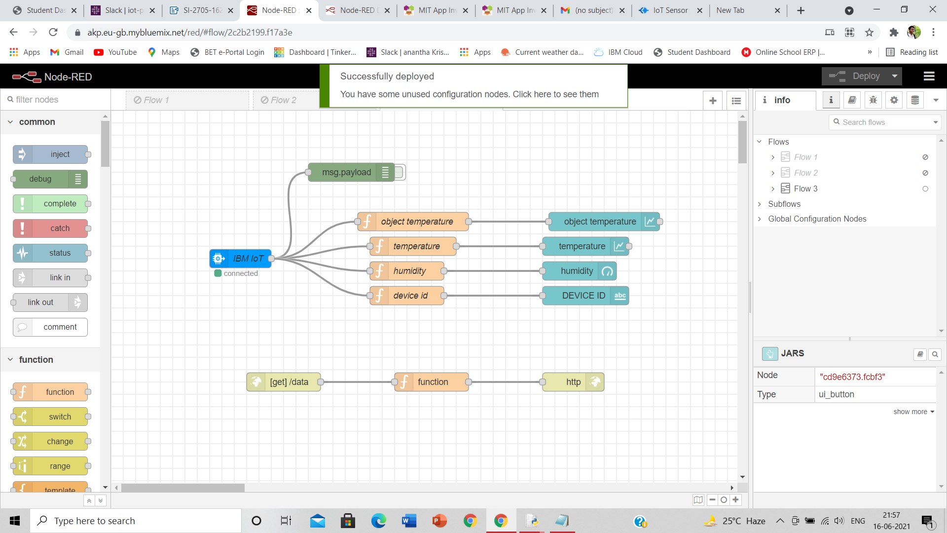

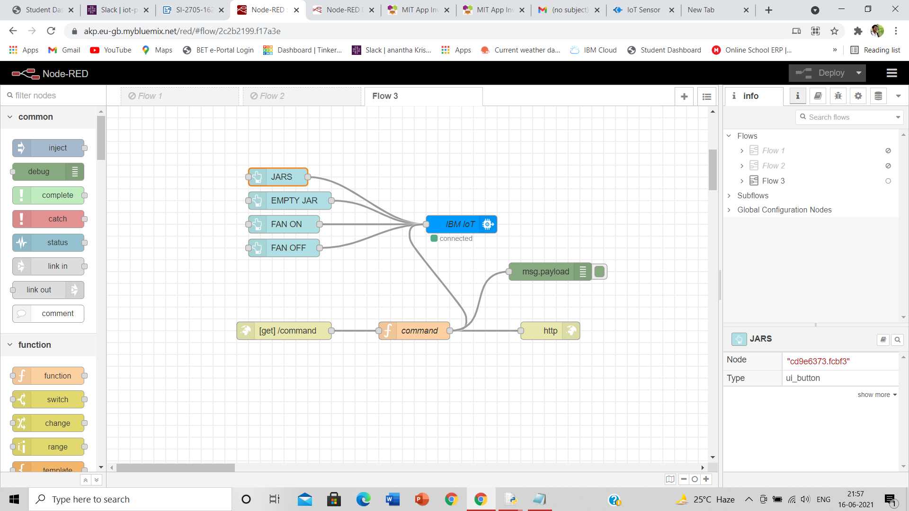

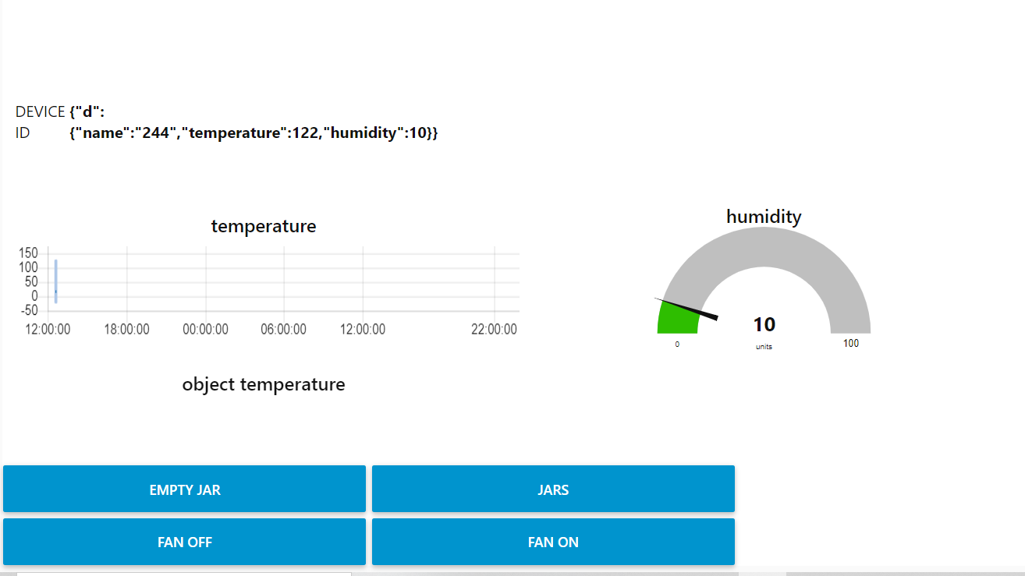

By the creating of UI after that we should Run the code of temperature and humidity and regarding Gas lekage and lights ON and OFF.

After that in the MIT App inventor we can create the buttons and by the web URL we can create the home automation things which will use for the kitchen to negotiate the gas lekage.

Proposed

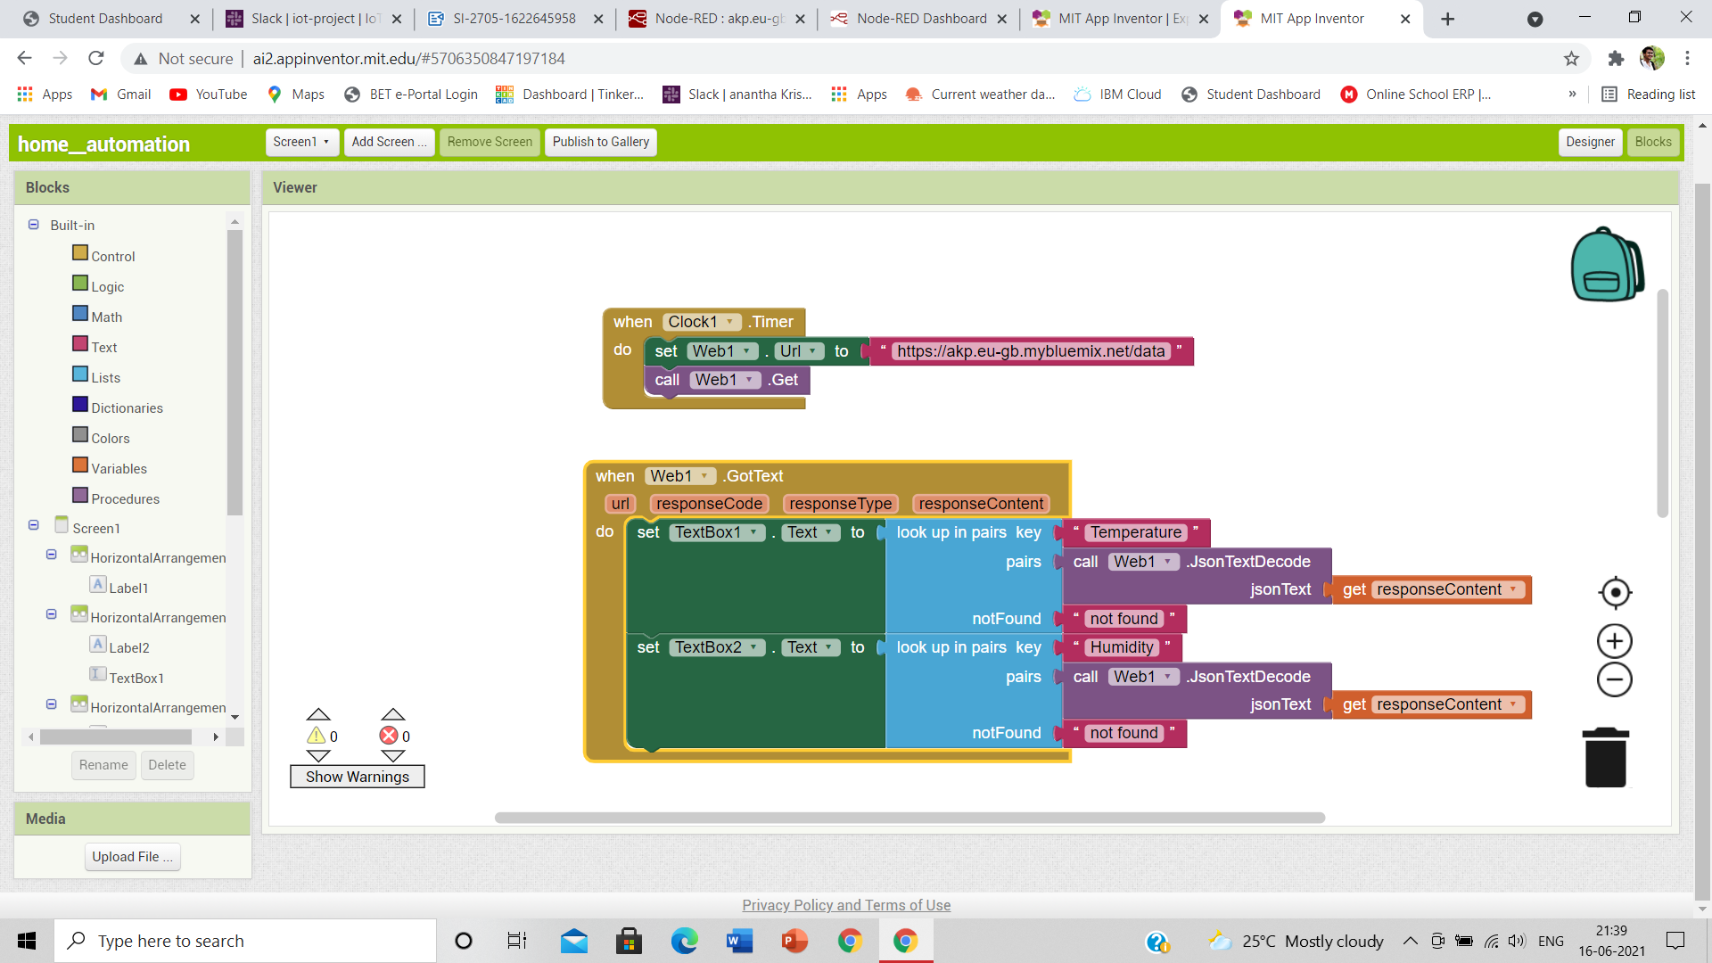

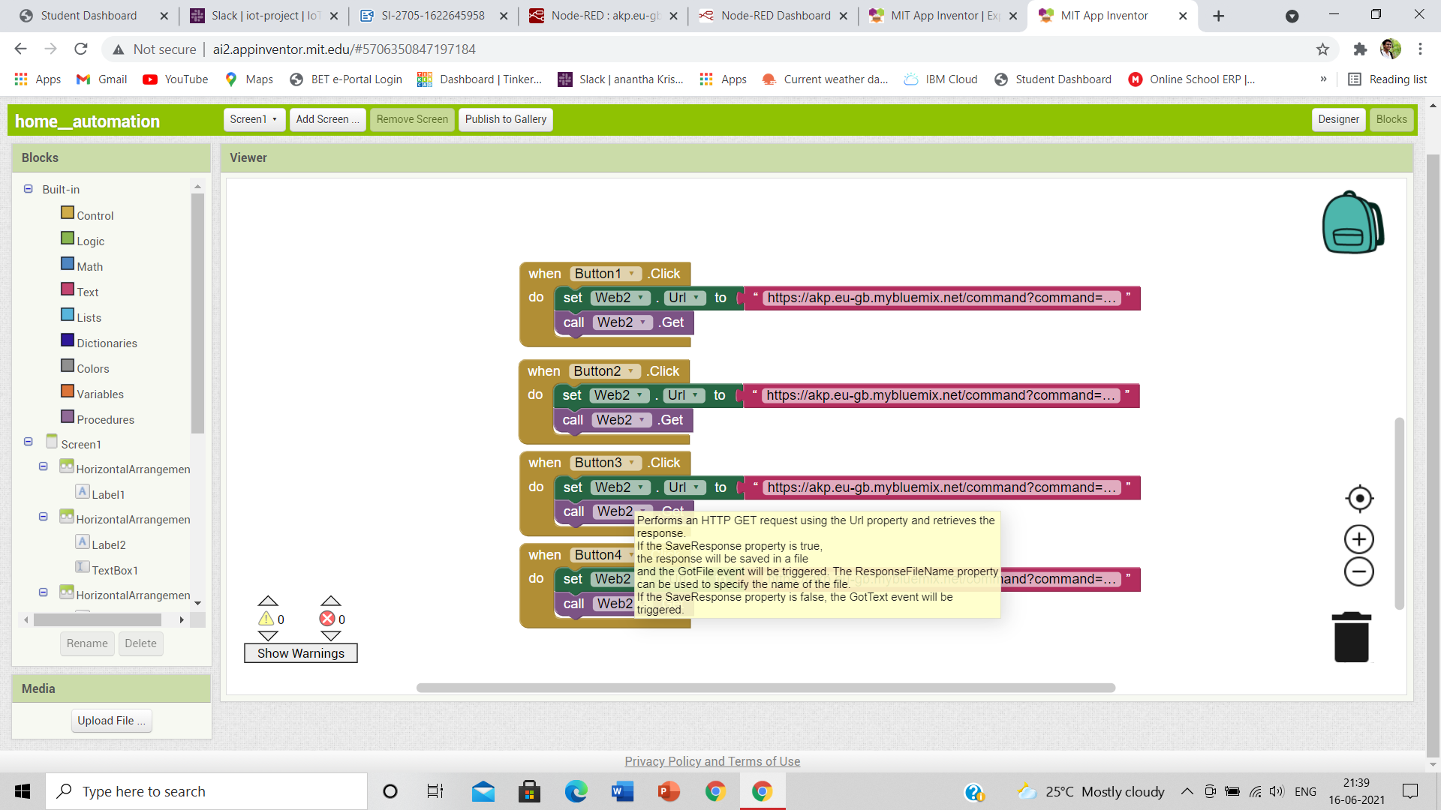solution

This the MIT app inventor which we can use in our mobile by installing the app in play store or google store. After installing the app in mobile scan the QR code or type the given given code in the place were they give. By that our created app will visiable in the mobile and can oparate from the mobile by that out put will show in the proggram that we will Run.

the code is given below

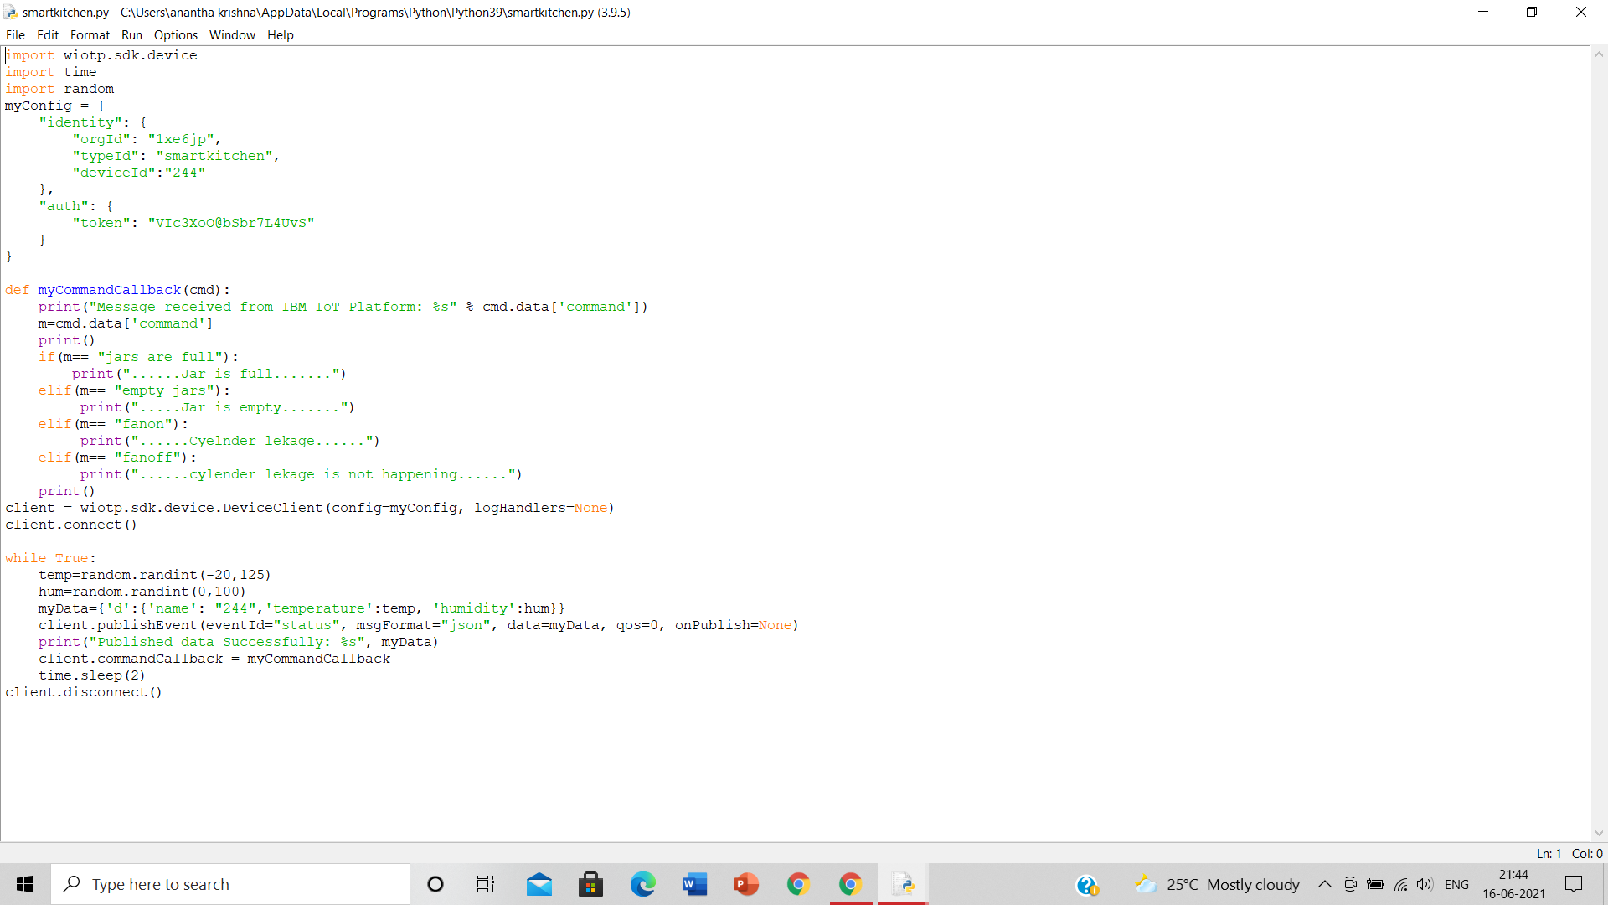

Out put of the above python program is

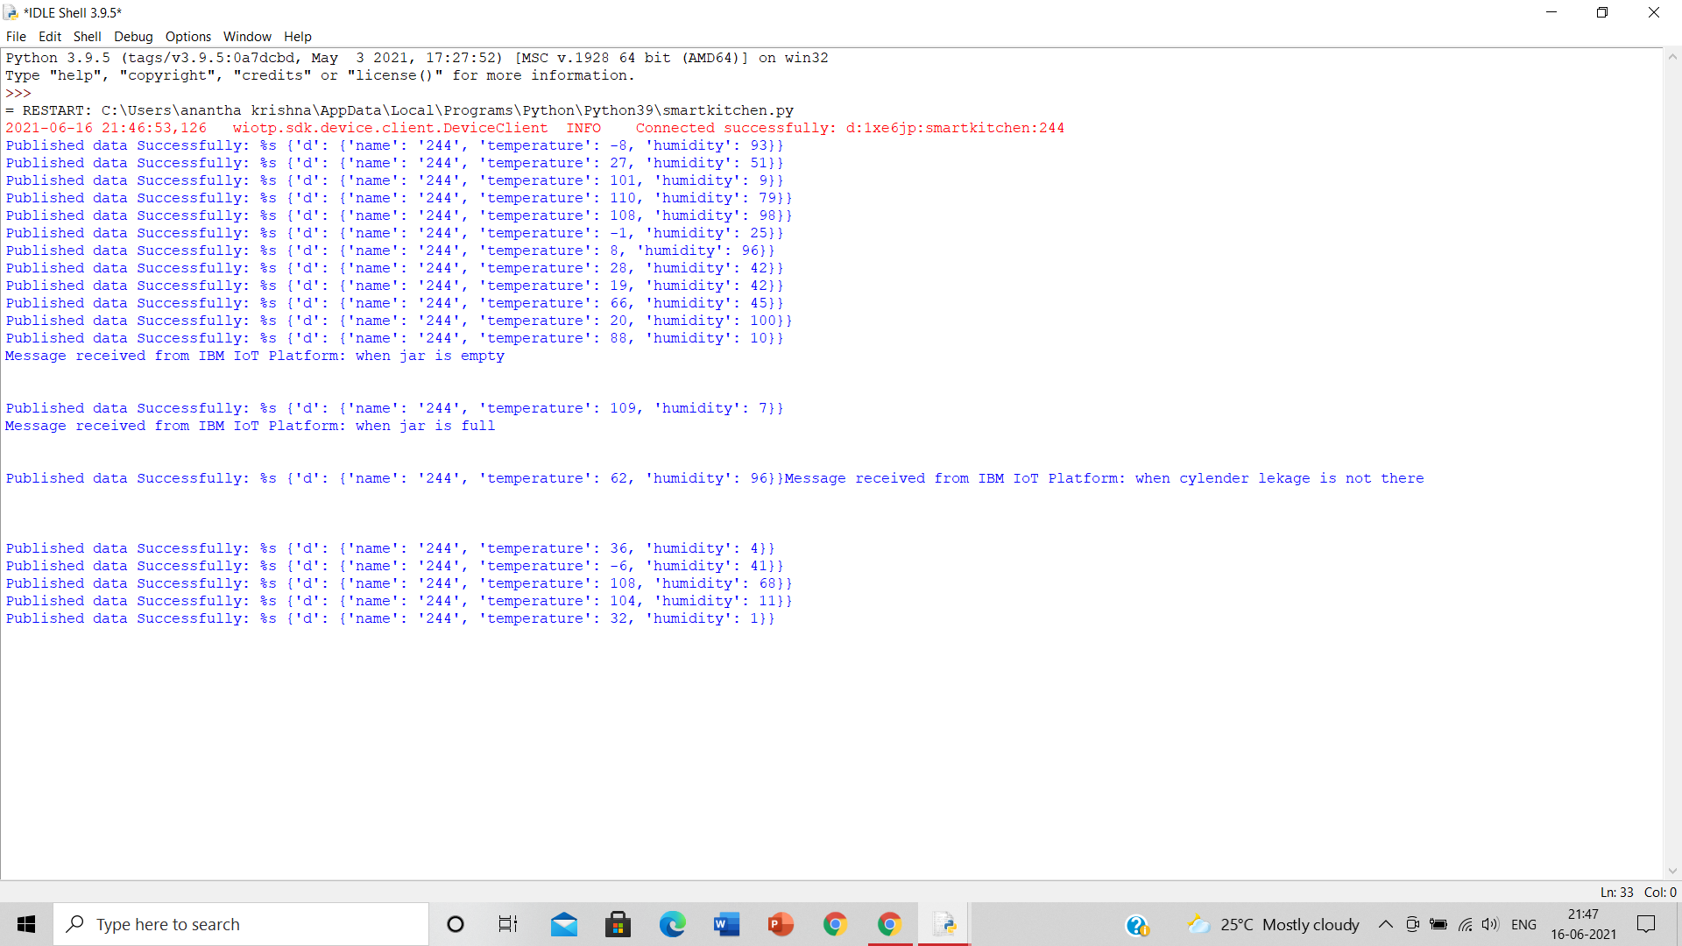

By this we can know the out of the code

Below the out put of the MIT app in the mobile has given, this is the process of the Smart Kitchen using IOT by software using

**Python,IBM Cloud,Node- RED,IBM IoT Platform,MIT App Inventor,IBM Cloudant DB.**

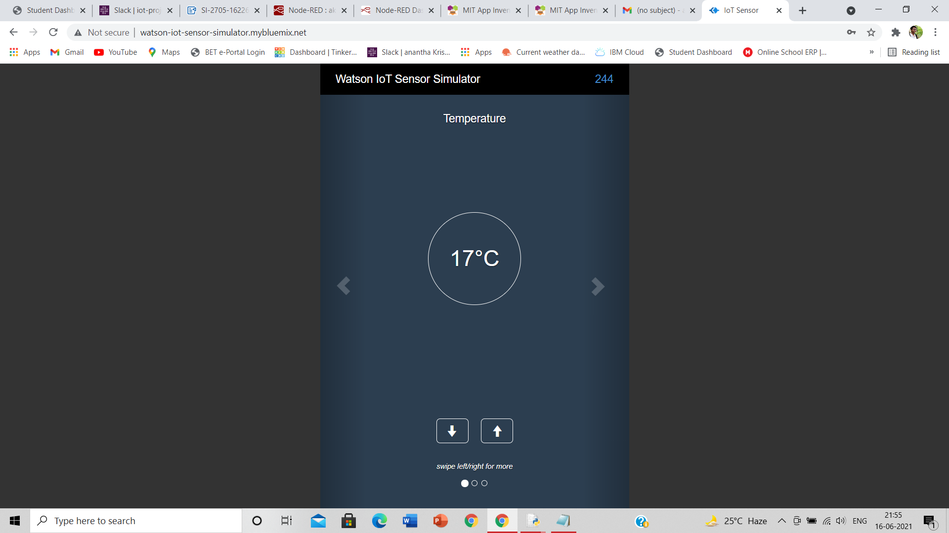

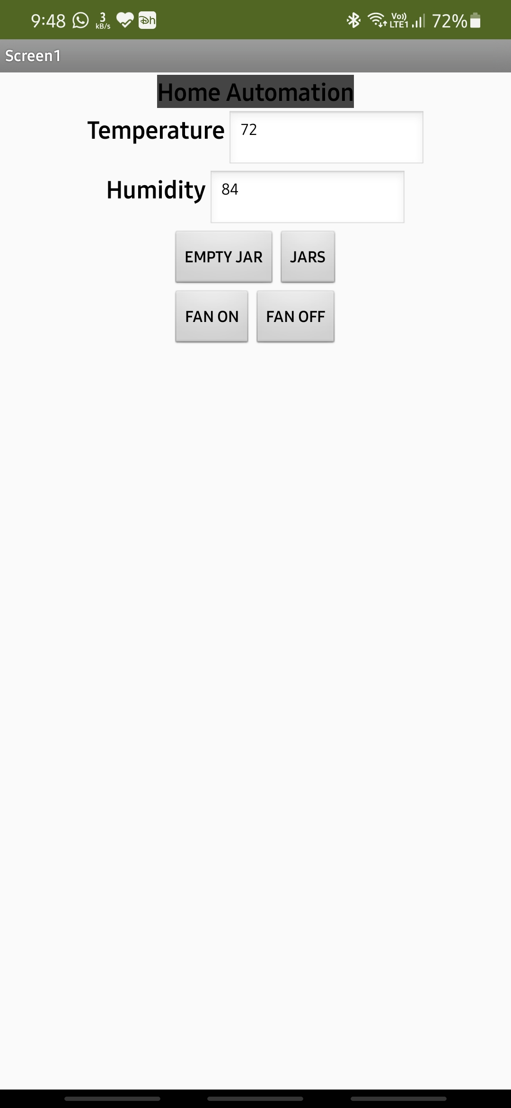

Experimental Investigations:

In the Creativity in the Kitchen project, a critical look is taken into the impetuous focus on ease and efficiency that is strived towards in many implementations of the Internet of Things and Smart Home movements, with a specific focus on the kitchen environment, since there are many possibilities for creative action in the kitchen but also a trend towards highly efficient appliances, tools and environments threatening to almost take the human out of the equation of cooking. It is proposed that the connectivity and intelligence of IoT solutions can alternatively be used to increase creativity and enhance daily interactions with surrounding things. To bring this vision to fruition a cutting board was made that through cognition-heightening interactions and a connection to a digital image representing work done helps the user experience the cooking process as less stressful and more fulfilling, while helping to create meals of a higher quality.

Flow Chart:





Result:



Advantages:

**Smart appliances can cut your electric bill**. Some equipment can calculate energy rates and schedule high-energy-use activities for low-energy-cost times of the day. For example, loads of laundry can be run when electricity rates are lowest, and integrated sensors can optimize drying times.

1. **They look cool.** The cutting-edge appearance of these appliances, including backlit touch screens, is particularly attractive to tech-loving homeowners and those with modern decorating motifs.

**2. Kitchens too.** New flexible refrigerators can change cooling sections from refrigeration to freezing and back again, depending on your changing needs. Find a sale on ice cream, but your freezer is full? No problem! You can also see what’s currently in your fridge while shopping. Or, do you want your stove to defrost and cook dinner and keep it warm until you arrive home? It’s possible.

Disadvantages:

1. **Smart appliances cost more.** In addition to higher purchase prices, they often require more repairs than mechanical versions of the same machines. According to [Angie’s List](https://www.angieslist.com/articles/do-smart-appliances-cost-more-repair.htm), those repairs can be 50 to 100 percent more expensive.
2. **They may pose data and privacy risks.** Smart home appliances may not utilize reliable internet security protocols, giving hackers a pathway to access other connected devices in your home. Also, the more data that these devices are collecting about you, your habits, and your home, the more that data could be vulnerable.
3. **Firmware issues.** Manufacturers may not provide timely firmware updates, which means an appliance may no longer integrate with other devices, like a smart home hub and voice-activated controllers. It’s also easier for hackers to access devices that aren’t kept up-to-date and secure.
4. **No connection = dumb appliances.** If your smart appliances can’t connect to the internet, they are no longer “smart.” Before buying, be sure to check reviews for individual products as well as the manufacturer’s customer service ratings.

Applications:

Monitoring the all sensors and its value for safty detection of gas leakage, temperature and Humidity of room,and daily usage of system to the user. 2. Exhaust fan switched on in case of abnormal readings 3. Stores the data related to the system like daily data monitoring Intelligent System for Domestic Gas Appliances using IOT. In our day-to-day life there is serious threat about leakage which leads to suffocation when inhaled, when ignited leads to explosion and causes a number of deaths. This project is about designing a LPG leakage monitoring system which is proposed for home safety. This system detects the leakage of the LPG and alerts the consumer about the leak by SMS and as an emergency measure the system will turnoff the power supply, while activating the alarm.

Conclusion:

Our system will detect the leakage of the gas, incase there is any leakage it will send a sms to the owner and it will turn off power and activate an alarm. The system will continuously monitor the weight of the gas. There will be automatic booking of the gas done. We will even measure the Humidity and the Temperature around the gas cylinder.

By this we can use the smart things in kitchen, when gas leakeage is there the message will come to our mobile.we can check the temperature also.

Future scope:

In **future**, there will be intelligent **applications** for smarter homes and offices, smarter transportation systems, smarter hospitals, smarter enterprises and factories. **IOT** can provide several advantages in Retail and supply chain management (SCM) operations.

**IoT** has proved to be one of the best tools for the healthcare industry. It helps provide advanced healthcare facilities to patients, doctors, and researchers. These facilities include smart diagnosis, wearable devices for tracking health, patient management, and many more.

According to a recent report, released by Zinnov[2] in June 2020, **IoT** investments in **India** were close to USD 5Bn in 2019, and this is expected to go up to USD 15Bn in 2021. **India** has already started working on the latest upcoming trends.

Bibliography:

International Journal of Advanced Research in Electronics and Communication Engineering (IJARECE) Volume 5, Issue 7, July 2016 IoT BASED SMART REFRIGERATORSYSTEM byDeepti Singh , Preet Jain, Electronics and Communication Department Shri Vaishnav Institute of Technology and Science,Indore, India. ➔ Internet of Things and its role in Smart Kitchen by Shivaranjani Moghali, University of Agricultural Sciences, Dharwad.