**SMART ASSISTANT FOR PUBLIC PARKS USNG IBM WATSON**

**1. Introduction :**

1.1 **Over view :**

Technology has rapidly grown and we are lucky enough about the wide range of instruments and resources that are available for every individual.One among those great designs is the Internet of things.

**"A new dimension has been added to the world of information and communication technologies (ICTs): from anytime, any place connectivity for anyone, we will now have connectivity for anything…. Connections will multiply and create an entirely new dynamic network of networks – an Internet of Things"**

Our project is smart assistant for public parks using IBM Watson,it is an application of the IoT. It is similar to that of *'****Alexa'***  which is developed by ***Amazon.*** This Alexa is trained prior for any input of speech,the output shall be relevant . Our smart assistant aims at a particular park and provides the user with the required information he puts for the assistant.

**1.2 Purpose :**

The main purpose of using this smart assistant is to make our work easier. We come across chatbots in a few webpages. They serve the user with the required information thus informating the user about his needed content within no time. Carrying through the information present in the respective websites is literally time-consuming and a difficult task. In those cases chatbots are used whose input is in the form of text and hence is the output we receive.

In the present scenario, our assistant takes the input from the user in speech form and yields the output in speech format. This enables the user to enquire about the data easily and effectively.This decreases the waste of time.

**2. Literature Survey:**

2.1 Existing problem :

Generally, the user faces a lack of information which he requires. Fortunately, we have a lot of browsing sites that support us with the information. But sometimes,this might not be the case. When the user requires only a specific data it is useless to browse the data and search for his requirements from webpages.

2.2 Proposed solution :

The smart assistant hence designed to overcome time complexity and thus making easier. It could even be used by illiterates and obtain their desired data from the assistant in their required language. Additionally, this helps the user to handle multiple tasks in a single instance.

3. **Theoretical Analysis:**

3.1 Block Diagram :

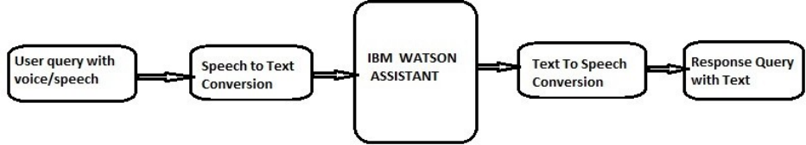

3.2 Hardware/Software Designing:

Software Designed:

* Installation of Node Red
* Installation of Watson Assistant
* Installation of Text to Speech(TTS)
* installation of Speech toText(STT)

along with their App URL and their respective API Keys.

**4**. **Experimental Investigations:**

For the experimental set up, initially we need to make the appropriate connects in the ***Node Red app*** provided with their service credentials and deploy the app. This yields the ***TTS*** and ***STT*** conversions.Later we need to design a chatbot in such a way that it takes the user input and results relevant output assigned by the developer. An assistant node is to taken and supply it with the ***Watson*** credentials so that voice enabled chatbot.

The Text to Speech node is used to convert the given text input to speech output. We use an inject node at the input end whereas play audio node at the output end. Similarly opposite to text to speech is the Speech to Text node. The input given is in the form of speech voice message using a microphone installed from the manage pallets and the output is text form which is displayed using debug node.

The assistant node is supplied with it's respective service credentials from the Watson assistant and its input is taken from the output of speech to text node. The output of ***assistant node*** is given to a function node rather than directly supplying to the speech to text node thereby avoiding bad requests. Necessary ***function*** is written inside the function node using the ***split*** method and the Node Red app is thus deployed to save the changes.

The Watson assistant is preliminary trained with few queries that the user might put to the bot and the answers were also saved to the bot.When the user requests for his required information using his microphone, the smart assistant gathers the information from the Watson Assistant using the assistant node and yields speech output.

Ensure that the API keys and the URL's are properly located in their respective block of nodes. If the service credentials are misplaced from their respective nodes we may encounter a few errors and if the assistant credentials are given mistake, then it displays missing property. In this manner we can find the flawless nodes and connect them.

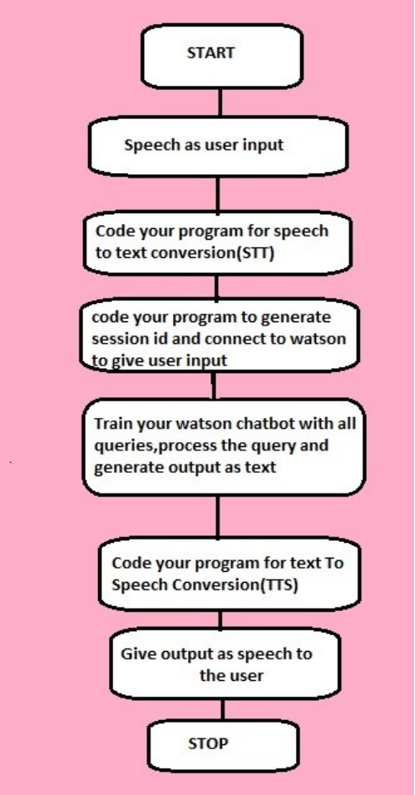**5. Flowchart:**

**6. Result:**

The smart assistant makes the search easy, which saves the time of the users who are struggling to find the information.

**7. Advantages and Disadvantages:**

Advantages:

* Time saving
* Stream line communication with foreigners
* VUI technology is evolving
* Beyond the usual devices
* Reach multiple users at once

Disadvantages:

* Smart assistant devices are expensive
* Signal strengths are not always strong
* Having a herd
* Physical limitations
* Voice recognition is not perfect

**8. Applications:**

Smart assistant can be used in several applications where the user input and the desired output are oral. These include:

* Cubic
* Alexa
* Cortana
* Siri
* Hound Voice Search and Assistant

**9. Conclusion:**

The smart assistant for public park is designed in such way that any one can use it easily and know more information about the park.

**10. Future Scope:**

Smart assistants are growing up rapidly in today's generation and there is lot of scope for smart assistance in these sectors in the future

* Mobile App Integrations
* Voice-Tech in **HEALTHCARE**
* Search Behaviors Will Change
* Individualized Experiences
* Voice cloning
* Smart Displays
* Voice In Gaming Industries

**11. Bibliography:**

[https://cloud.ibm.com/apidocs/assistant/assistant-v2?code=python#send-user-input-to-assistant-stateful](https://cloud.ibm.com/apidocs/assistant/assistant-v2?code=python&send-user-input-to-assistant-stateful)

<https://cloud.ibm.com/apidocs/speech-to-text?code=python>

<https://cloud.ibm.com/apidocs/text-to-speech?code=python>

**12. Appendix:**

1. **Source code:**

No source code is required to implement this project which makes it easy to design. We have just need the service credentials of the TTS, STT, Watson assistant to be linked with the **Node-Red** application to convert Speech-to-Text and Text-to-Speech.

**2. UI output screenshots:**

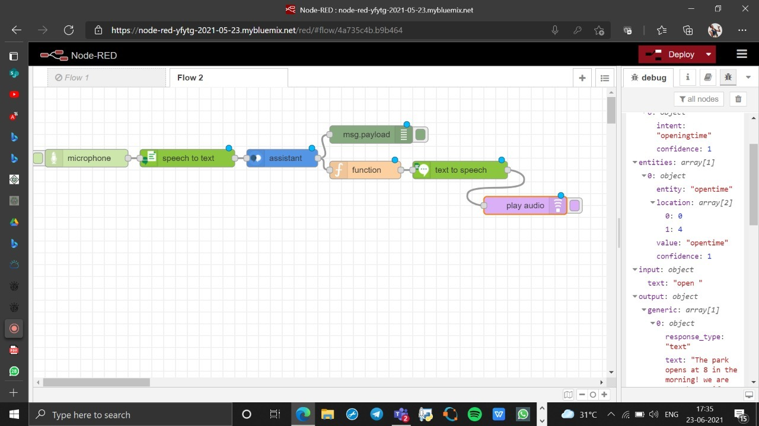

**(a).This illustrates the connection among the nodes using the Node Red Application.**

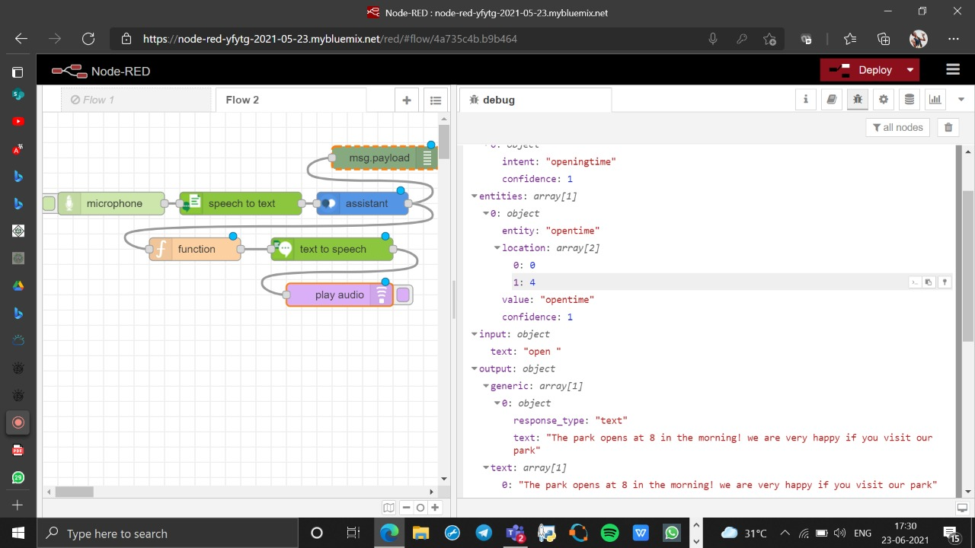

**(b). This is the output displayed in the debug window when the app is deployed.**