SMART SOLUTIONS FOR RAILWAY BASED ON IOT

* **INTRODUCTION**
* **Overview :**

a. The main overview of this project is to book the tickets by seeing the available

seats.

b. After booking the person will get a QR code which has to be showed to Ticket

Collector ,when T.C scans the QR code it will display the person details.

c. And also with this app we can order the food items and the notification will be

sent to pantry section.

d. GPS module is also present in this to track the train location so that the live

status of the journey is updated.

Through this the user can also set the intimating notification for both the boarding &

destination stations.

* **purpose :**

**\***  The main purpose of this project is to book tickets from anywhere without going

to railway station and waiting in the queue.

**\*** To save the time .

**\*** Through this we can get the location of the train, we can check whether seats are

available or not .

**\*** Because of Digitization Ticket we can avoid direct contact with counter and with

the help of QR code T.C will get the details of the person.

* LITERATURE SURVEY
* **Existing Problem :**

* The Delays...

* Crowding at the stations...

* Live Location of the Train...

* No Pantry section...

**Proposed Solution :**

* To avoid delays we have used IOT platform for booking Tickets online.

* we are using QR code ,when T.C scans this code he will get the details

of the person which is contact less.

* Because of digitalize ticket no fear about losing or missing the ticket.

* GPS is provided to get live location of the train.

* we can get the notifications for intimating the train live status for both boarding

and destination status.

* In this web app we can order food it will send notifications to pantry section.

* **THEORETICAL ANALYSIS**
* **Block Diagram :**

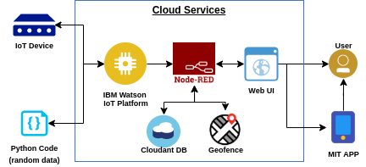

* **Hardware and Software design :**

**\* Software:**

* Install Python Idle
* Create IBM Account
* Create Node-Red Application
* Create IBM Watson IOT platform
* Create Cloudant DB in IBM cloud
* Create a code snippet using python to send

* Random GPS location values to the cloud

* To scan the QR code of Tickets

* Create Node-Red flow to get Data from Device
* Design UI to display the details of Seats available,

Location of the train.

* **EXPERIMENTAL INVESTIGATIONS**

* Sending live locaion of the train using python random.

* Taking Passenger input(Name,Mail,Phone number, Boarding station,Destination).

* Showing seat vacancy.

* Creating a QR code(also sending it to mail).

* Storing it to Cloudant DB.

* Creating a IoT of Geofences for the train location.

* showing it on the map UI.

* Check if either the boarding station or destination are equal to random train

location(the location of the train is stored in msg.location.isat)

* Checing whether the random gps is nearby and thus triggering a notification>a

popup or an email.

* To create a scanner application.

* **RESULT**

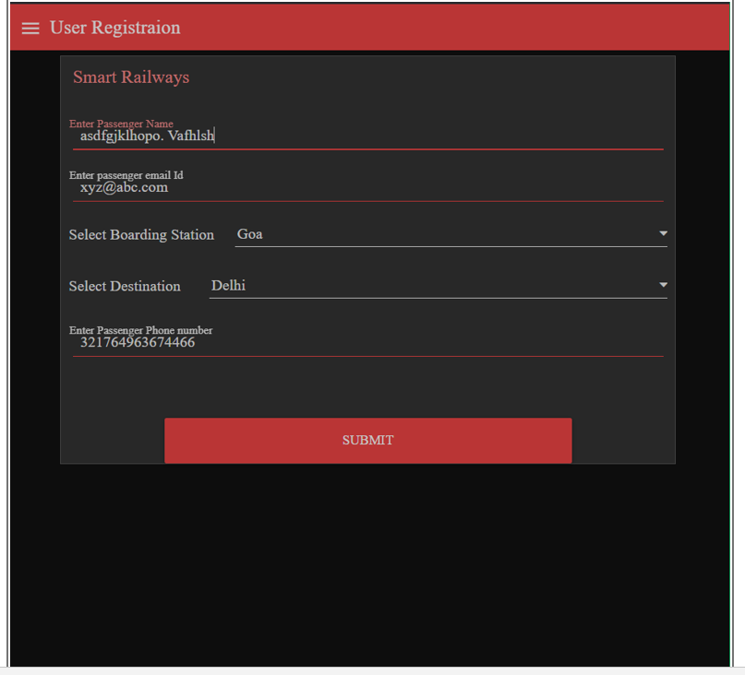

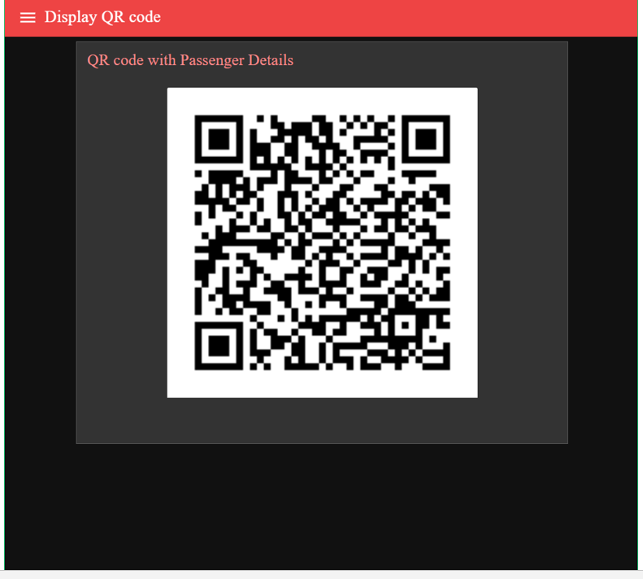

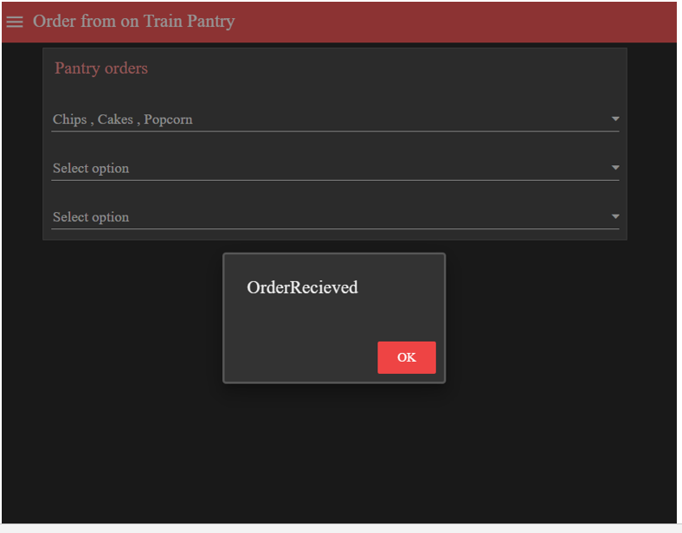

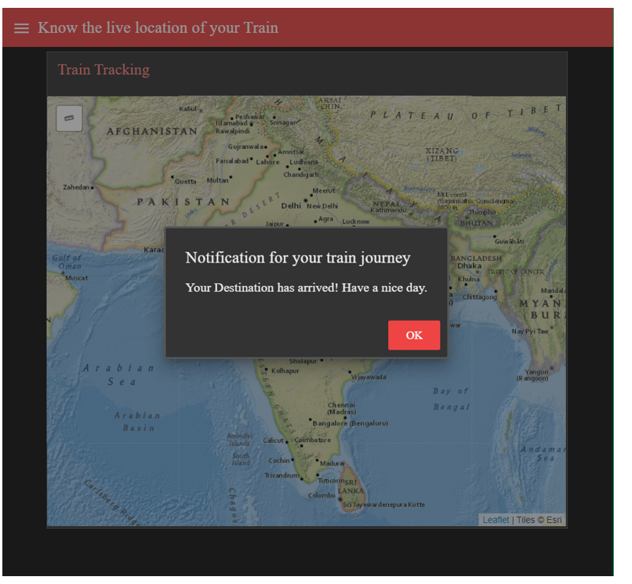

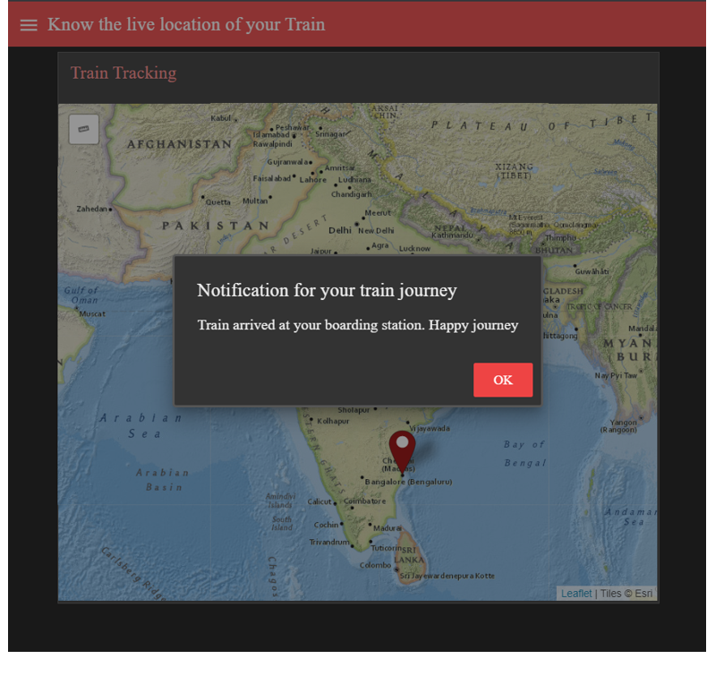

* **ADVANTAGES AND DISADVANTAGES**

**Advantages :**

**\* No more Wasting time in the Queues....**

Whenever we think about going on a train ticket, the first thing that comes to our mind

is the long Queue. There is something we always want to avoid, as the process can eat

up our valuable time. We have seen people miss their train when standing before the

ticket counters.

The process of booking tickets by using this web app can help people to avoid

standing in the long Queue for hours.

* **Book Your Ticket from Anywhere...**

We can book Tickets from any place like home , office etc ,this service can save our

time to travel.

* **Safe Payment..**

You do not need to pay for the tickets in person. You can easily use your credit card,

UPI pay etc.

* **Easy access to the Ticket...**

You need not take printed copy of Ticket because a QR code will be there ,whenever

T.C scans the QR code it will displays the person details.

* **Pantry Section..**

In this web app we can order food which will send notification to the pantry section.

* **Live location of the train..**

We have provided GPS tracker which provides the live location of the train,and we will

get the boarding and destination station notifications.

**Disadvantages :**

You need internet access. Reliable internet access is required to check reservations

and add bookings that are made over the phone.

* **APPLICATIONS**

Can be used in any booking platforms like bus ticket ,Hotels,Airports etc..

* **CONCLUSION**

We came up with a Web app which provides additional services better than online

booking like GPS Tracker,Pantry section, QR code generator and scanner and it safer

than other services.

* **BIBLIOGRAPHY :**

* Smart Internz mentors

* Smart Internz lecture videos

* Smart Internz material

* **APPENDIX**
* **Source Code :**

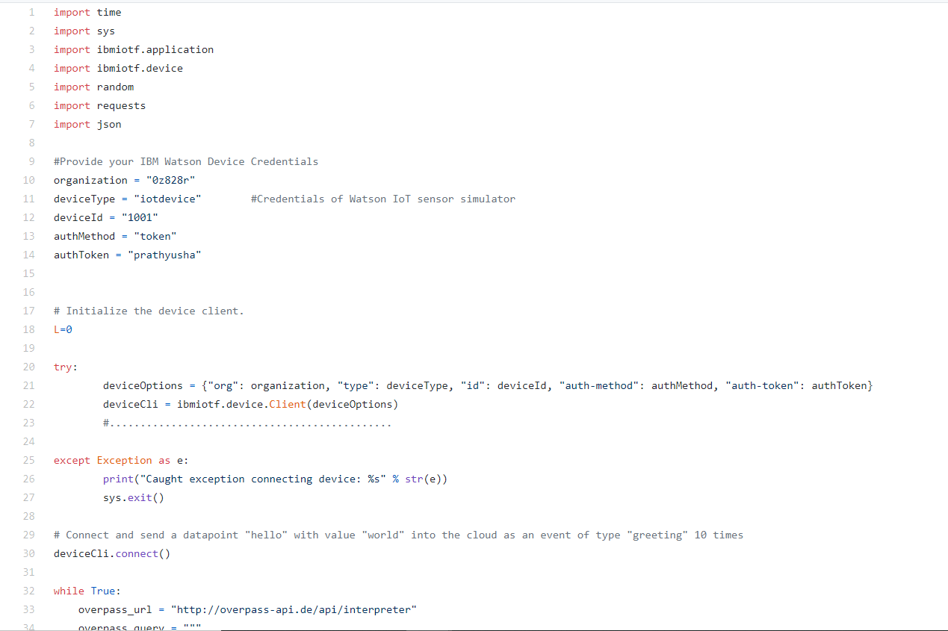

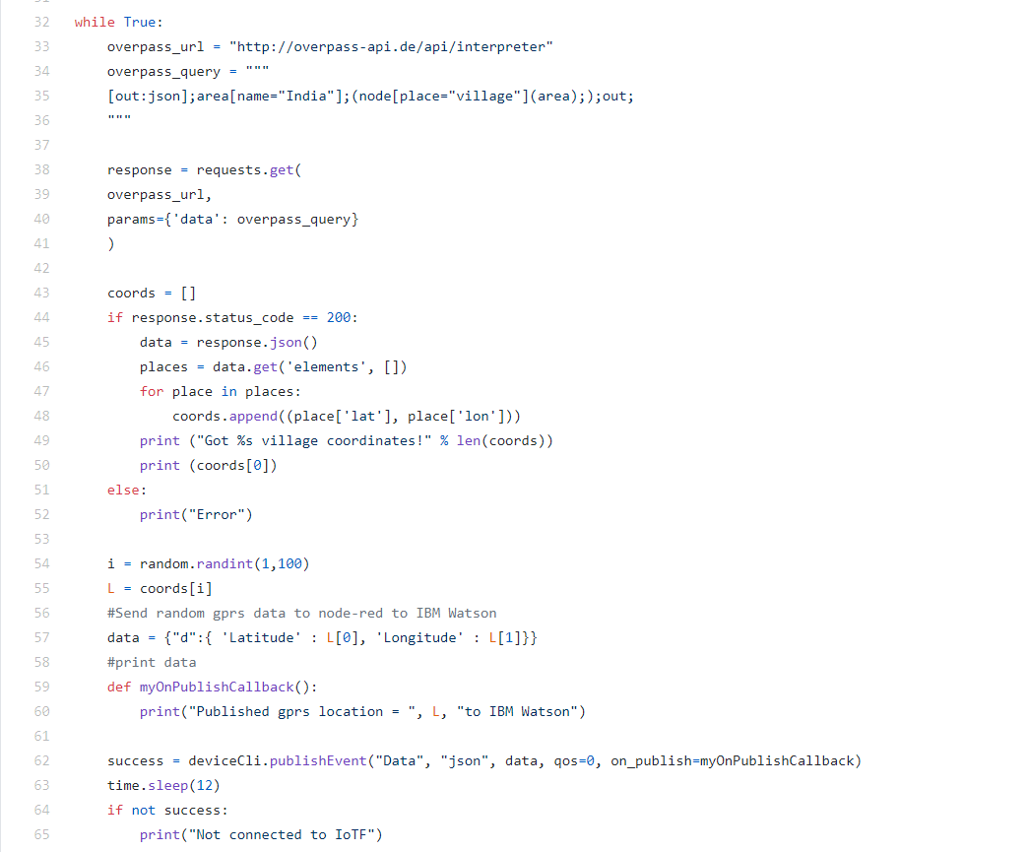

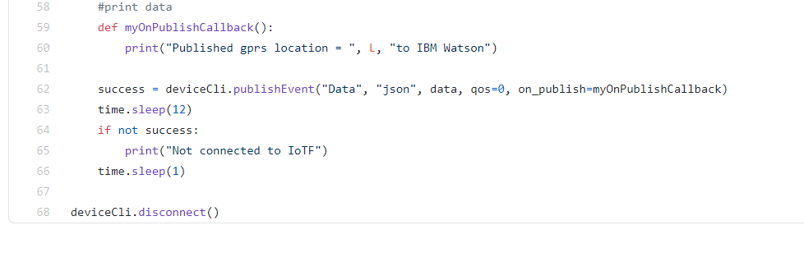

* **UI Output**

The UI Dashboard screen Grab : For Passenger Application

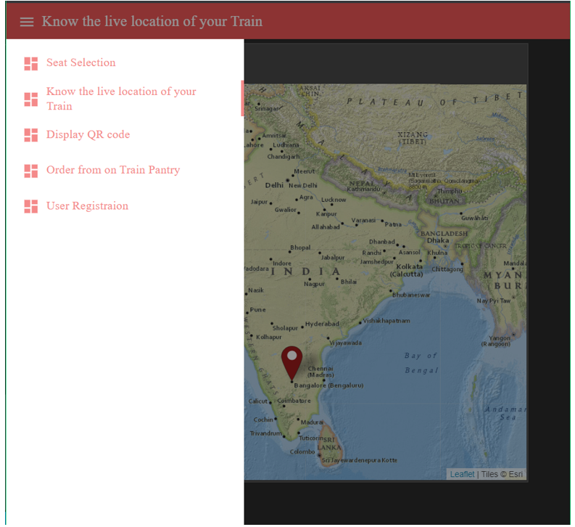

**The UI screen grab of Ticket Collector Application :**

