**Medicine Reminder For Elderly People Using IBM Cloud**

**TABLE OF CONTENTS:**

**1.INTRODUCTION**

1.1 Overview

1.2 Purpose

**2.LITERATURE SURVEY**

2.1 Existing problem

2.2 Proposed solution

**3.THEORETICAL ANALYSIS**

3.1 Block diagram

3.2 Hardware/Software designing

**4.EXPERIMENTAL INVESTIGATIONS**

**5.FLOW CHART**

**6.RESULT**

**7.ADVANTAGES & DISADVANTAGES**

**8.APPLICATIONS**

**9.CONCLUSION**

**10.FUTURE SCOPE**

**11.BIBLIOGRAPHY**

**12.APPENDIX**

a. Source code 4R

B. UI Output

1. **INTRODUCTION**
   1. **Overview**

The remarkable problem is that patients forget to take the proper medicines in proper proportion and in proper time. Medication adherence, which refers to the degree or extent to which a patient takes the right medication at the right time according to a doctor’s prescription, has recently emerged as a serious issue because many studies have reported that non-adherence may critically affect the patient, thereby raising medical costs. Medication nonadherence is a common, complex, and costly problem that contributes to poor treatment outcomes and consumes health care resources. So we are introducing an Android application whose objective is to remind the patients of their dosage timings through alerting system so that they can stay fit and healthy. This application focusses on the people who forget to take medicines on time. It allows users to set an alarm along with the fields of date, time and medicine description which will allow them to set alarm for multiple medicines at different time intervals. The notification system will send a notification after setting an alarm. The user can activate or deactivate the notification accordingly. The application alert the patient by an audio alert system. Medication reminders help in decreasing medication dispensing errors and wrong dosages.

* 1. **Purpose**

This medicine reminder system helps the patients to take medicine on time. It alerts them on time with medicine name and doses.

1. **LITERATURE SURVEY**
   1. **Existing problem**

If a person forgot to take medicine on time it put the patient life at risk. Most of the elderly people have a problem of forgetting things at a certain stage, they also forget to take medicine on time and this effect their health. Not only old people even young ones forget to take medicine on time when they are busy at their work or for different reasons. Irregular medicine consumption leads to severe health problems.

* 1. **Proposed solution**

The proposed system is based on IBM cloud Operating system which will remind the users to take medicines on time through notification and automatic alarm ringing system. The medicine reminder system will have one duty and that would be to remind the user that he/she is due for taking the medicine. We are trying to make sure that the user never forgets to take the medicine. The alarm will hit at the time of intake of the medicine with an image of medicine, so to recognize which medicine is to be taken. The web application can be installed on the android devices. It will add recurring events to the mobile’s calendar and will alert the user when he/she has to take the medicine with the image of medicines.

1. **THEORETICAL ANALYSIS**
   1. **Block diagram**

**Medicine Reminder For Elderly People Using IBM Cloud**

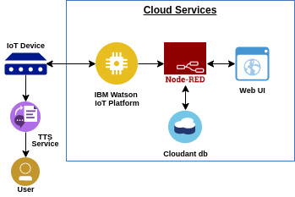

* 1. **Hardware/Software designing**

**Software Designing:**

The software used for this system is:

1. Python IDLE
2. IOT Open Hardware platform
3. IOT Cloud Platform
4. IOT Communication Technologies
5. IOT Communication Protocols
6. **EXPERIMENTAL INVESTIGATIONS**

Internet of things (IoT) is a system of interrelated computing devices, mechanical and digital machines provided with unique identifiers and the ability to transfer data over the network without requiring human-to-human or human-to-computer interaction. The definition of the Internet of things has evolved due to the convergence of multiple technologies, real-time analytics, machine learning, commodity sensors, and embedded systems.

The IoT can assist in the integration of communications, control, and information processing across various transportation systems. Application of the IoT extends to all aspects of transportation systems (i.e. the vehicle, the infrastructure, and the driver or user). Dynamic interaction between these components of a transport system enables inter- and intra-vehicular communication, smart traffic control, smart parking, electronic toll collection systems, vehicle control, safety, and road assistance. For example, an IoT platform can continuously monitor the location and vacancies of spaces in parking.

This can only be possible with the IoT and its seamless connectivity among devices. Sensors such as GPS, Humidity, and Temperature send data to the IoT platform and then the data is ANALYSED and then sent to the users. This way, users can track the real-time status of vehicles and can make appropriate decisions. The smart parking system is an IOT based device which is capable of automatic sensing of vehicles. ALSO, the data of sensors will be displayed in graphical form on the IBM cloud page.

1. **FLOW CHART**

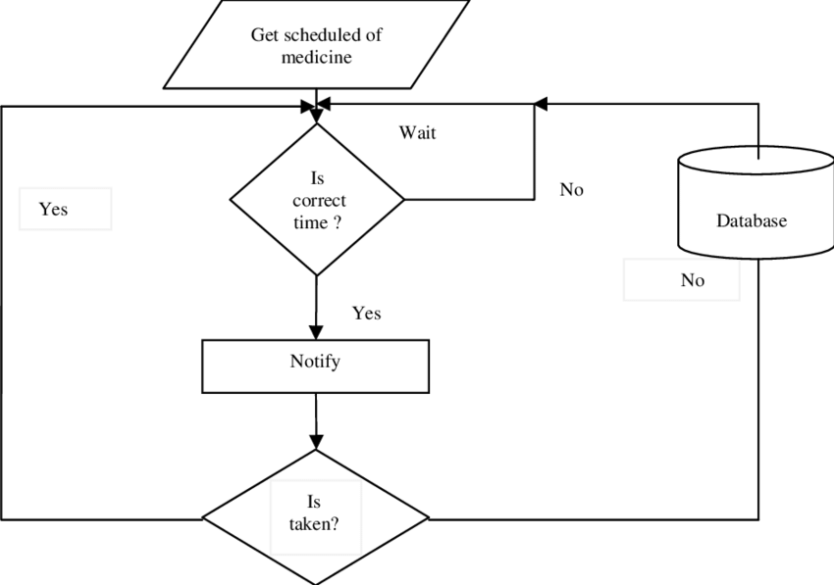

1. **RESULT**

**Python code**

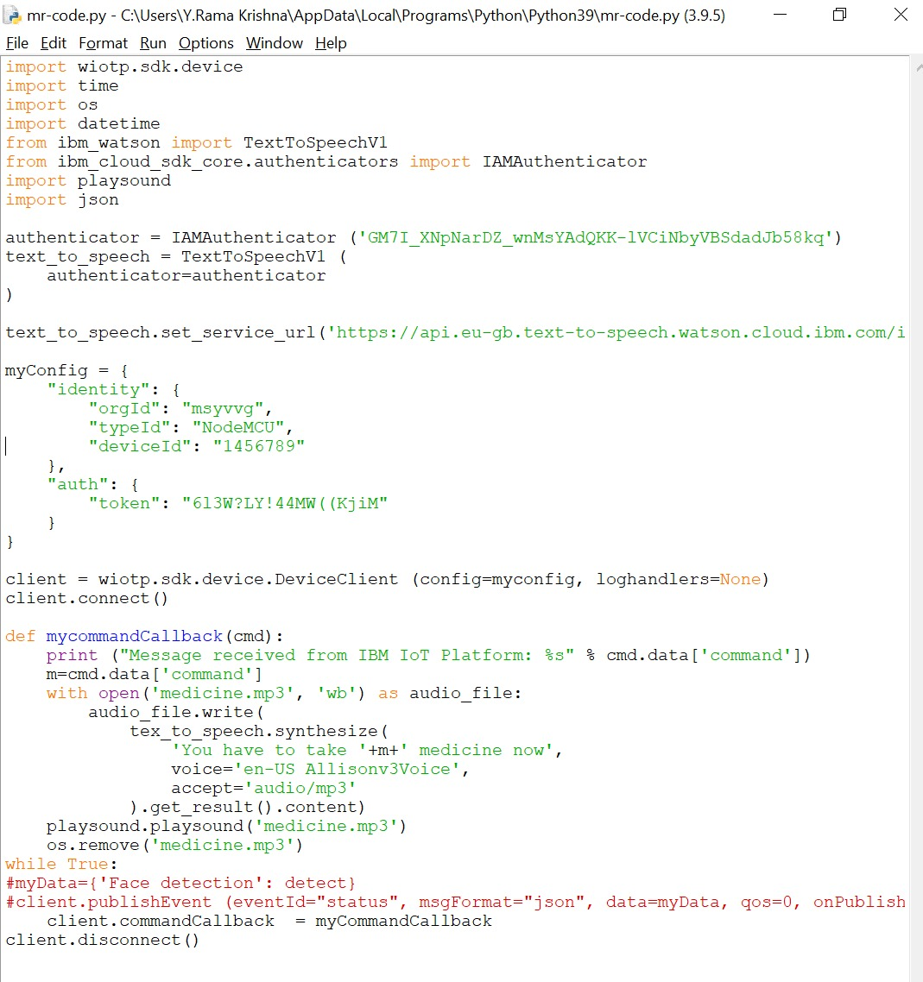

**Node red:**

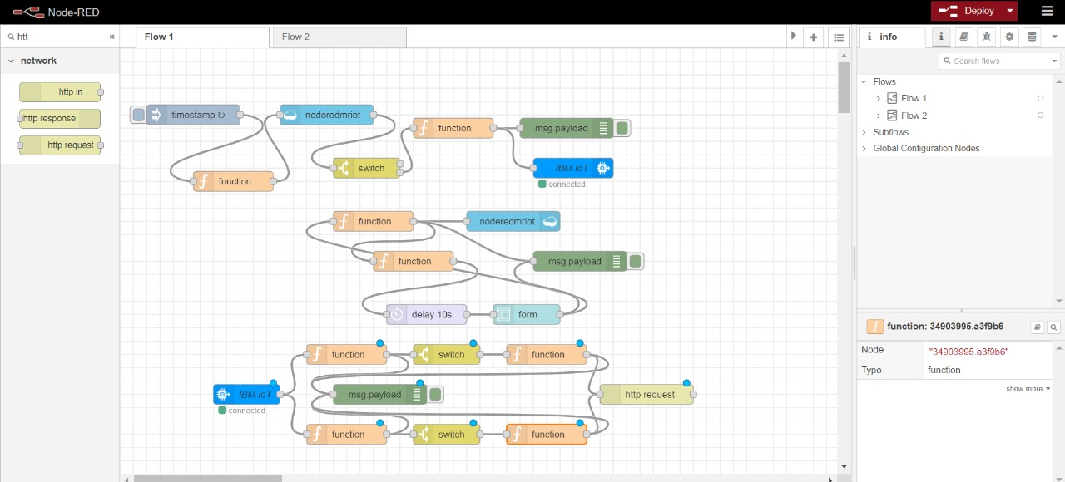

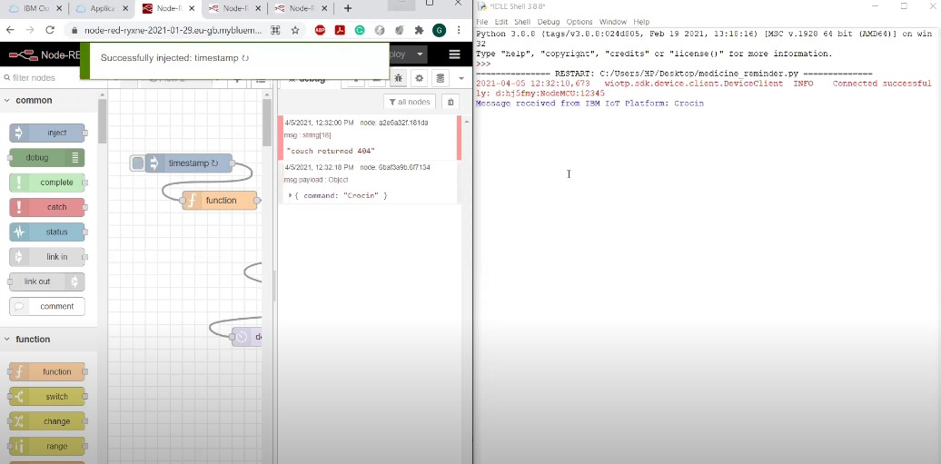

1. **ADVANTAGES & DISADVANTAGES**

**Advantages:**

* Takes the stress out of remembering
* Improved medication adherence
* Effortless function
* Backup supply

**Disadvantages:**

* Device should be connected to internet
* When device is switched off the application does not send the reminder

1. **APPLICATIONS**

* Event reminder
* Health care
* Automatic messaging at fixed time

1. **CONCLUSION**

The application gives reliable reminders, good user interface, nice user experience and it supports many new features supporting medication adherence.

Many Medication Reminder Systems have been developed on different platforms. Many of these systems require special hardware devices to remind the patients about the medicine in-take timings. Purchasing new hardware devices becomes costly and more time and money consuming. So in the given work an attempt has been made to implement a system which is economical, easily accessible and improves medication adherence. Medication non-adherence reduces the effectiveness of a treatment and imposes a financial burden on health care systems. The patients will get the schedule of medicine in-take time with medicine description, starting and ending date of medicine, notification through automatic alarm ringing system. The scheduled reminder will not suggest any kind of medicine which is not prescribed by the doctor that will assure the safety of the patient and also will avoid wrong dosages.

1. **FUTURE SCOPE**

In our system all the patients will receive the schedule of medication details, intake time, quantity, start and end time of current medication. Our application will not provide any other substitute medication to the medication prescribed by the doctor. This will assure the patient does not suffer any ill effects or do not partake wrong dosages. This will also allow the doctor to make new appointment schedules.

We plan to make overall improvements over other applications which in turn will result in better performance and easier access for the users.

1. **BIBLIOGRAPHY**

* <https://internetofthings.ibmcloud.com/>
* <https://cloud.ibm.com/>
* <https://github.com/>

1. **APPENDIX**
2. **Source code**

import wiotp.sdk.device

import time

import os

import datetime

from ibm_watson import TextToSpeechV1

from ibm_cloud_sdk_core.authenticators import IAMAuthenticator

import playsound

authenticator = IAMAuthenticator ('xp-FJmnJUbVYZG3C_zFINVfxmPNkQ1jtQnpcbnDLvUBi')

text_to_speech = TextToSpeechV1 (

authenticator=authenticator

)

text_to_speech.set_service_url('https://api.eu-gb.text-to-speech.watson.cloud.ibm.com/instances/277349e4-c7cb-4f5e-bb0c-61437492ba33')

myConfig = {

"identity": {

"orgId": "hj5fmy",

"typeId": "NodeMCU",

"deviceId": "12345"

},

"auth": {

"token": "613W?LY!44MW((KjiM"

}

}

client = wiotp.sdk.device.DeviceClient (config=myconfig, loghandlers=None)

client.connect()

def mycommandCallback(cmd):

print ("Message received from IBM IoT Platform: %s" % cmd.data['command'])

m=cmd.data['command']

with open('medicine.mp3', 'wb') as audio_file:

audio_file.write(

tex_to_speech.synthesize(

'You have to take '+m+' medicine now',

voice='en-US Allisonv3Voice',

accept='audio/mp3'

).get_result().content)

playsound.playsound('medicine.mp3')

os.remove('medicine.mp3')

while True:

#myData={'Face detection': detect}

#client.publishEvent (eventId="status", msgFormat="json", data=myData, qos=0, onPublish-None)

client.commandCallback = myCommandCallback

client.disconnect()

1. **UI Output**

