**AUTOMATIC TRAFFIC LIGHT CONTROLLING AT ZEBRA CROSSINGS**

An Internship project

Submitted by:

Shaik. Dilshad(18481A04J2)

Sai Krishna(18481A04L7)

Vardhil Raja kumar(18481A04H5)

**INTRODUCTION**

**Overview:**

The overview of our project is to generate a traffic signals will be controlled at the zebra crossings according to the time. Based on the people count at zebra crossing we can increase or decrease the signaling time which will be helpful for pedestrians to cross the road. We can display the countdown for the green signal by using the OLED display. Admin can get the people to count and the signaling time through the web application.

**Purpose:**

The main purpose of the Traﬃc control system come from many reasons but the biggest motivation behind Automatic Traﬃc Light Control system is the convenience. Convenience is really another way of saying "time saver" and in today’s world where everything moving faster, every second has value. Most of the technology we use today is based of convenience, for example phones get us information from other people faster. The main aspiration of the designed system is to compute total traﬃc density at targeted area which is then further used to reduce the traﬃc congestion caused by vehicles. Traﬃc lights are a very important. This project will be very useful and will be widely

used. It can be implemented wherever necessary.

**LITERATURE SURVEY**

**Existing problem:**

Traﬃc congestion is an increasing problem in cities and sub urban spend more of their time commuting to work, school, shopping, and social event as well as dealing with traﬃc light jams and accidents. Traﬃc became heavy in all directions, more to and from cities as well as between sub urban locations. . Due to the duration of red signal if there is no more amount of people in zebra crossing but the red signal will show for more time. In that case, waste of time for people in vehicles.

**Proposed solution:**

In this project, we find a smart solution to the above mentioned problem, making use of the Internet Of Things (IOT). The solution is such that, we can integrate a camera at the traffic signals and using the IBM visual recognition service we can count the number of people standing at the zebra crossing to cross the road. Based on that count we can increase or decrease the signaling time.

**THEORITICAL ANALYSIS**

**Block diagram:**

IOT Devices

USER

WEB UI

Node Red

IBM Watson IOT Platform

Python Code

Fig.1: Proposed block model

**Flow chart**

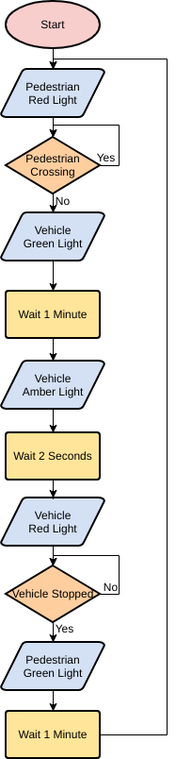

**Result**

The output of this automatic traffic light controlling at zebra crossing will generate the people count by integrate a camera at the traffic signals and using the IBM visual recognition service we can count the number of people standing at the zebra crossing to cross the road. We can even display the countdown for the green signal by using the OLED display.

**Advantages**

**1**. Reduces Accidents.

2. The traffic control signals provide for an orderly movement of traffic.

3. By the people count we can reduce the red signal duration.so that we cannot waste the time.

4. It provide economy over manual control at the intersection.

**Disadvantages**

1. They delay the traffic by stopping the vehicles at the intersection during the peak hours.

2. Traffic control signals may result in a re-entrant collision of vehicles.

3. They may cause a delay in the quick movement of traffic.

**Applications**

1. Fully automatic.

2. Low power consumption.

3. It provides the easy access in the traffic light.

4. Transport system.

5. Ramp metering.

6. Timers.

**Conclusion**

Automatic Traﬃc control system is based on a very eﬀective way of optimizing traﬃc, with redeﬁnition of threshold values for a real time application. This proposed system will be able to build a developed country with less traﬃc jams and it will also help the emergency vehicle to reach in time to the destination. So, this intelligent system will help us to control traﬃc in more autonomous way. In practice presently in India we are following time based control on traﬃc signals and we are experiencing a heavy traﬃc jams all over which in turn consumes lot of time

and fuel. We hope this method will be adopted as soon as possible so that the limitations we are experiencing with present method can be overcome.

**Future Scope**

As the systems take care of few drawbacks of the existing system, there is scope for further improvement and expansion of this work. The system can be expanded with smart traﬃc light control and congestion avoidance system during emergencies emergency cars such as ﬁre engines and ambulance and have priority over other traﬃc. This system gives highest priority to emergency vehicle to pass them.

B

**Bibliography**

1. J. H. P. P. A. Amit Bhat, Kaushik Roy, “Design and implementation of a dynamic intelligent traﬃc control system,” UKSIM-AMSS International Conference on Modelling and Simulation.
2. A. B. B. K. Vidhya, “Density based traﬃc signal system,” International Journal of Innovative Research in Science, Engineering and Technology.
3. Innovative Research in Science, Engineering and Technology.
4. elling and Simulation.

**APPENDIX**

**PYTHON CODE:**

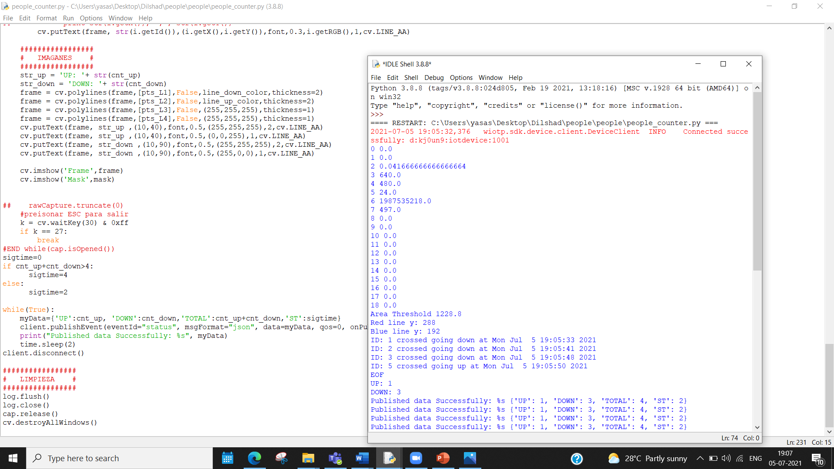

**NODE RED CONNECTIONS:**

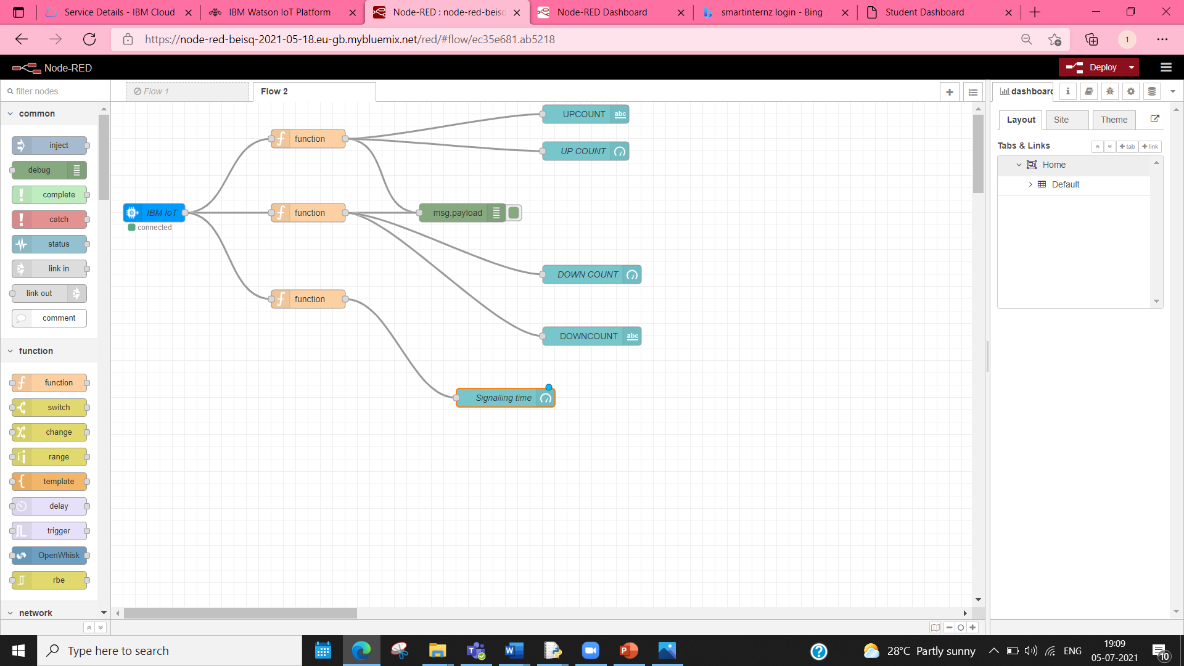

**WEB APPLICATION :**

