Project Name : Smart Home Assistant With Ibm Cloud.

Node Red:

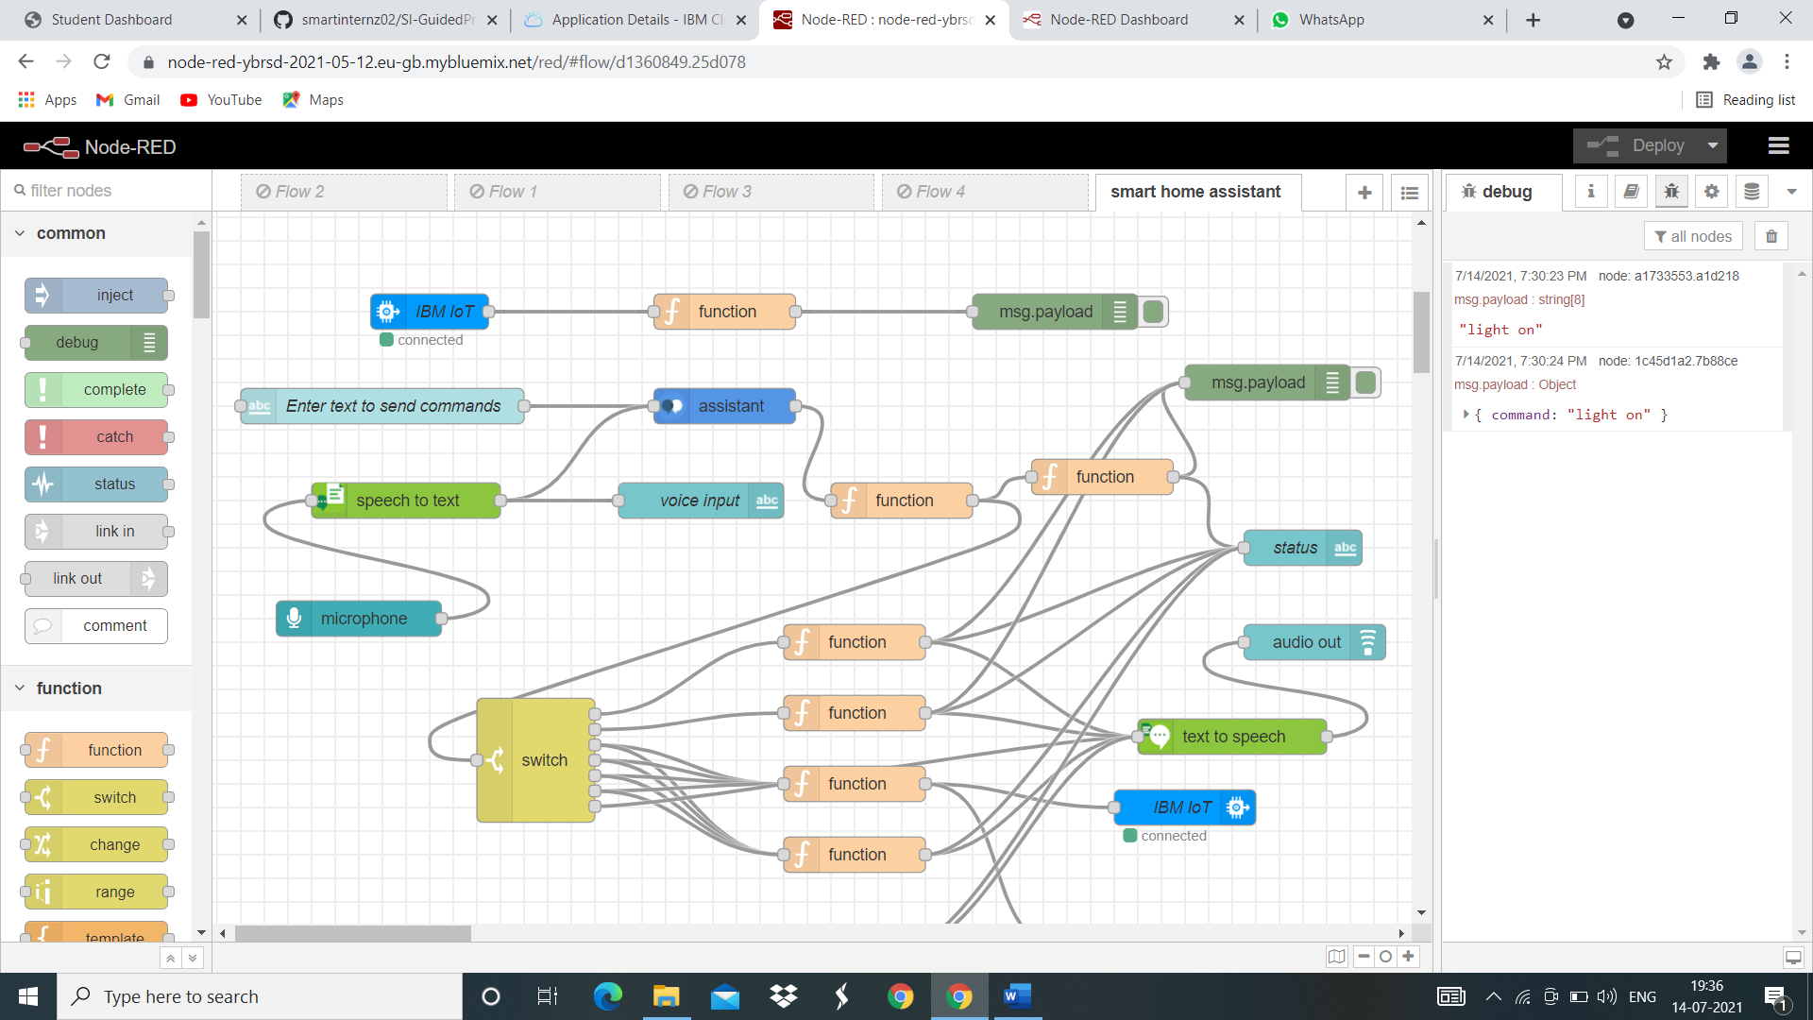

UI:

