**PREDICTING CO2 EMISSION IN VEHICLES**

**INDEX**

**TOPICS PAGE NO.**

1. **Introduction 1**
   1. Overview
   2. Purpose
2. **Literature Survey 1**
   1. Existing problem
   2. Proposed solution
3. **Theoretical Analysis 2**
   1. Block Diagram
   2. Hardware/Software Designing
4. **Experimental Investigations 3**
5. **Flow Chart 4**
6. **Result 5**
7. **Advantages 5**
8. **Applications 5**
9. **Conclusion 6**
10. **Future Scope 6**
11. **Bibliography 6**
12. **Appendix 6**
    1. Source Code
    2. UI output Screenshot

**1. INTRODUCTION**

* 1. **Overview:**

Transportation sector accounts for a large proportion of global greenhouse gas and toxic pollutant emissions.

Even though alternative fuel vehicles such as all-electric vehicles will be the best solution in the future, mitigating emissions by existing gasoline vehicles is an alternative countermeasure in the near term. A typical passenger vehicle emits about 4.6 metric tons of carbon dioxide per year.

This assumes the average gasoline vehicle on the road today has a fuel economy of about 22.0 miles per gallon and drives around 11,500 miles per year. Every gallon of gasoline burned creates about 8,887 grams of CO2. The aim of this study is to predict the vehicle CO₂ emission.

**1.2 Purpose:**

The amount of CO2 emission from the transport sector (including cars) accounts for about 20% of total CO2 emissions. Accordingly, from the viewpoint of preventing global warming, reducing that proportion is a key issue.

In regard to CO2 emissions from cars, fuel economy standards are getting tougher all over the world, so improving the fuel economy of cars is strongly desired. From now onwards, it is considered that the fuel economy of engines will be further improved by boosting engine efficiency and by hybridization (electrification) of cars. What’s more, improving fuel economy by improving “driving operation” (i.e. the operation in which a car is driven) and by smoothing traffic flows will come into the picture in the near future.

Under these circumstances, with concern for the environment from the viewpoint of reducing CO2 and other exhaust emissions, the Hitachi Group is comprehensively promoting a broad range of technical developments for reducing CO2 emissions from cars.

**2. LITERATURE SURVEY**

**2.1 Existing Problem:**

* Recently, the increasing interest in the estimation of CO2 emissions has heightened the development of CO2 emissions forecasting method, which are mainly divided into mathematical methods and artificial intelligence (AI) These factors differ from one company to another company.
* To overcome the limitations of mathematical methods, lots of researches have focused on AI, such as BP neural network (BPNN) , radical basis function neural network (RBFNN) , Elman neural network (ENN) , support vector machine (SVM) , and extreme learning machine (ELM)

**2.2 Proposed Solution:**

* There are several Machine Learning algorithms to be used depending on the data you are going to process such as images, sound, text, and numerical values. The algorithms can be chosen according to the objective. As the dataset which we are using is a Regression dataset we can use the following algorithms
* Linear Regression
* Random Forest Regression / Classification
* Decision Tree Regression / Classification
* In order to get appropriate predictions, the dataset can be trained with any of the above algorithms.
* After the model is built, we will be integrating it to a web application so that normal users can also use it to know the amount of CO2 emitted in a no-code manner.

**3. THEORETICAL ANALYSIS**

**3.1 Block Diagram:**

**(At the web-application)**

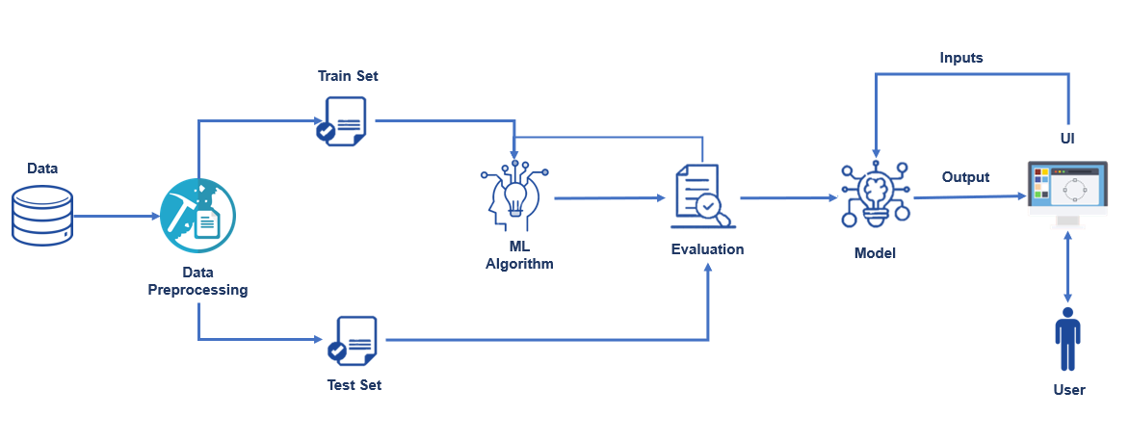

**3.2 Hardware/Software Requirements:**

**Software Requirements:**

* OS - Windows XP 7, 8, 10
* Anaconda Navigator – Spyder and Jupyter Notebook
* Sklearn
* Numpy
* Matplotlib
* Pandas
* Flask

**Hardware Requirements:**

* Processor - i3
* RAM - 1GB

**4. EXPERIMENTAL INVESTIGATIONS**

Carbon dioxide (CO2) is considered as a major contributor to global warming. Automobile contributes to around 65% of total carbon dioxide emissions globally when compared with other sources. On considering the upcoming stringent emission norms, this problem needs to be addressed properly.

The amount of CO2 emission from the transport sector (including cars) accounts for about 20% of total CO2 emissions. Accordingly, from the viewpoint of preventing global warming, reducing that proportion is a key issue. In regard to CO2 emissions from cars, fuel economy standards are getting tougher all over the world, so improving the fuel economy of cars is strongly desired. From now onwards, it is considered that the fuel economy of engines will be further improved by boosting engine efficiency and by hybridization (electrification) of cars. What's more, improving fuel economy by improving "driving operation" (i.e. the operation in which a car is driven) and by smoothing traffic flows will come into the picture in the near future.Significantly reducing CO2 emissions from cars will not be easy, but the available data can be used to extract the features, know the behavior of cars, and try to reduce the emissions. Machine Learning techniques can be used in this regard.

 The parameters that are required for this project are

1. Selecting the type of car.

2. Selecting the car class.

3. Entering the engine size.

4. Cylinder size

5. Selecting the transmission of the car.

6. Entering the fuel consumption city.

7. Combined fuel consumption.

So after entering all the required answers, the this will predict the co2 emitting by that particular car

**5. FLOW CHART**

(at the UI Interface)

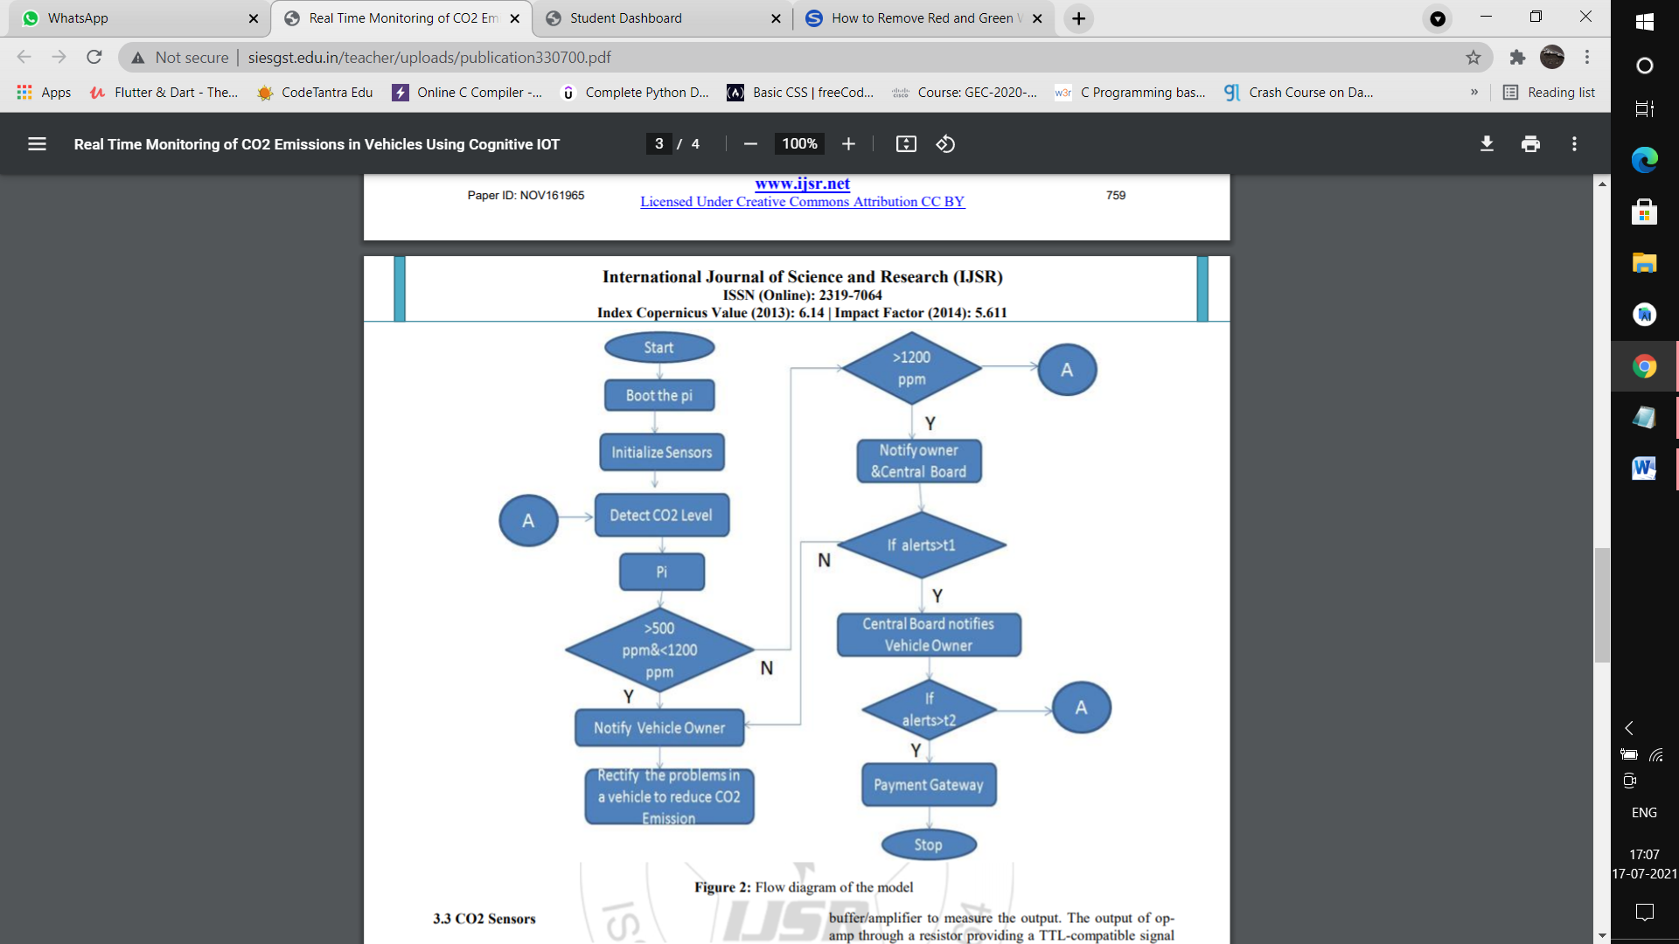

**6. RESULT**

This project mainly focuses on the following steps

* Step1 : Download the data set and preprocess the data set to make it more efficient in predicting the results
* Step2 : Analyses the pre-processed data and train the machine with appropriate machine learning algorithm
* Step3 : After training the machine with appropriate algorithm save the model and its dependencies
* Step4 : Build a web application using flask that integrates with the model built

The above mentioned procedure analyses the data and produces the result based on the predictions using machine learning algorithm and flask

The result is based on some parameters like car type ,car class,engine size,cylinder size ,etc.

The result gives us the info that how much amount of CO2 is emitted by a particular vehicle based on the above factors

**7. ADVANTAGES**

**Advantages:**

* With this project:
* You’ll be able to understand the problem to classify if it is a regression or a classification kind of problem.
* You will be able to know how to pre-process/clean the data using different data pre-processing techniques.
* You will be able to analyse or get insights into data through visualization.
* Applying different algorithms according to the dataset
* You will be able to know how to find the accuracy of the model.
* You will be able to build web applications using the Flask framework.

**8. APPLICATIONS**

* This is useful for the cities and locations with high population and many vehicles.
* Also this will be helpful for the automobile companies for reducing the harmful emissions and increasing their performance.

**9. CONCLUSION**

There are many things that can cause co2 emissions. One of the main reasons is automobile emission. We can use this project for efficient prediction of CO2 that could be released by the vehicles and thus those particular companies can watch the performance and improve them in way that the harmful emissions are low.

**10. FUTURE SCOPE**

The proposed model detects only emission of carbon dioxide. But, there are many harmful gases which pollute the environment like carbon monoxide, methane, nitrous oxide etc. The prototype can be extended to detect these gases which cause harm to our precious environment.

**11. BIBLIOGRAPHY**

* <https://www.researchgate.net/publication/281940407_Methods_in_forecasting_carbon_dioxide_emissions_A_decade_review>
* <https://19january2017snapshot.epa.gov/climatechange/social-cost>
* <https://www.weforum.org/agenda/2020/07/climate-change-increased-carbon-dioxide-emissions-scientists/>
* [https://www.nationalgeographic.com/environment/2019/01/carbon-capture trees-atmosphere-climate-change/](https://www.nationalgeographic.com/environment/2019/01/carbon-capture%20trees-atmosphere-climate-change/)

**12. APPENDIX**

**12.1 Source Code**

# importing the necessary dependencies

from flask import Flask,request,render_template

import numpy as np

import pandas as pd

import pickle

# initializing the flask app

app = Flask(__name__)

filepath=r"C:\Users\JYOTHSNA\Downloads\CO2-Emission-of-Cars-main\Flask\CO2.pkl"

model = pickle.load(open(filepath,'rb'))

# route to display the home page

@app.route('/')

def home():

return render_template('home.html') # rendering the home page

# route which will take you to the prediction page

@app.route('/Prediction',methods=['POST','GET'])

def prediction():

return render_template('indexnew.html')

@app.route('/Home',methods=['POST','GET'])

def my_home():

return render_template('home.html')

# route to show the predictions in a web UI

@app.route('/predict',methods=["POST","GET"])

def predict():

# reading inputs from the user

input_feature=[float(x) for x in request.form.values()]

features_values=[np.array(input_feature)]

feature_name=['Make','Vehicle_Class','Engine_Size','Cylinders','Transmission','Fuel_type','Fuel_Consumption_City','Fuel_Consumption_Hwy','Fuel_Consumption_Comb(mpg)']

x = pd.DataFrame(features_values,columns=feature_name)

# predictions using the loaded model file

prediction=model.predict(x)

print("Prediction is:",prediction)

# showing the prediction results in a UI

return render_template("resultnew.html",prediction=prediction[0])

if __name__ == "__main__":

app.run(debug=True) # running the app

**12.2. UI Output Screenshots**

