**EMPLOYEE APPRECIATION BASED ON CUSTOMER SATISFACTION**

1. **INTRODUCTION**

Employee satisfaction is becoming an irreplaceable part of positive company culture. Along with that, customer satisfaction has also become a prime aim. But, building a loyal and happy customer base is not an easy task. It is achievable if you have a workforce that is satisfied with their job. Their satisfaction levels will reflect on how they interact with a customer. The prime goal should be keeping your employees engaged, satisfied, and happy with their work.

The way you treat your employees is the way they treat your customers According to a recent article, creating an employee recognition culture can increase employee retention by up to 31%. Employee recognition is the process of showing appreciation for an employee’s achievements, actions, and contributions. In big companies (Amazon/Swiggy/Uber ) appreciation is given to the employees based on the customer feedback or satisfaction (chat process/ voice process). Analyzing all the feedback of each customer towards an employee work manually is a tedious job.

**1.1 OVERVIEW**

Employee satisfaction is a distinct measurement, and it is often related to how you’ve developed company culture, your pay, your services, the work itself, the people you’ve hired, and more. The customers your play a role (especially if they have frequent contact with the employee), but most of employee satisfaction is dependent on you as a company. The way you treat your employees is the way they treat your customers According to a recent article, creating an employee recognition culture can increase employee retention by up to 31%. Employee recognition is the process of showing appreciation for an employee’s achievements, actions, and contributions.

**1.2 PURPOSE**

The purpose of the project to appreciate the employee work based on the feedbacks given by the customers to the employees. The feedback given by the customers to a respective employee is analyzed i.e. is it polite feedback/satisfied feedback…etc. Based on that, employee will be given with an appreciation.

**2. LITERATURE SURVEY**

**2.1 EXISTING PROBLEM**

According to a recent article, creating an employee recognition culture can increase employee retention by up to 31%. Employee recognition is the process of showing appreciation for an employee’s achievements, actions, and contributions. In big companies (Amazon/Swiggy/Uber ) appreciation is given to the employees based on the customer feedback or satisfaction (chat process/ voice process). Analyzing all the feedback of each customer towards an employee work manually is a tedious job.

**2.2 PROPOSED SOLUTION**

The main objective of this project is to appreciate the employee work based on analysis of customer feedback. We are designing an application where the HR/ user can upload the feedback report of all the employees. The analysis of each employee report is displayed on the Web application in the form of Bar charts.

1. **THORETICAL ANALYSIS**

**3.1 BLOCK DIAGRAM**

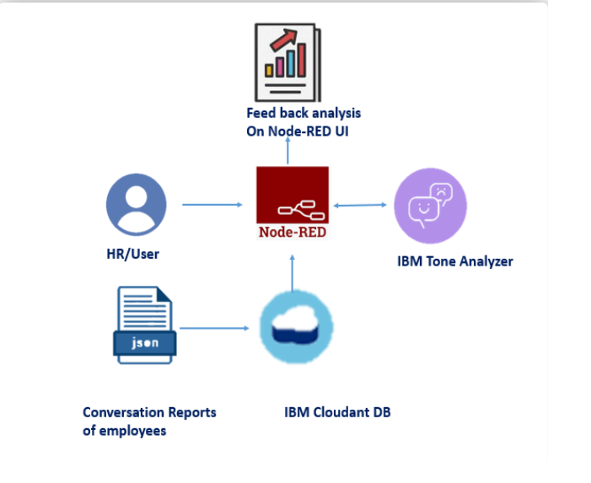

**3.2 HARDWARE/SOFTWARE SOLUTION**

1. IBM Cloud
2. IBM Watson Tone Analyzer
3. Node-RED
4. Creating employee database in IBM cloud and upload sample 4 employees feedback json files.
5. **EXPERIMENTAL INVESTIGATION**

1. **Choose a Project Idea:**

Employee Appreciation Based on Customer Satisfaction.

1. **Conduct Background Research**
2. **Compose a Hypothesis:**

Based on our Study and information gathered we can decide how well an employee is appreciable.

1. **Design your Experiment:**

First we need to collect employees reports in which feedbacks are given by the customers. Next, we give those reports as input to the Tone analyzer service which predicts the emotion behind those feedbacks.

1. **Draw Conclusions:**

After Building our model, we can able to know how well the employee is working and appreciate the employee work based on analysis of customer feedback.

1. **FLOWCHART**

Select a employee

Input customer’s Feedback (.json files) from IBM cloud

Tone Analyzer Service

Output as the emotion (polite, satisfied, sad, etc.) in a bar graph.

Store the o/p data in IBM cloud under sentiment database

1. **RESULT**

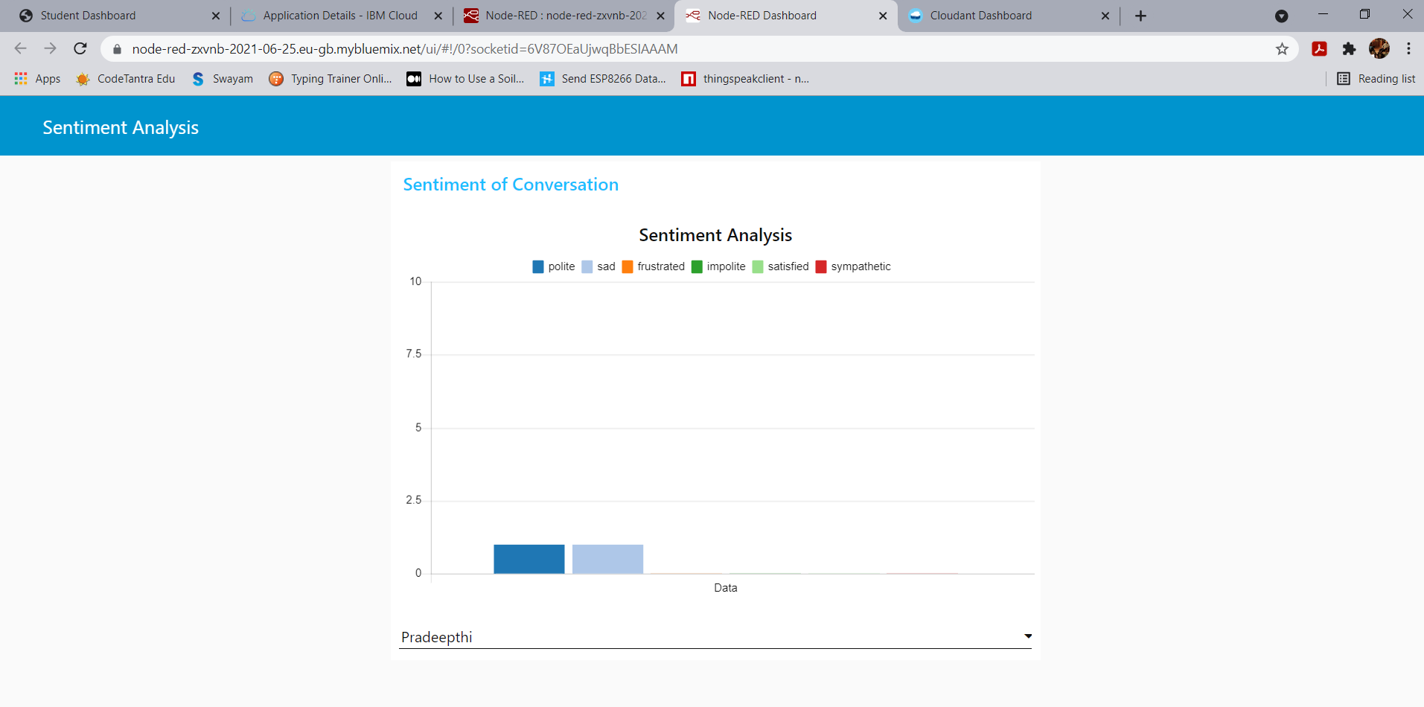

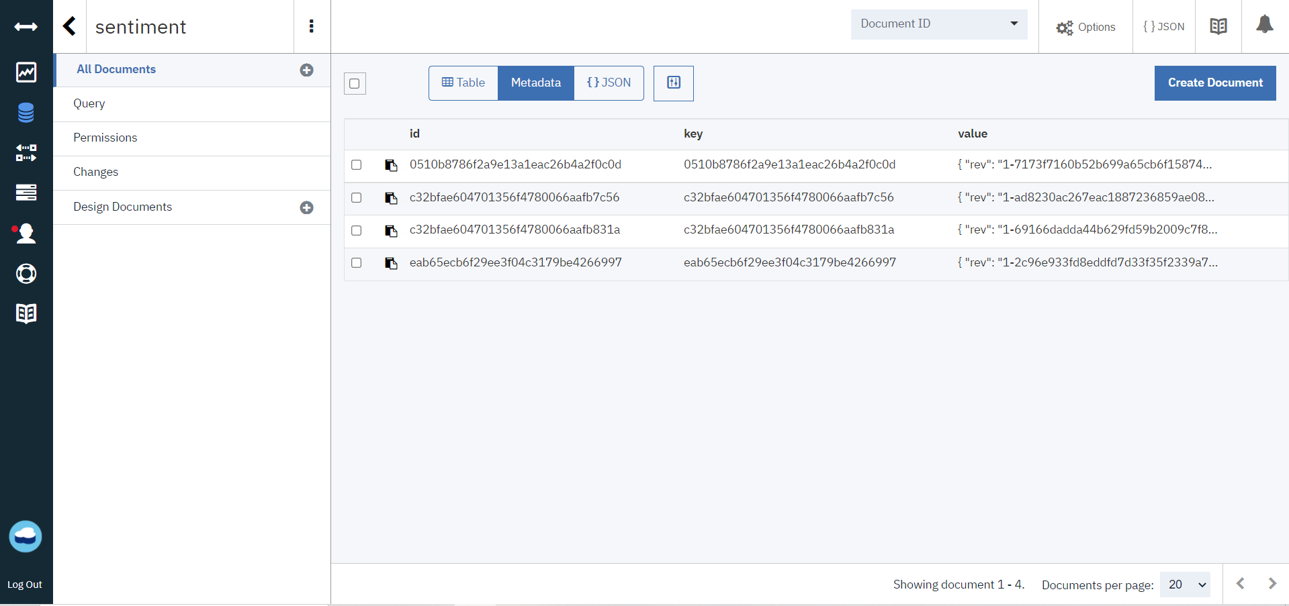

**7. ADVANTAGES AND DISADVANTAGES**

**7.1 ADVANTAGES**

1. This project is used to appreciate the employee work based on analysis of customer feedback.
2. The analysis of each employee report is displayed on the Web application in the form of Bar charts which reduces manual work.
3. Increase Employee Productivity.

**7.2 DISADVANATGES**

1. Too much appreciation and disappointment to a person is not good.

**8. APPLICATIONS**

* This application is used for deciding the employee’s work is upto the mark or not.
* This system can also be used to employee to check whether they receiving good or bad feedback from the customers so that they will improve their work.

**9. CONCLUSION**

The employee work is measured based on analysis of customer feedback. We are designing an application where the HR/ user can upload the feedback report of all the employees. The analysis of each employee report is displayed on the Web application in the form of Bar charts.

**10. FUTURE SCOPE**

Employee satisfaction is becoming an irreplaceable part of positive company culture. Along with that, customer satisfaction has also become a prime aim. But, building a loyal and happy customer base is not an easy task. It is achievable if you have a workforce that is satisfied with their job. Their satisfaction levels will reflect on how they interact with a customer. The prime goal should be keeping your employees engaged, satisfied, and happy with their work. This project will help you out in this by extracting the emotions from the feedbacks of the customers for the employees. It had a good future scope also.

**11. BIBILOGRAPHY**

* <https://www.youtube.com/watch?v=beCCPIH0-8c>
* <https://www.youtube.com/watch?v=vYreeoCoQPI>
* <https://www.youtube.com/watch?v=wUb--6FPBik>
* Smartinternz project description.

**12. APPENDIX**

Node-RED Flow

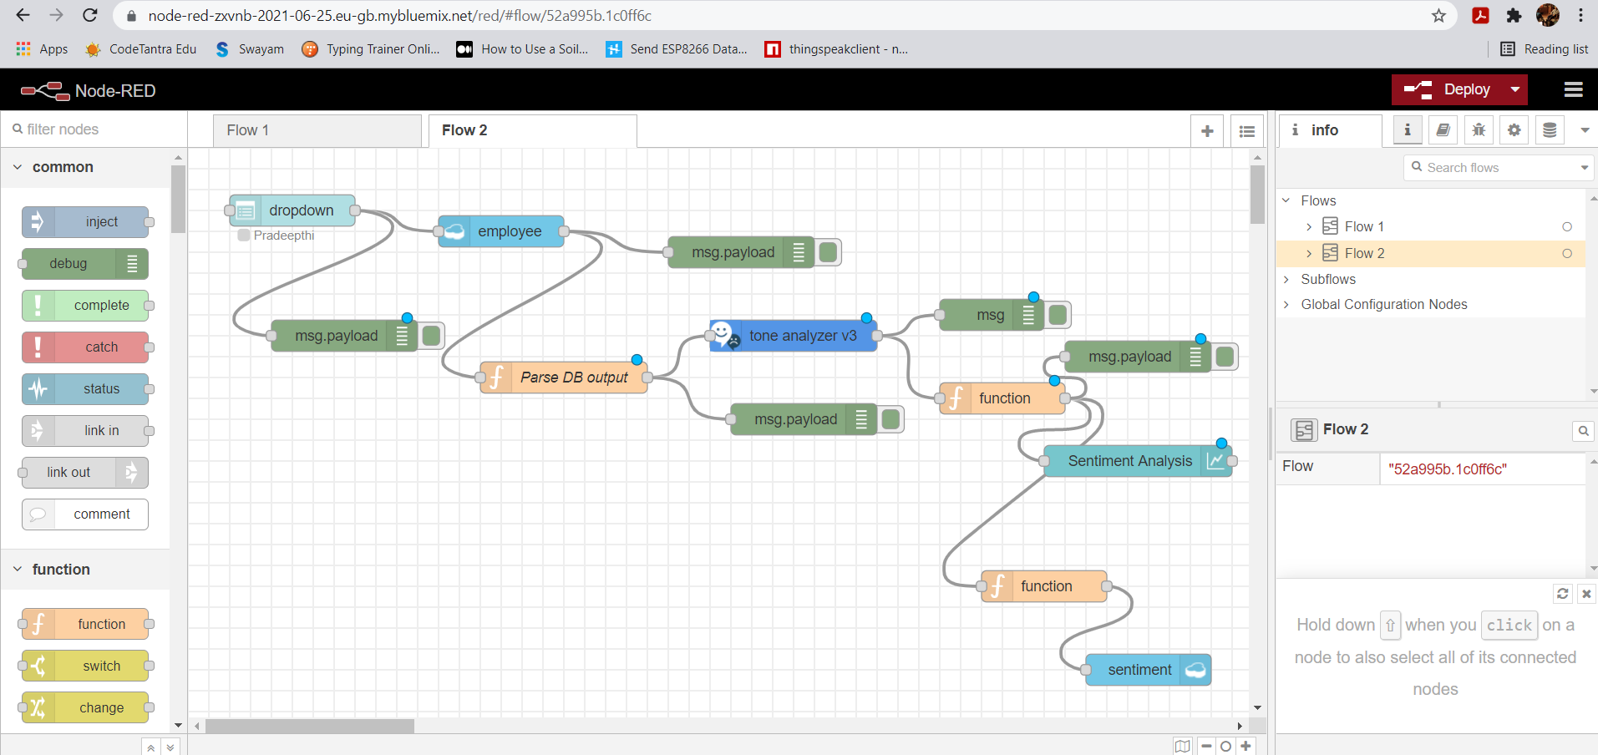

IBM Cloud databases:

Input employees reports stored in employee database

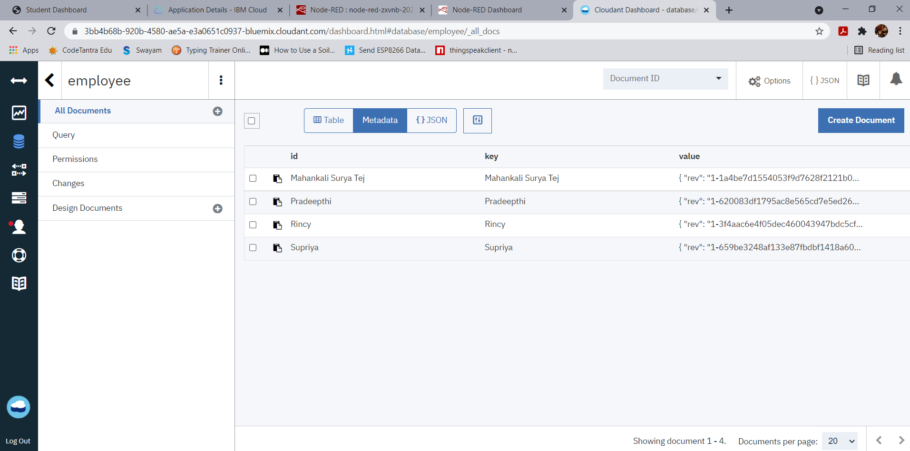

Output sentiment by tone analyzer stored in sentiment database



**UI SCREENSHOTS**



