SMART INTERNZ

**Loan Status Prediction Using IBM Watson**

**Machine Learning**

**Index**

**Topics Page No**

1. Introduction 2
   1. Overview
   2. Purpose
2. Literature Survey 3
   1. Existing problem
   2. Proposed solution
3. Theoretical Analysis 3
   1. Block diagram
   2. Hardware / Software designing
4. Experimental Investigations 4
5. Flowchart 5
6. Result 6
7. Advantages & Disadvantages 6
8. Applications 7
9. Conclusion 7

1

1. **Future Scope 7**
2. **Bibliography 8**
3. **Appendix 9**
   1. **Source code**
   2. **UI output Screenshot**

## 2

## **1. Introduction:**

In India, the number of people applying for loans gets increased for various reasons in recent years. The bank employees are not able to analyze or predict whether the customer can pay back the amount or not (good customer or bad customer) for the given interest rate. The aim is to find the nature of the client applying for a personal loan.

The result of the analysis shows that short term loans are preferred by the majority of the clients and the clients majorly apply loans for debt consolidation. The results are shown in graphs that help the bankers to understand the client’s behavior.

**a. Overview**

User interacts with browser which contains questions. We integrate our html files with model which is trained with available dataset. Based on the user input our trained model predict whether he will pay fully or charged off.

**b. Purpose**

1.     Knowledge of Machine Learning Algorithms.

2.     Knowledge of Python Language with Machine Learning

3.     Knowledge of Statistics and Graphs and their relations

4.     Real-Time Analysis of Project

5.     Building ease of User Interface (UI)

6.     Navigation of ideas towards other projects(creativeness)

## 

3

## **1. Literature Survey**

## a. Existing problem

## Bank Employees have to predict whether an employee is feasible or not to give loan based on their previous experience and based on user credit score and his property and some other parameters. But predicting user behavior on fewer parameters make wrong predictions. As a human we do not remember things for larger extent and even our predictions go wrong or biased according to surroundings.

## **b. Proposed Solution**

## As we all know that machines not effected by surrounding pressures. We proposed a system where we train the machine with our available previous data to get it experience and for new users, we take a good number of inputs required to predict and give to trained model and get predicted output.

## **Theoretical Analysis**

1.     Installing the required packages and libraries.

2.     Importing the required libraries for the model to run.

3.     Downloading the dataset, feeding it to the model, and understanding the dataset

4.     Data Preprocessing – Checking for outliers and null values. If there any null values we use Label Encoding to convert then into binary format.

5.     Dividing the model into Train and Test data. Fitting the model and predicting.

6.    Building Flask Web Application.

4

**a. Block Diagram**

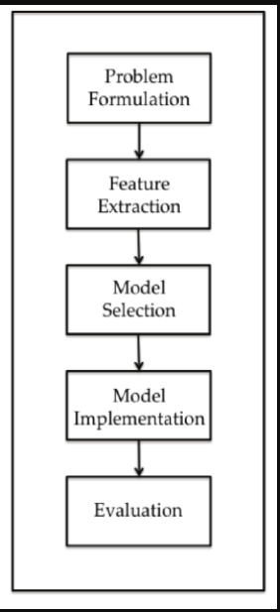

**b. Software/Hardware Designing**

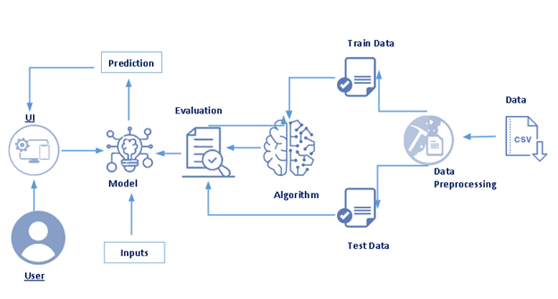

## 5

## **4. Experimental Investigations**

## 1. Choose a Project Idea

## Loan Status Prediction using IBM Watson Machine Learning.

## 2. Conduct Background Research

## By doing research we found what are fields required for Prediction.

## 3. Compose Hypothesis

## Based on our study and information gathered we can decide whether we can give loan to particular customer or not by taking simple answers from him.

## 4. Design Your Experiment

## We need to prepare a dataset based on the information available to us. Then perform some preprocessing tasks. Train the model by applying different machine learning algorithms and select the one which gives good results. Then integrate our model with html files to create user interface which takes answers from user.

## 5. Draw Conclusions

## After model predicts the results we able to know how model is performing by comparing the actual results and predicted results.

## 

## 6

## **5. Flowchart**

## 

## **6. Result**

## The model is giving good results by passing different values and the predicted values are closer to actual results. Based on the user input model giving output which is of 3 types

## 1. If required fields are not filled then model is not predicting anything instead of predicting wrong value.

## 2. If values entered by user are closer to chargedoff model is predicting ‘ChargedOff’

## 3.If values entered by user good and based on previous training model predicting ‘FullyPaid’.

## 7

## **7. Advantages and Disadvantages**

## **Advantages**

## Bank Employees need not to spend hours of time to analyze all previous records to give loan.

## Can consider all necessary parameters to get accurate results.

## No fear of considering many parameters to predict as system will manage once trained.

## **Disadvantages**

## The model may give inaccurate results if it is trained with outliers.

## In some scenarios present conditions also need to consider but model always considers previous trained data to predict results.

## **8. Applications**

## This application is mainly used to predict whether user is fullypaid or chargedoff.

## **9. Conclusion**

## The loan status of user is predicted based on input given by employee. So, it is very important that entered data is correct. Based on the inputs received the predicted output is displayed on the user screen.

## 

## 

## 8

## **Future Scope**

## For any country to develop companies and industries are backbones. And a development of middle class and poor make the country developed. At any phase during development of above categories they need money and went for banks to loan. And it is also very important to bank that if give loan to people who can repay. So for increasing population and increasing demand for loans banks should automate the process in which this type of projects makes their work easier.

## **11. Bibliography**

## <http://sersc.org/journals/index.php/IJAST/article/view/460>

## <https://towardsdatascience.com/predict-loan-eligibility-using-machine-learning-models-7a14ef904057>

## **12.Appendix**

## **a. Source Code**

## Create and Load dataset into project folder.

## Perform the preprocessing tasks on dataset.

## Train the model on different machine learning models and choose the best one.

## Save the model for offline results.

## Create flask and html files to create user interface.

## Deploy the model on IBM Cloud.

## 9

## **b. UI Output Screenshots**

## 

## 

## 10

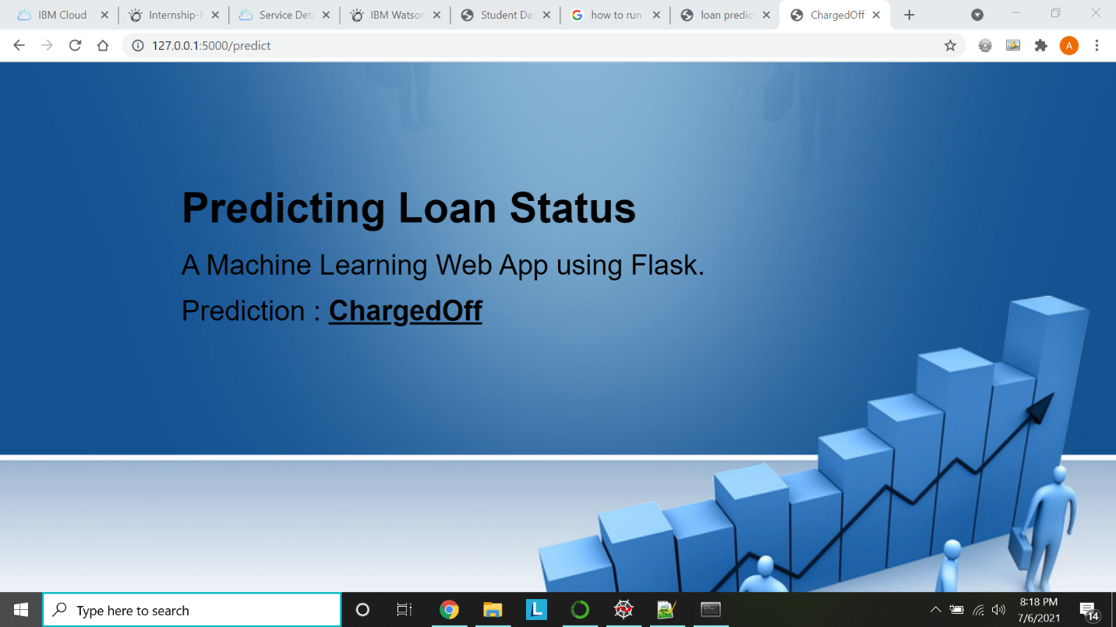

11