**DIGITAL NATURALIST USING IBM WATSON STUDIO**

**1.Introduction:**

Accurate species identification is the basis for all aspects of taxonomic research and is an essential component of workflows in biological research. Biologists are asking for more efficient methods to meet the identification demand. Smart mobile devices, digital cameras as well as the mass digitisation of natural history collections led to an explosion of openly available image data depicting living organisms. This rapid increase in biological image data in combination with modern machine learning methods, such as deep learning, offers tremendous opportunities for automated species identification.

**a) Overview:**

A naturalist is someone who studies the patterns of nature, identifies a different kind of flora and fauna in nature. Being able to identify the flora and fauna around us often leads to an interest in protecting wild spaces, and collecting and sharing information about the species we see on our travels is very useful for conservation groups like NCC.

**b) Purpose:**

When venturing into the woods, field naturalists usually rely on common approaches like always carrying a guidebook around everywhere or seeking help from experienced ornithologists. There should be a handy tool for them to capture, identify and share the beauty to the outside world.

Field naturalists can only use this web app from anywhere to identify the birds, flowers, mammals and other species they see on their hikes, canoe trips and other excursions.

**2. Literature Survey:**

**a) Existing problem:**

**b) Proposed solution:-**

* The proposed solution for the problem is first we need to collect the data related to the different species among Birds and Animals.
* According to the collected data we perform different actions for getting the Exact Information about Endemic species.
* Animal identification can generally be done with the images, audio, or video. The audio or video processing technique makes it possible to detect birds by analyzing audio and video signals; however, the processing of such information is made more complicated by mixed sounds such as insects and the presence of other real-world objects in the frame.

**3.Theretical Analysis:**

**a) Block Diagram:**

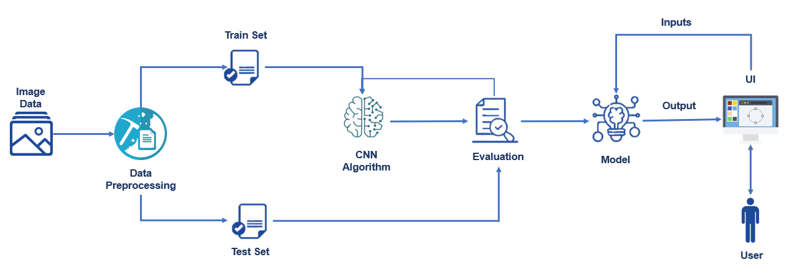

**b)** **Hardware/software designing**

**Software Requirements:**

* OS – Windows XP,7,8,10
* Jupyter Software
* Spyder Software
* Anaconda Command Prompt

**Hardware Components:**

* Processor – i3
* Hard Disk Storage – 10 GB
* RAM – 1GB

**4. Experimental Investigations:**

Machine learning enables computers to solve tasks without being explicitly programed to solve them . State-of-the-art methods teach machines via supervised learning (i.e., by showing them correct pairs of inputs and outputs). For example, when classifying images, the machine is trained with many pairs of images and their corresponding labels, where the image is the input and its correct label.

**5.Result:**

Image Pre-processing includes the following main tasks

* Import ImageDataGenerator Library.
* Configure ImageDataGenerator Class.
* Applying ImageDataGenerator functionality to the trainset and test set.
* The model is to be tested with different images to know if it is predicting correctly.

After the model is built, we will be integrating it into a web application so that normal users can also use it. The users need to give the images to know the predictions

**6. Future Scope:**

There are many directions for future work, but here we mention three particularly promising ones.

* The first is studying the actual time savings and effects on accuracy of a system hybridizing DNNs and teams of human volunteer labelers. Time savings should come from three sources: automatically filtering empty images, accepting automatically extracted information from images for which the network is highly confident in, and by providing human labelers with a sorted list of suggestions from the model so they can quickly select the correct species, counts, and descriptions. However, the actual gains seen in practice need to be quantified.
* A second, but related, promising direction is studying active learning , a virtuous cycle in which humans label only the images in which the network is not confident, and then those images are added to the dataset, the network is retrained, and the process repeats.
* The third is automatically handling multispecies images, which we removed for simplicity. While our current trained pipeline can be applied to all images, for images with multiple species, it provides only one species label. In 97.5% of images, it correctly listed one of the species present, providing useful information, but the impact of missing the other species should be kept in mind and will depend on the use case. However, one could train networks to list multiple species via a variety of more sophisticated deep-learning techniques, a profitable area for future research.

**7. Conclusion:**

In this work, we tested the ability of state-of-the-art computer vision methods called DNNs to automatically extract information from images in the SS dataset, the largest existing labeled dataset of wild animals. We first showed that DNNs can perform well on the SS dataset, although performance is worse for rare classes.

Perhaps most importantly, our results show that using deep-learning technology can save a tremendous amount of time for biology researchers and the human volunteers that help them by labeling images. In particular, for animal identification, our system can save 99.3% of the manual labor (>17,000 h) while performing at the same 96.6% accuracy level of human volunteers. This substantial amount of human labor can be redirected to other important scientific purposes and also makes knowledge extraction feasible for camera-trap projects that cannot recruit large armies of human volunteers. Automating data extraction can thus dramatically reduce the cost to gather valuable information from wild habitats and will thus likely enable, catalyze, and improve many future studies of animal behavior, ecosystem dynamics, and wildlife conservation.

**8. Biblography:**

1. TÃ³th, B.P. and Czeba, B., 2016, September. Convolutional Neural Networks for Large-Scale Bird Song Classification in Noisy Environment. In CLEF (Working Notes) (pp. 560-568).
2. Fagerlund, S., 2007. Bird species recognition using support vector machines. EURASIP Journal on Applied Signal Processing, 2007(1), pp.64-64.
3. Pradelle, B., Meister, B., Baskaran, M., Springer, J. and Lethin, R., 2017, November. Polyhedral Optimization of TensorFlow Computation Graphs. In 6th Workshop on Extreme-scale Programming Tools (ESPT-2017) at The International Conference for High Performance Computing, Networking, Storage and Analysis (SC17).
4. Cirean, D., Meier, U. and Schmidhuber, J., 2012. Multi-column deep neural networks for image classification. arXiv preprint arXiv:1202.2745.
5. AndrÂ´eia Marini, Jacques Facon and Alessandro L. Koerich Postgraduate Program in Computer Science (PPGIa) Pontical Catholic University of ParanÂ´a (PUCPR) Curitiba PR, Brazil 80215901 Bird Species Classication Based on Color Features
6. Image Recognition with Deep Learning Techniques ANDREI- PETRU BRAR, VICTOR-EMIL NEAGOE, NICU SEBE Faculty of Electronics, Telecommunications & Information Technology Polytechnic University of Bucharest.
7. Xception: Deep Learning with Depthwise Separable Convolutions FranÃ§ois Chollet Google, Inc.
8. Zagoruyko, S. and Komodakis, N., 2016. Paying more attention to attention: Improving the performance of convolutional neural networks via attention transfer. arXiv preprint arXiv:1612.03928.
9. Inception-v4,Inception-ResNetand the Impact of Residual Connectionson Learning Christian Szegedy, Sergey Ioffe,Vincent Vanhoucke ,Alexandrr A.Alemi
10. Stefan Kahl, Thomas Wilhelm-Stein, Hussein Hussein, Holger Klinck, Danny Kowerko, Marc Ritter, and Maximilian Eibl Large-Scale Bird Sound Classification using Convolutional Neural Networks

**Source Code : (Application Building)**

from __future__ import division, print_function

import os

import numpy as np

from tensorflow.keras.preprocessing import image

from tensorflow.keras.models import load_model

import tensorflow as tf

from flask import Flask, request, render_template

from werkzeug.utils import secure_filename

from tensorflow.keras.models import model_from_json

# Define a flask app

app = Flask(__name__)

# Load your trained model

json_file = open('final_model.json', 'r')

loaded_model_json = json_file.read()

json_file.close()

loaded_model = model_from_json(loaded_model_json)

loaded_model.load_weights("final_model.h5")

print('Model loaded. Check http://127.0.0.1:5000/')

@app.route('/', methods=['GET'])

def index():

# Main page

return render_template('digital.html')

@app.route('/predict', methods=['GET', 'POST'])

def upload():

if request.method == 'POST':

# Get the file from post request

f = request.files['image']

# Save the file to ./uploads

basepath = os.path.dirname(__file__)

file_path = os.path.join(

basepath, 'uploads', secure_filename(f.filename))

f.save(file_path)

img = image.load_img(file_path, target_size=(224, 224))

x = image.img_to_array(img)

x = np.expand_dims(x, axis=0)

#a=np.argmax(model.predict(x),axis=1)

preds = loaded_model.predict_classes(x)

found = ["The great Indian bustard is a bustard found on the Indian subcontinent. A large bird with a horizontal body and long bare legs, giving it an ostrich like appearance, this bird is among the heaviest of the flying birds. It belongs to Otididae family and is listed among critically endangered species.",

"The spoon-billed sandpiper is a small wader which breeds in northeastern Russia and winters in Southeast Asia. It belongs to Scolopacidae family and is listed among critically endangered species.",

"Amorphophallus Titanum is endemic to sumantra. Due to its odor, like that of a rotting corpse, the titan arum is characterized as a Carrion Flower or Corpse Flower. It belongs to Araceae family.",

"Lady's slipper, (subfamily Cypripedioideae), also called lady slipper or slipper orchid, subfamily of five genera of orchids (family Orchidaceae), in which the lip of the flower is slipper-shaped.",

"Pangolins, sometimes known as scaly anteaters, are of the order Pholidota. Often thought of as a reptile, but pangolins are actually mammals. They are the most trafficked mammals.",

"The white deer found at Seneca Army Depot are a natural variation of the white-tailed deer (Odocoileus virginianus), which usually have brown coloring. The Seneca White Deer are leucistic, meaning they lack all pigmentation in the hair, but have the normal brown-colored eyes."]

text = found[preds[0]]

return text

if __name__ == '__main__':

app.run(threaded = False)

**Output :**



