1. INTRODUCTION
1.1 Overview
Now a day’s people are suffering from skin diseases, more than 125 million people suffering from Psoriasis also skin cancer rate is rapidly increasing over the last few decades especially Melanoma is most diversifying skin cancer. If skin diseases are not treated at an earlier stage, then it may lead to complications in the body including spreading of the infection from one individual to the other. The skin diseases can be prevented by investigating the infected region at an early stage. The characteristic of the skin images is diversified so that it is a challenging job to devise an efficient and robust algorithm for automatic detection of skin disease and its severity. Skin tone and skin colour play an important role in skin disease detection. Color and coarseness of skin are visually different. Automatic processing of such images for skin analysis requires quantitative discriminator to differentiate the diseases. To overcome the above problem. we are building a model which is used for the prevention and early detection of skin cancer, psoriasis. Basically, skin disease diagnosis depends on the different characteristics like colour, shape, texture etc. Here the person can capture the images of skin and then the image will be sent the trained model. The model analyses the image and detect whether the person is having skin disease or not.
1.2 Purpose
Skin diseases are characterized as disorders that often begin inside the body or start from the skin, and outwardly show on the skin [1, 2]. Some of them are extremely uncommon, however, others are commonly occurring. They bring the person itch, and pain, as well as emotional and social impacts because of its visibility. All things considered, dermatologists guaranteed that a large portion of the skin diseases are manageable with legitimate medications, if they are decisively diagnosed [3]. Thus, an effective automatic skin disease detection design which can be used by the dermatologist to reduce their workload is highly anticipated.
2. LITERATURE SURVEY
2.1 Existing problem
Computer-aided diagnosis (CAD) is a computer-based system that is used in the medical imaging field to aid healthcare workers in their diagnoses¹. CAD has become a mainstream tool in several medical fields such as mammography and colonography^{1,2}. However, in dermatology, although skin disease is a common disease, one in which early detection and classification is crucial for the successful treatment and recovery of patients, dermatologists perform most noninvasive screening tests only with the naked eye. This may result in avoidable diagnostic inaccuracies as a result of human error, as the detection of the disease can be easily overlooked. Furthermore, classification of a disease is difficult due to the strong similarities between common skin disease symptoms. Therefore, it would be beneficial to exploit the strengths of CAD using artificial intelligence techniques, in order to improve the accuracy of dermatology diagnosis. CAD may be a
viable option in the field of dermatology using state-of-the-art deep learning models.

2.2 Proposed solutions
Owing to the disadvantages of these traditional approaches, convolution neural networks (CNNs) have gained popularity because of their ability to extract high-level features with minimal preprocessing¹⁰. CNNs can expand the advantages of SVMs, such as robustness in noisy datasets without the need for optimal preprocessing, by capturing image context and extracting features through down-sampling.. To solve this, up-sampling is needed, which works in a manner opposite to that of down-sampling, in the sense that it increases the resolution of the image. In the classification model, these skip-connections exist in the form of inverted residual blocks. This allows our models to grow in complexity without any performance degradation.
It introducing a method to sequentially combine two separate models to solve a larger problem. In the past, skin disease models have been applied to either segmentation or classification. We sequentially combine both models by using the output of a segmentation model as input to a classification model. non-CNN segmentation models used innovative preprocessing methods, recent CNN developments have focused more on the architecture of the model than on the preprocessing of data. As such, we apply an innovative preprocessing method to the data of our CNN segmentation model. The methods described above lack the ability to localize and classify multiple diseases within one image; however, we have developed a method to address this problem. Our objective is two-fold. First, we show that CAD can be used in the field of dermatology. Second, we show that state-of-the-art models can be used with current computing power to solve a wider range of complex problems than previously imagined.
3. THEORITICAL ANALYSIS
3.1 Block diagram
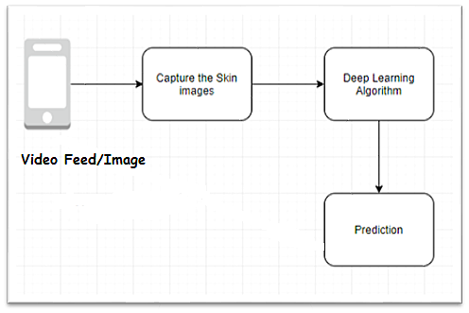

3.2 Hardware / Software designing

In this project we needed to know about train a YOLO model in the windows environment. And also annotate images using Microsoft's Visual Object Tagging Tool (VoTT).we are using Keras and TensorFlow for building models
To complete the project, require the following software’s, concepts, and packages
- Python IDE (IDLE / Spyder / PyCharm (Python 3.7)
- Microsoft's Visual Object Tagging Tool (VoTT)
- Python Packages need to be installed
The packeges needed are
- Tensorflow- This package is used as backend support to Keras
- Keras-This package is used for building Neural Network layers
- opencv-This package is used for image processing
- Pillow
- Progress bar

4. EXPERIMENTAL INVESTIGATION

We introducing a method to sequentially combine two separate models to solve a larger problem. In the past, skin disease models have been applied to either segmentation or classification. We sequentially combine both models by using the output of a segmentation model as input to a classification model. non-CNN segmentation models used innovative preprocessing methods; recent CNN developments have focused more on the architecture of the model than on the preprocessing of data. As such, we apply an innovative preprocessing method to the data of our CNN segmentation model. The methods described above lack the ability to localize and classify multiple diseases within one image; however, we have developed a method to address this problem. Our objective is two-fold. First, we show that CAD can be used in the field of dermatology. Second, we show that state-of-the-art models can be used with current computing power to solve a wider range of complex problems than previously imagined.

5. FLOWCHART
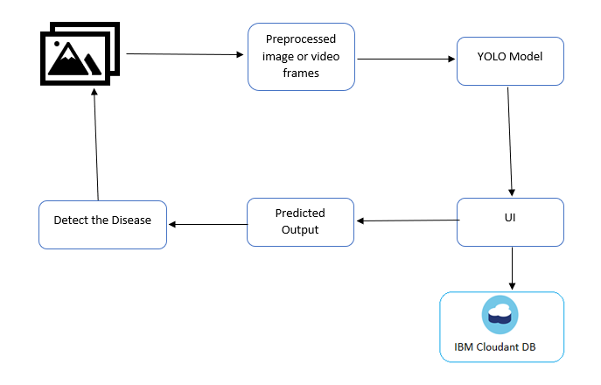
6. RESULT
To overcome the problems, we are building a model which is used for the prevention and early detection skin cancer psoriasis. Basically, skin disease diagnosis depends on the different characteristics like colour, shape, texture etc. Here the person can capture the image of the skin and then the image will be sent to the trained model. The model analyses the image and detect whether the person is having skin disease or not.

6.1 HOME PAGE (home.html)

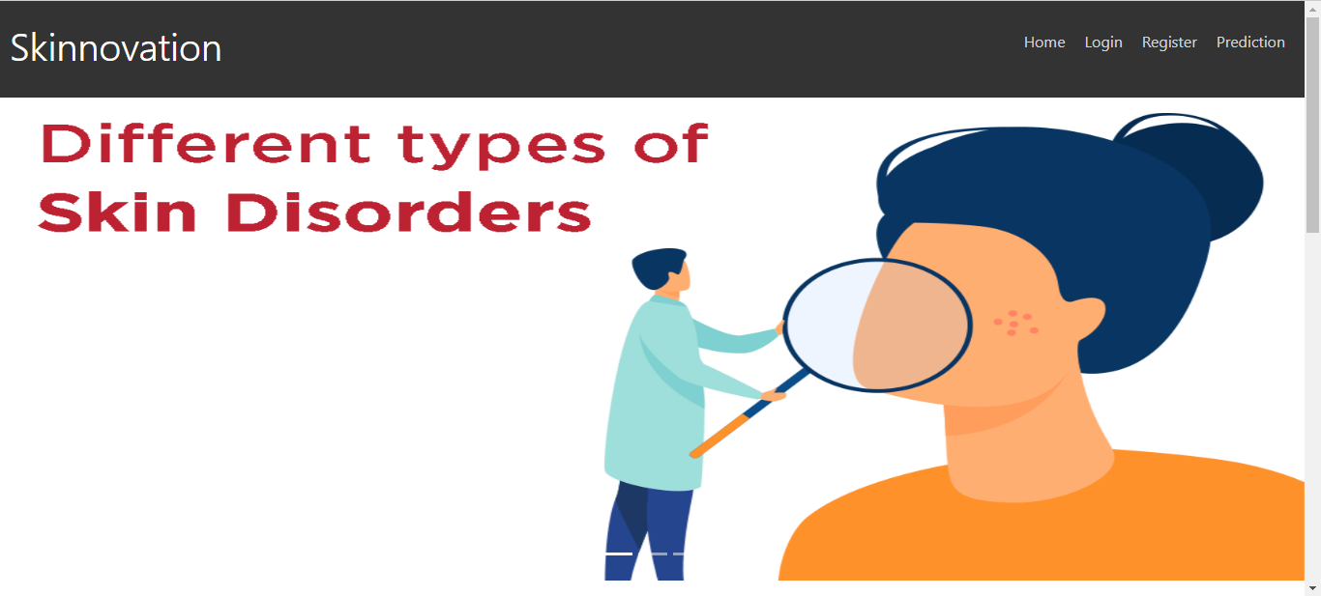

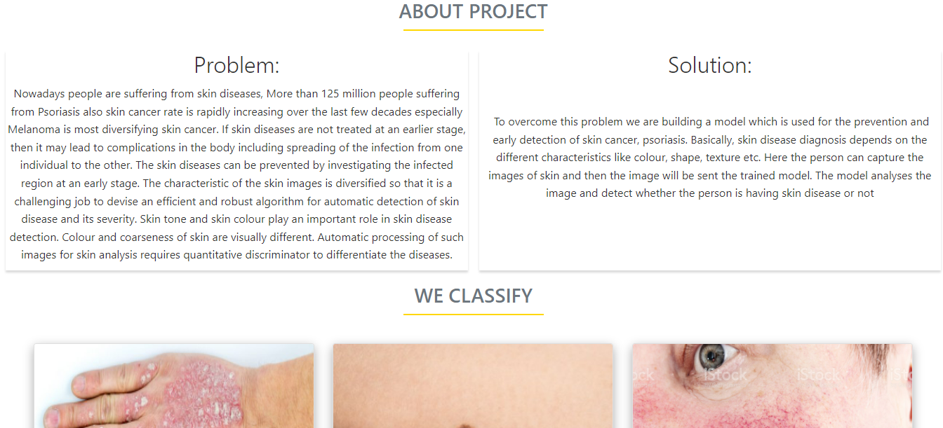
6.2 REGISTRATION PAGE (register.html)

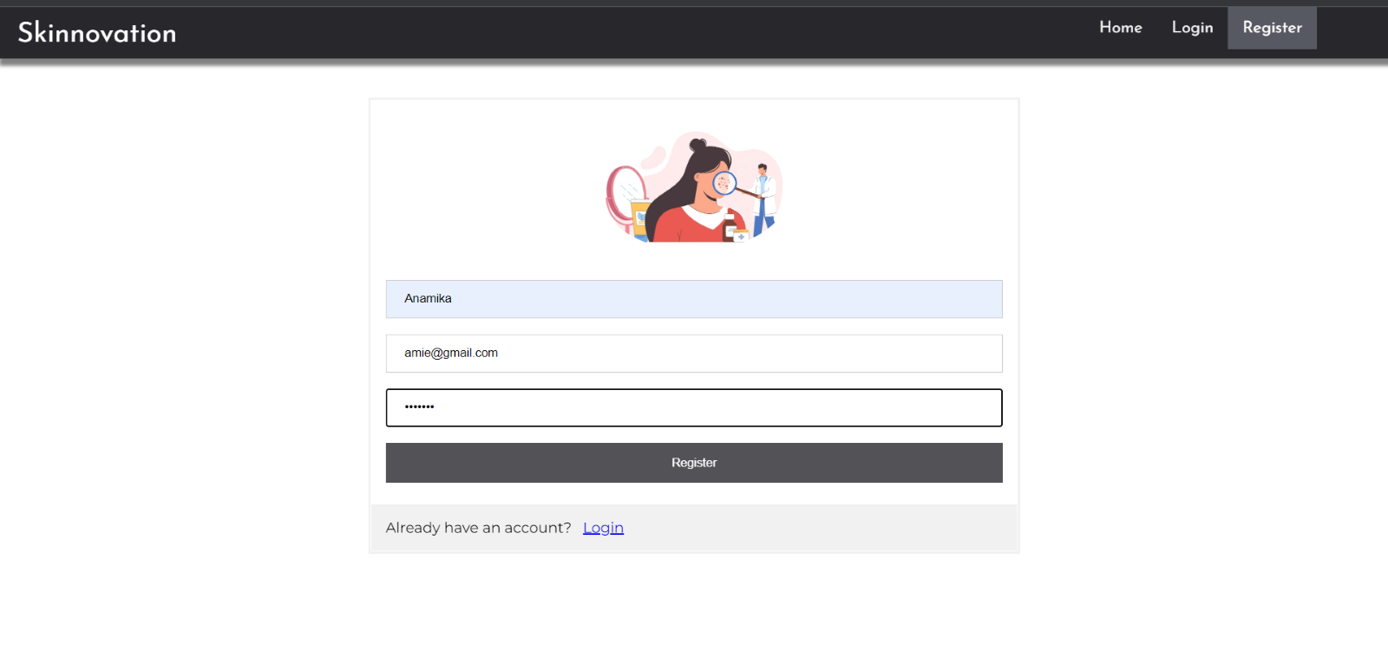

s 6.3 LOGIN PAGE (login.html
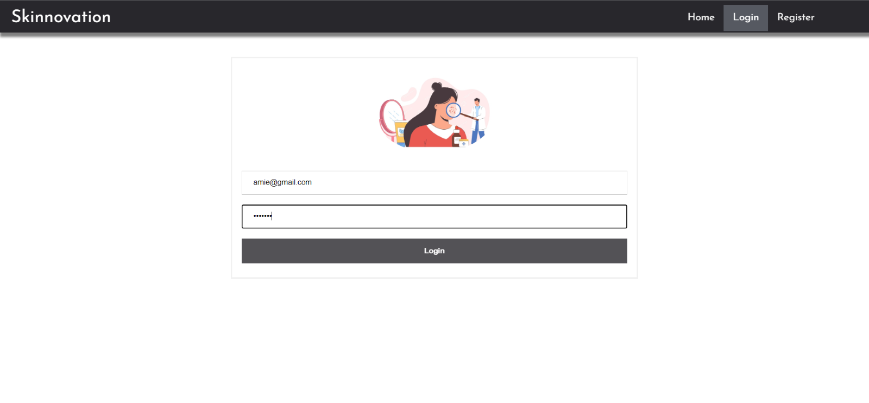
6.4 PREDICTION PAGE (prediction.html)

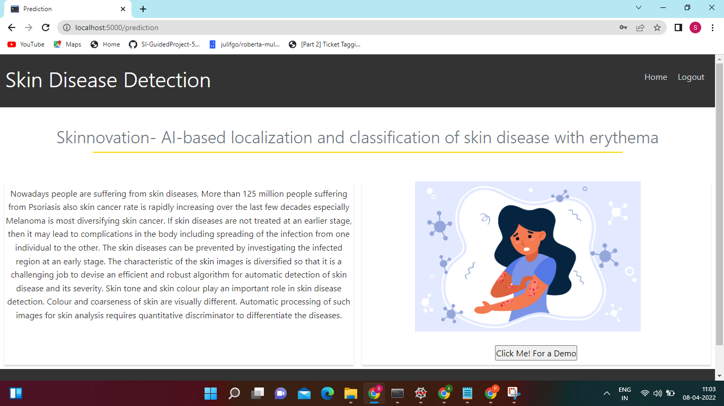

6.5 LOGOUT PAGE (logout.html)



6.6 Detection_Results

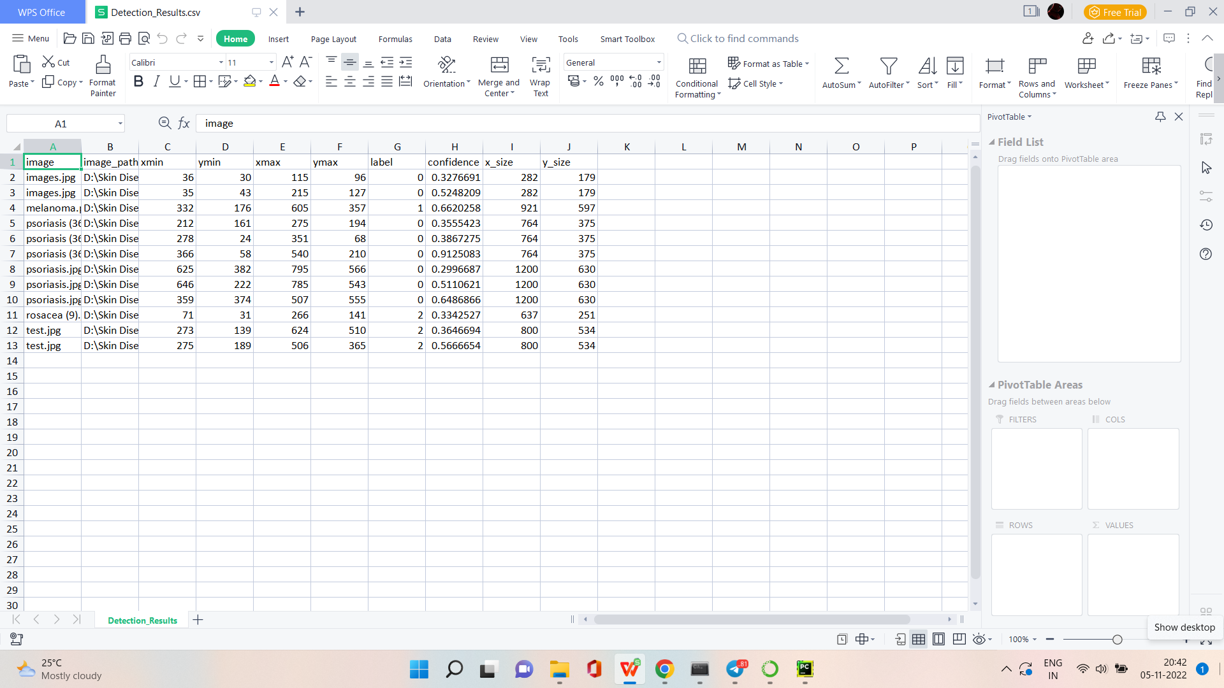

7. ADVANTAGES & DISADVANTAGES
7.1 Advantages
- Solving the problems of using the old system
- helping prevention and early detection of deseases like skin cancer, psoriasis etc.
- Easy to use.
- Giving more accurate result.
- Reducing the chances occuring errors, especially human errors.
- CAD is become a viable option in the field of dermatology using state-of-the-art deep learning models.
7.2 Disadvantages
- It needed to capture quality images to predict the result.
- Sometimes occurring errors because the colour, shape, texture etc. Of image is important.
8. APPLICATIONS
Now a day’s people are suffering from skin diseases, more than 125 million people suffering from Psoriasis also skin cancer rate is rapidly increasing over the last few decades especially Melanoma is most diversifying skin cancer. If skin diseases are not treated at an earlier stage, then it may lead to complications in the body including spreading of the infection from one individual to the other. The skin diseases can be prevented by investigating the infected region at an early stage. The characteristic of the skin images is diversified so that it is a challenging job to devise an efficient and robust algorithm for automatic detection of skin disease and its severity. Skin tone and skin colour play an important role in skin disease detection. Color and coarseness of skin are visually different. Automatic processing of such images for skin analysis requires quantitative discriminator to differentiate the diseases. To overcome the above problem. we are building a model which is used for the prevention and early detection of skin cancer, psoriasis. Basically, skin disease diagnosis depends on the different characteristics like colour, shape, texture etc. Here the person can capture the images of skin and then the image will be sent the trained model. The model analyses the image and detect whether the person is having skin disease or not.
9. CONCLUSION
We are introducing a model to the prevention and early detection of skin diseases like cancer, melanoma, psoriasis etc. Here we using yolo modeling techniques to predict the result by analyzing the image. We training the dataset to give an accurate result. Through this model we can resolve the problems of using the old model which always causes human errors. CNNs can expand the advantages of SVMs, such as robustness in noisy datasets without the need for optimal preprocessing, by capturing image context and extracting features through down-sampling.

10. FUTURE SCOPE
As our main objective was to demonstrate the viability of CAD, the performance was mostly determined using pixel-level sensitivity rather than the Intersection over Union or the Dice coefficient metrics that are often used to measure segmentation performance. Moreover, we mainly focused on the true positive rates of segmentation, represented by the sensitivity metric. This is because our aim was to create a screening test method to help healthcare workers make a more accurate diagnosis by preventing abnormal skin from being overlooked. Nevertheless, we also measured the performance of our model using the specificity, Dice coefficient, and Hausdorff distance to provide a more complete performance comparison. We measured these metrics by comparing the output from our U-Net model to an image that was masked by professional dermatologists. Going through each pixel, if a pixel of the U-Net output was black and the pixel of the dermatologist-masked image at the same location was black, this is seen as a true negative. If both were white, this was seen as a true positive. If the U-Net output was black but the dermatologist mask was white, this was seen as a false negative, and the converse was a false positive. The equations for sensitivity, specificity, and Dice coefficient metric can be represented by formulas.
11. BIBILOGRAPHY
- T. B. Murdoch, and A. S. Detsky. The inevitable application of big data to health care, Jama, vol. 309, no. 13, pp. 1351-1352, 2013. https://doi.org/10.1001/jama.2013.393
- D. D. Miller and E. W. Brown. Artificial intelligence in medical practice: the question to the answer? The American journal of medicine, vol. 131, no. 2, pp. 129-133, 2018. 13. S.
- L. C. De Guzman, R. P. C. Maglaque, V. M. B. Torres, S. P. A. Zapido, and M. O. Cordel. Design and Evaluation of a Multi-model, Multi-level Artificial Neural Network for Eczema Skin Lesion Detection, in 2015 3rd International Conference on Artificial Intelligence, Modelling and Simulation (AIMS), pp. 42-47, 2015.
- L. K. Tolentino, R. M. Aragon, W. R. Tibayan, A. Alvisor, P. G. Palisoc, and G. Terte. Detection of Circulatory Diseases Through Fingernails Using Artificial Neural Network, Journal of Telecommunication, Electronic and Computer Engineering (JTEC), vol. 10, no. 1-4, pp. 181-188, 2018.
- H. Alquran, I. A. Qasmieh, A. M. Alqudah, S. Alhammouri, E. Alawneh, A. Abughazaleh, and F. Hasayen. The melanoma skin cancer detection and classification using support vector machine, in 2017 IEEE Jordan Conference on Applied Electrical Engineering and Computing Technologies (AEECT), pp. 1-5, 2017.
- D. Goldfarb. Understanding Deep Neural Networks Using Topological Data Analysis. arXiv preprint arXiv:1811.00852, 2018.
- Rajab MI, Woolfson MS, Morgan SP. Application of region-based segmentation and neural network edge detection to skin lesions. Comput. Med. Imaging Graph. 2004;28:61–68. doi: 10.1016/S0895-6111(03)00054-5. [PubMed] [CrossRef] [Google Scholar]

APPENDIX
Source Code
App.py
from timeit import default_timer as timer
from utils import load_extractor_model, load_features, parse_input, detect_object
import test
import utils
import pandas as pd
from Get_File_Paths import GetFileList
import random
os.environ["TF_CPP_MIN_LOG_LEVEL"] = "3"
# Set up folder names for default values
data_folder = os.path.join(get_parent_dir(n=1), "Skin Disease Flask", "Data")
image_folder = os.path.join(data_folder, "Source_Images")
image_test_folder = os.path.join(image_folder, "Test_Images")
detection_results_folder = os.path.join(image_folder, "Test_Image_Detection_Results")
detection_results_file = os.path.join(detection_results_folder, "Detection_Results.csv")
model_folder = os.path.join(data_folder, "Model_Weights")
model_weights = os.path.join(model_folder, "trained_weights_final.h5")
model_classes = os.path.join(model_folder, "data_classes.txt")
anchors_path = os.path.join(src_path, "keras_yolo3", "model_data", "yolo_anchors.txt")
FLAGS = None
from cloudant.client import Cloudant
# Authenticate using an IAM API key
client = Cloudant.iam('42981c92-11ba-4c50-b63a-ffd30a0fbcec-bluemix','YMglPLj7jRMVggly-13jBWo1YGcTPUDoAO-I4tOCw3O8', connect=True)
# Create a database using an initialized client
my_database = client.create_database('my_database')
app=Flask(__name__)
#default home page or route
@app.route('/')
def index():
return render_template('index.html')
@app.route('/index.html')
def home():
return render_template("index.html")
#registration page
@app.route('/register')
def register():
return render_template('register.html')
@app.route('/afterreg', methods=['POST'])
def afterreg():
x = [x for x in request.form.values()]
print(x)
data = {
'_id': x[1], # Setting _id is optional
'name': x[0],
'psw':x[2]
}
print(data)
query = {'_id': {'$eq': data['_id']}}
docs = my_database.get_query_result(query)
print(docs)
print(len(docs.all())
if(len(docs.all())==0):
url = my_database.create_document(data)
#response = requests.get(url)
return render_template('register.html', pred="Registration Successful, please login using your details")
else:
return render_template('register.html', pred="You are already a member, please login using your details")
#login page
@app.route('/login')
def login():
return render_template('login.html')
@app.route('/afterlogin',methods=['POST'])
def afterlogin():
user = request.form['_id']
passw = request.form['psw']
print(user,passw)
query = {'_id': {'$eq': user}}
docs = my_database.get_query_result(query)
print(docs)
print(len(docs.all()))
if(len(docs.all())==0):
return render_template('login.html', pred="The username is not found.")
else:
if((user==docs[0][0]['_id'] and passw==docs[0][0]['psw'])):
return redirect(url_for('prediction'))
else:
print('Invalid User')
@app.route('/logout')
def logout():
return render_template('logout.html')
@app.route('/prediction')
def prediction():
return render_template('prediction.html')
@app.route('/result',methods=["GET","POST"])
def res():
# Delete all default flags
parser = argparse.ArgumentParser(argument_default=argparse.SUPPRESS)
"""
Command line options
"""
parser.add_argument(
"--input_path",
type=str,
default=image_test_folder,
help="Path to image/video directory. All subdirectories will be included. Default is "
+ image_test_folder,
)
parser.add_argument(
"--output",
type=str,
default=detection_results_folder,
help="Output path for detection results. Default is "
+ detection_results_folder,
)
parser.add_argument(
"--no_save_img",
default=False,
action="store_true",
help="Only save bounding box coordinates but do not save output images with annotated boxes. Default is False.",
)
parser.add_argument(
"--file_types",
"--names-list",
nargs="*",
default=[],
help="Specify list of file types to include. Default is --file_types .jpg .jpeg .png .mp4",
)
parser.add_argument(
"--yolo_model",
type=str,
dest="model_path",
default=model_weights,
help="Path to pre-trained weight files. Default is " + model_weights,
)
parser.add_argument(
"--anchors",
type=str,
dest="anchors_path",
default=anchors_path,
help="Path to YOLO anchors. Default is " + anchors_path,
)
parser.add_argument(
"--classes",
type=str,
dest="classes_path",
default=model_classes,
help="Path to YOLO class specifications. Default is " + model_classes,
)
parser.add_argument(
"--gpu_num", type=int, default=1, help="Number of GPU to use. Default is 1"
)
parser.add_argument(
"--confidence",
type=float,
dest="score",
default=0.25,
help="Threshold for YOLO object confidence score to show predictions. Default is 0.25.",
)
parser.add_argument(
"--box_file",
type=str,
dest="box",
default=detection_results_file,
help="File to save bounding box results to. Default is "
+ detection_results_file,
)
parser.add_argument(
"--postfix",
type=str,
dest="postfix",
default="_disease",
help='Specify the postfix for images with bounding boxes. Default is "_disease"',
)
FLAGS = parser.parse_args()
save_img = not FLAGS.no_save_img
file_types = FLAGS.file_types
#print(input_path)
if file_types:
input_paths = GetFileList(FLAGS.input_path, endings=file_types)
print(input_paths)
else:
input_paths = GetFileList(FLAGS.input_path)
print(input_paths)
# Split images and videos
img_endings = (".jpg", ".jpeg", ".png")
vid_endings = (".mp4", ".mpeg", ".mpg", ".avi")
input_image_paths = []
input_video_paths = []
for item in input_paths:
if item.endswith(img_endings):
input_image_paths.append(item)
elif item.endswith(vid_endings):
input_video_paths.append(item)
output_path = FLAGS.output
if not os.path.exists(output_path):
os.makedirs(output_path)
# define YOLO detector
yolo = YOLO(
**{
"model_path": FLAGS.model_path,
"anchors_path": FLAGS.anchors_path,
"classes_path": FLAGS.classes_path,
"score": FLAGS.score,
"gpu_num": FLAGS.gpu_num,
"model_image_size": (416, 416),
})
# Make a dataframe for the prediction outputs
out_df = pd.DataFrame(
columns=[
"image",
"image_path",
"xmin",
"ymin",
"xmax",
"ymax",
"label",
"confidence",
"x_size",
"y_size",
]
)
# labels to draw on images
class_file = open(FLAGS.classes_path, "r")
input_labels = [line.rstrip("\n") for line in class_file.readlines()]
print("Found {} input labels: {} ...".format(len(input_labels), input_labels))
if input_image_paths:
print(
"Found {} input images: {} ...".format(
len(input_image_paths),
[os.path.basename(f) for f in input_image_paths[:5]],
))
s start = timer()
text_out = ""
# This is for images
for i, img_path in enumerate(input_image_paths):
print(img_path)
prediction, image,lat,lon= detect_object(
yolo,
img_path,
save_img=save_img,
save_img_path=FLAGS.output,
postfix=FLAGS.postfix,
)
print(lat,lon)
y_size, x_size, _ = np.array(image).shape
for single_prediction in prediction:
out_df = out_df.append(
pd.DataFrame(
[
[
os.path.basename(img_path.rstrip("\n")),
img_path.rstrip("\n"),
]
+ single_prediction
+ [x_size, y_size]
],
columns=[
"image",
"image_path",
"xmin",
"ymin",
"xmax",
"ymax",
"label",
"confidence",
"x_size",
"y_size",
],))
end = timer()
print(

"Processed {} images in {:.1f}sec - {:.1f}FPS".format(
len(input_image_paths),
end - start,
len(input_image_paths) / (end - start),
))
sout_df.to_csv(FLAGS.box, index=False)
# This is for videos
if input_video_paths:
print(
"Found {} input videos: {} ...".format(
len(input_video_paths),
[os.path.basename(f) for f in input_video_paths[:5]],
))
start = timer()
for i, vid_path in enumerate(input_video_paths):
output_path = os.path.join(
FLAGS.output,
os.path.basename(vid_path).replace(".", FLAGS.postfix + "."),
)
detect_video(yolo, vid_path, output_path=output_path)
end = timer()
print(
"Processed {} videos in {:.1f}sec".format(
len(input_video_paths), end - start
))
# Close the current yolo session
yolo.close_session()
return render_template('prediction.html')
""" Running our application """
if __name__ == "__main__":
app.run(debug=False)

