**Smart Home – Temperature Prediction**

## 1.INTRODUCTION

A smart home's devices are connected with each other and can be accessed through one central point like a smartphone, tablet, laptop, or game console. Door locks, televisions, thermostats, home monitors, cameras, lights, and even appliances such as the refrigerator can be controlled through one home automation system. Smart Wi-Fi thermostats have moved well beyond the function they were originally designed for controlling heating and cooling comfort in buildings. They are now also learning from occupant behaviours and permit occupants to control their comfort remotely. Thermal comfort in buildings has been managed for many years by thermostats. At a most basic level, a thermostat allows a resident to set a desired indoor temperature, a means to sense actual temperature within the thermostat housing, and a means to signal the heating and/or cooling devices to turn on or off in order to affect control of the heating, ventilating, and air conditioning (HVAC) system in order to equilibrate the room temperature to the set point temperature. Thermostats use sensors such as thermistors or thermal diodes to measure temperature, they also often include humidity sensors for measuring humidity and microprocessor-based circuitry to control the HVAC system and operate based upon user-defined set point schedules. This project seeks to go beyond this state of the art by utilizing smart Wi-Fi thermostat data in residences to develop dynamic predictive models for room temperature and cooling/heating demand. .While efforts are being made around the world to minimize greenhouse gas emissions and make progress towards a more sustainable society, global energy demand continues to rise. Building energy consumption accounts for 20–40% of the total global energy consumption and Heating, Ventilation, Air Conditioning (HVAC) answer for around 50% of this amount. Therefore, implementing energy efficiency-related strategies and optimization techniques in buildings is a critical step in reducing global energy consumption.

## In this project we will just take the data that is generated by the sensors by The University of CEU Cardenal Herrera (CEU-UCH)-Spain. We will preprocess the data and pass it to the Regression algorithms such as Linear Regression, Random forest, LightGDBM, and Xgboost. We will train and test the data with these algorithms. From this best model is selected and saved in pkl format. We will be doing flask integration and IBM

## 2.LITERATURE SURVEY

### 2.1 EXISTING PROBLEM

The existing temperature monitoring systems generally use weather stations that use multiple instruments such as thermometers,etc. to measure tempearture changes. Most of these instruments use simple analog technology which is later physically recorded and stored in a data base. Existing temperature monitoring systems that are used in the field generally consist of unconventional and heavy machinery that consists of numerous moving parts that require constant maintenance and need to be manually monitored and changed frequently.The use of thermometers to measure external temperature; however accurate is still outdated and constantly needs to be manually checked for any change in temperature. Data that is collected by the instruments needs to be manually transferred from the logger to a laptop or computer via a cable. Existing systems consist of large and heavy instruments that occupy a lot of space hence making it difficult to install them in remote location and places which have limited space. The instruments used in the existing systems are expensive and add up to the already high cost of installation and maintenance.

### 2.2 Proposed Solution

The system proposed is an advanced solution for weather monitoring that uses IoT to make its real time data easily accessible over a very wide range. The system deals with monitoring temperature.Our proposed ‘Smart home temperature prediction system’ unlike conventional temperature monitoring instruments is very small and compact allowing it to be installed easily on smart home. It is light and portable; this advantage allows us to easily carry it to remote location for installationThe power requirements for our system (sensors and boards) is much less compared to the existing instruments in the market hence enabling us to use solar cells as power supply . This not only cuts down on cost but allows us to leave the monitoring system in remote, areas where power is not easily available, for long periods of time. Addition of solar panels also helps our design be eco-friendly. The sensors used in our product are much cheaper compared to the ones that are used in the existing weather monitoring systems making our design more cost effective. These sensors send the data to a web page and the sensor data is plotted as graphical statistics. The data uploaded to the web page can easily be accessible from anywhere in the world. The data gathered in these web pages can also be used for future references . Unlike the existing system where data has to be physically transferred. Due to the presence of fewer moving parts less amount of maintenance will be needed cutting down on maintenance charges. The product even consists of an app that sends notifications as an effective alert system to warn people about sudden and drastic temperature changes.

## 3.THEORITICAL ANALYSIS

### 3.1 Block diagram

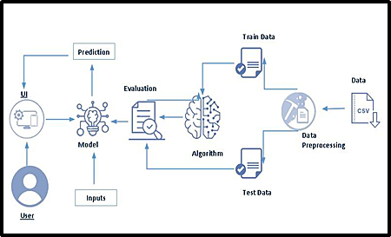

### 3.2 Hardware/Software designing

**To complete this project, you must required following software’s, concepts and packages**

1. **Anaconda navigator and pharm:**

a. download anaconda navigator

1. **Python packages:**
   * Open anaconda prompt as administrator
   * Type “pip install numpy” and click enter.
   * Type “pip install pandas” and click enter.
   * Type “pip install scikit-learn” and click enter.
   * Type”pip install matplotlib” and click enter.
   * Type”pip install scipy” and click enter.
   * Type”pip install pickle-mixin” and click enter.
   * Type”pip install seaborn” and click enter.
   * Type “pip install Flask” and click enter.

## 4.EXPERIMENTAL INVESTIGATIONS

1. Know fundamental concepts and techniques used for machine learning.
2. Gain a broad understanding about data.
3. Have knowledge on pre-processing the data/transformation techniques on outlier and some visualization concepts.

# Project Flow:

1. User interacts with the UI to enter the input.
2. Entered input is analyzed by the model which is integrated.
3. Once model analyses the input the prediction is showcased on the UI

To accomplish this, we have to complete all the activities listed below,

1. Data collection
   1. Collect the dataset or create the dataset
2. Visualizing and analyzing data
   * Univariate analysis
   * Bivariate analysis
   * Multivariate analysis
   * Descriptive analysis
3. Data pre-processing
   1. Checking for null values
   2. Handling outlier
   3. Handling categorical data
   4. Splitting data into train and test

## 5. FLOWCHART

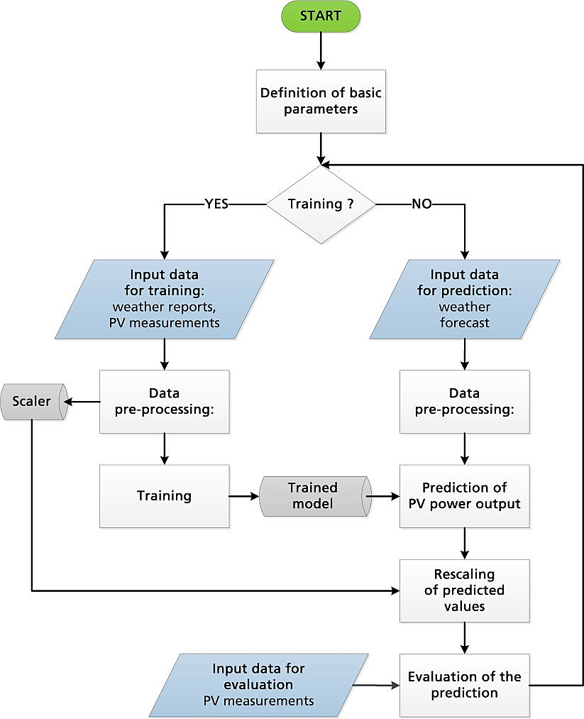

## 6.RESULTS

**Activity 1: Importing the libraries**

Import the necessary libraries as shown in the image.

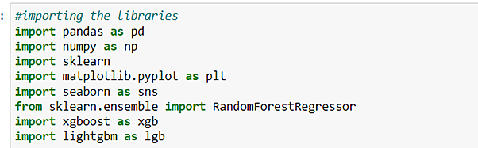

**Activity 2: Read the Dataset**

Our dataset format might be in .csv, excel files, .txt, .json, etc. We can read the dataset with the help of pandas.

In pandas we have a function called read_csv () to read the dataset. As a parameter we have to give the directory of csv file.

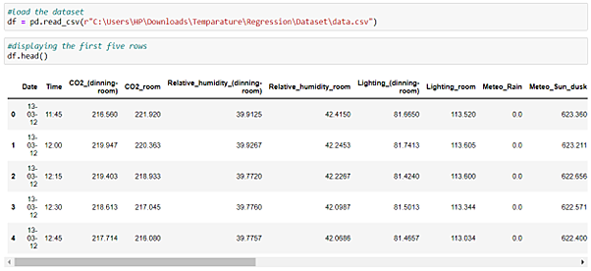

**Activity 3: Univariate analysis**

In simple words, univariate analysis is understanding the data with single feature. Here we have displayed two different graphs such as distplot and countplot.

Seaborn package provides a wonderful function distplot. With the help of distplot, we can find the distribution of the feature. To make multiple graphs in a single plot, we use subplot.

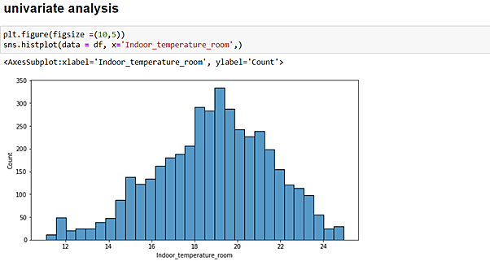

1. From the plot we came to know, Indoor_temperature_room column, which is our output column it follows normal distribution.

**Activity 4: Bivariate analysis**

**Scatter Plot():**

Scatter plots are the graphs that present the relationship between two variables in a data-set. It represents data points on a two-dimensional plane or on a Cartesian system. The independent variable or attribute is plotted on the X-axis, while the dependent variable is plotted on the Y-axis.

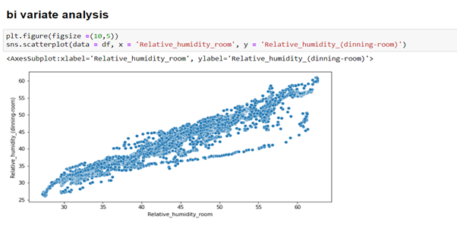

**Activity 5: Multivariate analysis**

In simple words, multivariate analysis is to find the relation between multiple features. Here we have used swarm plot from Seaborn package.

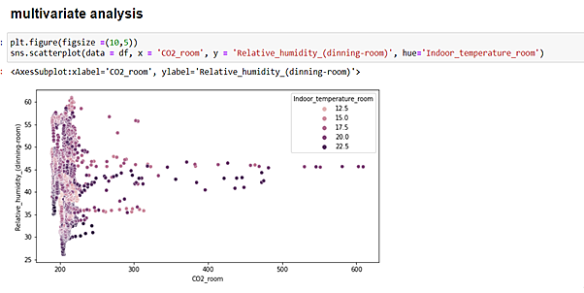

**Activity 6: Descriptive analysis**

Descriptive analysis is to study the basic features of data with the statistical process. Here pandas has a worthy function called describe. With this describe function we can understand the unique, top and frequent values of categorical features. And we can find mean, std, min, max and percentile values of continuous features.

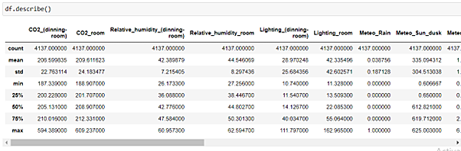

# Milestone 3: Data Pre-processing

As we have understood how the data is lets pre-process the collected data.

The download data set is not suitable for training the machine learning model as it might have so much of randomness so we need to clean the dataset properly in order to fetch good results. This activity includes the following steps.

1. Handling missing values
2. Handling categorical data
3. Handling outliers
4. Scaling Techniques
5. Splitting dataset into training and test set

Note: These are the general steps of pre-processing the data before using it for machine learning. Depending on the condition of your dataset, you may or may not have to go through all these steps.

**Activity 1: Checking for null values**

1. Let’s find the shape of our dataset first, to find the shape of our data, df.shape method is used. To find the data type, df.info() function is used.
2. 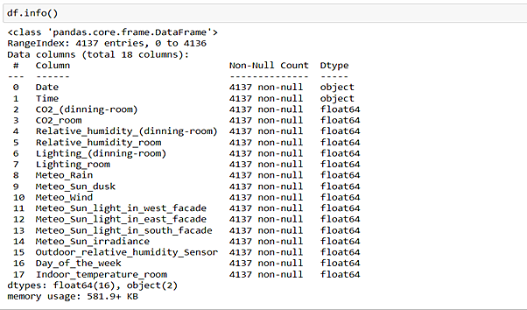

1. For checking the null values, df.isnull() function is used. To sum those null values we use .sum() function to it. From the below image we found that there are no null values present in our dataset. So we can skip handling of missing values step.

From the above code of analysis, we can infer that columns Do not have any Null Values, so we don’t perfrom numll values operations on this dataset.

**Activity 2: Handling Categorical Values**

As we can see our dataset has categorical data we must convert the categorical data to integer encoding or binary encoding.

To convert the categorical features into numerical features we use encoding techniques. There are several techniques but in our project we are using manual encoding with the help of list

comprehension.

1. In our dataset, we don’t have any categorical values and most of the values we have are float so, we don’t perform any encoding techniques.
2. 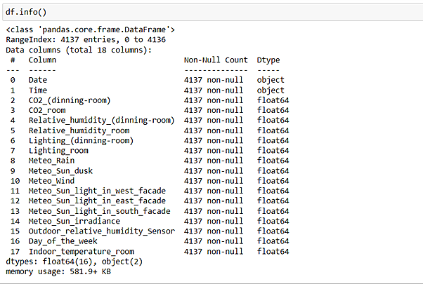

**Activity 3: Scaling the Data**

Scaling is one the important process, we have to perform on the dataset, because of data measures in different ranges can leads to mislead in prediction

Models such as linear regression need scaled data, as they follow distance based method and Gradient Descent and Tree concept no need of scaling.

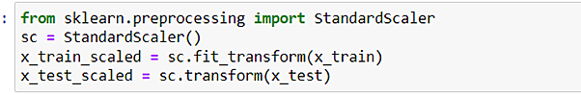

We will only perform scaling on the input values and in this project scaling is performed for only linear regression

**Activity 4: Splitting data into train and test**

Now let’s split the Dataset into train and test sets

Changes: first split the dataset into x and y and then split the data set

Here x and y variables are created. On x variable, df is passed with dropping the target variable.



And on y target variable is passed. For splitting training and testing data we are using train_test_split() function from sklearn. As parameters, we are passing x, y, test_size, random_state.

# Milestone 4: Model Building

Now our data is cleaned and it’s time to build the model. We can train our data on different algorithms. For this project we are applying four classification algorithms. The best model is saved based on its performance.

**Activity 1: Liner Regression model**

A function named Linear Regression is created and train and test data are passed as the parameters. Inside the function, Linear Regression algorithm is initialized and training data is passed to the model with .fit() function. Test data is predicted with .predict() function and saved in new variable. For evaluating the model, used r2 score

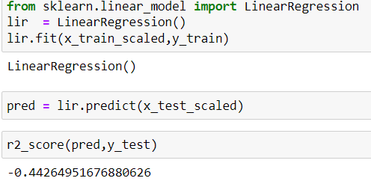

**Activity 2: Random forest model**

A function named randomForest is created and train and test data are passed as the parameters. Inside the function, RandomForestRegressor algorithm is initialized and training data is passed to the model with .fit() function. Test data is predicted with .predict() function and saved in new variable. For evaluation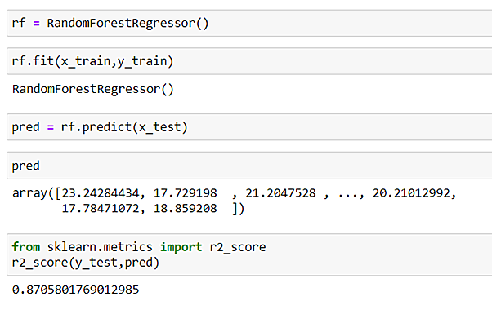ng the model, used r2 score

**Activity 3: Light Gradient Boost model**

A function named lg is created and train and test data are passed as the parameters. Inside the function, LGBM Regressor algorithm is initialized and training data is passed to the model with .fit() function. Test data is predicted with .predict() function and saved in new variable. For evaluating the model used r2 score.

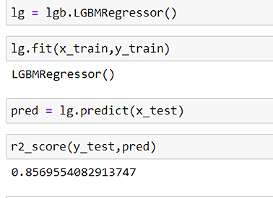

**Activity 4: Xgboost model**

A function named xgboost is created and train and test data are passed as the parameters. Inside the function, GradientBoostingClassifier algorithm is initialized and training data is passed to the model with .fit() function. Test data is predicted with .predict() function and saved in new variable. For evaluating the model used r2score

Now let’s see the performance of all the models and save the best model

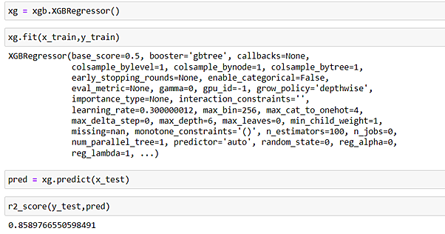

**Activity 5: Evaluating performance of the model and saving the model**

From sklearn, cross_val_score is used to evaluate the score of the model. On the parameters, we have given rf (model name). Our model is performing well. So, we are saving the model by pickle.dump().

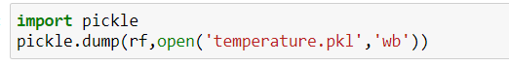

# Milestone 5: Application Building

In this section, we will be building a web application that is integrated to the model we built. A UI is provided for the uses where he has to enter the values for predictions. The enter values are given to the saved model and prediction is showcased on the UI.

This section has the following tasks

1. Building HTML Pages
2. Building server side script

**Activity1: Building Html Pages:**

For this project create three HTML files namely

1. index.html
2. predict.html and save them in templates folder.

Let’s see how our index.html page looks like:

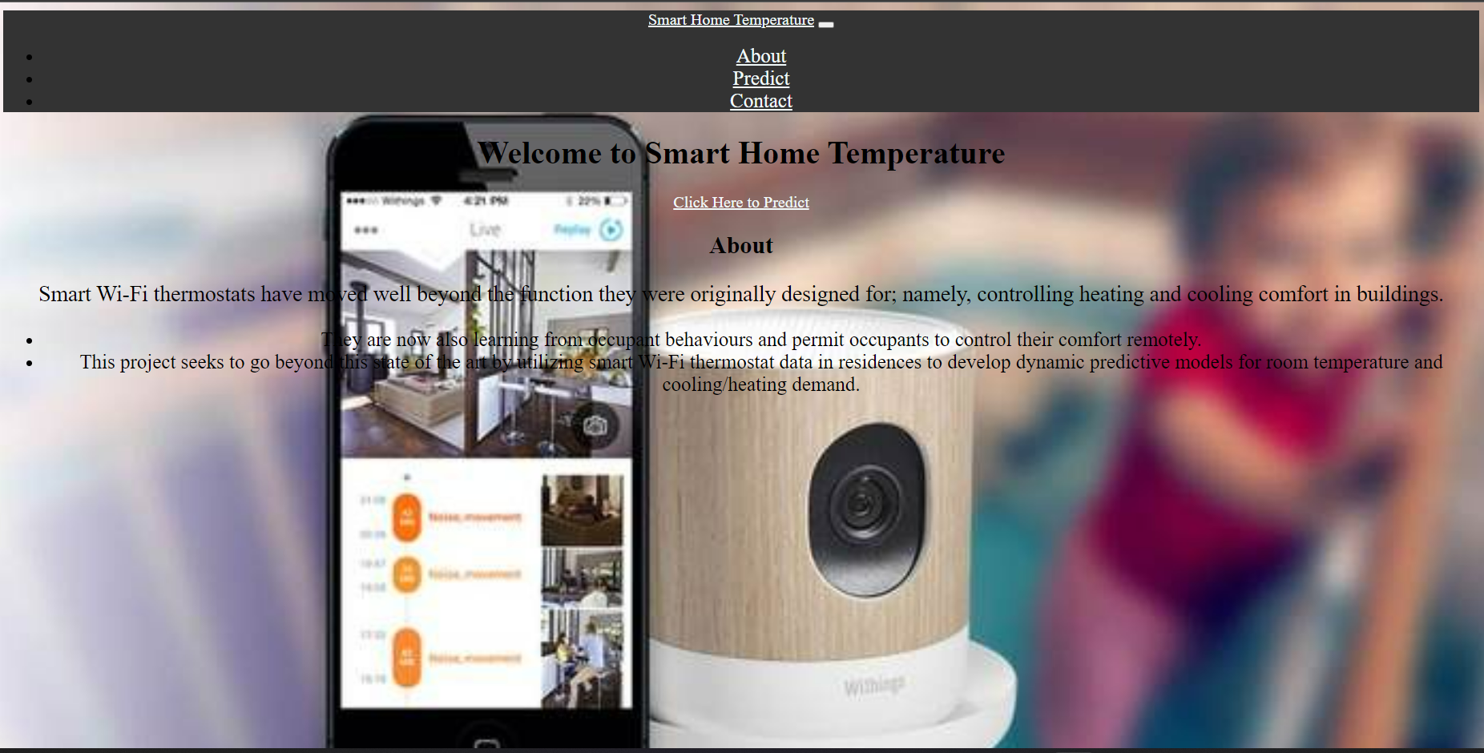

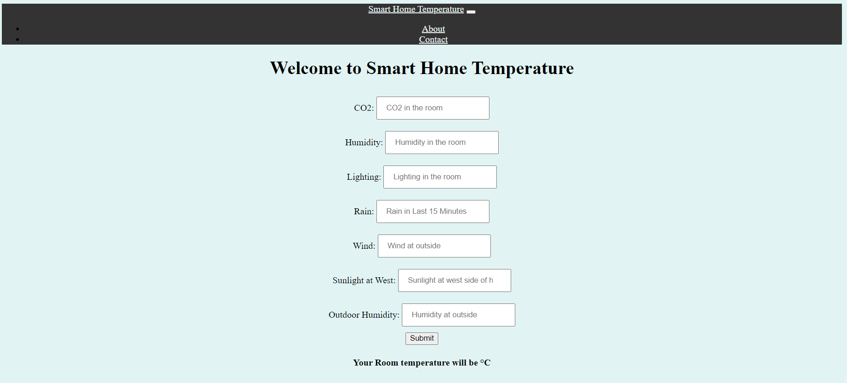

## 

## 

## 9.CONCLUSION

To implement this need to deploy the sensor devices in the home for collecting the data and analysis. By deploying sensor devices in the environment, it will record real time data. It can cooperate with other objects through the network. Then the collected data and analysis results will be available to the end user through the Wi-Fi. The smart way to monitor home and an efficient, low-cost entrenched system is presented with different models in this paper.

## APPENDIX

from flask import Flask, request, render_template

import pickle

import numpy as np

import pandas as pd

model = pickle.load(open(r'C:\Users\Rahul PK\Smart Home - Temperature Prediction\Flask\temperature.pkl', 'rb'))

app = Flask(__name__)

**@app.route**("/")

def **home**():

return render_template("index.html")

**@app.route**("/predict")

def **predict**():

return render_template("predict.html")

**@app.route**('/output', methods = ['post','get'])

def **output**():

# reading the inputs given by the user

input_feature= [float(x) for x in request.form.values()]

input_feature=[np.array(input_feature)]

print(input_feature)

names = ['CO2_room', 'Relative_humidity_room', 'Lighting_room', 'Meteo_Rain', 'Meteo_Wind', 'Meteo_Sun_light_in_west_facade',

'Outdoor_relative_humidity_Sensor']

print(names)

data = pd.DataFrame(input_feature,columns=names)

print(data)

prediction=model.predict(data)

print(prediction)

return render_template('predict.html', prediction=prediction[0])

if __name__ == '__main__':

app.run(debug = True)