Smart Mathematics Tutor Using IBM Watson.

**By Team Members**

* Adapa SDM Chandana
* Kumbham Divya
* Gariganti Madhu Sampath Kumar
* Naraharisetti Mani Sandeep

**1.INTRODUCTION:**

Nationally, the average age at which kids get a phone of their own is 10.3 years. One thing experts agree on is that later is better. Once you open the door, it can be very difficult to close. A 2016 study found that most kids are getting their first social media account between the ages of 10 and 12. Thisich will ultimately lead to unproductive work. Due to lack of interactive learning students doesn't show much interest in learning things. Interactive Learning is a pedagogical approach that incorporates social networking and urban computing into course design and delivery. Interactive Learning has evolved out of the hyper-growth in the use of digital technology and virtual communication, particularly by students. Beginning around 2000, students entering institutes of higher education have expected that interactive learning will be an integral part of their education. The use of interactive technology in learning for these students is as natural as using a pencil and paper were to past generations.

To solve the above mentioned problem we are building a GUI which helps the students in learning maths and they can easily remember all the formulas. They can draw the shapes in the application which recognizes the shape gives all the related information like list of formulas. This helps the students to learn interactively.

**OVERVIEW:**

1.Defining our classification categories

2.Collect training images

3.Train the model

4.Test our mode

**PURPOSE:**

The purpose of Smart Mathematics Tutor is to record student work and tracks the steps a student chose to solve a math problems. It provides immediate and customized instruction or feedback to learners,usually without requiring intrvention from a human teacher

**2.LITERATURE SURVEY:**

To complete this project,you must required following software's, concepts and packages

* Anaconda Navigator:

* Refer to the link below to download anaconda navigator
* Python Packages:

Open anaconda prompt as administrator

* Type "pip install tensorflow"
* Type "pip install opencv-python"
* Type "pip install flask".

**EXISTING PROBLEM:**

Many students would face lot of trouble while solving their Mathematical Problems. Due to this they lack concentration.Due to lack of interactive learning, students doesn't show much interest in learning things.They find themselves difficult to understand and learn things and try to quit.

**PROPOSED SOLUTION:**

To solve the above

problem,we are bulding a GUI which helps the students learn interactively and learn maths that they easily remember all problems.They can draw the shapes in the application. which can recognize the shapes and gives all related formulas and information.So they can learn easily without any help.

**3. THEORETICAL ANALYSIS:**

**BLOCK DIAGRAM:**

INSTALL THE SOFTWARE AND PACKAGES

- Anaconda Prompt

- pip install tensorflow

- pip install opencv python

- pip install flask

COLLECTION OF DATASET

-Download the dataset

IMAGE PREPROCESSING

- Import the ImageDataGenerator Library

- Configure ImageDataGenerator Class

- Apply ImageDataGenerator Functionality to trainset and testset

MODEL BUILDING

- Importing the model building libraries

- Initializing the model

- Adding CNN layers

- Adding Dense layers

- Configure the learning process

- Train the model

- Save the model

- Test the model

APPLICATION BUILDING

- Create HTML pages

- Build Python code

- Run the aplication

TRAIN THE MODEL ON IBM

- Register for IBM Cloud

- Train model on IBM

**4.EXPERIMENTAL INVESTIGATIONS:**

**CNN:** a convolutional neural network is a class of deep neural networks,most commonly applied to analyzing visual imagery.

**Opencv:** It is an Open source Computer Vision Library which are mainly used for image processing video capture and analysis including features like face detection and object detection.

**Flask:** Flask ia a poplar Python web framework, meaning it is a third-party Python library used for developing web applications.

**Project flow:**

* User interacts with UI to launch the tutor.
* Then in the GUI we will be drawing a shape.
* And finally,with the help of our model we will be predicting and using opencv to showcase the respective formula.

To accomplish this, we have to complete all the activities and tasks listed below

* Data collection
* Collect the dataset or Create the dataset
* Data Preprocessing
* Import the ImageDataGenerator Library
* Configure ImageDataGenerator Class
* Apply ImageDataGenerator functionality to Trainset and Testset
* Model Building
* Import The Model Building Libraries
* Initializing the model
* Adding input Layers
* Adding hidden Layers
* Adding Output Layer
* Configure the Learning Process
* Training and Testing the model
* Save the Model
* Application Building
* Create HTML pages
* Build python code

**5.FLOWCHART:**

Start

Install jupiter notebook from anaconda prompt

Collect the dataset

Image preprocessing

Model Building

Application Building

End

**6.RESULT :**

Smart Maths tutor system is a web based graphical user interface where a user gets to draw shapes of mathematical figures such as square, triangle, circle etc. for which the output would be related formulas to the drawn figure.

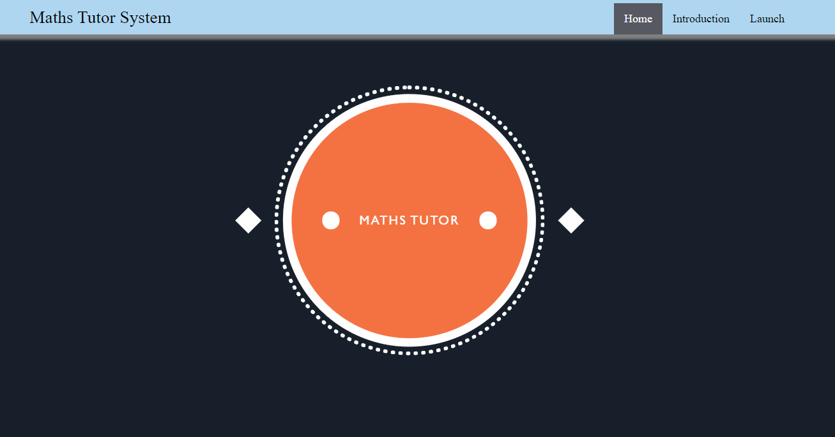

* When “Introduction” button is clicked, localhost redirects to “intro.html”

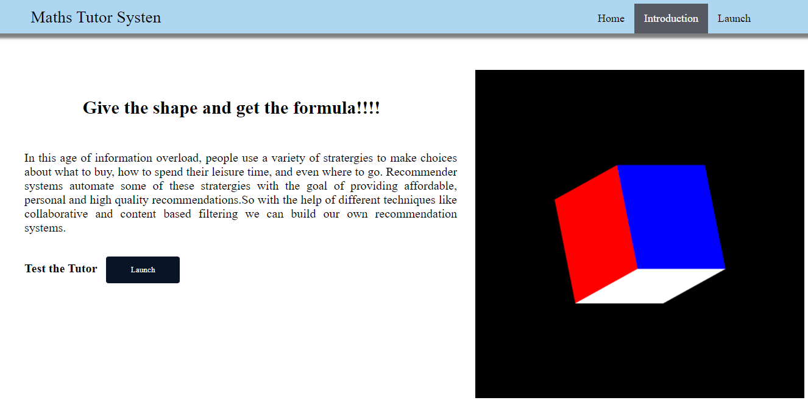

* Finally when you click on Launch button a GUI will be popped up where you have to draw the shapes which we trained and it will give you the formula according to the prediction.

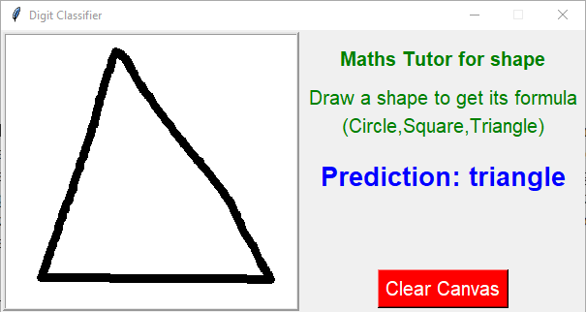

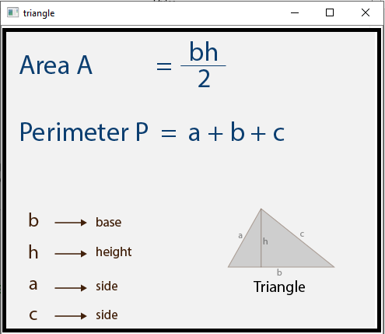

**7.ADVANTAGES and DISADVANTAGES :**

**ADVANTAGES:**

* Improves Visualization and Creativity.
* Gives Students a better understanding of concepts.
* Real-time blended teaching and learning.
* Improves student-teacher interaction and communication.

**DISADVANTAGES :**

* The technology is expensive.
* The Skilled faculty are required.
* Proper maintainance is required.

**8.APPLICATIONS :**

* Digital Classrooms

**9.CONCLUSION :**

* knows fundamental concepts and techniques of IBM Watson.
* Gain the broad understanding.
* Know how to pre-process the data using different pre-processing techniques.

**10.FUTURE SCOPE :**

* Smart tutoring systems are designed to continuously track student progress, provide next step hints and pick practise problems that help students learn new skills.
* Students can learn anytime, and adjust the learning process to their needs.

**11.BIBILOGRAPHY:**

We saw some reference videos in youtube.

https://youtu.be/5mDYijMfSzs

**12.APPENDIX**

**SOURCE CODE:**

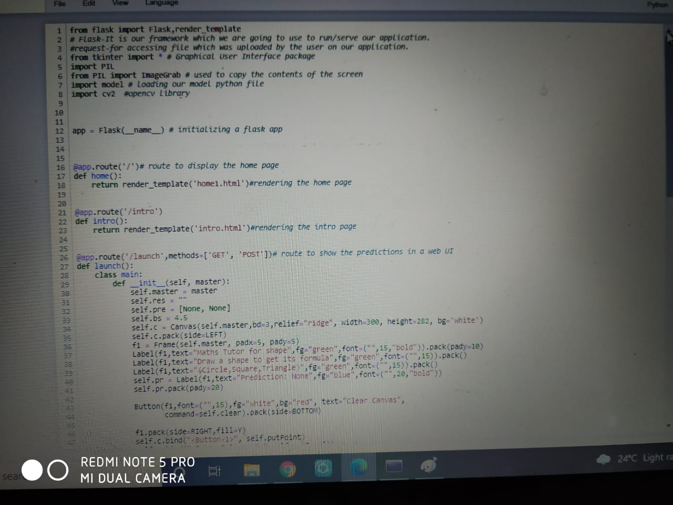

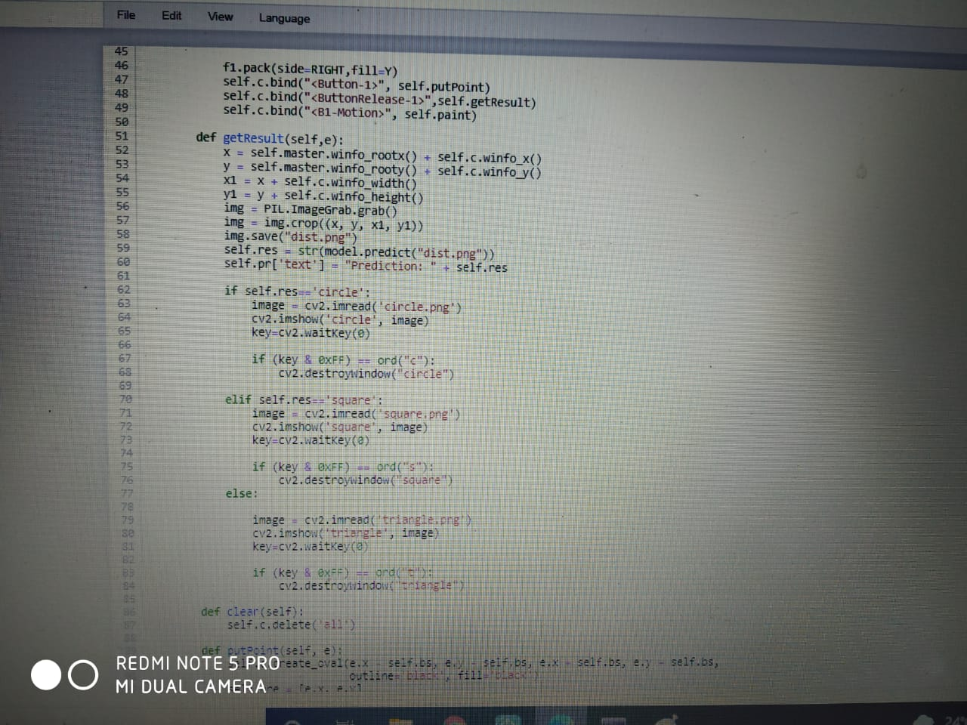

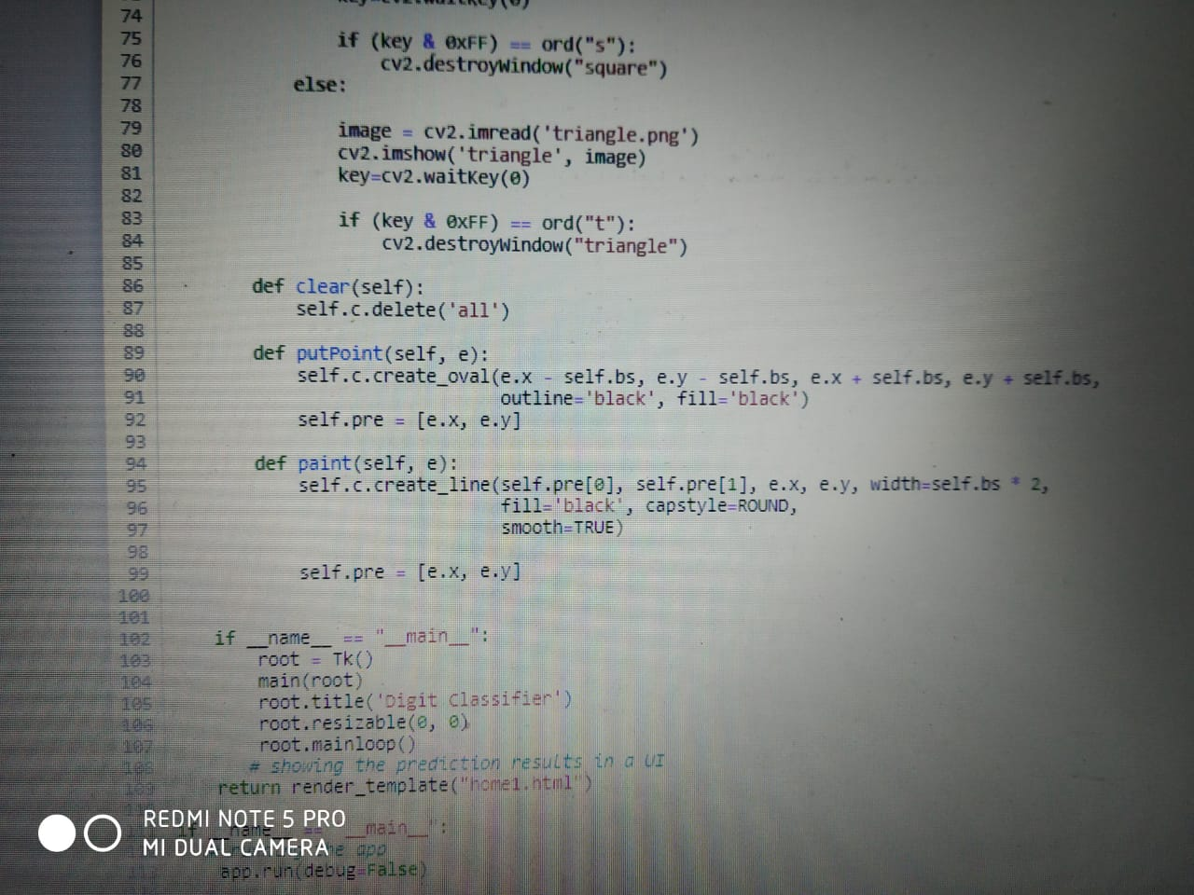

**UI OUTPUT SCREENSHOT:**

