  Early Stage Disease Diagnosis System Using Human Nail Image Processing Using IBM Watson

1.INTRODUCTION

1.1 **Project Description:**

**In the healthcare domain, many diseases can be predicted by observing the color and shape of humans nails. A white spot here, a rosy stain there, or some winkle projection may be an indication of disease than  body. Problems in the liver, lungs, and heart can show up in your nails. Doctors observe the nails of patients to get assistance in disease identi?cation. Usually, pink nails indicate a healthy human. Healthy nails are smooth and consistent in color. Anything else a?ecting the growth and appearance of the ?fingernails or toenails may indicate an abnormality. A person’s nails can say a lot about their health condition. The need for such systems to analyze nails for disease prediction is because the human eye is having subjectivity about colors, having limitations of the resolution, and a small amount o color change in a few pixels on the nail not being highlighted to human eyes which may lead to the wrong result, whereas computer recognize small color changes on nails.**

**To overcome the above problem we are building a model which is used for the prevention and early detection of Nail Disease, Basically nail disease diagnosis depends on the different characteristics like color, shape, texture, etc. Here the person can capture the images of the nail and then the image will be sent to the trained model. The model analyzes the image and detects whether the person is having nail disease or not and its type**

**Overview Different Disease is the main causes of  death worldwide. Computer-aided diagnosis systems showed the potential for improving diagnostic accuracy. But early detection and prevention can significantly reduce the chances of death. It is important to detect disease as early as possible.**

**Project Objectives**

**By the end of this project you will:**

* **Know fundamental concepts and techniques of Convolution Neural networks.**
* **Gain a broad understanding of image data.**
* **Know how to pre-process/clean the data using different data preprocessing techniques.**
* **know how to build a web application using the Flask framework.**

**Project Flow**

* **The user interacts with the UI (User Interface) to choose the image.**
* **The chosen image analyzed by the model which is integrated with flask application.**
* **VGG16 Model analyzes the image, then prediction is showcased on the Flask UI.**

**To accomplish this, we have to complete all the activities and tasks listed below**

* **Data Collection.**
  + **Create Train and Test Folders.**
* **Model Building**
  + **Importing the Model Building Libraries**
  + **Loading the model**
  + **Adding Flatten Layers**
  + **Adding Output Layer**

**2. LITERATURE SURVEY**

**2.1 Existing problem**

One of the main cauesesowed the potential for improving diagnostic accuracy. But early detection and prevention c of cancer death worldwide is Breast Cancer. Computer-aided diagnosis systems scan significantly reduce the chances of death. It is important to detect different cancer as early as possible.

**2.2 Proposed Solution**

This project goal is to classify images into two classifications of malignant and benign. As early diagnostics significantly increases the chances of correct treatment and survival. In this application, we are helping the doctors and patients to classify the Type of disease for the specific image given with the help of Neural Networks.

* **1.2 Purpose**

The goal is to classify images into two classifications of malignant and benign. As early diagnostics significantly increases the chances of correct treatment and survival. In this application, we are helping

**Technical Architecture:**

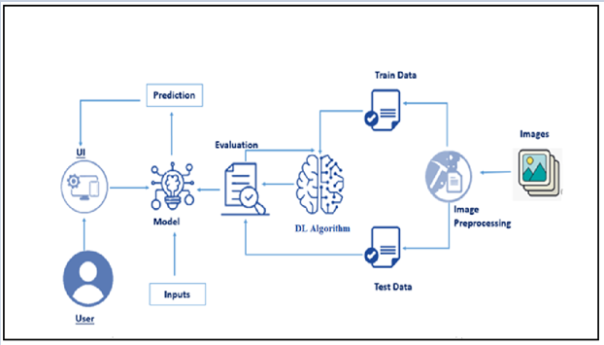

**Project Structure**

**Create a Project folder that contains files as shown below**

* **The Dataset folder contains the training and testing images for training our model.**
* **We are building a Flask Application that needs  HTML pages stored in thetemplatesfolder and a python scriptapp.pyfor server-side scripting**
* **we need the model which is saved and the saved model in this content is aVgg-16-nail-disease.h5**
* **templates folder contains about.html, index.html, nailhome.html, and nailpred.html pages.**

**Data Collection**

**You can download the dataset used in this project using the below link**

**Dataset:** [**Link**](https://drive.google.com/drive/folders/1AXTYsbiarS1TCAgfj0mancTSrJYYMWMs?usp=sharing)

**Note: For better accuracy, train on more images, which can be downloaded from google and place it in respective folders.**

  **Model Building**

**Now it iss time to Build input and output layers for VGG16 model**

**Hidden layers freeze because they have trained sequence, so changing the input and output layers.**

**Training**

**W**  **ere we train the model, based the images we have till now.**

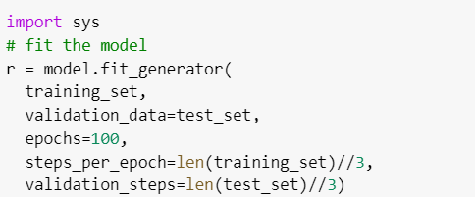

**Note: for model, we need to fit the data**

**The model is saved with .h5 extension as follows**

**An H5 file is a data file saved in the Hierarchical Data Format (HDF). It contains multidimensional arrays of scientific data.**

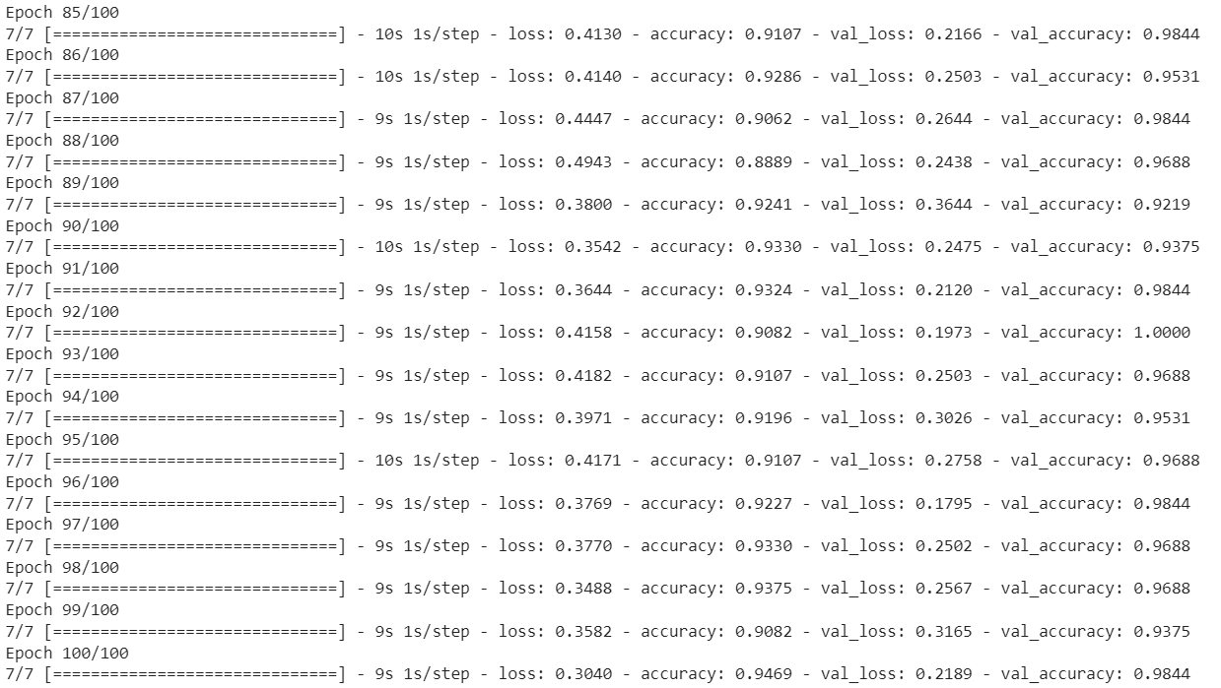

**The model is saved with .h5 extension as follows**

**An H5 file is a data file saved in the Hierarchical Data Format (HDF). It contains multidimensional arrays of scientific data.**

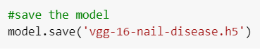

**Application Building**

**Now that we have trained our model, let us build our flask application which will be running in our local browser with a user interface.**

**In the flask application, the input parameters are taken from the HTML page; these factors are then given to the model to predict the cost estimation for damage on the HTML page to notify the user. Whenever the user interacts with the UI and selects the “Image” button, the next page is opened where the user chooses the image and predicts the output.**

**Create  HTML pages**

* **We use HTML to create the front end part of the web page.**
* **Here, we  have created 4 HTML pages- about.html, index.html, nailhome.html and nailpred.html**
* **inex.html displays the home page.**
* **abou.html display the about of the project**
* **nailhome.html displays information about nail disease.**
* **Nailpred.html takes the input image and displays the prediction.**

**For more information regarding HTML :** [**Link**](https://www.w3schools.com/html/)

* **We also use JavaScript-main.js and CSS-main.css to enhance our functionality and view of HTML pages.**
* **Link :**[**CSS**](https://www.w3schools.com/css/)**,** [**JS**](https://www.w3schools.com/js/DEFAULT.asp)

**Index HTML**

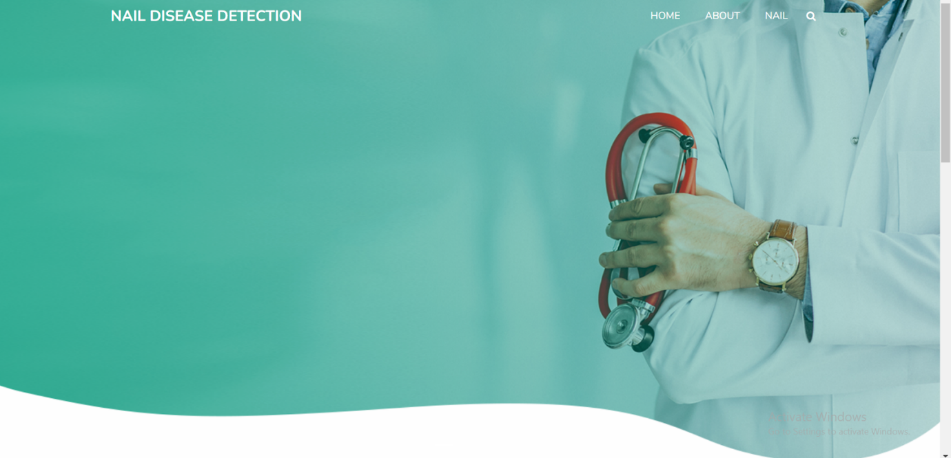

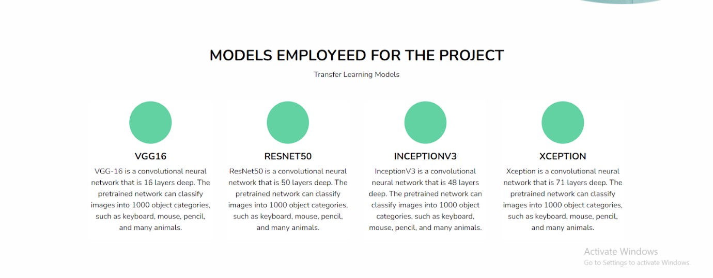

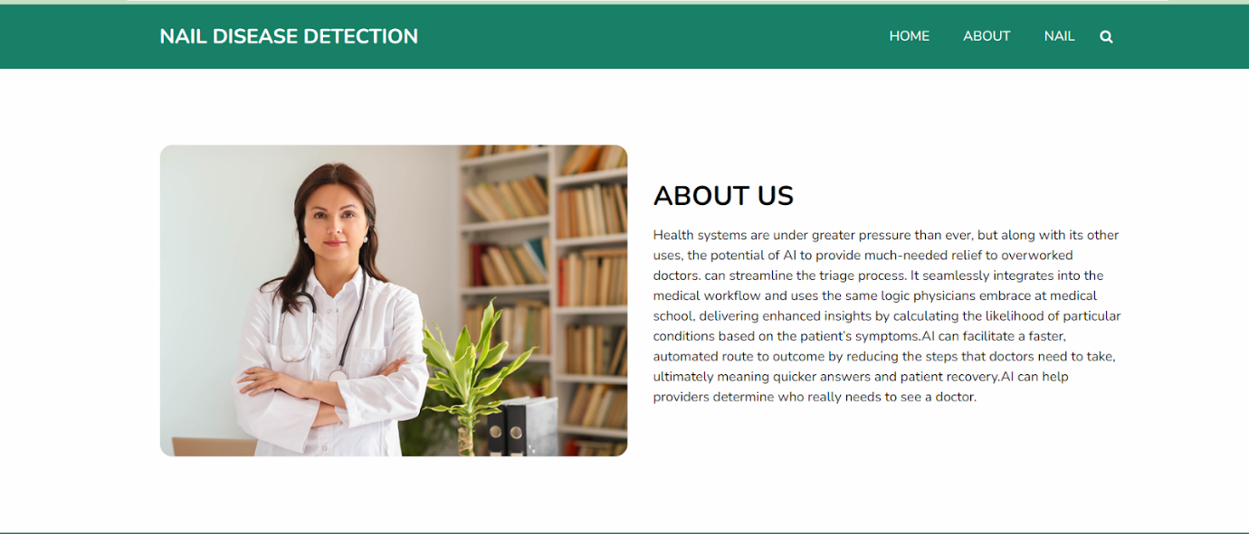

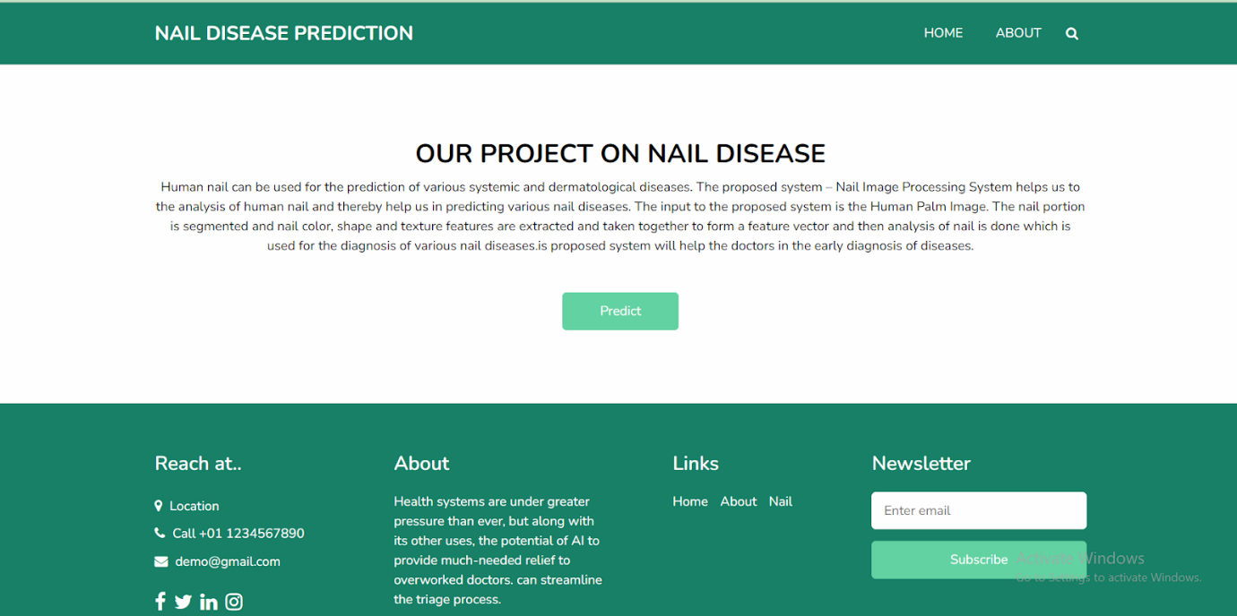



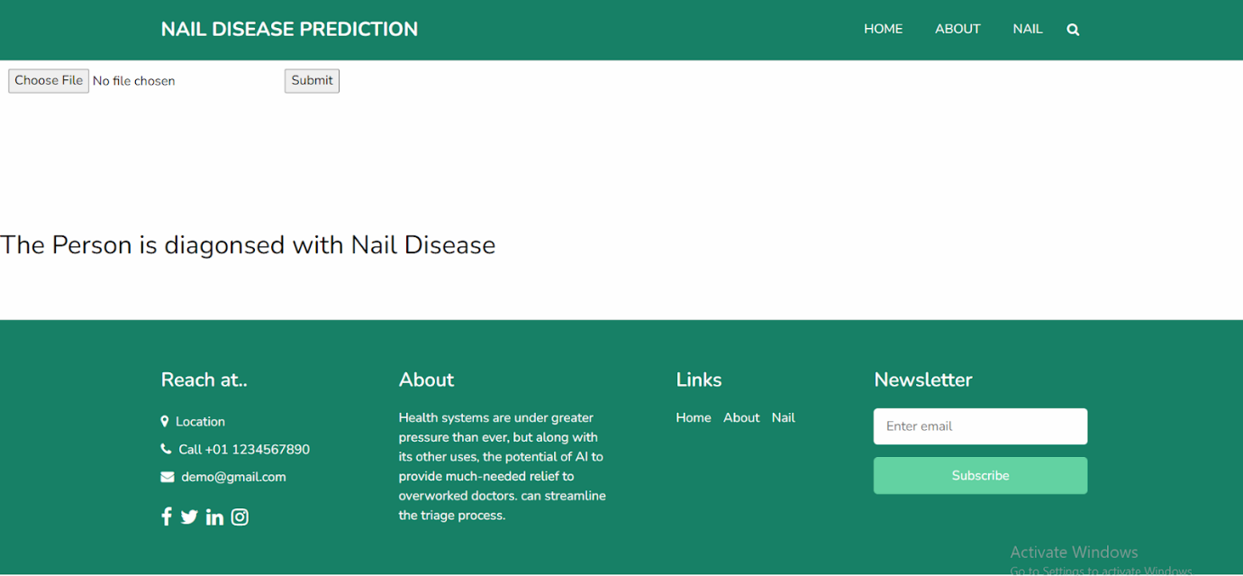



**Build Python Code**

