  Early Stage Disease Diagnosis System Using Human Nail Image Processing Using IBM Watson

1.INTRODUCTION

1.1   **Overview:**

**Disease is one of the main cause of death worldwide. Computer-aided diagnosis systems showed the potential for improving diagnostic accuracy. But early detection and prevention can significantly reduce the chances of death. It is important to detect the disease as early as possible by Nail image processing**

**Project Description:**

**In the healthcare domain, many diseases can be predicted by observing the colour and shape of human’s nails. A white spot here, a rosy stain there, or some winkle projection may be an indication of disease than the  body. Problems in the liver, lungs, and heart can show up in your nails. Doctors observe the nails of patients to get assistance in disease identifying Usually, pink nails indicate a healthy human. Healthy nails are smooth and consistent in colour. Anything else acting the growth and appearance of the fingernails or toenails may indicate an abnormality. A person’s nails can say a lot about their health condition. The need for such systems to analyses nails for disease prediction is because the human eye is having subjectivity about colours, having limitations of the resolution, and a small amount o colour change in a few pixels on the nail not being highlighted to human eyes which may lead to the wrong result, whereas computer recognize small colour changes on nails.**

**To overcome the above problem we are building a model which is used for the prevention and early detection of Nail Disease, Basically nail disease diagnosis depends on the different characteristics like colour, shape, texture, etc. Here the person can capture the images of the nail and then the image will be sent to the trained model. The model analyses the image and detects whether the person is having nail disease or not and its type**

**Overview Different Disease is the main causes of  death worldwide. Computer-aided diagnosis systems showed the potential for improving diagnostic accuracy. But early detection and prevention can significantly reduce the chances of death. It is important to detect disease as early as possible.**



**2. LITERATURE SURVEY**

**2.1 Existing problem**

One of the main caueses owed the potential for improving diagnostic accuracy. But early detection and prevention dieases death worldwide. Computer-aided diagnosis systems scan significantly reduce the chances of death. It is important to detect different cancer as early as possible.

**2.2 Proposed Solution**

This project goal is to classify images into two classifications of malignant and benign. As early diagnostics significantly increases the chances of correct treatment and survival. In this application, we are helping the doctors and patients to classify the Type of disease for the specific image given with the help of Neural Networks.

* **1.2 Purpose**

The goal is to classify images into two classifications of malignant and benign. As early diagnostics significantly increases the chances of correct treatment and survival. In this application, we are helping in Predicting Different Dieases.

**Technical Architecture**

**Block Diagram:**

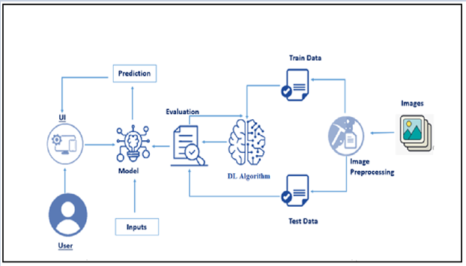

**3. Hardware / Software designing**

**Software Requirements:**

**● Ananconda Navigator**

**● Tensor flow**

**● Keras**

**● Flask Hardware Requirements:**

**● Processor : Intel Core i3**

**● Hard Disk Space   : Min 100GB**

**● Ram                         : 4GB**

**● Display                    : 14.1 “Color Monitor(LCD, CRT or LED)**

**● Clock Speed           : 1.67 GHz**

**4. EXPERIMENTAL INVESTIGATIONS**

**It shows that a model provided with different dieases scanning report images will predict the Cause and dispalys the output. Choose the image and click on upload, then it will predict the output.**

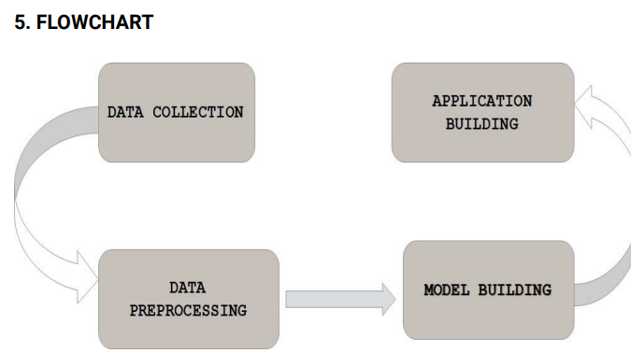

Result:

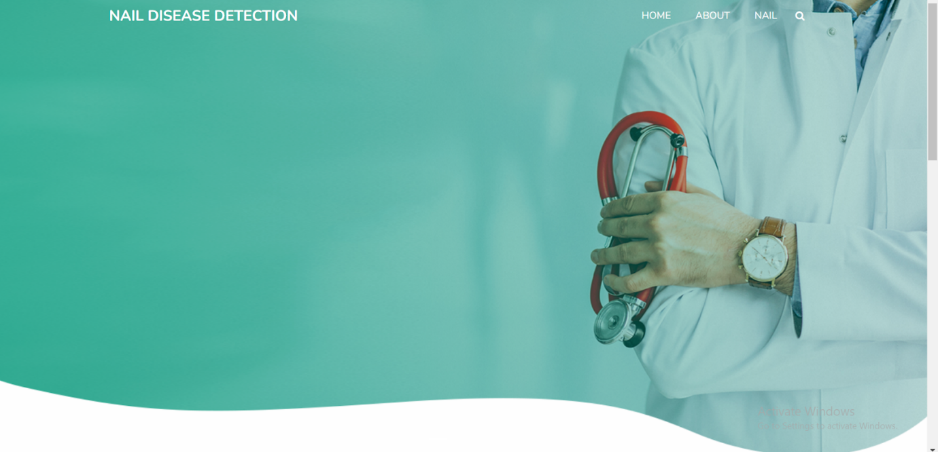

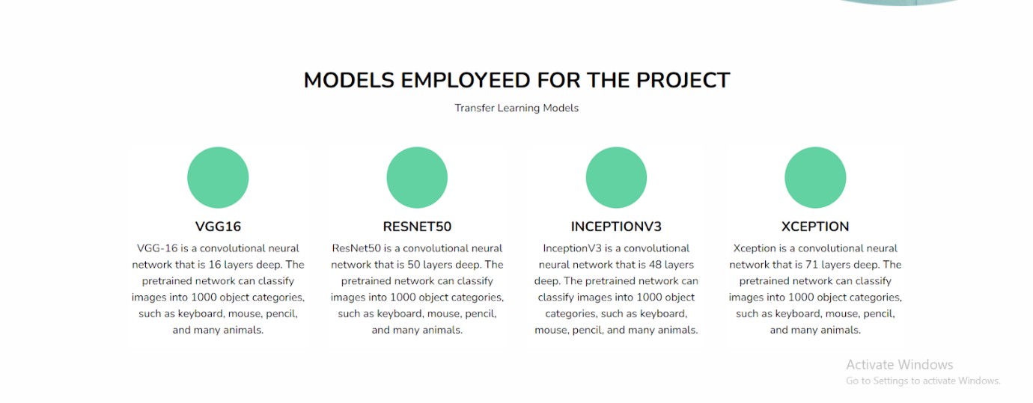

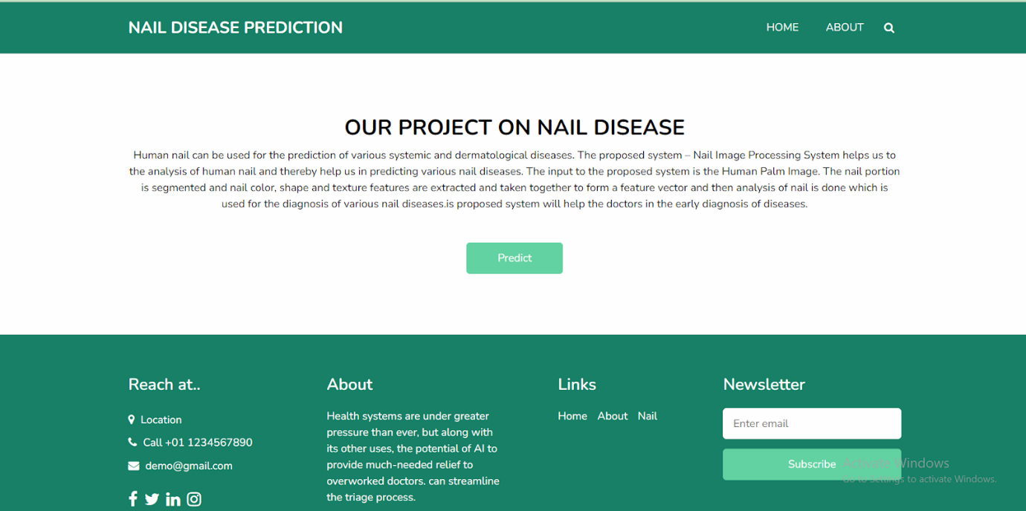

**7. ADVANTAGES AND DISADVANTAGES**

**Advantages:**

**● Early detection and prevention can significantly reduce the chances of death**

**● Increased accuracy for risk prediction.**

**● Reduce the time complexity.**

***Disadvantages:***

**● Requires massive datasets to train on**

**. ● Time consuming and more resources required**

**. 8. APPLICATIONS**

**● Deep learning and Neural networks are key technologies used in the breast cancer risk prediction**

**. ● It presents the results obtained by processing input from uploading image.**

**9. CONCLUSION**

**In this project, we have established the application to predict from uploaded image based on the IBM Cloud application. Disease risk prediction can only use this web app to predict the risk.**

**.10. FUTURE SCOPE**

**The project can be further enhanced by deploying the deep learning   model obtained using a web application and larger dataset could be used for prediction to give higher accuracy and produce the better result.**

***APENDIX PYTHON CODE***

 ● Main Project.

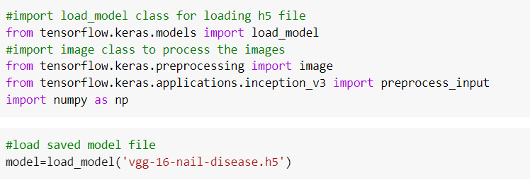

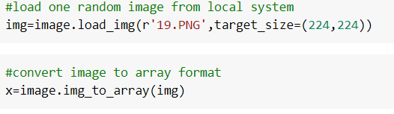

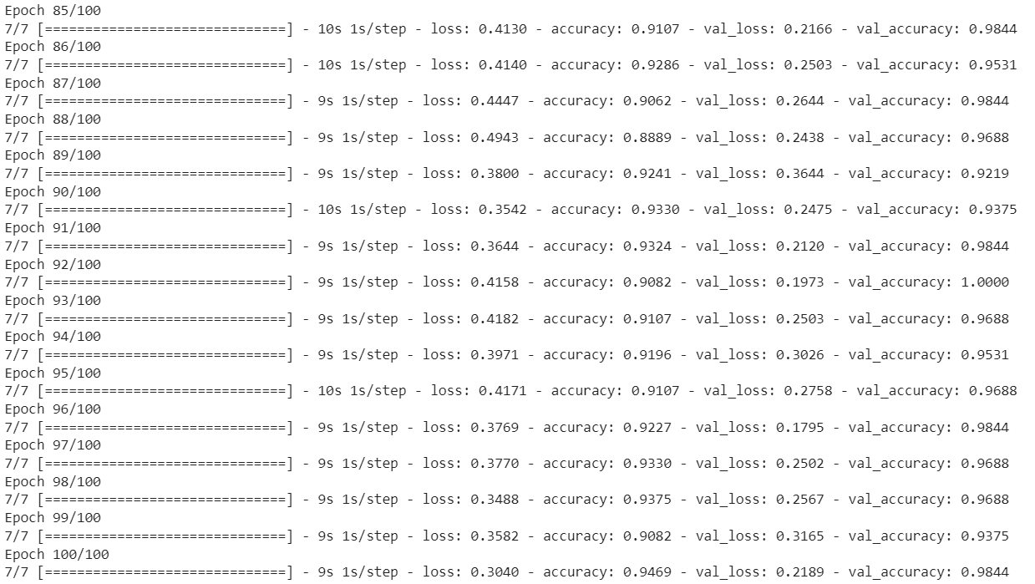

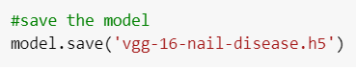

**Build Python Code**

