**Univariate Time series analysis for weather prediction using Prophet library with IBM Cloud**

**1.INTRODUCTION:-**

**1.1.Overview:-**

Any data associated with the time and is dependent on time-related matters can be termed as time-series data. Time series analysis comprises methods for analyzing time series data in order to extract meaningful statistics like trends, nonstationarity, and seasonality based on a daily, weekly, yearly basis and other characteristics of the data. Time series forecasting is the use of a model to predict future values based on previously observed values. The main objective of our project is to build a time series model for weather forecasting using Prophet library

**1.2.Purpose:-**

The goal of weather prediction is to provide information.people and organizations can use to reduce weather-related losses and enhance societal benefits, including protection of life and property, public health and safety, and support of economic prosperity and quality of life.

**2.LITERATURE SURVEY:-**

**2.1. Existing problem:-**

* Design and successful implementation of weather predicting model is very difficult task because weather changes time to time.
* Weather forecasting is the application of science and technology to predict the conditions of the atmosphere for a given time.People have attempted to predict the weather informally for millennia and formally since the 19th century.
* There are many models present for the predictive analysis of time series like Machine learning ARIMA (Auto-Regressive Integrated Moving Average model), Auto-Regressive model, Exponential Smoothing, LSTM (Long Short Term Memory), etc. These models require the data to be fed and with certain tweaking and fine-tuning they help us to make predictions

**2.2. Proposed solution:-**

* Any data associated with the time that is dependent on time-related matters can be termed as time-series data.
* Facebook Prophet library is a third party library that could perform all the fine-tuning part within and we just need to feed the model.The main idea of our project is to create an application for forecasting the weather by using this library.

**3.THEORITICAL ANALYSIS:-**

**3.1.Block diagram:-**

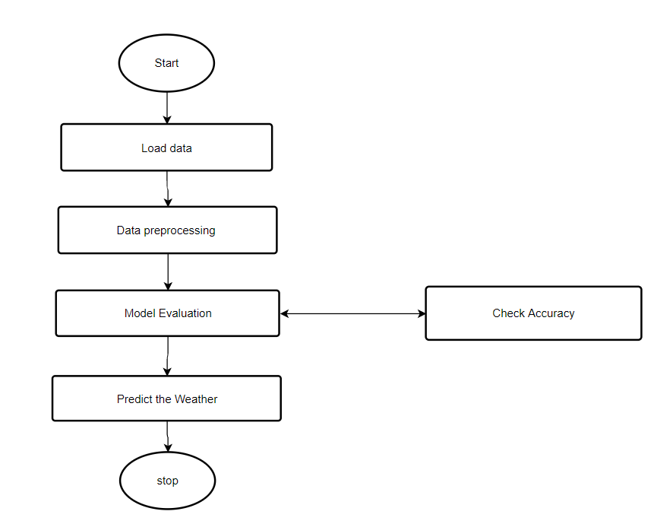

**3.2.Technical Architecture:-**

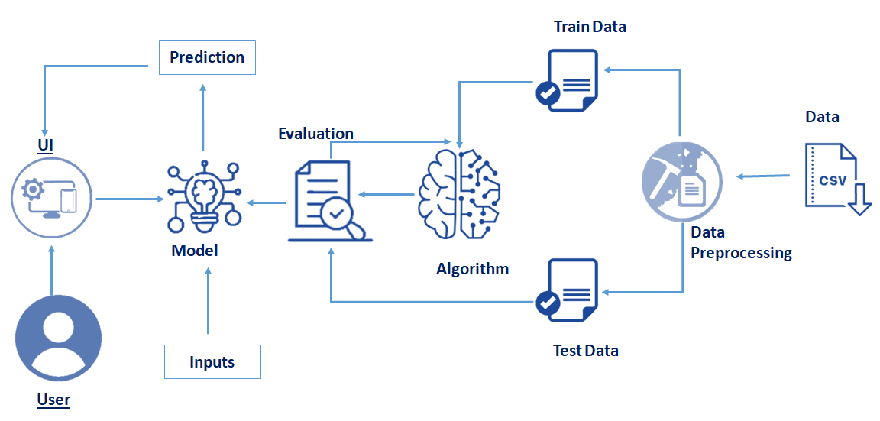

**3.3.Hardware/software designing**

**Software Requirements:**

* OS – Windows XP,7,8,10
* Jupyter Software
* Spyder Software
* Anaconda Command Prompt

**Hardware Components:**

* Processor – i3
* Hard Disk Storage – 10 GB
* RAM – 1GB

**4.EXPERIMENTAL INVESTIGATIONS:-**

We are doing this research in order to bring best and accurate results.Prophet is a procedure for forecasting time series data based on an additive model where non-linear trends are fit with yearly, weekly, and daily seasonality, plus holiday effects. It works best with time series that have strong seasonal effects and several seasons of historical data. Prophet is robust to missing data and shifts in the trend, and typically handles outliers well. Prophet is open source software released by Facebook’s Core Data Science team.

**5.Results:-**

This weather prediction process constitutes of three steps. These steps are mentioned below:

· There is one input to be considered that is date

· In the next step we use the prediction by train and testing the data which is analysed during the process of accuracy calculation.

· The output is generated related to the analysis based on the data collected related to the prediction of weather.

**6.ADVANTAGES AND DISADVANTAGES:-**

**Advantages:-**

* The weather forecast can help to guide and encourage tourists to visit certain areas.
* People can schedule there plans based on the weather conditions.
* We can reduce the loses related to weather.
* Anyone can use our website to known about the weather of a particular date.

**Disadvantages:-**

* Forecasts are never 100% and it is almost impossible to predict the future with certainty.
* In some cases it may mislead people with wrong predictions.
* If we want to predict with 100% percent accuracy it becomes more cost.

**7.APPLICATIONS:-**

* **Severe weather alerts and advisories:**

A major part of modern weather forecasting is the severe weather alerts and advisories, which the national weather services issue in the case that severe or hazardous weather is expected. This is done to protect life and property.

* **Air Traffic:**

Because the aviation industry is especially sensitive to the weather, accurate weather forecasting is essential considering the fact that a greater number of plane crashes recorded the world over have weather related causes

* **Agriculture:**

Farmers rely on weather forecasts to decide what work to do on any particular day. For example, drying hay is only feasible in dry weather. Prolonged periods of dryness can ruin cotton, wheat, and corn crops.

* **Military applications:**

Military weather forecasters present weather conditions to the war fighters, community. Military weather forecasters provide preflight weather briefs to pilots and provide real time resource protection services for military installations.

**8. CONCLUSION :-**

We have used prophet library it is accurate, fast and fully automatic. By taking date as a input we are predicting weather with great accuracy so it is easy for the people to known about weather of a particular date.

**9. FUTURE SCOPE :-**

Time series analysis for weather prediction using Prophet Library gives accurate weather prediction. Since weather is an important factor in our life. Every person day to day activities are decided based on the weather conditions. We are predicting weather with less cost and more accuracy it has more future scope and it is useful for the people.

**10.BIBILOGRAPHY:-**

Mohan, J. M. and Morgan, M. D. (1991). Meteorology: The Atmosphere and Science of Weather, Fourth edition. Macmillan Ontario, pp. 356 – 381.

Lutgens, F. K. and TarBuck, E. J. (1989). The Atmosphere: An Introduction to Meteorology, Fourth edition. Prentice Hall, New Jersey, pp. 299 – 331.

Ackerman, S. A. and Knox, J. A. (2003). Meteorology: Understanding the Atmosphere. Brooks/Cole USA, pp 362 – 379

Forecasting Time Series Data with Facebook Prophet: Build, improve, and optimize time series forecasting models using the advanced forecasting tool by [Greg Rafferty](https://www.amazon.in/s/ref=dp_byline_sr_book_1?ie=UTF8&field-author=Greg+Rafferty&search-alias=stripbooks)

**Source Code(Model Building):**

from fbprophet import Prophet

import pandas as pd

import matplotlib.pyplot as plt

import numpy as np

weather_data = pd.read_csv("weather_forecast.csv")

weather_data.head()

weather_data.tail()

weather_data.dtypes

weather_data['datetime_utc'] = pd.to_datetime(weather_data['datetime_utc'])

weather_data.set_index('datetime_utc',inplace=True)

weather_data = weather_data.resample('D').mean()

weather_data = weather_data[[' _tempm']]

weather_data.info()

weather_data.isnull().any()

weather_data.reset_index(inplace=True)

weather_data.reset_index(inplace=True)

weather_data.rename(columns = {'datetime_utc':'ds',' _tempm':'y'},inplace=True)

weather_data.head()

weather_data["ds"]

plt.plot(weather_data["ds"],weather_data["y"],ms=20,mec ="r")

plt.xlabel("date")

plt.ylabel("Temperature")

plt.title("weather prediction")

plt.grid()

plt.figure(figsize=(12,8))

plt.plot(weather_data.set_index(["ds"]))

model = Prophet()

model.fit(weather_data)

future = model.make_future_dataframe(periods=365,freq="D")

future.tail()

forecast = model.predict(future)

forecast.head()

forecast[['ds','yhat','yhat_lower','yhat_upper']].tail()

forecast[['ds','yhat','yhat_lower','yhat_upper']].head()

model.plot(forecast)

fig = model.plot_components(forecast)

from fbprophet.diagnostics import cross_validation

df_cv = cross_validation(model,initial='730 days',period='180 days',horizon='365 days')

df_cv.head()

from fbprophet.plot import plot_cross_validation_metric

fig = plot_cross_validation_metric(df_cv,metric='rmse')

import pickle

pickle.dump(model,open("weather_prediction.pickle","wb"))

**Source Code(Application Building):**

import numpy as np

import pandas as pd

from flask import Flask,request,jsonify,render_template

import pickle

app = Flask(__name__)

model = pickle.load(open('weather_prediction.pickle','rb'))

@app.route('/')

def home():

return render_template('home.html')

@app.route('/predict',methods=['POST'])

def predict():

if request.method == "POST":

ds = request.form["date"]

a = {"ds":[ds]}

ds = pd.DataFrame(a)

prediction = model.predict(ds)

output = round(prediction.iloc[0,18],2)

print(output)

return render_template('home.html',output="Temperature on selected date is. {} degree celsius".format(output))

#return "<h1>Temperature on selected date is. {} degree celsius</h1>".format(output)

return render_template("home.html")

if __name__ == "__main__":

app.run(port=5000,debug=False)

**Output :-**

