**CONTENTS**

|  |  |
| --- | --- |
| S NO | TOPIC |
| 1 | INTRODUCTION |
| 2 | LITERATURE SURVEY |
| 3 | THEORITICAL ANALYSIS |
| 4 | EXPERIMENTAL INVESTIGATIONS |
| 5 | FLOWCHART |
| 6 | RESULT |
| 7 | ADVANTAGES & DISADVANTAGES |
| 8 | APPLICATIONS |
| 9 | CONCLUSION |
| 10 | FUTURE SCOPE |
| 11 | BIBILOGRAPHY |

**OVERVIEW**

To leverage the voice of the customer to drive business results, companies need AI to gain actionable insights from sentiment, emotion, concepts, and keywords mentioned in customer feedback. Much of the important data a customer wants to share can already be found. It exists in public forums, blogs, social media posts, and chat logs with customer representatives. The challenges to leveraging this information have historically been the unstructured nature of it. To address this, IBM has AI solutions such as services like IBM Watson® Discovery that can be trained to aggregate, enrich, and help surface key customer insights.

In code patterns for this solution, unstructured data consisting of product reviews and customer surveys are imported into Cognos® Analytics from IBM Watson® Discovery.

Cognos Analytics is a business intelligence solution that empowers users with AI-infused self-service capabilities that accelerate data preparation, analysis, and report creation. IBM Watson® Discovery is an insight engine and AI search technology that breaks open data silos and retrieves specific answers to your questions while analyzing trends and relationships buried in your customer care data. Watson Discovery applies the latest breakthroughs in machine learning, including natural language processing capabilities, and is easily trained on the language of your domain. In this solution, unstructured data consisting of product reviews and customer surveys is imported into Cognos Analytics from Watson Discovery, and Watson Discovery identifies the sentiment toward the products surveyed. This data can then be displayed on a Cognos Analytics dashboard along with corresponding sales revenue and product inventory data. By combining Cognos Analytics with Watson Discovery, you can:

* Get early warning of trends based on customer feedback
* Identify and address escalating customer interactions with early intervention
* Understand customer preferences to target the right customers with the right products and the right marketing
* Know what is driving growth and where to invest in your business to drive revenue and customer adoption
* Catch product inventory issues early for trending products before they take off
* Get to the root cause of churning customers
* Identify actions to increase your net promoter score or other customer satisfaction metric

2 **PURPOSE** The use of this project.what we can achieved using this.

● By coffee reviews analysis using IBM cog nos dashboard we will :

>> know fundamental concepts and can work on IBM Cog nos Analytics.

>> Gain a board understanding of plotting different graphs.

>> Able to create meaningful dashboards. >> can make any dataset to understand different graphs.

**LITERATURE SURVEY**

**EXISTING PROBLEM**

[Coffee](https://en.wikipedia.org/wiki/Coffee) is a popular beverage and an important [commodity](https://en.wikipedia.org/wiki/Commodity). Tens of millions of small producers in developing countries make their living growing coffee. Over 2.25 billion cups of coffee are consumed in the world daily. Over 90 percent of [coffee production](https://en.wikipedia.org/wiki/Coffee_production) takes place in [developing countries](https://en.wikipedia.org/wiki/Developing_countries)—mainly [South America](https://en.wikipedia.org/wiki/South_America)—while consumption happens primarily in industrialized economies. There are 25 million small producers who rely on coffee for a living worldwide. In [Brazil](https://en.wikipedia.org/wiki/Brazil), where almost a third of the world's coffee is produced, over five million people are employed in the cultivation and harvesting of over three billion coffee plants; it is a more labour-intensive culture than alternative cultures of the same regions, such as [sugar cane](https://en.wikipedia.org/wiki/Sugar_cane) or cattle, as its cultivation is not [automated](https://en.wikipedia.org/wiki/Automation), requiring frequent human attention.

Coffee is a major export commodity and was the top agricultural export for 12 countries in 2004; the world's seventh-largest legal agricultural export, by value, in 2005; and "the second most valuable commodity exported by developing countries," from 1970 to circa 2000,[[](https://en.wikipedia.org/wiki/Economics_of_coffee#cite_note-talbot2004-1)At least 20 to 25 million families around the world make a living from growing coffee. With an assumed average family size of five people, more than 100 million pople are dependent on coffee growing. A total of 10.3 million tons of green coffee were harvested worldwide its difficult to identify every single estimations.

**PROPOSED SLOUTION**

Here we are going to detect the dataset format survey in easy format by the service IBM Cog nos Analytic dashboard. Cog nos Analytics integrates reporting,modeling,dashboards,stories and events management so you can we can understand our organization's data, and make effective decisions.By exporting the dataset into IBM Cog nos analytic we can monitor events or activities at a glance by providing key insights and analysis about your data on one or more pages or screens.we can change the visualization type or change the columns that are used in the visualization.we can add widgets such as text,media,web pages,images and shapes.we can sort data in either the x-axis or y-axis,depending on what type of data is in x-axis.we can customize a dashboard,story,or visualization by changing its visual properties also we can adjust the appearance of data in an asset.

**THEORTICAL ANALYSIS**

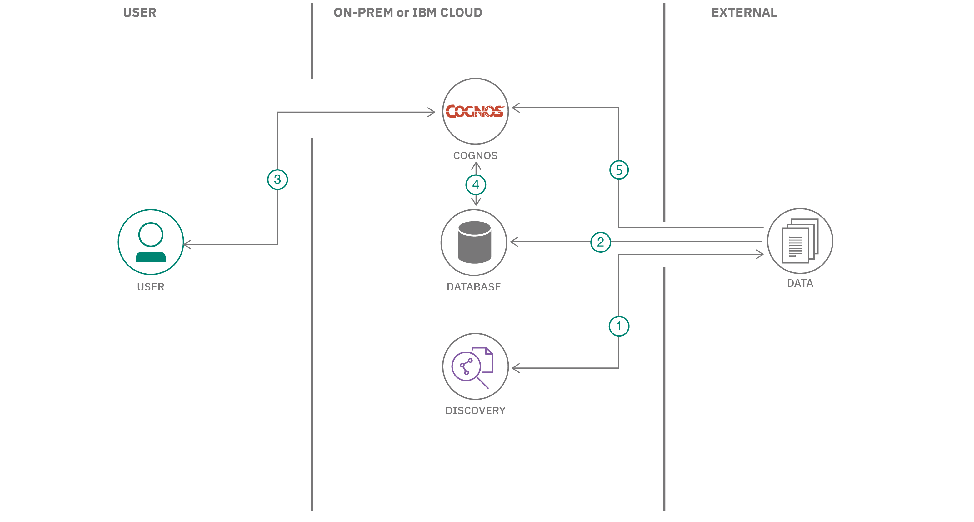

3.2 **HARDWARE/SOFTWARE DESIGNING**

Hardware and software requirements of the project software requirements:- About this accelerator All customers desire the capability to squeeze the maximum performance out of their IBM Cog nos Analytics investment. Cog nos Analytics is but a part of software and hardware environment. A single bottleneck in either the software or hardware has a ripple effect for the entire system.software product compatibility reports provide up to date information about the supported environments and minimum requirements for the product/data. Cog nos Analytics on premises 11.1.x Cog nos Analytics on Premises (11.1.7),(11.1.6),(11.1.5).....

|  |  |  |
| --- | --- | --- |
| Requirements by type | Requirements by platform | Supplementary information |
| ● Operating Systems | ● AIX |  |
| ● Software(including application servers, data sources, and web browsers) | ● Linux  ● Mobile OS  ● Windows |  |
| ● Hardware |  | ● supported and tested client drivers 11.7.0 |

**Hardware requirements:-**

The hardware requirements depend on our IBM Cog nos environment.we may require additional resources,such as disk space. Requirement RAM with recommended: 4GB Note: Although it is possible to run controller using the minimum specifications,unless there are exceptional circumstances it is best to use at least the recommended specifications. operating system specification is Microsoft windows 2008 R2 Enterprise Edition, Ram with minimum 8GB, Disk space with minimum 4GB , CPU Cores of 4, Web server is Microsoft Internet Information Services(IIS), Data base for IBM cog nos Business intelligence content store must be one of the following types are: -- Oracle -- DB2 -- Microsoft SQL server -- TCP/IP connectivity to microsoft SQL server Database for IBM Cognos Controller data must be one of the following types are: -- DB2 -- Oracle -- Microsoft SQL Server Oracle client Database if are using Oracle client as database, the following components are the minimum requirements: -- Oracle Network Utilities -- Oracle Database Utilities -- SQL*Plus -- Oracle JDBC/OCI Interface -- Oracle Windowa Interface Note: we must install both the 32-bit and 64 bit on the server.

Database for financial analytics publisher requires DB2, Oracle,Microsoft SQL Server Web browser microsoft internet explorer. Reporting tool for Financial Analytics is IBM cog nos TM1,other TM1 supported viewers.

others are Microsoft Excel is required to be installed on IBM Cog nos controller computers. Microsoft Excel is required only to use the IBM Cog nos Controller Link for Microsoft excel.

**4 EXPERIMENTAL INVESTIGATIONS**

**In this project, we will be building a Product review Analytics Dashboard using IBM Cognos Analytics and Watson discovery. This Dashboard should have the following capabilities:**

1. **Get early warning of developments primarily based on client feedback.**
2. **Address escalating customer interactions with early intervention.**
3. **Target the proper clients with the right product and the proper marketing..**
4. **Know the place to make investments in your business to power income and customer adoption.**
5. **Get to the root purpose of churning customers.**
6. ***The theme of this code pattern is built around data for a small coffee manufacturer that* sells their products in local markets.**
7. **The statistics will consist of evaluations and scores for their specific coffee flavors.**
8. **Product Review records are loaded into Watson Discovery for enrichment. Results consist of sentiment evaluation and key-word discovery.**
9. **User runs Cognos Analytics.**
10. **Data files are loaded directly into Cognos Analytics.**

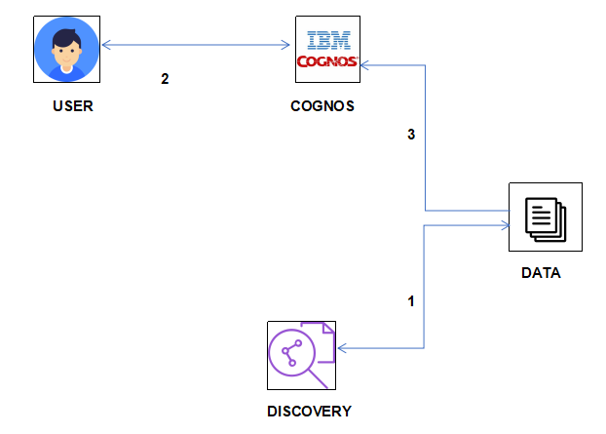**Architecture:**

**IBM Cloud Account:**IBM Acquired soft layer, a public cloud platform, to serve as the foundation for its IaaS offering.In October 2016, IBM rolled the soft layer brand under its Blue mix brand of Pa as offerings, giving users access to both IaaS and PaaS resources from a single console. IBM cloud provides a full-stack, public cloud platform with various products in the catalog, including options for compute,storage,networking, end to end developer solutions for app development, testing and deployment,security databases, and cloud native services.

creating the IBM cloud account by going to the IBM cloud login page,and click create on IBM cloud account. Enter our IBMid,and an ID is created based on the email that we enter.Completing the remaining fields with our information,and click create account by this the account is created

**Dataset collection:** The data collection on crop production by:

● Articulate the problem early.

● Establish data collection.

● check our data quickly.

● Format data to make it consistent.

● Reduce data.

● Complete data cleaning.

● Decompose data.

● Join transactional and attribute data.

**IBM Cog nos Analytics:** IBM cog nos analytic is a web-based integrated business intelligence suite by IBM. It provides a tool set for reporting,analytics,score carding,and monitoring of events and metrics. creating amazing meaning full dashboards using cog nos analytics.

**Creating a Dashboard:** Dashboard track KPIs,metrics,and other data points in one visual,central place. They give a high level view of work,helping to make quick decisions and keeping everyone up to date. storing the dataset into the dashboard we need to import the data into it. set up our excel dashboard file create a table with the raw data Analyze the data build the dashboard customize with Macros,color,and More..

**To export the Dashboard:** To save the dashboard as image , select image. The select location for download dialog box opens..

To save the dashboard as a Flash file, select MHT, then do one of the following.

To save the dashboard as a PDF file, select PDF dashboard is exported and displayed in a browser window.

**FLOW CHART**

Datacollection

Data Visualization

Address escalating customer interactions with early intervention.

Target the right customers with the right products and the right marketing.

Know where to invest in your business to drive revenue and customer adoption

Get to the root cause of churning customers.

Get to the root cause of churning customers.

Identify actions to increase your NPS or other customer satisfaction metric.

Identify actions to increase your NPS or other customer satisfaction metric.

Creating a dashboard

Exporting and conclusion

Exporting and conclusion

Get to the root cause of churning customers.

I

**RESULT**

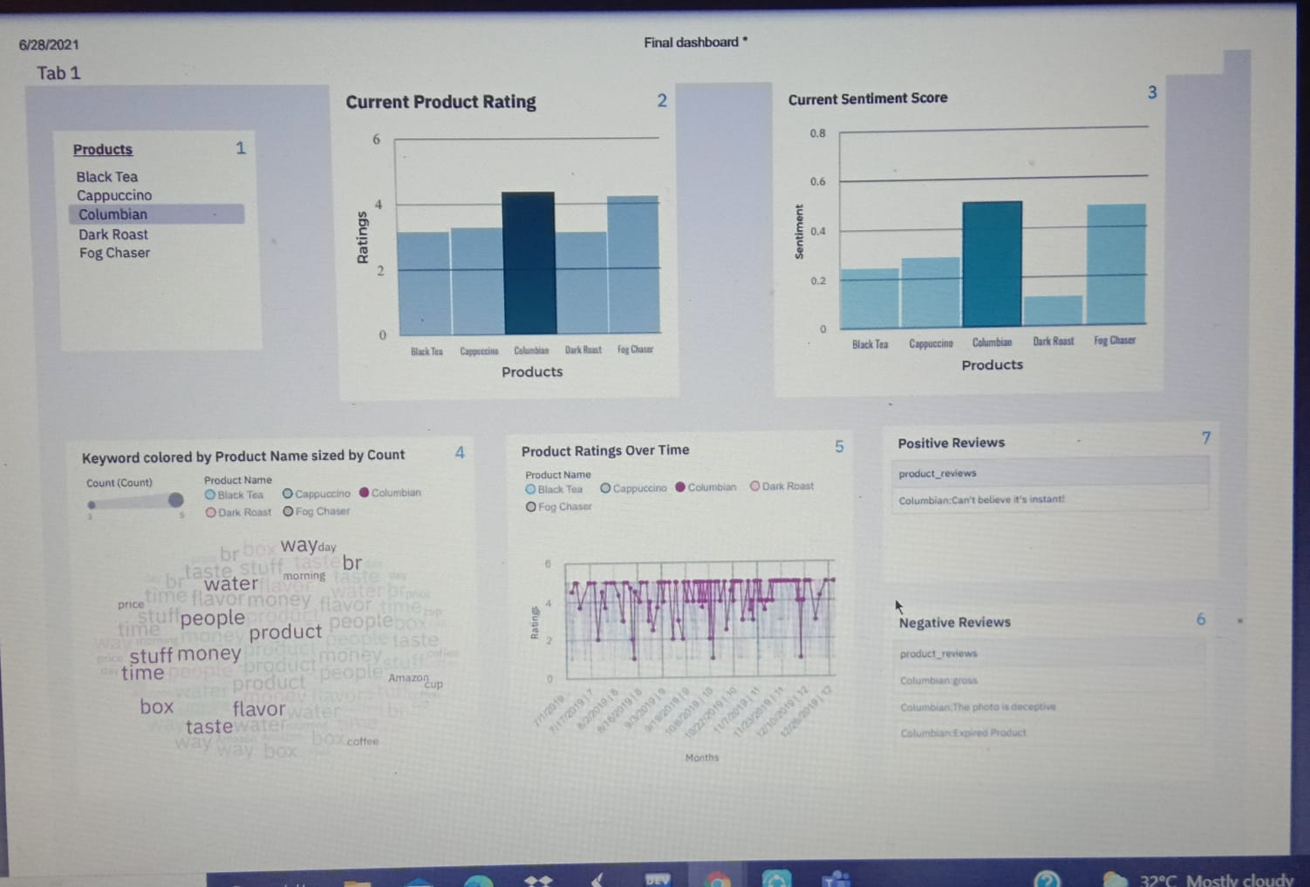

**ADVANTAGES AND DISADVANTAGES**

**Advantages:**

-- Lower costs--reduces maintenance due to complete report coverage and zero-footprint environment.

-- Faster results--shortens reporting time due to seamless integration and adaptive authoring.

-- Improved decision making--reports and dashboards present data in easily-understood formats.

--Adaptive authoring automatically adjusts report layout when objects are added,moved,or removed.

-- Ability to work with data using familiar business terms.

-- Ability to use a variety of charts

--cross tabs,bar or 3D bar,pie or doughnut,line,gauge,funnel,scatter,dot density,waterfall,and so forth.

-- Ability to create complex, multi-page layouts using different data sources.

-- High performance data access across all sources.

-- Complete connectivity regardless of environment.

-- open architecture that leverages XML,SOAP,and WSDL.

-- Ability to integrate seamlessly with the selling and Fulfillment Foundation, without the user

**Disadvantages:** Along with benefits of IBM Cog nos analytics mentioned above, there are a few drawbacks to know about, as well. some of the disadvantages are:

● Total cost of ownership(TCO) is more significant than other tools.

● Minimal forecast capabilities.

● Investment in cog nos R and D by IBM is declining.

● wont work smoothly with large data sets having many parameters.

● cross-browser compatibility is often problematic.

**APPLICATIONS**

The areas where this solution can be applied.

● Query performance

● General production system performance

● Aggregate view of data vs transactional view

● Complex SQL

● Normalized databases are typically tuned for simple queries

**CONCLUSION**

Conclusion summarizing the entire work and findings.

>>From this entire findings we know fundamental concepts and can work on IBM Cog nos Analytics

>>Gain a board understanding of plotting different graphs.

>>Able to create meaningful dashboards

>>Learn to build stunning dashboards with cog nos analytics

>>create tabbed dashboards and stories using the new dashboard tool of cog nos v11

>>Master the full-fledged Report Authoring tool

>>We will understand how a dashboard is different from a report,when to use both

>>we will understand the reporting interface

>>Implementing cross tabs and SQL queries From the crop production we entries the value of commitment, stay grounded and humble to our nature, gratitude goes a long way, great things take time,working hard and having fun can happen at the same time,pay it forward with generosity

**FUTURE SCOPE**

Enhancements that can be made in the future. Cog nos is the one of the leading BI suites in the market for meta data modelling and reporting so learning this will be definitely helpful in our career growth in BI domain. IBM cog nos TM1 form 10 haas been around for decent time and has officially experienced a few minor and real updates

IBM cog nos analytics leads to better decisions and improves company performance and profitability.

we can scope the better job in future with easy experience.

Total 709 companies are most often in computer software industry.

Rightly so, a good majority of them focus on the strategic aspects of dashboard creation such as understanding our audience and purpose first, and choosing the best charts to display our data visually for maximum readability and insights.

The training industry quarterly further narrow scope for specific industries,audiences,or purposes, providing tips on the tailor dashboards for learning& development.

**BIBILOGRAPHY**

References of previous works or websites visited/books referred for analysis about the project, solution previous findings etc.

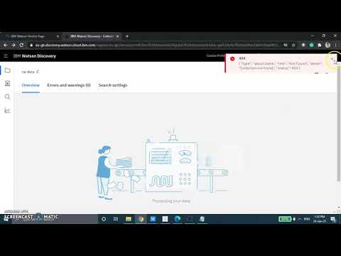

<https://www.youtube.com/watch?v=TJHf0V4aWBI>

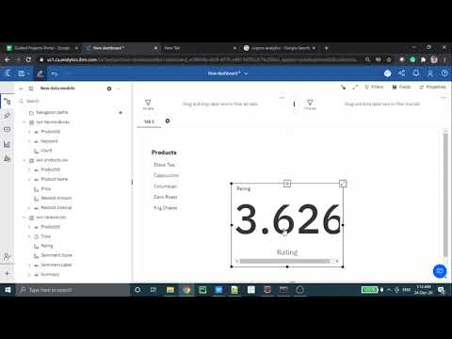

<https://www.youtube.com/watch?v=BQCJ0pgYqf4>

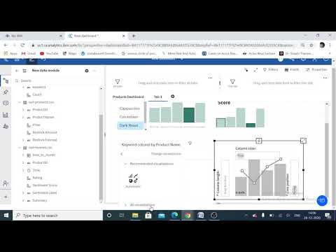

<https://www.youtube.com/watch?v=Ov_JZXjijBs>

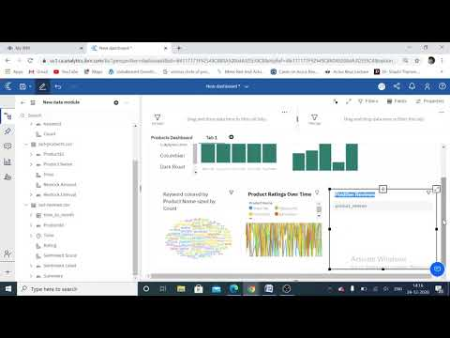

<https://www.youtube.com/watch?v=F2Q_7UC5EkI>