**GARBAGE CLASSIFICATION USING IBM CLOUD**

**DEVELOPED BY:** MOHAMMED FAHAD, MOHAMMED IRFANUDDIN, B. PRAHARSHA

**SMART BRIDGE – Mini Project Report**

**1. INTRODUCTION**

With the increase in the number of industries in the urban area, the disposal of solid waste is becoming a big problem, and solid waste includes paper, wood, plastic, metal, glass, etc. The common way of managing waste is burning waste and this method can cause air pollution and some hazardous materials from the waste spread into the air which can cause cancer. Hence it is necessary to recycle waste to protect the environment and human beings’ health, and we need to separate the waste into different components which can be recycled using different ways. The present way of separating waste/garbage is the hand-picking method, whereby someone is employed to separate out the different objects/materials. The person who separates waste is prone to diseases due to the harmful substances in the garbage. This problem can be overcome by automating the garbage classification process.

In this project, we will be building a deep-learning model that can detect and classify types of garbage. A web application is integrated with the model, from where the user can upload a garbage image like paper waste, plastic waste, etc., and see the analyzed results on User Interface.

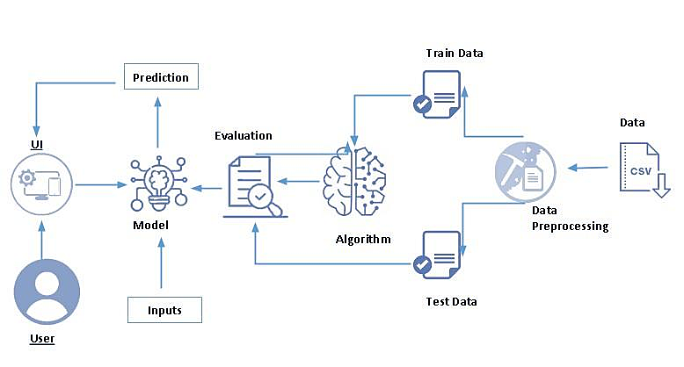

**1.1. OVERVIEW**

By the end of this project we will:

* know fundamental concepts and techniques of Artificial Neural Networks and Convolution Neural Networks
* Gain a broad understanding of image data.
* Work with Sequential type of modeling.
* Work with Keras capabilities
* Work with image processing techniques
* know how to build a web application using the Flask framework.

**1.2. PURPOSE**

Several times we have come across the news that people working in garbage yards face severe diseases which directly impact their health.

The purpose of this project is to reduce human involvement in the process of Garbage classification and replace this with an Intelligent machine that does the Garbage classification the same as humans and this protects humans from the toxic and dangerous environment of garbage classification.

“We can save people working in Garbage yards which in turn is a great achievement.”

**2. LITERATURE SURVEY**

**2.1. EXISTING PROBLEM**

Municipal solid waste (MSW) is hazardous to human health and the environment if not properly handled  throughout  all  management  processes,  beginning  with  collection,  separation,   transfer, treatment,  disposal, or  recycling and  reuse. The  World Health  Organization (WHO)  has  raised awareness of the dangers of improper solid waste disposal in terms of soil, water, and air pollution, as well as the health consequences for the people living in the surrounding areas. MSW production is predicted to reach 3.40 billion tonnes globally by 2050.  Inadequate waste management is one of the causes  of the  rise of  infectious diseases.  Most viruses, bacteria,  and parasites  that cause illness are found in blood, bodily fluids, and bodily secretions, which are components of bio-medical waste. This spreads through several human contacts, each of whom is a possible "receiver" of the illness. The Human Immunodeficiency Virus  (HIV) and hepatitis viruses are  at the forefront of a long  list  of illnesses  and disorders  that have  been linked  to biomedical waste.  Other prevalent diseases  spread  owing to  poor  waste management  include  tuberculosis,  pneumonia,  diarrhea, tetanus, whooping cough, and others.

“Workers who work in dumping areas are badly exposed and are more probable of getting infected.”

**Existing Solutions**

When we speak about the existing solutions workers in garbage dumping areas are just facilitated with a Mask, Jacket ( Few areas), and, a pair of Gloves which is protecting the worker to some extend but anyhow it cannot be assured that human is fully protected and shielded.

Though above wearables help defending diseases but this process never stops it's the daily routine of a worker and how long can he/she be protected?

The present way of separating waste/garbage is the hand-picking method, whereby someone is employed to separate out the different objects/materials. The person, who separates waste, is prone to diseases due to the harmful substances in the garbage. With this in mind, it motivated to develop an automated system that can sort waste.

Offering good salaries and few precautionary tools never brings a healthy life back and to solve this human must be replaced with a Intelligent machine.

**2.2. PROPOSED SOLUTION**

Aim is to design a intelligent human like machine which is capable of classifying garbage based on its previous training given by using multiple images of distinct garbage materials.

The present way of separating waste/garbage is the hand-picking method, whereby someone is employed to separate out the different objects/materials. The person, who separates waste, is prone to diseases due to the harmful substances in the garbage. With this in mind, it motivated to develop an automated system that can sort waste.

and this system can take short time to sort the waste, and it will be more accurate in sorting than the manual way. With the system in place, the beneficial separated waste can still be recycled and converted to energy and fuel for the growth of the economy. The system that is developed for the separation of the accumulated waste is based on the combination of Convolutional Neural Networks.

**3. THEORETICAL ANALYSIS**

**3.1 BLOCK DIAGRAM**

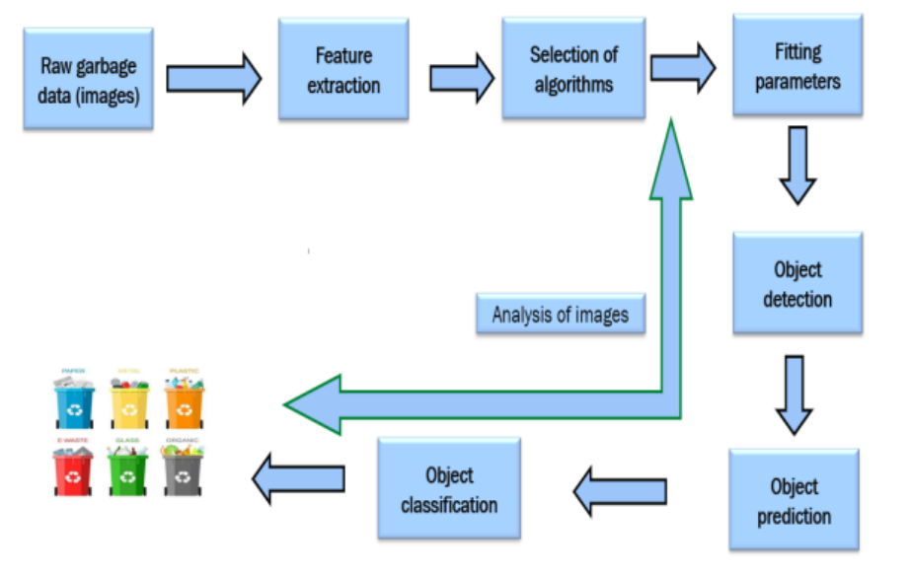

The above picture depicts the block diagram of the process which gives clear insights into the entire process where raw garbage data i.e., images then feature extraction is done in which features of garbage are extracted and then stored which are further used in the classification process.

After this selection of appropriate algorithms is done then parameters are fitted for the process of object detection and then object prediction and classification is the final step.

**Project Flow:**

* User interacts with a user interface to upload the image.
* The uploaded image is analyzed by the model which is integrated.
* Once the model analyses the uploaded image, the prediction is showcased on the UI.

To accomplish this, we have to complete all the activities and tasks listed below

* Data Collection.
* Data Preprocessing.
  + Import the ImageDataGenerator library.
  + Configure ImageDataGenerator class.
  + Apply ImageDataGenerator functionality to Trainset and Testset.
* Model Building.
  + Import the model-building Libraries.
  + Initializing the model.
  + Adding Input Layer.
  + Adding Hidden Layer.
  + Adding Output Layer.
  + Configure the Learning Process.
  + Training and testing the model.
  + Optimize the Model.
  + Save the Model.
* Application Building.
  + Create an HTML file.
  + Build Python Code.

**3.2 HARDWARE / SOFTWARE DESIGNING**

To complete this project you should have the following software  and packages

**Anaconda Navigator:**

Anaconda Navigator is a free and open-source distribution of the Python and R programming languages for data science and machine learning-related applications. It can be installed on Windows, Linux, and macOS. Conda is an open-source, cross-platform,  package management system. Anaconda comes with so very nice tools like JupyterLab, Jupyter Notebook,

QtConsole, Spyder, Glueviz, Orange, Rstudio, Visual Studio Code. For this project, we will be using Jupiter notebook and spyder.

To build Deep learning models you must require the following packages

**Tensor flow:**TensorFlow is an end-to-end open-source platform for machine learning. It has a comprehensive, flexible ecosystem of tools, libraries, and community resources that lets researchers push the state-of-the-art in ML and developers can easily build and deploy ML-powered applications.

**Keras:** Keras leverages various optimization techniques to make high-level neural network API easier and more performant. It supports the following features:

* Consistent, simple, and extensible API.
* Minimal structure - easy to achieve the result without any frills.
* It supports multiple platforms and backends.
* It is a user-friendly framework that runs on both CPU and GPU.
* Highly scalability of computation.

**Flask**: Web framework used for building  Web applications

**Python packages:**

* + open anaconda prompt as administrator
  + Type “pip install numpy” and click enter.
  + Type “pip install pandas” and click enter.
  + Type “pip install sci-kit-learn” and click enter.
  + Type “pip install tensorflow==2.3.2” and click enter.
  + Type “pip install keras==2.3.1” and click enter.
  + Type “pip install Flask” and click enter.

**4. EXPERIMENTAL INVESTIGATIONS**

One should have knowledge of the following Concepts:

* Supervised and unsupervised learning.
* Regression, Classification, and Clustering.
* Artificial Neural Networks.
* Convolation Neural Networks.
* Flask.

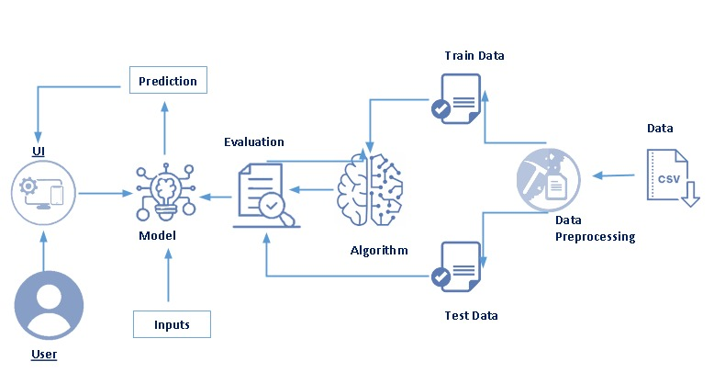**5. FLOWCHART**

By seeing the above image we can understand that the user is interacting with the user interface (UI) and a model is built which is taking inputs and predicting the classified result.

Data (Images) is given as input then the processing of the image is done by training the machine with training data, here machine is trained using the appropriate algorithm and then evaluation is done to verify the outputs, and the training is continued until the machine is capable of classifying the garbage fairly.

The machine is tested by providing testing data and again evaluation is done, at last, the model is built upon successful evaluation for the usage and this model is used for making the classification.

Users can now directly interact with the user interface and give inputs and then classification is done by using the model.

**6. RESULTS**

Following are the outputs which are presented in the screenshot format.

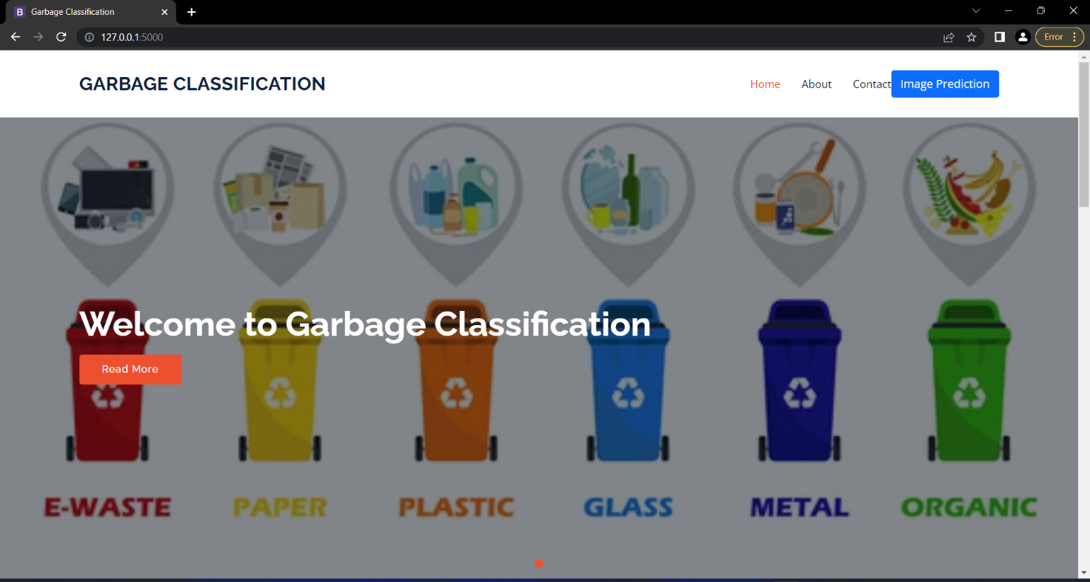1. HOME PAGE

 2. ABOUT

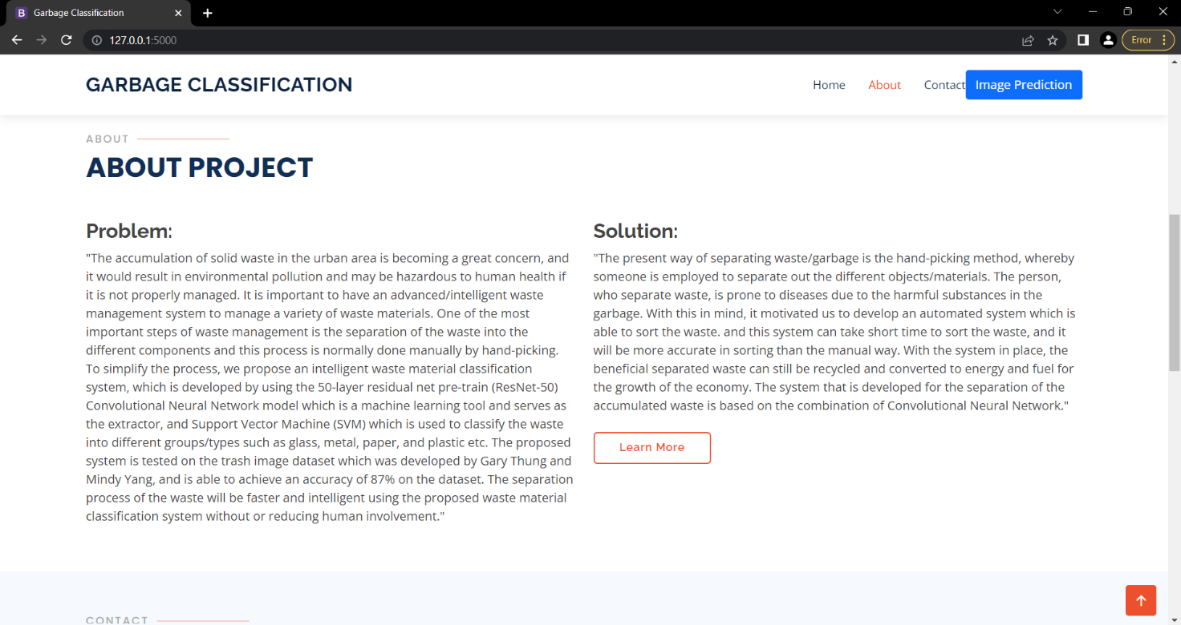

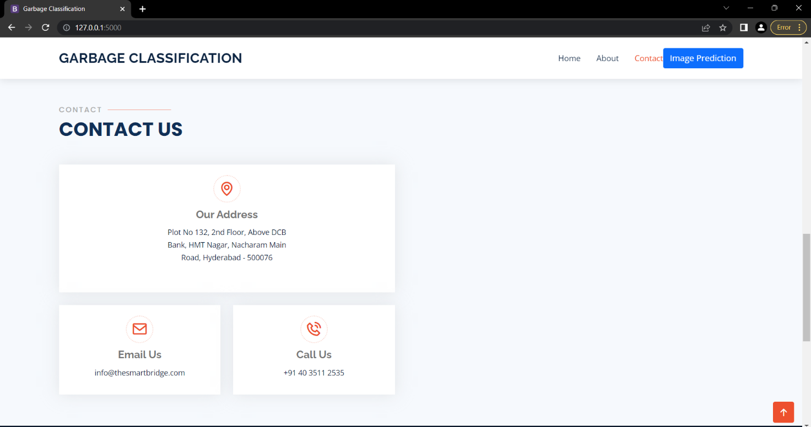3. CONTACT

4. INFORMATION (ABOUT US)

5. CLICK ON IMAGE PREDICTION ON TOP RIGHT CORNER.

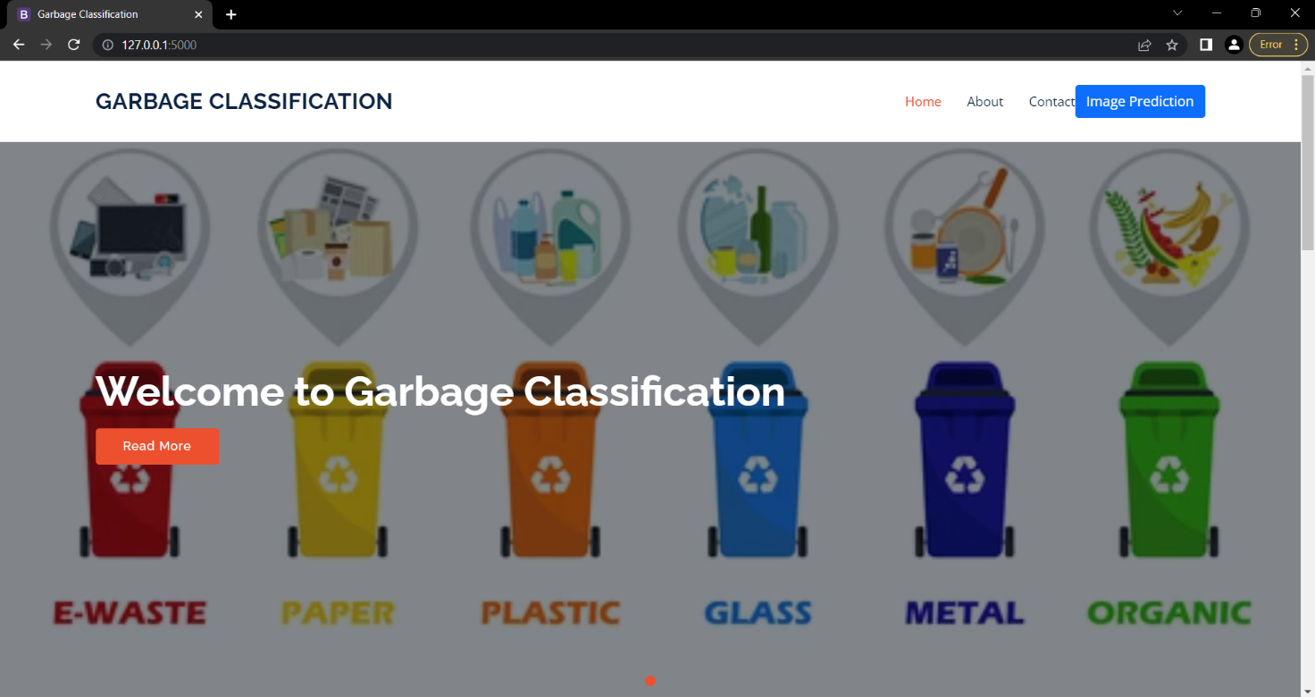

6. CLICK ON CHOOSE.

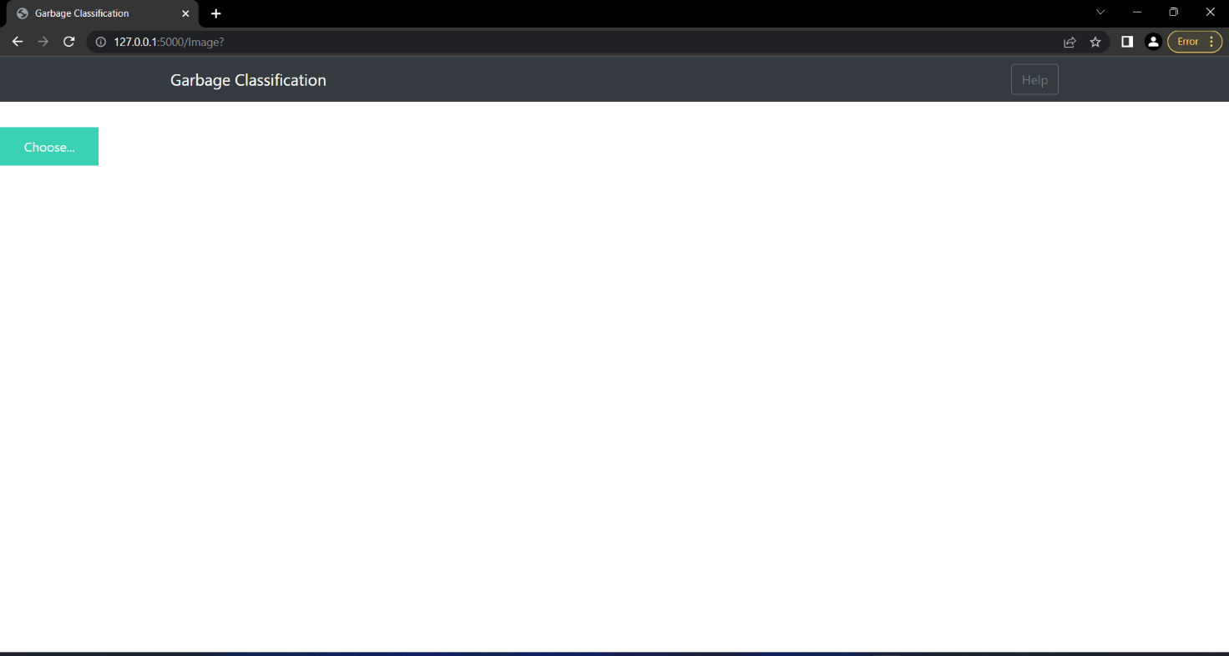

7. CHOOSE IMAGE (GARBAGE/WASTE).

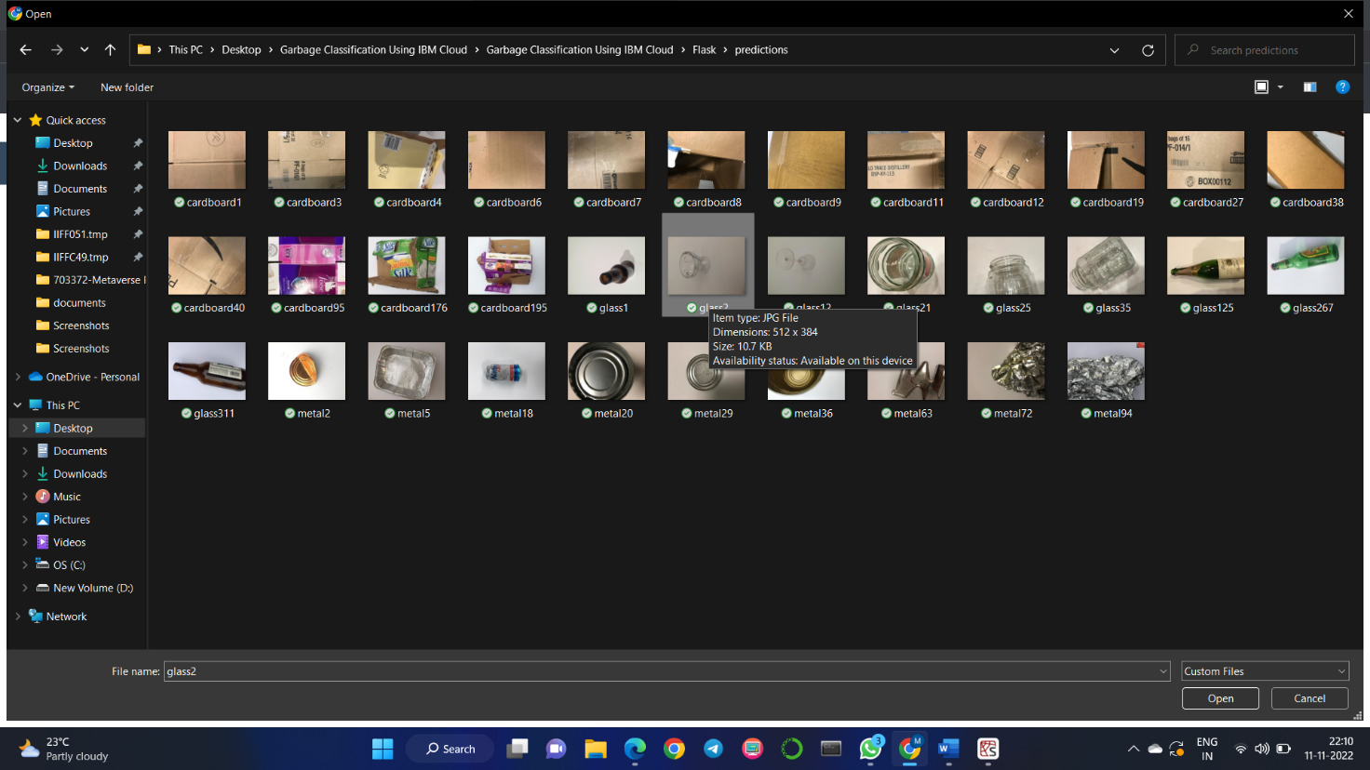

8. FOLLOWING IS A MACHINE-PREDICTED OUTPUT WHICH IS A CLASSIFIED RESULT.

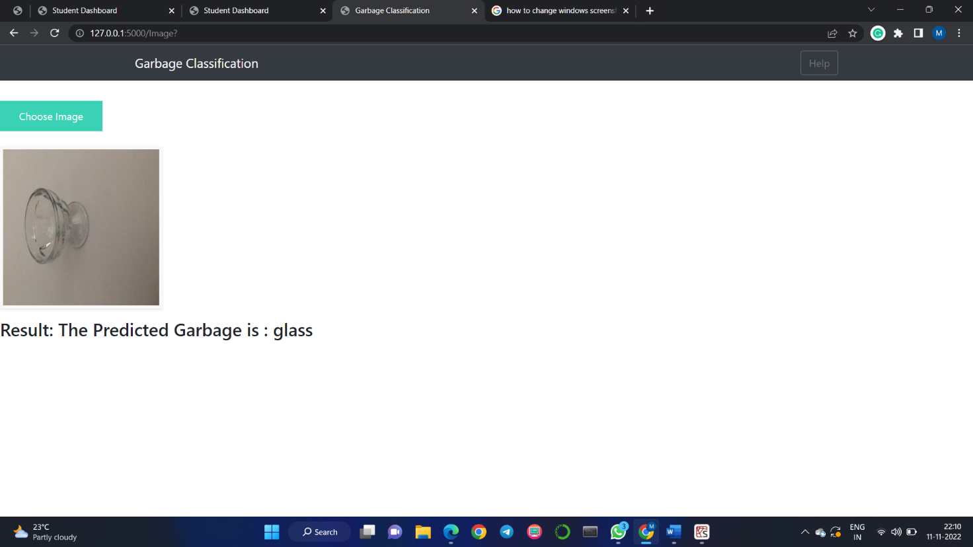

**7. ADVANTAGES**

* Human Involvement in the Garbage Classification process is reduced.
* Time taken in classification is very quick.
* Efficiency in the classification of garbage is also increased.
* Placing garbage for a long duration may result in increasing diseases and this is resolved.

**7. DISADVANTAGES**

* People working in dump yards lose their job.
* Error in classification may result in completely inconsistent results.
* Continuous maintenance is required.
* May be expensive for maintenance.

**8. APPLICATIONS**

Garbage classification has always been an important issue in environmental protection, resource recycling, and social livelihood. In order to improve the efficiency of front-end garbage collection, an automatic garbage classification system is proposed based on deep learning.

The model can be applied in all the garbage classification areas and this implementation will surely help us to classify the garbage efficiently.

We can save people working in garbage dump yards from deadly diseases and make the classification more advanced by using the proposed model.

**9. CONCLUSIONS**

By using the model that we developed in this project we can classify the garbage based on its attributes and parameters and make the process of classification more efficient and robust.

A machine exposed to harmful garbage yards can be used efficiently as it is robust and has nothing to do with the harmful and toxic environment of dump yards.

Whereas if humans are exposed to a harmful and toxic environment will encounter multiple severe diseases in the long run and the healthy life of a human cannot be retrieved at any cost.

So we can conclude by saying that “Human life can’t be replaced but a machine can be replaced.”

**10. FUTURE SCOPE**

The current prototype is capable of picking up 100-200gms of garbage. A future version of the machine is being designed keeping in mind to pick up the garbage of up to 2-3Kgs in weight. Whereas, the number of garbage that can be detected by the machine can be easily increased either by training a new Convolutional Neural Network from scratch, or by using techniques like transfer learning. The machine can be further connected to the internet and using it as an IoT device.

**11. BIBLIOGRAPHY**

[1] The datasets are collected from kaggle.com, data.gov, the UCI machine learning repository, etc.

[2] Image Data Generator Reference

<https://keras.io/api/preprocessing/image/>

[3] You can download the dataset used in this project using the GitHub link

<https://github.com/Guided-Projects/Garbage-Classification>

[4] Load data from the directory reference

<https://keras.io/api/preprocessing/image/#imagedatasetfromdirectory-function>

[5] Convolution Neural Networks reference

<https://youtu.be/umGJ30-15_A>

[6] For information regarding CNN Layers refer to the link

<https://victorzhou.com/blog/intro-to-cnns-part-1/>

[7] Flask app reference

<https://www.youtube.com/watch?v=lj4I_CvBnt0>

[8] HTML reference

<https://www.w3schools.com/html/>

**APPENDIX**

**A. SOURCE CODE**

(app.py)

from __future__ import division, print_function

# coding=utf-8

import sys

import os

import glob

import numpy as np

from tensorflow.keras.preprocessing import image

from tensorflow.keras.models import Sequential

from tensorflow.keras.layers import Dense

from tensorflow.keras.layers import Dropout

from tensorflow.keras.applications.imagenet_utils import preprocess_input, decode_predictions

from tensorflow.keras.models import load_model

from tensorflow.keras import backend

from tensorflow.keras import backend

from tensorflow import keras

import tensorflow as tf

# global graph

# # #graph=tf.get_default_graph()

# graph=tf.compat.v1.get_default_graph()

#global graph

#graph = tf.get_default_graph()

from skimage.transform import resize

# Flask utils

from flask import Flask, redirect, url_for, request, render_template

from werkzeug.utils import secure_filename

from gevent.pywsgi import WSGIServer

# Define a flask app

app = Flask(__name__)

# Model saved with Keras model.save()

#MODEL_PATH = 'models/crop_protection.h5'

# Load your trained model

model = load_model(r'C:\Users\Mohammed Fahad\OneDrive\Desktop\Garbage Classification Using IBM Cloud\Garbage Classification Using IBM Cloud\models\Garbage1.h5')

# Necessary

# print('Model loaded. Start serving...')

# You can also use pretrained model from Keras

# Check https://keras.io/applications/

#from keras.applications.resnet50 import ResNet50

#model = ResNet50(weights='imagenet')

#model.save('')

#print('Model loaded. Check http://127.0.0.1:5000/')

@app.route('/', methods=['GET'])

def index():

# Main page

return render_template('index.html')

@app.route('/Image',methods=['POST','GET'])

def prediction(): # route which will take you to the prediction page

return render_template('base.html')

@app.route('/predict', methods=['GET', 'POST'])

def upload():

if request.method == 'POST':

# Get the file from post request

f = request.files['image']

# Save the file to ./uploads

basepath = os.path.dirname(__file__)

file_path = os.path.join(

basepath, 'predictions',f.filename)

f.save(file_path)

img = image.load_img(file_path, target_size=(128, 128))

x = image.img_to_array(img)

x = np.expand_dims(x, axis=0)

a=np.argmax(model.predict(x),axis=1)

# preds = model.predict_classes(x)

index = ['cardboard','glass','metal','paper','plastic','trash']

text = "The Predicted Garbage is : "+str(index[a[0]])

# ImageNet Decode

return text

if __name__ == '__main__':

app.run(debug=False,threaded = False)

Garbage classification has always been an important issue in environmental protection,

resource recycling and social livelihood. In order to improve the efficiency of front-end garbage collection,

an automatic garbage classification system is proposed based on deep learning

Garbage classification has always been an important issue in environmental protection,

resource recycling and social livelihood. In order to improve the efficiency of front-end garbage collection,

an automatic garbage classification system is proposed based on deep learning

Garbage classification has always been an important issue in environmental protection,

resource recycling and social livelihood. In order to improve the efficiency of front-end garbage collection,

an automatic garbage classification system is proposed based on deep learning